Online Gradebook

Analysis and Design Document

# Elaboration – Iteration 1.1

# Domain Model

# Architectural Design

## Conceptual Architecture

I decided to decompose my project into 5 (vertical) layers: view, controller, service, persistence and database. The view is represented by the browser webpage, and the controller “listens” to the user input and sends the required operation to the service layer (business logic). There a check is done whether the requested data is valid (mark is between 1 and 10, there is such person in the database, etc.) and then through the persistence layer the needed data is extracted from the database by using the adequate operation (CRUD – create, read, update, delete).

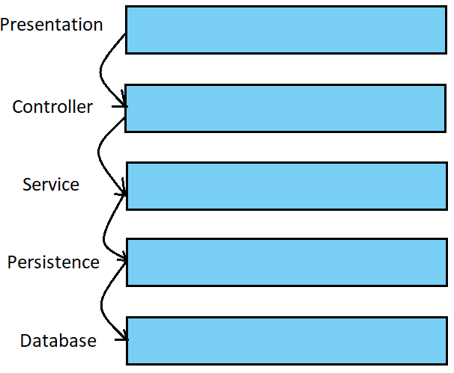

## Package Design

## Component and Deployment Diagrams

# 

# Elaboration – Iteration 1.2

# Design Model

## Dynamic Behavior

*[Create the interaction diagrams (1 sequence, 1 communication diagrams) for 2 relevant scenarios]*

## Class Design

*[Create the UML class diagram; apply GoF patterns and motivate your choice]*

# Data Model

*[Create the data model for the system.]*

# Test Strategy

*[Present the used testing methods and the associated test case scenarios.]*

# Elaboration – Iteration 2

# Architectural Design Refinement

*[Refine the architectural design: conceptual architecture, package design (consider package design principles), component and deployment diagrams. Motivate the changes that have been made.]*

# Design Model Refinement

## *[Refine the UML class diagram by applying class design principles and GRASP; motivate your choices. Deliver the updated class diagrams.]*

# Construction and Transition

# System Testing

*[Describe how you applied integration testing and present the associated test case scenarios.]*

# Future improvements

*[Present future improvements for the system]*