VideoPlace

Analysis and Design Document

# Elaboration – Iteration 1.1

# Domain Model

The domain model will consist of 4 main classes: User, Video, Tag and Comment represented as such:

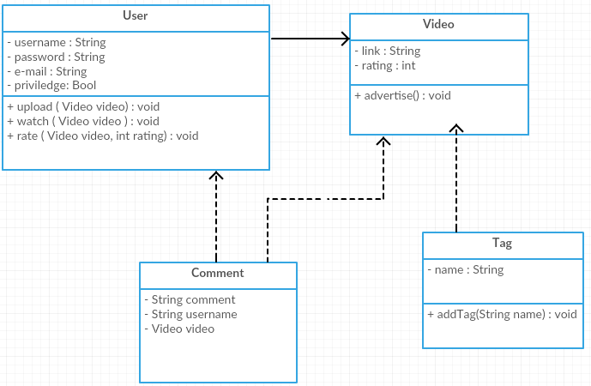

# Architectural Design

## Conceptual Architecture

For this project I have decided to use the Layered Architecture, consisting of the following layers:

- User Interface

- Presentation

- Business Logic

- Persistence

- Database

This architecture was chosen because my application performs specific roles which can be distributed into layers as described above, making dependencies flow from the upper level to the lower level, thus methods belonging to a certain layer not being able to be used by a regular user. This architecture is also permits modifying classes without needing to change code in others.

## Package Design

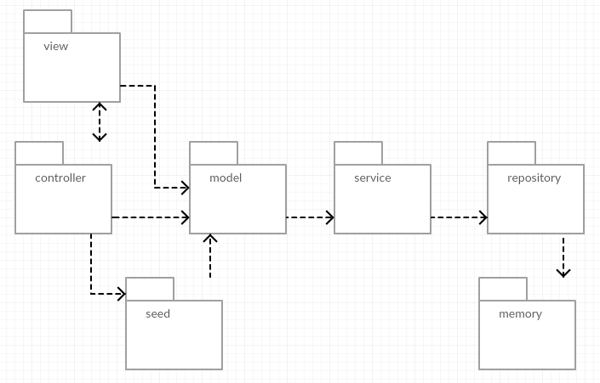

## Component and Deployment Diagrams

Component diagram:

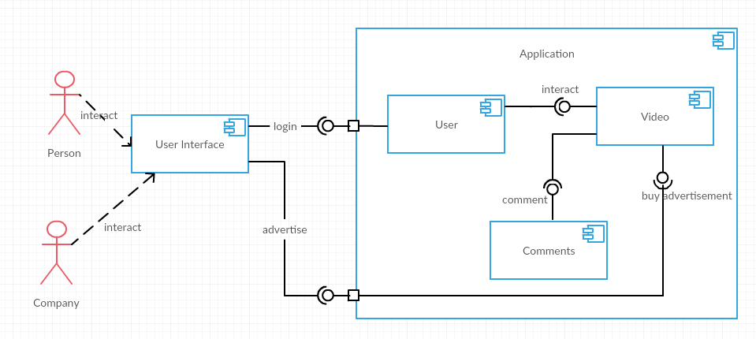

Deployment diagram:

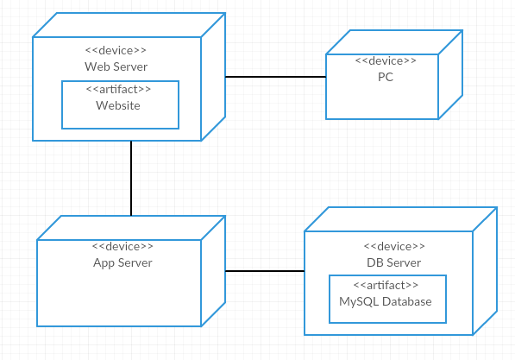

# Elaboration – Iteration 1.2

# Design Model

## Dynamic Behavior

*[Create the interaction diagrams (1 sequence, 1 communication diagrams) for 2 relevant scenarios]*

## Class Design

*[Create the UML class diagram; apply GoF patterns and motivate your choice]*

# Data Model

*[Create the data model for the system.]*

# Test Strategy

*[Present the used testing methods and the associated test case scenarios.]*

# Elaboration – Iteration 2

# Architectural Design Refinement

*[Refine the architectural design: conceptual architecture, package design (consider package design principles), component and deployment diagrams. Motivate the changes that have been made.]*

# Design Model Refinement

## *[Refine the UML class diagram by applying class design principles and GRASP; motivate your choices. Deliver the updated class diagrams.]*

# Construction and Transition

# System Testing

*[Describe how you applied integration testing and present the associated test case scenarios.]*

# Future improvements

*[Present future improvements for the system]*