CrowdfundMe

Analysis and Design Document

# Elaboration – Iteration 1.1

# Domain Model

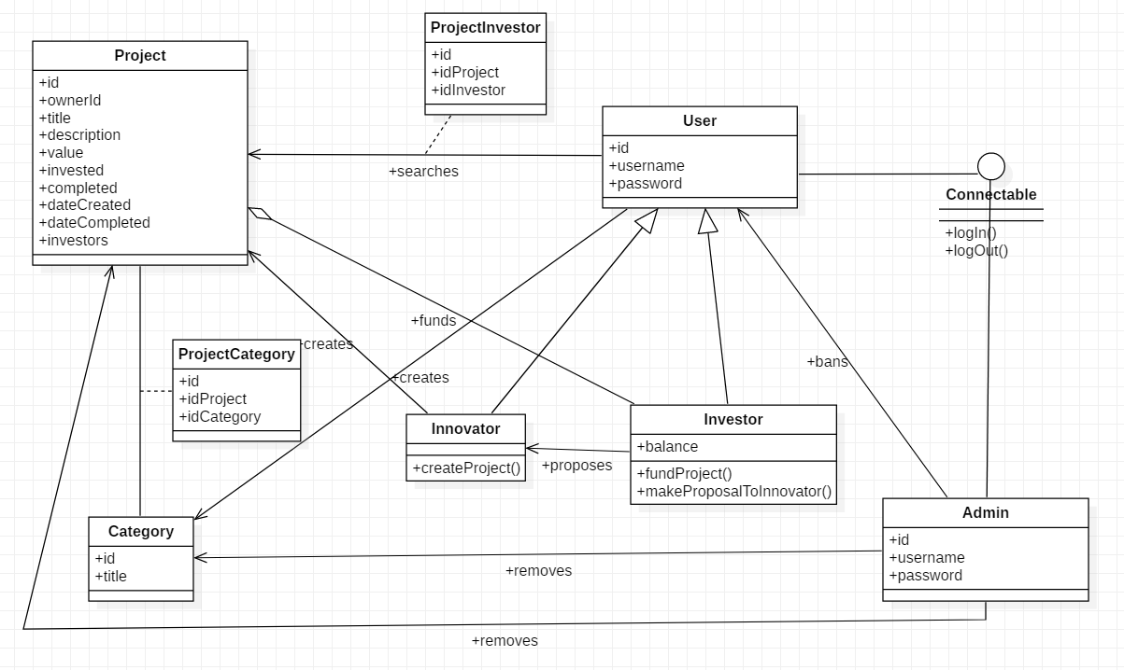

# Architectural Design

## Conceptual Architecture

Observer design pattern shall be used so that the project owner and investors would be notified when a project is completely funded

Abstract factory for repositories

Model view presenter approach for front-end

## Package Design

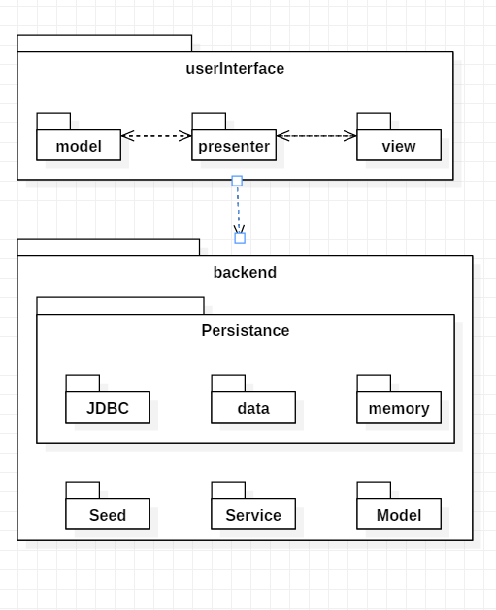

## Component and Deployment Diagrams

# 