CrowdfundMe

# Interaction diagram

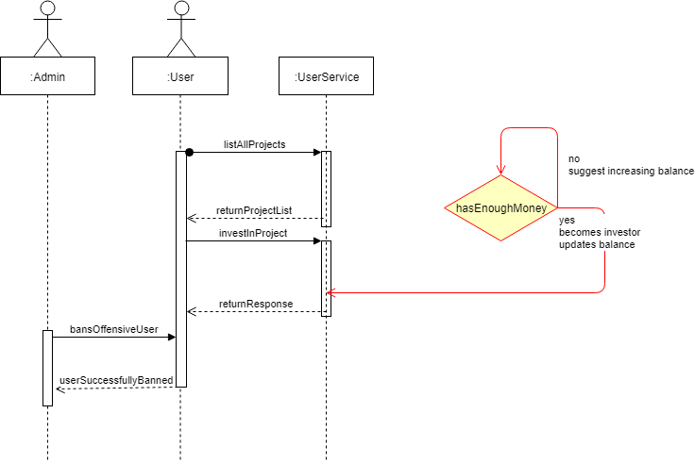

# Class diagram

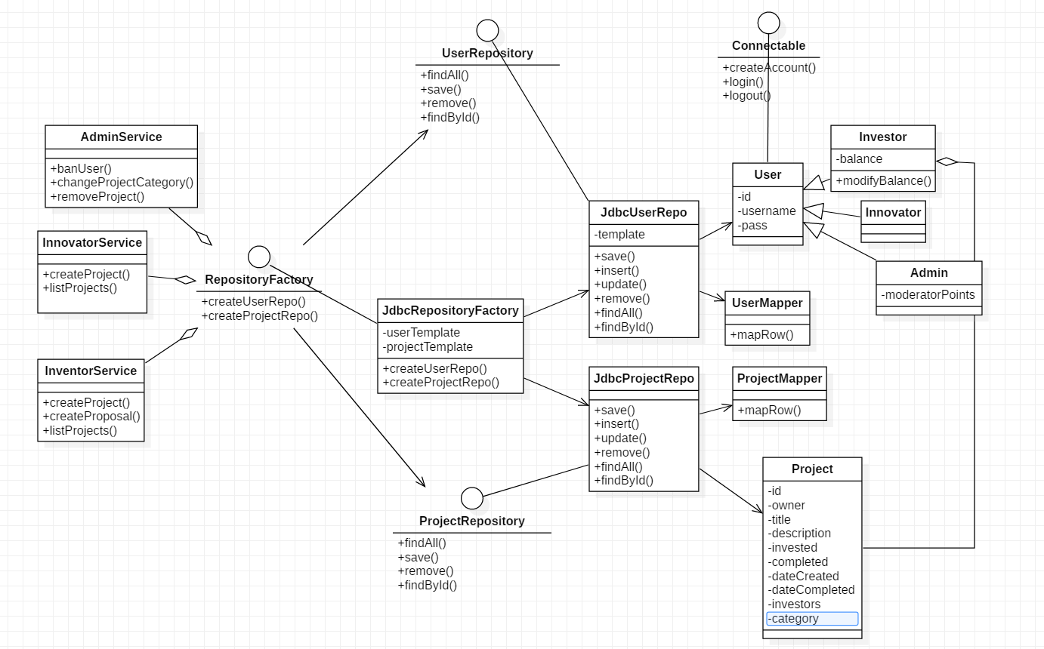

# Data model

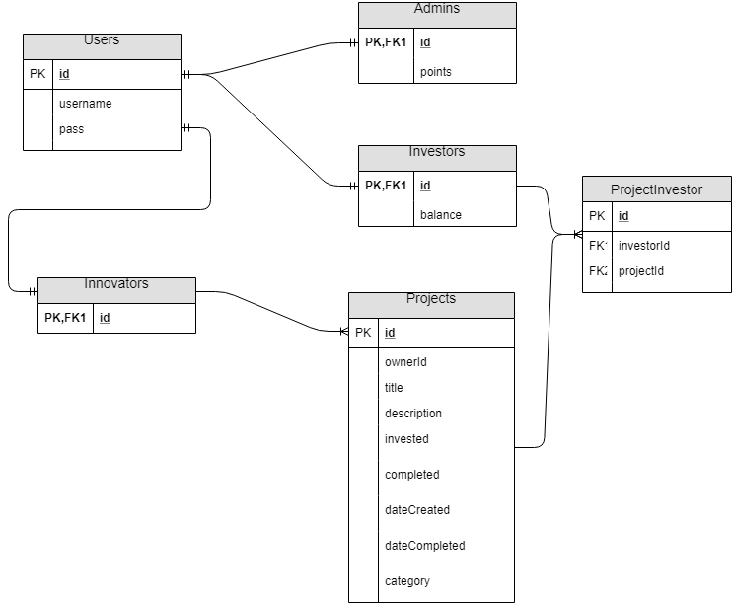

# Testing strategy

Programmer tests:

* login working
* adding a project should modify the database

Unit tests:

* project list size increases by 1 upon creating a project
* user list size decreases by 1 upon banning a user

Integration tests:

* black-box testing, click on buttons until something changes

Live demonstration