Martuneac

Alexandru

30431



Stock market platform

Analysis and Design Document

# Elaboration – Iteration 1.1

## Domain Model

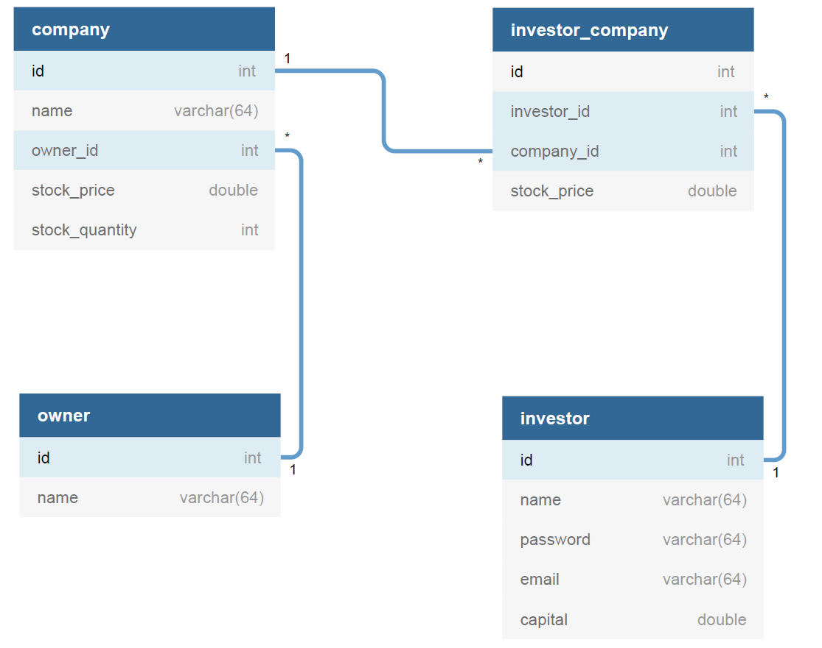

## Architectural Design

### Conceptual Architecture

For the back-end, a layered architecture will be implemented to better organize and differentiate between entities, services, business logic, etc. Furthermore, abstract factory (creational pattern) will be present, since it allows to easily switch between the concrete implementation of the objects instantiated. Also, it is easier to write, understand, test and extend.

Observer pattern will be implemented to announce the investors that a new company was listed.

Abstract factory pattern for creating families of related objects without specifying their type. This allows us to change the implementation of different classes, in case a new technology appears or we have to use multiple implementations.

The front-end will use a variation of the famous MV* design pattern, more specifically MVP (model-view-presenter).

The Presenter receives the input from users via View, then process the user’s data with the help of Model and passing the results back to the View.

Presenter communicates with view through interface. Interface is defined in presenter class, to which it passes the required data.

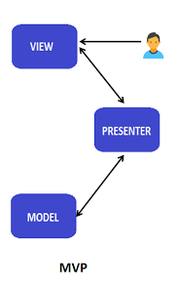

### Package Design

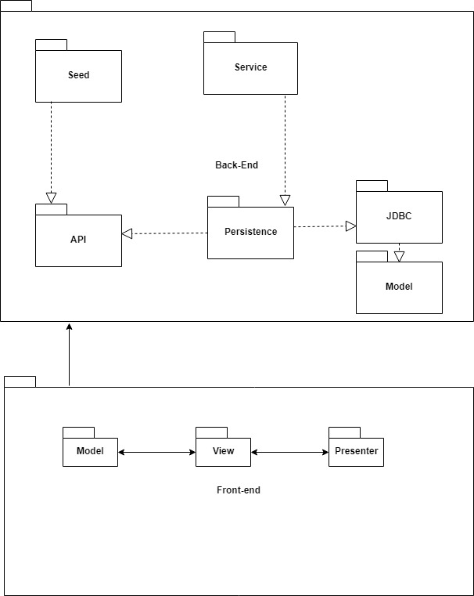

### Component and Deployment Diagrams

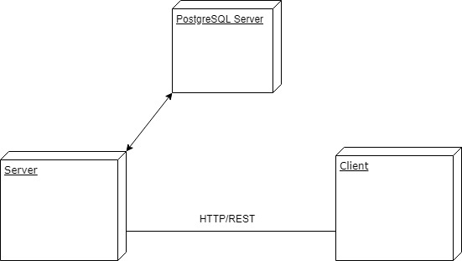

# Elaboration – Iteration 1.2

## Design Model

### Dynamic Behavior

1. *Investor authenticates and performs a buy.*

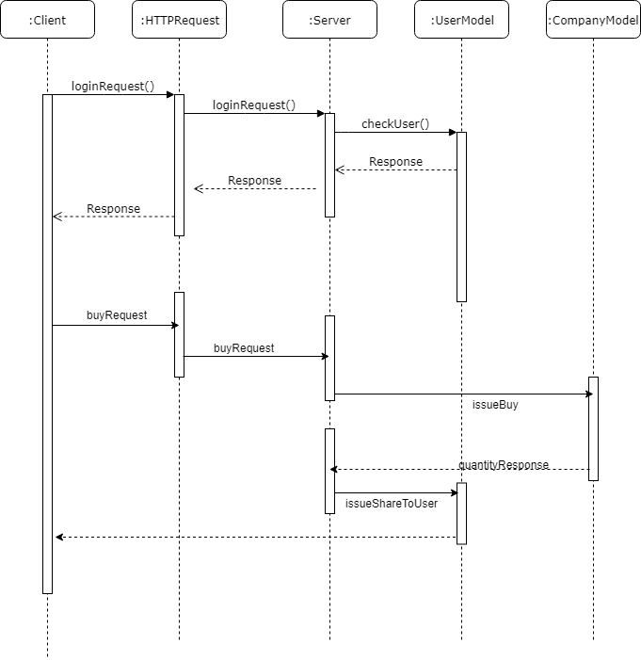

1. 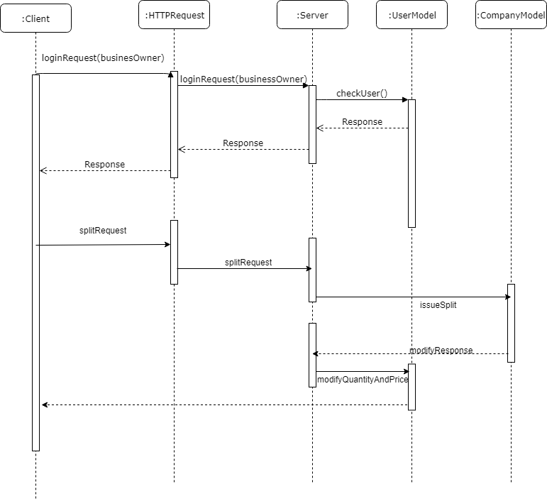*Business owner authenticates and issues a split.*

### Class Design

The pattern used will be the repository pattern. It uses an abstract factory to identify between different repos and allows for a convenient access to the data. Moreover, repository has the job to deliver to the business layer the required objects.

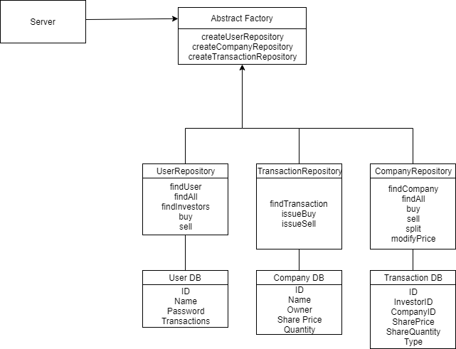

# Data Model

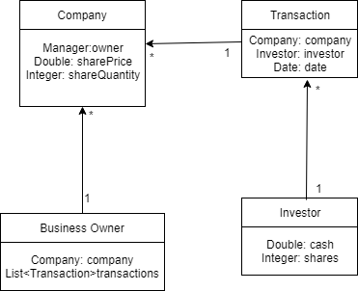

The database tables will be integrated based on the above specified diagram,

# Test Strategy

The project will use several unit tests and some integration tests. The tests will focus mainly on getting correct responses out of the api(correct splitting and its effect, invalid login credentials, etc.).

# Elaboration – Iteration 2

# Architectural Design Refinement

*[Refine the architectural design: conceptual architecture, package design (consider package design principles), component and deployment diagrams. Motivate the changes that have been made.]*

# Design Model Refinement

## ***[Refine the UML class diagram by applying class design principles and GRASP; motivate your choices. Deliver the updated class diagrams.]***

# Construction and Transition

# System Testing

*[Describe how you applied integration testing and present the associated test case scenarios.]*

# Future improvements

*[Present future improvements for the system]*