Video Games Store

Analysis and Design Document

# Elaboration – Iteration 1.1

# Domain Model

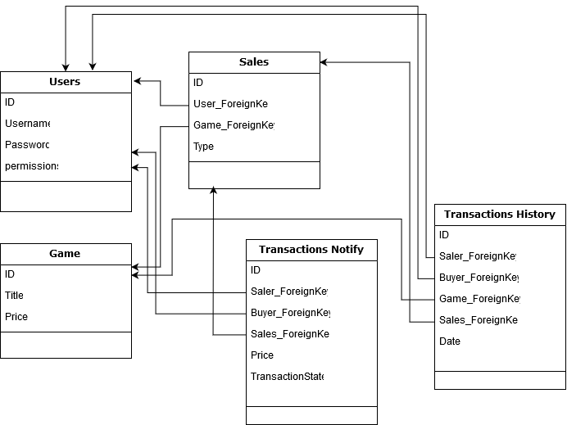

# Architectural Design

## Conceptual Architecture

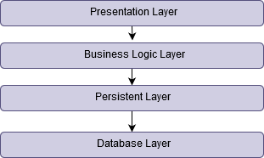

* Implemented pattern: Observer.
  + In order to notify different types of users that another type of user has been implemented.
* Model view presenter design pattern
  + Design pattern for the front-end.
* Abstract factory pattern
  + An efficient way to implement classes and form relations between entities.

## Package Design

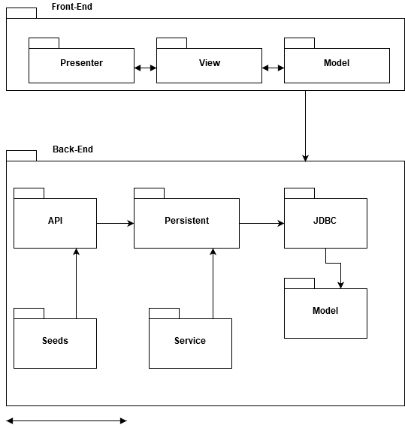

## Component and Deployment Diagrams

# 