

UTCN-Wiki

Student: Marasescu-Duran Antonio

Group: 30431

# Interaction Diagram

## Client authenticates and searches after a course

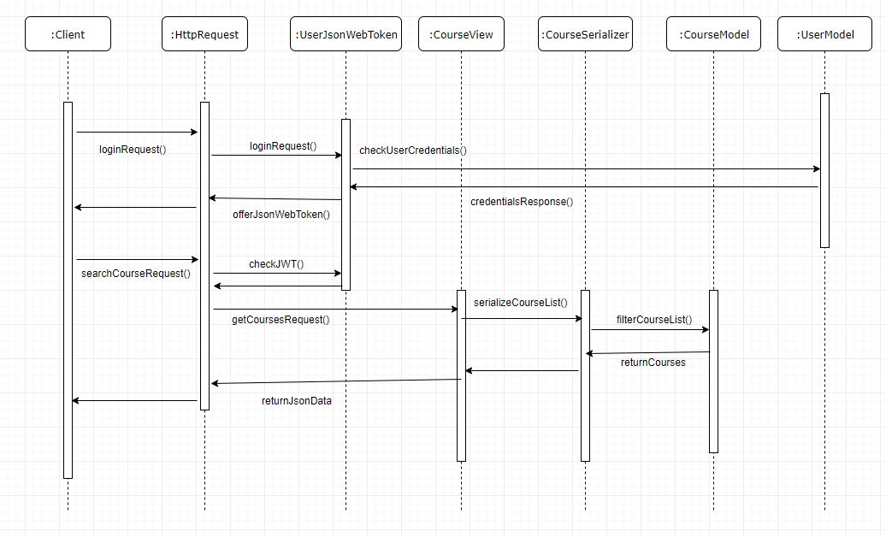

## List Users and Ban user (Admin)

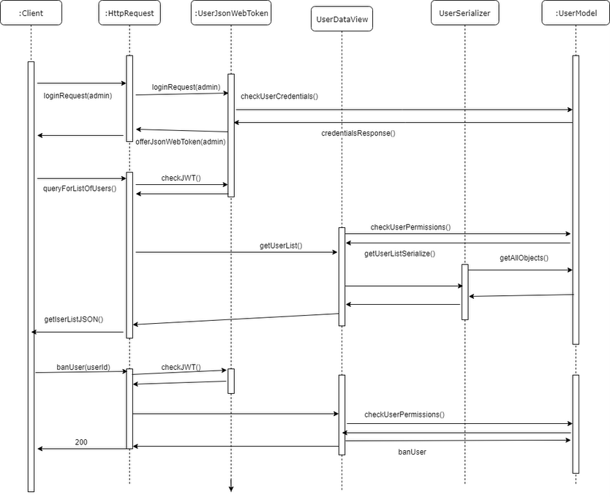

# Class Diagram

## Django Rest Framework

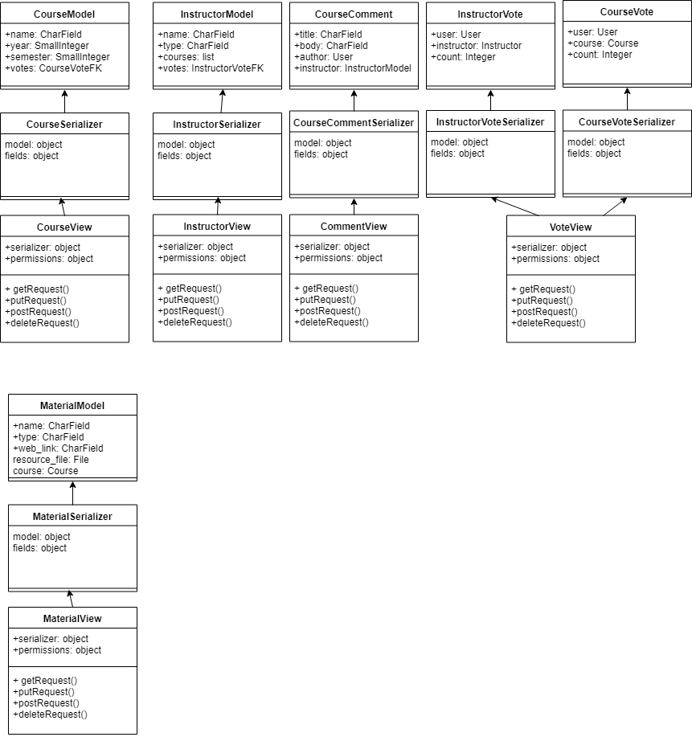

# Data Model Diagram

As described in Deliverable2 Django integrates the database table in a class model.

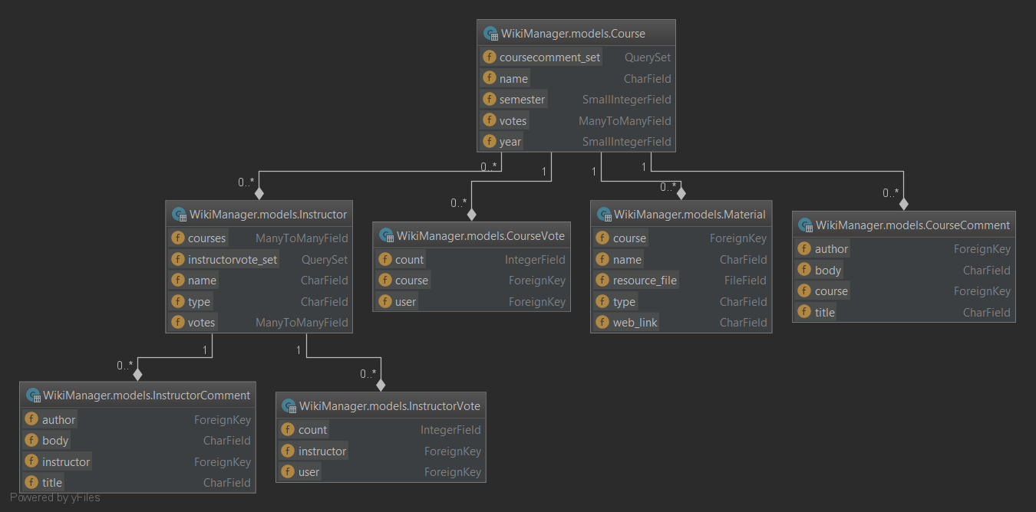

# Test Strategy

This project will make several unit tests and integraton tests using the Django Rest Framework APIRequestFactory and the standard testing library provided by the Django Framework. The tests will be executed by running the command “python manage.py test” made available by the framework and using PyCharm. The test cases will mainly focus on the getting the correct responses out of the api (invalid login credentials, correct filtering of course, correct voting, etc.)