Book review

Analysis and Design Document

# Elaboration – Iteration 1.1

# Domain Model

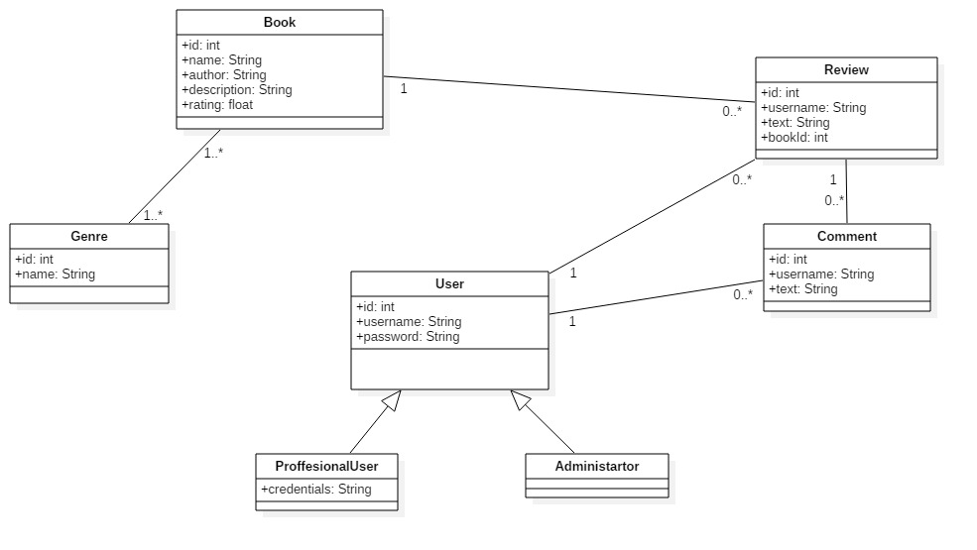

# Architectural Design

## Conceptual Architecture

*For this application I will use the layered architecture and the MVC architecture .*

*I have chosen the layered architecture because it organizes the code into layers that each have a different responsibility, all dependencies go in one direction, a change in one of the layers doesn’t affect the other layers and it is easy to test.*

*I have chosen MVC architecture to isolate the application logic from the user interface.*

## Package Design

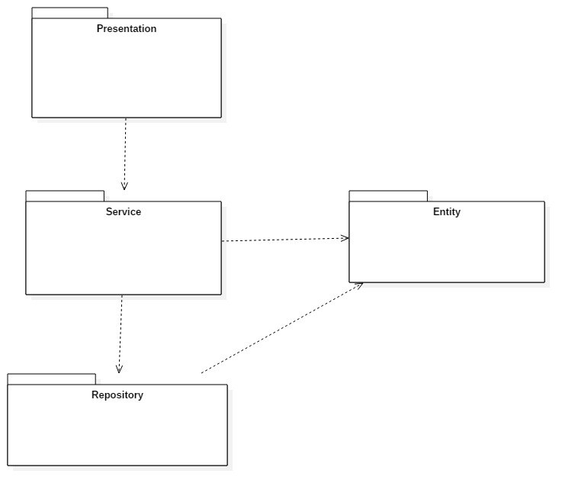

## Component and Deployment Diagrams

# 

# Elaboration – Iteration 1.2

# Design Model

## Dynamic Behavior

*[Create the interaction diagrams (1 sequence, 1 communication diagrams) for 2 relevant scenarios]*

## Class Design

*[Create the UML class diagram; apply GoF patterns and motivate your choice]*

# Data Model

*[Create the data model for the system.]*

# Test Strategy

*[Present the used testing methods and the associated test case scenarios.]*

# Elaboration – Iteration 2

# Architectural Design Refinement

*[Refine the architectural design: conceptual architecture, package design (consider package design principles), component and deployment diagrams. Motivate the changes that have been made.]*

# Design Model Refinement

## *[Refine the UML class diagram by applying class design principles and GRASP; motivate your choices. Deliver the updated class diagrams.]*

# Construction and Transition

# System Testing

*[Describe how you applied integration testing and present the associated test case scenarios.]*

# Future improvements

*[Present future improvements for the system]*