Saloon for Dogs

Analysis and Design Document

# Elaboration – Iteration 1.1

# Domain Model

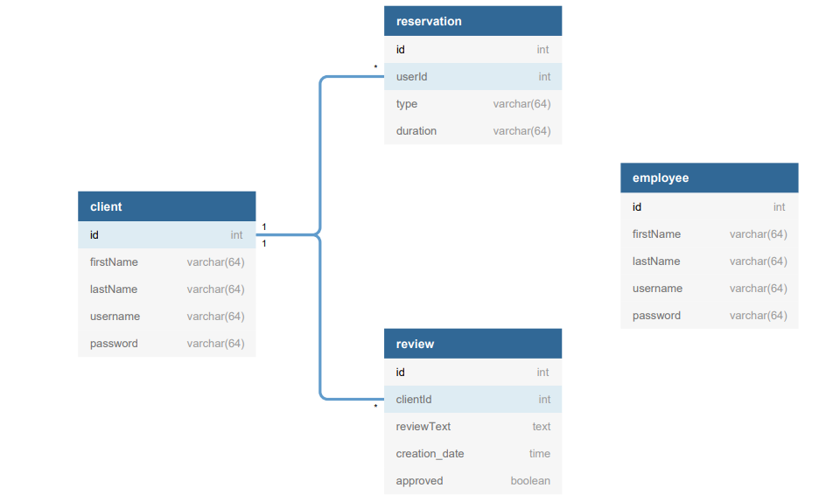

# Architectural Design

## Conceptual Architecture

I will use

* layered architecture because I want each layer to have a single responsibility.
* Domain logic pattern: service layer: to encapsulate the business logic.
* Repository pattern because I worked with it in the 1st assignment and I understood it. It is useful because the business layer will access directly the entities it needs, without looking at how they were made.
* Transactions scripts: service per operation (encapsulates the logic related to a given database table)
* For the front-end I will use MV* design pattern

## Package Design

## 

## Component and Deployment Diagrams

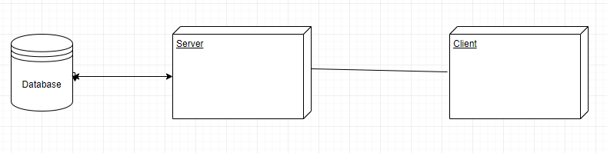

# Elaboration – Iteration 1.2

# Design Model

## Dynamic Behavior

*[Create the interaction diagrams (1 sequence, 1 communication diagrams) for 2 relevant scenarios]*

## Class Design

*[Create the UML class diagram; apply GoF patterns and motivate your choice]*

# Data Model

*[Create the data model for the system.]*

# Test Strategy

*[Present the used testing methods and the associated test case scenarios.]*

# Elaboration – Iteration 2

# Architectural Design Refinement

*[Refine the architectural design: conceptual architecture, package design (consider package design principles), component and deployment diagrams. Motivate the changes that have been made.]*

# Design Model Refinement

## *[Refine the UML class diagram by applying class design principles and GRASP; motivate your choices. Deliver the updated class diagrams.]*

# Construction and Transition

# System Testing

*[Describe how you applied integration testing and present the associated test case scenarios.]*

# Future improvements

*[Present future improvements for the system]*