Pharmacy management application

Student:Ilas Alexandra

**Group:30235**

Table of Contents

1. Requirements Analysis 3

1.1 Assignment Specification 3

1.2 Functional Requirements 3

1.3 Non-functional Requirements 3

2. Use-Case Model 4

3. System Architectural Design 6

4. UML Sequence Diagrams 6

5. Class Design 7

6. Data Model 7

7. System Testing 8

8. Bibliography 9

1. Requirements Analysis

# Assignment Specification

Use Java/C# API to design and implement an application for the employees of a pharmacy (chemists). The application should have two types of users (a regular user represented by the chemist employee and an administrator user) which have to provide a username and a password in order to use the application.

The regular user can perform the following operations:

* Search medication by name, ingredients, manufacturer.
* Sell medication.

The administrator can perform the following operations:

* + CRUD on medication (medication information: by name, ingredients, manufacturer, quantity and price).
  + CRUD on regular users’ information.
  + Generate two types of reports files, one in pdf format and one in csv format, with the medication out of stock.

# Functional Requirements

The regular user can:

* search medication by name, ingredients or manufacturer;
* sell medication.

The administrator can:

* CRUD on medications;
* CRUD on chemists;
* generate two types of files, one in pdf format and one in csv format, with the medicines that are out of stock.

# Non-functional Requirements

* + 1. **Availability**

The system is available for all users, while the Java application is running.

* + 1. **Performance**

The application it s develop to work really fast, answer fast when the regular user or administrator tries to make an operation, no matter if they try to add, delete, view or update something.

* + 1. **Security**

The application it’s safe, because both the administrators and the regular users have to log in before entering it. They have to enter an username and a password, which is encrypted with the special character *.

* + 1. **Usability**

The system allows users to access the application using Java, so it’s a desktop application. The system it’s friendly and simple.

2. Use-Case Model

2.1 **Chemist**

The employee has the purpose to log in successfully in the application, and make operations based on medications dates. He can also sell medicine to a client.

He has an important role for selling medicine, and making sure the client has enough money, and the product is on stock. He also can search and see all the products that have a specific name, manufacturer or ingredients.

A successful scenario would be: the employee is trying to log in the application, and succeeds. Before he tries to sell something, he is looking for the products with some specific information, and he finds them. After, he is selling a product to a client, that has enough money to buy the product.

A success-failure scenario would be:

*Preconditions*: the employee tries to log in to see some product

*Postconditions*:

Success : the employee logs in the application, and see the products

Failure: the employee can’t log in the application, because he didn’t write their password correctly.

Use case:

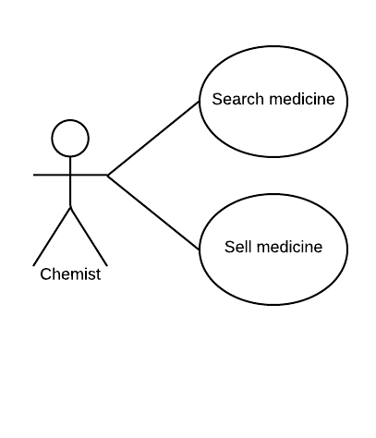

2.2 **Administrator**

The administrator has the purpose to log in the application, and make different operations based on the information about employees and medications. He can also generate reports about the medications that are out of stock.

He has an important role for taking care of the farmacy.

A successful scenario would be: the administrator logs in the application, and wants to add a medication. He writes the name, manufacturer, ingredients, available quantity, and the price of the medication, and a new medication is saved in the XML file.

A success-failure scenario would be:

*Preconditions*: the administrator tries to log to delete an employee.

*Postconditions*:

Success: the administrator will log in the application, and will delete an employee from the farmacy

Failure: the administrator has an error while he tries to log in, because he made a mistake with the password.

Use case:

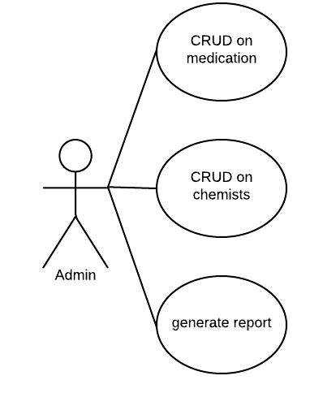

3. System Architectural Design

**3.1 Architectural Pattern Description**

**3.1.1 MVC Design Pattern**

Stand for Model-View-Controller Pattern. This pattern is used to separate application's concerns.

* **Model** - Model represents an object carrying data. It can also have logic to update controller if its data changes.
* **View** - View represents the visualization of the data that model contains.
* **Controller** - Controller acts on both model and view. It controls the data flow into model object and updates the view whenever data changes. It keeps view and model separate.

I put in Model all the classes, like: Administrator, Employee, Medication. In View I have the interfaces for the log in, for the administrator, and for the regular user also a option one. And I have 4 controllers, for each of the interface, where I’m making all the operations.

**3.2 Diagrams**

3.2.1 Package

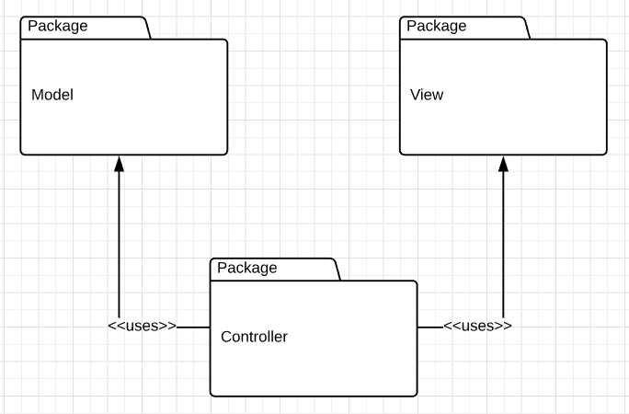

3.2.2

5. Class Design

**5.1 Design Patterns Description**

The design pattern that I used is Factory Pattern. This type of design pattern comes under creational pattern as this pattern provides one of the best ways to create an object.

In Factory pattern, we create object without exposing the creation logic to the client and refer to newly created object using a common interface. We have an interface Report, and two classes: CreateCsv and CreatePdf that will implement Report’s method: generate. We have another class ReportFactory, that will choose what class will create, depending on a name.

**5.2 UML Class Diagram**

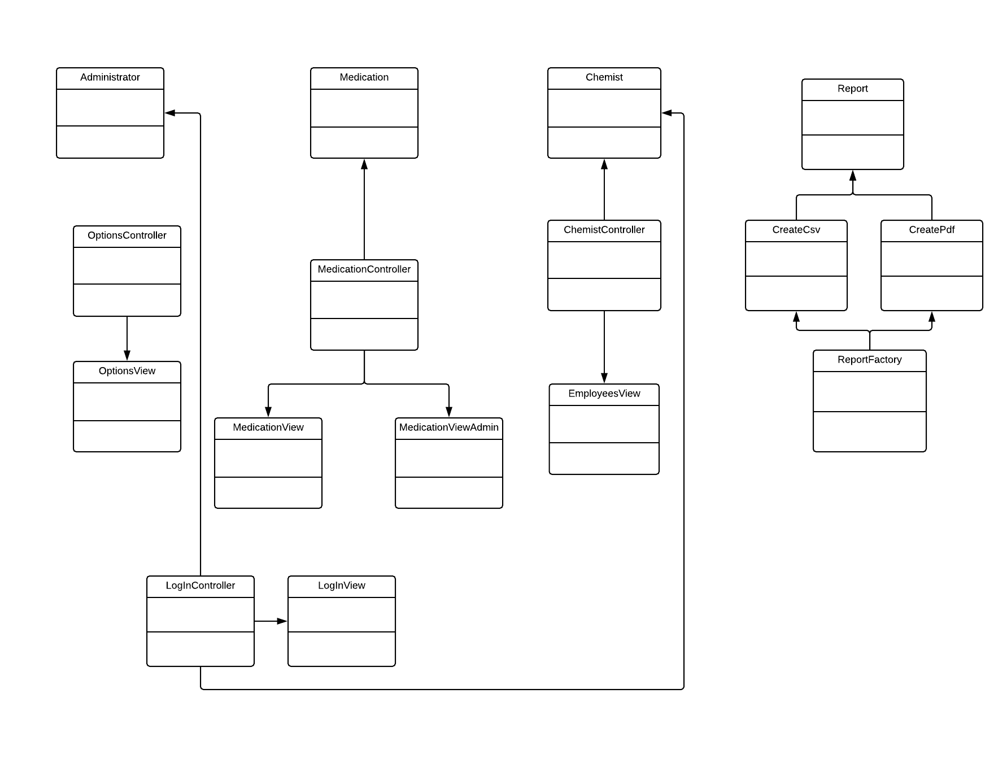

6. Data Model

I used XML files for keeping the data about Chemists, Medications and Administrators.

7. System Testing

8. Bibliography

<https://www.tutorialspoint.com/design_pattern/mvc_pattern.htm>

<https://www.tutorialspoint.com/design_pattern/factory_pattern.htm>

<https://stackoverflow.com/questions/13063815/save-xml-file-with-xstream>

<http://x-stream.github.io/tutorial.html>

<https://examples.javacodegeeks.com/core-java/writeread-csv-files-in-java-example/>

<http://www.baeldung.com/java-pdf-creation>