Study protocol
Evaluating [tool name], a tool for data extraction from scientific plots

Tamires Martins¹, Gabriel da Silva Stuart¹, Vitória Soares dos Santos¹, Alexandra Bannach-Brown²
¹Universidade Federal de Santa Catarina (UFSC), ²Berlin Institute of Health (BIH), Charité - Universitätsmedizin Berlin

Background
The increasing accumulation of scientific publications necessitates effective methods for synthesizing information, such as systematic reviews and meta-analyses (Ioannidis, 2023). Conducting systematic reviews is time-consuming, particularly in fields with a high volume of publications (Bannach-Brown et al, 2021; Bugajska et al, 2025). Among the data collected, quantitative data extraction is one of the most time-consuming and error-prone processes, which may influence the results of the meta-analysis (Cramond et al, 2018; Van der Mierden et al, 2021). The most common methods involve using digital rulers and digital applications, such as the measuring tool in Adobe Acrobat and WebPlotDigitizer (Cramond et al, 2018). The rulers are less precise methodologies, and although available applications improve accuracy and reduce time requirements, they still leave the data collection process entirely dependent on the reviewer (Cramond et al, 2018; Kadic et al, 2016). A new tool has been developed to extract data from multiple plots within diverse PDFs simultaneously in a more automated manner. The system developed in Python extracts structured data from plots using computer vision, OCR, and mathematical algorithms. First, the tool imports the user-selected PDFs, detects plot images, classifies them, and extracts their data. Users can filter, review, and correct the extracted values directly in the interface, and the final cleaned dataset can then be exported as a CSV file. The tool structure will be available on GitHub, and the models will be accessed via HuggingFace. Validation of this tool is necessary to identify potential flaws, provide users with guidance on its use, and assess performance levels.
Aims
- Evaluate the performance of the [tool name] in extracting data from different types of plots within PDF files.
- Collect user feedback on the tool's usability and intuitiveness.

Name of the tool
Plot-in Data-out
Plot-out
Plot-in
Version
1.0.0
Testers
To be determined.
Tool and its functionalities
The system supports data extraction from images containing bar, line, scatter, box, histogram, heatmap, and pie plots in scientific PDFs. The architecture is divided according to the plot's coordinate system, as shown in Figure 1. The process starts with file import, where the user can select a single PDF file or a folder containing multiple PDF files. The user can choose the classification model settings, though a default model is provided. The system will recognize images in the PDFs and classify them into plot types, which will be decisive for subsequent processing (Figure 1), depending on it's the coordinate system. Data extraction will be performed for each image, and the results will be displayed on the user interface. The user will be able to filter the context of interest (group and outcome) with the checkbox and the input box. The final extracted data will be displayed to the user so they can check and correct it by interacting with the text boxes. Finally, the results will be exported as structured CSV data, which can be downloaded by clicking a button.
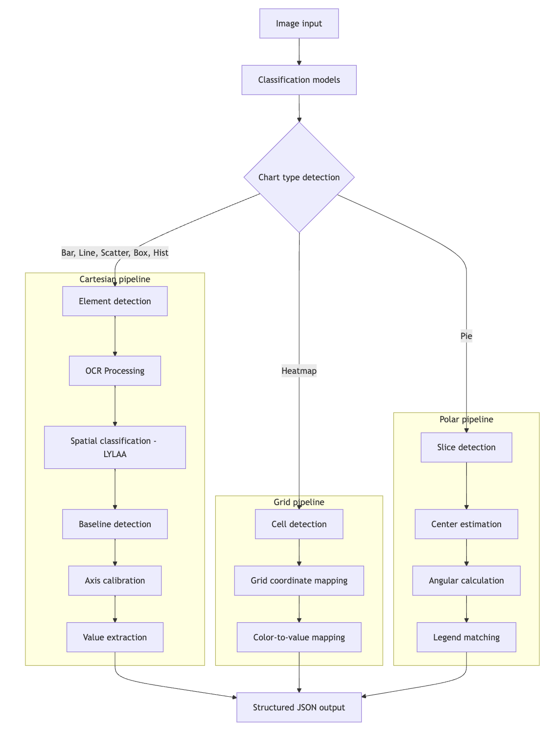
Figure 1. High-level architecture.
Dataset
Most articles used in this study originated from a systematic review investigating the effects of antidepressants on rodents in the forced swim test (Martins et al, 2025). This behavioural test is widely used in preclinical research to evaluate the potential antidepressant effect of substances. Considered a valuable tool due to its predictive validity, the test measures the response to antidepressants through behavioural analysis of immobility, swimming, and climbing of rodents. The data set is divided into two samples (I and II):
- The sample of 200 out of 2560 articles was randomly generated using the "RANDBETWEEN" function in Microsoft Excel (v. 16.0, Microsoft Corp., Redmond, WA, USA). The sample publication date range spans 1986 to 2017, reflecting changes in the literature over time. Most of the included publications presented data, primarily the mean immobility time and the standard error of the mean (SEM), in a graphical format (i.e., 435 of 561 studies within the 200 publications). The bar plots represented 97.24% (n = 423) of the total extracted graphs; the others were line plots (n = 12).
- A sample of approximately 800 plots for each plot type was synthetically generated for an in-depth evaluation of the data extraction functionality (Test Test ID = T4, Table 1), encompassing scientific and business domains. The synthetic data generation pipeline generates labels (bounding boxes, keypoints, text content) simultaneously with the image, ensuring 100% label accuracy and avoiding the errors of human annotation. The generated values are based on specific statistical distributions reported in the scientific literature and rendered with the Matplotlib library. After that, the images are processed through an augmentation pipeline to simulate scanning artifacts, low resolution, and sensor noise, reflecting the quality of some plots found in scientific PDFs. The diversity of the dataset is increased by the system's combination of 8 plot patterns, more than 20 themes, and more than 15 visual effects. Those figures will be incorporated into real PDF files of scientific papers drawn from the remaining records included in the library review, for an in-depth evaluation of the plot and text recognition and context-of-interest filtering functionalities (Test IDs T3 and T5). This sample was created to increase sample size and plot type variability.
- Cramond et al (2018) dataset of 23 plots. (could not find access to PDFs or image files (access was denied). Maybe talking with them?).

Requirements
The tool should be able to import PDF files from a specified directory, automatically detect plots and their types, extract quantitative data, support optional data correction and filtering, and export the final dataset as a .csv file.
Cross-platform compatibility
The software must run on Windows, macOS, and Linux.
Accessibility
The tool will be available for installation, allowing users to run it locally with an interactive interface.
Workflow integration
The tool must be provided as a package to enable integration into automated R and Python pipelines.
Documentation
Comprehensive installation instructions, input/output specifications, and example workflows will be provided.

Validation Planning
Test planning
Test ID | Functionality | Input | Expected Result | Acceptance Criteria
T1 | File import | Folder containing PDF files | File loaded successfully | No reading error (success rate > 99%)
T2 | Choice of settings | Interaction with the interface | Selection of chosen settings | No errors during the load of the chosen module (success rate > 99%)
T3 | Plot and text recognition | .pdf files | Recognition of diverse types of plots: a) bar, b) box, c) scatter, d) line, e) heatmap, f) histogram, g) area, h) pie | Accuracy > 90%
T4 | Data extraction | Plot of diverse types: a) bar, b) box, c) scatter, d) line, e) heatmap, f) histogram, g) area, h) pie | Values of legend, title, axis titles, and: a) scale, groups/categories, heights (axis unity), and error bars, b) scale, groups/categories, minimum, Q1, median, Q3, maximum, outliers, c) scale x, scale y, coordinate x (axis unity), coordinate y (axis unity), category (by color, point size, shape, d) x values, y values, groups/categories, e) row categories, column categories, values for each square, f) center value (x), edges value (x), bins height (y), g) AUC, baseline value, groups/categories, h) categories, corresponding proportion. | Categorical variables: accuracy > 90%  Numeric variables:  CCC > 0.90
T5 | Context-of-interest filtering | .json file | .json file with only outcome and groups of interest (checkbox) | Accuracy > 90%
T6 | Correction of extracted data by the user | Interface with the .json file in the backend | Corrected .json file | Categorical variables: accuracy > 90%  Numeric variables:  CCC > 0.90
T7 | Export of results | Process | .csv file | No errors during the export process (success rate > 99%)
T8 | Time | Time at the start of the process | Time at the end of the process | Total time being less than a manual extraction or from the use of another tool (Cramond et al, 2019)
Table 1. Test summary for each tool functionality.
Test execution
Procedures
Sample I
The validation process will be performed twice: (1) with the default settings and (2) with customized settings for the "Choice of settings" step. All functionalities should be tested for each setting as described below.
i) File import (T1):
At the beginning of each validation round, a folder containing PDF files will be provided as input to test the "file import" functionality. The system will attempt to load all files into the interface.
ii) Choice of setting(T2):
After importing the file, the default settings will be automatically selected. The tester will not choose anything in the first validation round but will customize it in the second validation round through the graphical user interface. The system will attempt to load the corresponding module environment. The tester should export the chosen settings.
iii) Plot and text recognition (T3):
Each article in PDF format will contain at least one figure. The system will be tested for its ability to identify and classify plot types (bar, box, scatter, line, heatmap, histogram, area, and pie) and to recognize embedded textual elements, such as axis labels and embedded figure legends.
iv) Data extraction from plots (T4):
For each plot, the system will attempt to extract numerical and descriptive information, including the legend, title, axis titles, scales, categories, values, and error bars. The extracted outputs will be compared with the gold-standard data, evaluated by two human reviewers.
v) Context-of-interest filtering (T5):
A .json file containing metadata on outcomes and experimental groups will be provided as input. The system will apply user-selected filters (via the filter box) to retain only the groups, interventions, and outcomes relevant to the research question.
vi) Correction of extracted data by the user (T6):
Users will load the backend .json file into the interface and manually correct extracted values as needed. After saving, the corrected .json file will be verified to ensure that all edits were properly recorded without system errors.
vii) Export of results (T7):
After validation and user corrections, the export process will be executed to generate a .csv file containing the complete dataset of extracted and validated information.
viii) Time (T8):
For each process, the start and end times will be recorded. The total processing time will be compared with the duration required for manual data extraction or for a comparator tool (Cramond et al., 2019).
Register of results
Test ID | Expected Result | Obtained Results | Accordance | Obs
T1 | File loaded successfully with no reading error
T2 | Selection of settings with no error during the load of chosen sets
T3 | Recognition of diverse types of plots: a) bar, b) box, c) scatter, d) line, e) heatmap, f) histogram, g) area, h) pie with accuracy > 95%
T4 | Values of legend, title, axis titles, and: a) scale, groups/categories, heights (axis unity), and error bars, b) scale, groups/categories, minimum, Q1, median, Q3, maximum, outliers, c) scale x, scale y, coordinate x (axis unity), coordinate y (axis unity), category (by color, point size, shape, d) x values, y values, groups/categories, e) row categories, column categories, values for each square, f) center value (x), edges value (x), bins height (y), g) AUC, baseline value, groups/categories, h) categories, corresponding proportion, with accuracy > 95% for categorical variables and CCC > 0.90 for numeric variables
T5 | '.json' file with only outcome and groups of interest (via filter box) with accuracy > 95%
T6 | Corrected the .json file with no errors during the correction process
T7 | .csv file with no errors during the export process
T8 | Time at the end of the process is less than that of a manual extraction or from the use of another tool (Cramond et al, 2019)

Sample II
Plot and text recognition (T3):
Each article in PDF format will contain at least one figure. The system will be tested for its ability to identify and classify plot types (bar, box, scatter, line, heatmap, histogram, area, and pie) and to recognize embedded textual elements.
Context-of-interest filtering (T5):
A .json file containing metadata on outcomes and experimental groups will be provided as input. The system will apply user-selected filters (via the filter box) to retain only the outcomes and groups of interest.
Data extraction from plots (T4):
For each plot, the system will attempt to extract numerical and categorical information, including the legend, title, axis titles, scales, categories, values, and error bars. The extracted outputs will be compared with the ground-truth data afterwards.
Sample III
The time spent on the entire sample processing will be recorded for further comparison with the "current method" and the "new method" from Cramond et al. (2018).
Performance metrics
The metrics will be calculated using the {yardstick} R package.
T1, T2, and T7:
Success rate (%) = (N of successful executions\ N of attempts) x 100
T3 and T5:
For each plot type (T3) and outcome/group (T5):
A𝑐𝑐𝑢𝑟𝑎𝑐𝑦 = 𝑇𝑃 + 𝑇𝑁 / 𝑇𝑃 + 𝑇𝑁 + 𝐹𝑃 + 𝐹𝑁
𝐹 − 𝑠𝑐𝑜𝑟𝑒 = 2 ∗ 𝑇𝑃 / 2 ∗ 𝑇𝑃 + 𝐹𝑃 + 𝐹𝑁
Recall/𝑆𝑒𝑛𝑠𝑖𝑡𝑖𝑣𝑖𝑡𝑦 = 𝑇𝑃 / 𝑇𝑃 + 𝐹𝑁
𝑆𝑝𝑒𝑐𝑖𝑓𝑖𝑐𝑖𝑡𝑦 = 𝑇𝑁 / 𝑇𝑁 + 𝐹𝑃
𝑃𝑟𝑒𝑐𝑖𝑠𝑖𝑜𝑛 = 𝑇𝑃 / 𝑇𝑃 + 𝐹𝑃
T4 and T6:
For each data extracted (e.g., axis titles, scale, groups/categories, error bars, median):
- Descriptive data: Accuracy, F-score, Recall/Sensitivity, Specificity, and Precision.
- Numerical data: Concordance Correlation Coefficient (CCC)
T8:
The time difference will be expressed as a percentage, and statistical comparisons will be made using a t-test for normally distributed data or a Wilcoxon test for non-normally distributed data.
Success criteria
A success rate and accuracy greater than 99% and 90%, respectively, and a CCC greater than 0.90, depending on the functionality.
For the inter-rater reliability measure, at least a 0.81 Cohen's Kappa is desirable for descriptive data, and 0.81 Intraclass Correlation Coefficient for numerical data.
Qualitative survey
1. The interface and layout are intuitive.
2. The instructions and error messages were clear.
3. With more experience using the tool, it becomes easier to use.
4. The tool processed the files in an adequate time.
5. The tool did not experience any crashes or slowdowns.
6. The tool provides all the necessary functionalities for extracting data from plots
7. I trust the results provided by the tool.
8. I would use the tool in future projects.
9. I would recommend the tool to colleagues.
10. Are the setting/customization options comprehensive enough for your needs?
11. Anything you want to comment on or suggest?

The responses for the objective questions (1-10) will be measured with a Likert scale:
-2 Strongly disagree, -1 Disagree, 0 Neutral, +1 Agree, +2 Strongly agree

References
Bannach-Brown, A., Hair, K., Bahor, Z., Soliman, N., MacLeod, M., & Liao, J. (2021). Technological advances in preclinical meta-research. BMJ Open Science, 5(1). https://doi.org/10.1136/bmjos-2020-100131
Bugajska, J. V., Hild, B. F., Brüschweiler, D., Meier, E. D., Bannach-Brown, A., Wever, K. E., & Ineichen, B. V. (2025). How long does it take to complete and publish a systematic review of animal studies?. BMC medical research Methodology, 25(1), 226. https://doi.org/10.1186/s12874-025-02672-5
Cramond, F., O'Mara-Eves, A., Doran-Constant, L., Rice, A. S., Macleod, M., & Thomas, J. (2019). The development and evaluation of an online application to assist in the extraction of data from graphs for use in systematic reviews. Wellcome open research, 3, 157. https://doi.org/10.12688/wellcomeopenres.14738.3
Ioannidis J. P. A. (2023). Systematic reviews for basic scientists: a different beast. Physiological reviews, 103(1), 1–5. https://doi.org/10.1152/physrev.00028.2022
Martins, T., Ramos-Hryb, A. B., da Silva, M. A. B., do Prado, C. S. H., Eckert, F. B., Triches, F. F., da Costa, J. E., Bolzan, J. A., McCann, S. K., & Lino de Oliveira, C. (2025). Antidepressant effect or bias? Systematic review and meta-analysis of studies using the forced swimming test. Behavioural pharmacology, 36(6), 347–363. https://doi.org/10.1097/FBP.0000000000000844
Van der Mierden, S., Spineli, L. M., Talbot, S. R., Yiannakou, C., Zentrich, E., Weegh, N., Struve, B., Zur Brügge, T. F., Bleich, A., & Leenaars, C. H. C. (2021). Extracting data from graphs: A case-study on animal research with implications for meta-analyses. Research Synthesis Methods, 12(6), 701–710. https://doi.org/10.1002/jrsm.1481

