**PHASE-2**

**Setting-up Raspberry pi:**

**Step-1:**

Downloading pre-configured Raspbian OS image.

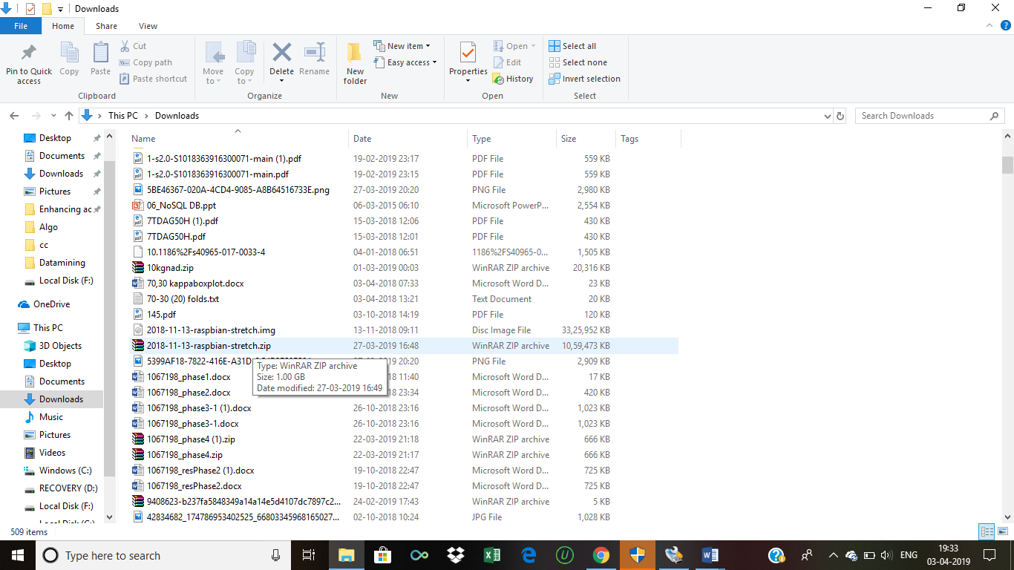

**Step-2:**

* Writing the image into SD card using Win32 Disk imager.

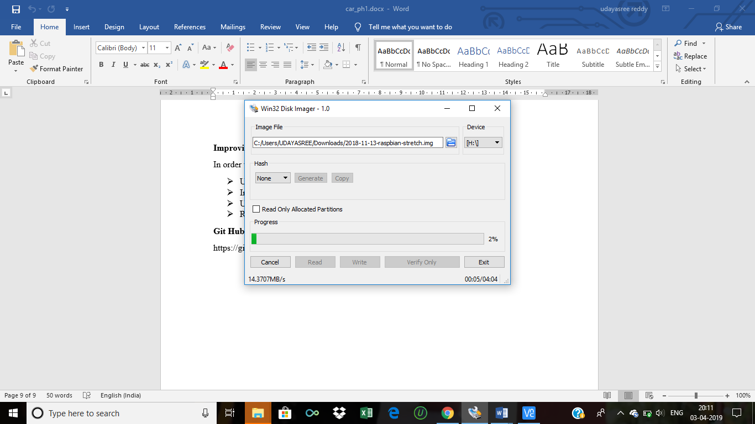

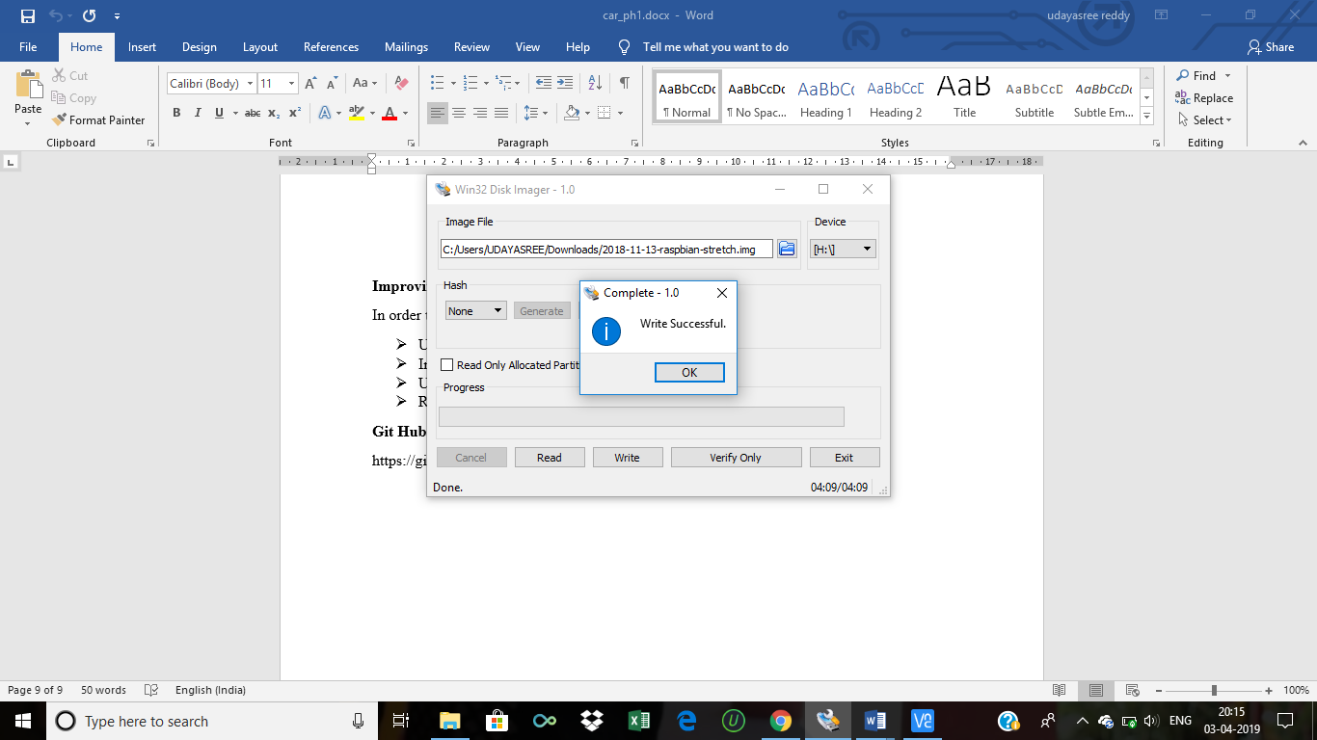

* Adding ssh and wpa_supplicant.conf files in order to connect with Wi-Fi.

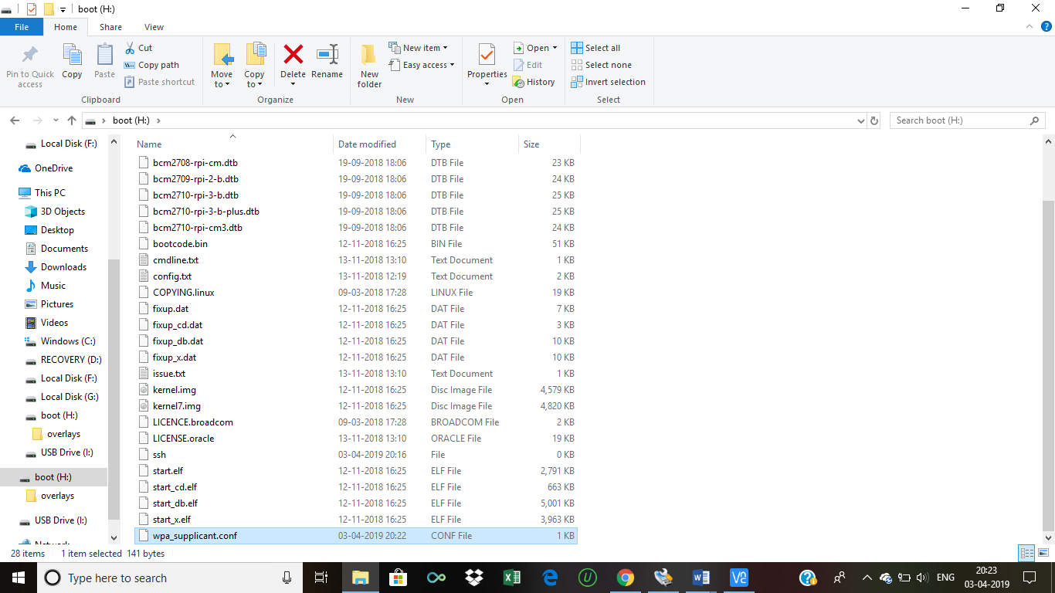

**Step-3:** Connecting to raspberry-pi using VNC viewer.

* Installing VNC viewer.

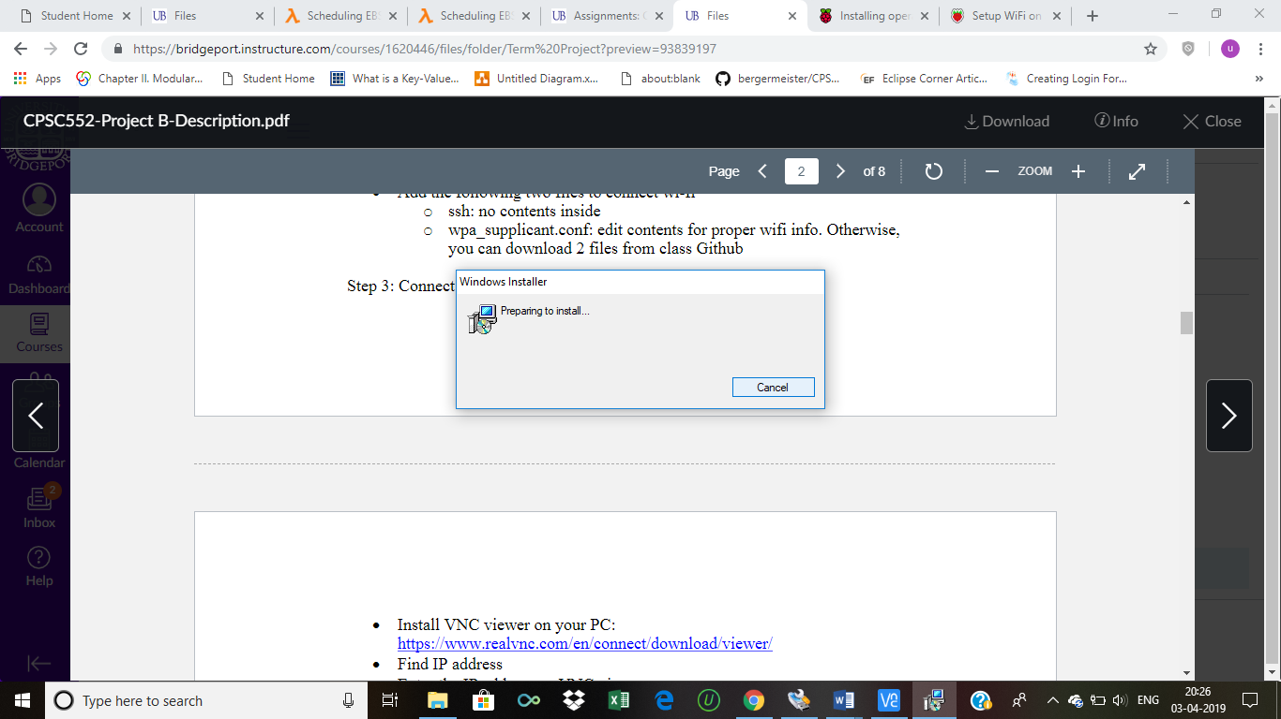

* Establishing the connection by entering the IP address and by using username and password.

**Step-4:** Connection to raspberry pi and updating commands.

