Roberto Johnson

Instructor Name

CS2

3/6/2020

SortOfSort

In this report I am going to explain on how my program work for creating a sort on java. The plan is to place the greatest numbers elements to the expected position on the index. For instance, the first two greatest numbers elements to the last two index and the next two numbers will be placing from the first two index. The only different with these elements is that the order goes opposite. For this java, I had label all of the steps that are mark in different locations in order to keep on track on explain each of the function. So, the best way to describe generally for this array is to have the double greatest numbers in both edge and it close each other with lower number. This program will not show a chart, instead it will tell to print the results that will tell if the element had change in different position.

Step 1: The method will start by identify two integers “numLow” and “numGreat”, which these two will focus on keeping identify the original element on the index that its been told. The numLow will start from 0 while it will soon increase the number and the numGreat will start from the length while decreasing the number.

Step 2: Here we have the first loop that use the j (keep in mind that this is the main type of loop that will be use most of the function further on.) that allow to compare on one of the integers to see if they have a greatest number than all of the ones on the array. If the j have a greater number than the one from the numGreater, it will allow to change the element to the greatest one.

Step 3: Is the same thing how the step 2 went. The only different is that it will make sure that the greatest number is also the lowest number than the one from the previous loop of the index element. In other words, finding the secondary greatest number for the length-1 index. Then the next similar 2 upcoming will focused on finding the 3rd and the 4th greatest number for the first 2 index.

Step 4: This i loop has almost the similar to the 4 previous loop that were use to find the first 4 greatest number. However, this loop will continue finding the next greatest number in order to lowest and put in the correct index until it reaches the limit of the loop. Before starting on the one of the loops, the program will have to check if the limit of the length in order to break the loop to end the function.

The result will be expected to print, showing that what number represent on each of the index of the array.

This is how it expect from each array test case:

Case 1:

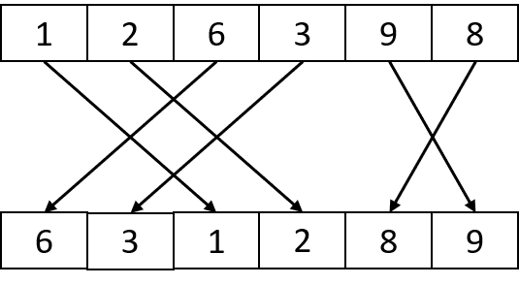

Case 2:

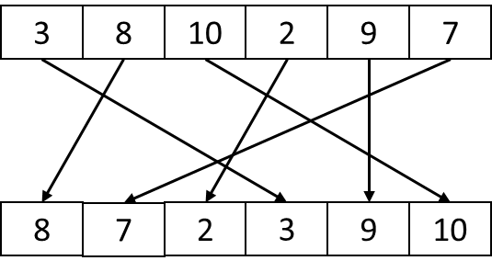

Case 3:

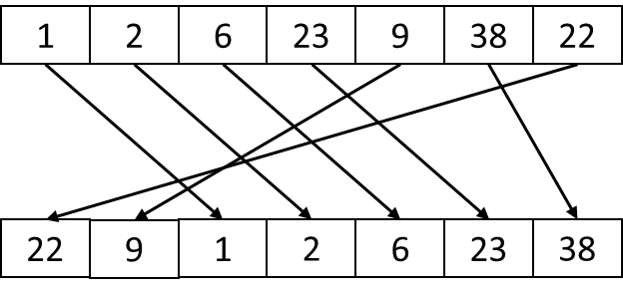

Case 4:

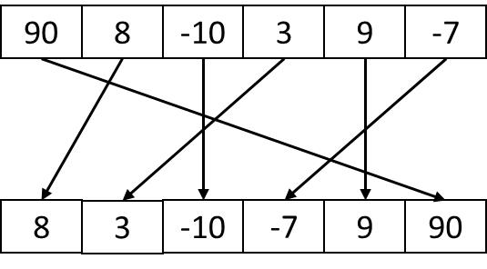

Case 5:

