**Report**

My algorithm firs searches for the bigger integer that has not been sorted. This means that the amount of elements that it checks decreases for every element that is already sorted, so the amount of checks would be: (n)(n-1)(n-2)(n-3)(n-4)(n-5)…1. We can represent it somewhat like a triangle:

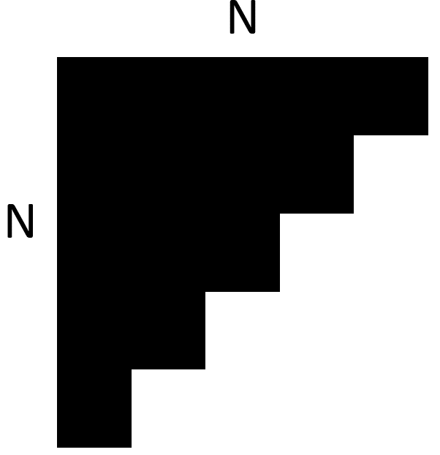

The number of times it runs that search is n times and looks through **n-i**, where **i** is the number of elements already sorted.

Now for the number operations inside the inner loop: 1 counter initialization, 1 counter comparison, 1 counter increment, all of these except the counter initialization happen every loop iteration. The search goes through the loop every time looking at 1 element less for every iteration so the if comparison occurs approximately n/2 times. This gives us: 1 + 2n + n/2 = 2n + n/2 + 1 operations in average for the inner loop operations.

For the outer loop there are two if statements and its arguments. Depending on which branch the algorithms goes through it will run in average 7 operations. So, the outer loop will enter the inner loop n -1 amount of times. Therefore, the amount of operations it does is: 1 + (n-1) (10 + 2n + n/2 + 1) = 10n +2n2+ n2/2 + n -10 -2n -n/2 -1= n2 + n – 1.

Before entering the outer loop it first makes 7 operations so the complete number of operations it does is n2 + n – 1 + 7 = n2 + n + 6.I added a photo of my code after the first for loop to illustrate a little bit my reasoning.

|  |  |  |
| --- | --- | --- |
| Best case | Average Case | Worst Case |
| The input array is empty or has a length of 1, so it only checks the length and then returns the same array. | The average case would run in the amount steps I described before since the number of operations was obtained calculating the average of steps the inner loop and if-else operations occur. | An array that is in an order where every element is not on its corresponding place even after being changed for another number. This means that the nth element is not in its corresponding place until the algorithm is searching for that nth element. |

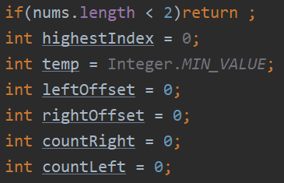

1 First 7 constant operations

