Performance of Method
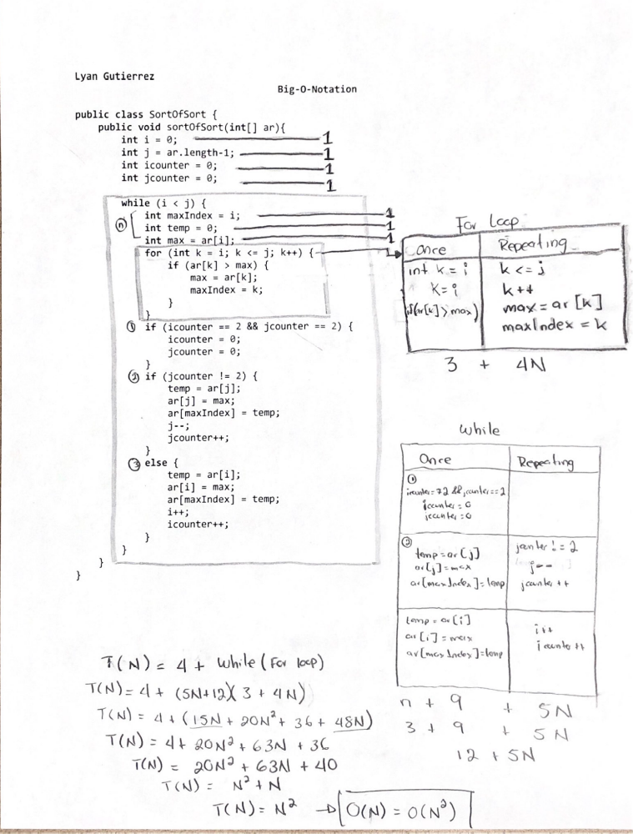

Explanation:
The code is running at O(N^2) since the while loop is nested with the for loop. That causes the code to run at N^2. A best-case scenario would be using a helper method to split the while and for loops in order to reduce the time complexity of the code. This could help the code to run at N complexity. The worst-case scenario at this moment is the one on the code provided since the time complexity is not to optimal for a code. Ideally it should be logarithmic or linear function in order to have a better time complexity and at the same time a best-case scenario.

