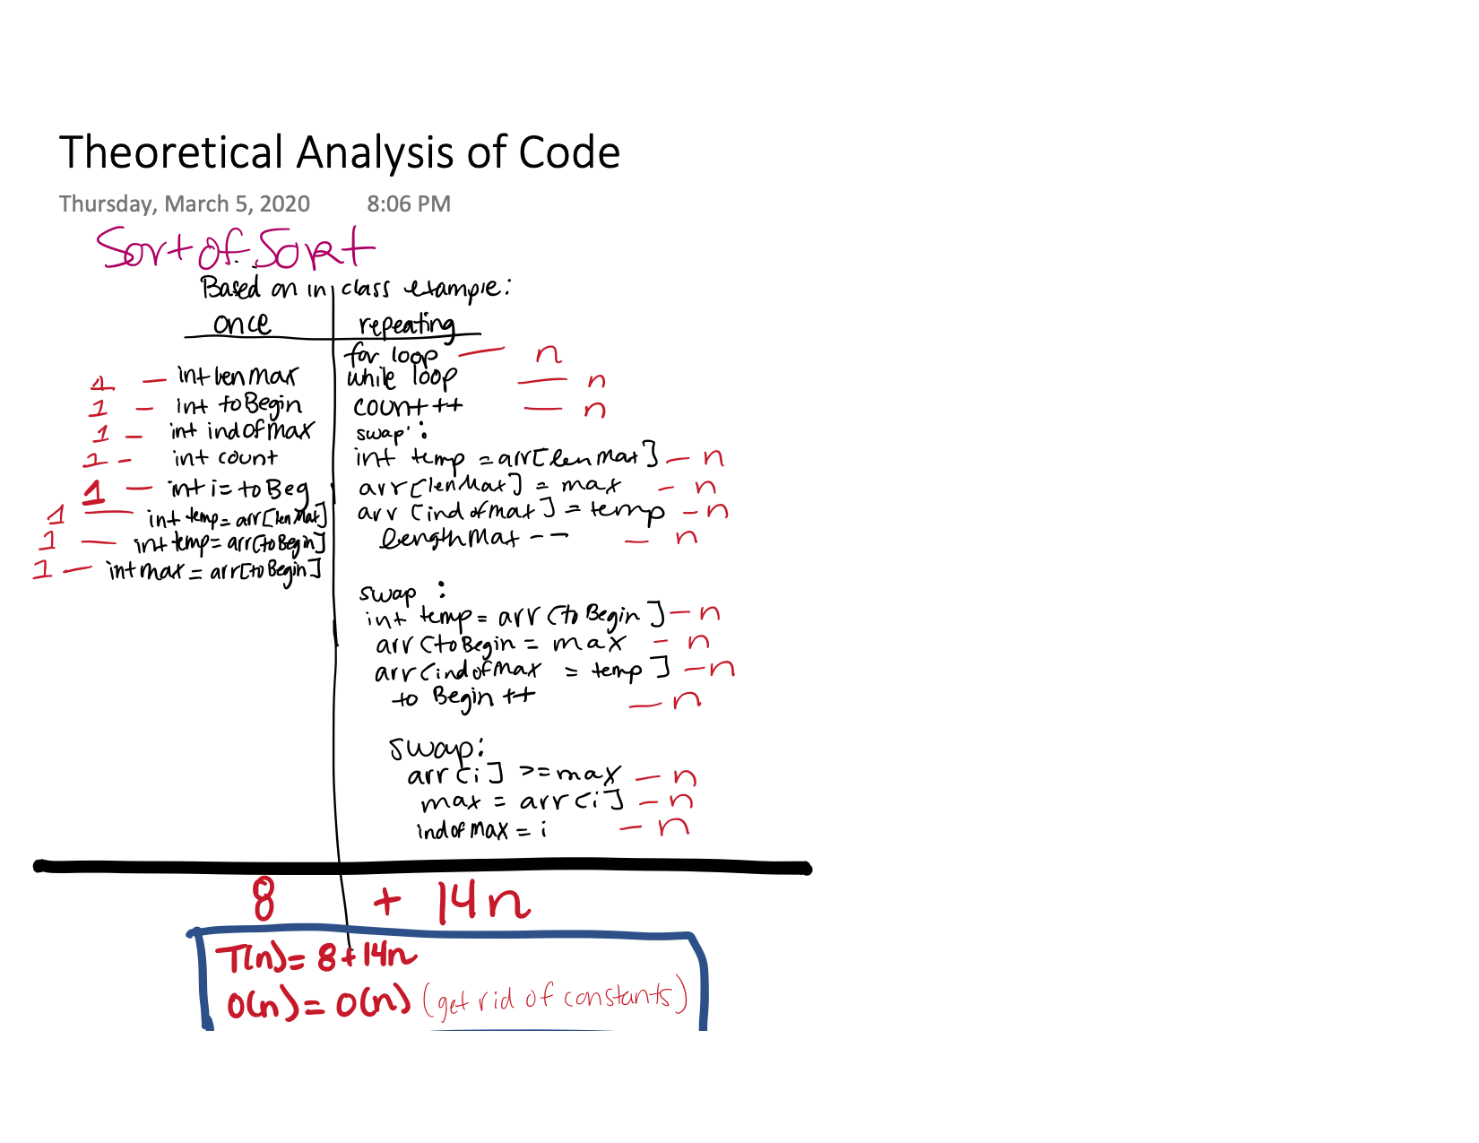

**Average case:** **O(n).** If my understanding is correct, the average should be the length of the array. In the test cases, n will always be 8.

**Best case: O(n).** The best case would be where n is the smallest amount it can be.

**Worst case: O(n).** The worst case would be if we have a large n (infinity).