ISIC Archive PMS Integration
User Journeys
Document ID: PRD-PMS-ISICARCHIVE-001
Version: 1.0
Date: February 21, 2026
Author: Ammar (CEO, MPS Inc.)
Status: Draft

Table of Contents
Journey 1: DermaCheck — Skin Lesion Capture, Classification, and Review
Journey 2: Longitudinal Lesion Monitoring — Change Detection Over Time
Journey 3: Specialist Referral Workflow — High-Risk Lesion to Dermatology
Journey 4: Similar Lesions Comparison — Visual Evidence for Clinical Confidence
Journey 5: Multi-Lesion Body Map Session — Full Body Region Assessment
Journey 6: Offline Field Triage — On-Device Inference Without Connectivity
Journey 7: Web-Based Lesion Review — Desktop Clinical Workflow
Journey 8: Dermatology Dashboard & Reporting — Clinic-Level Analytics
Journey 9: Model Update Pipeline — Deploying New ISIC Challenge Models

Journey 1: DermaCheck — Skin Lesion Capture, Classification, and Review
Persona: Physician
Platform: Android
PRD Reference: Phase 1–2 (core classification pipeline), Section 6.1–6.6 (all CDS components)
The primary end-to-end workflow on Android, from the physician's perspective:
- Patient Selection — Physician opens the patient list, searches or filters by name/ID, and selects a patient.
- DermaCheck Entry — From the patient's record, the physician taps the branded "DermaCheck" button to enter the dermatology CDS workflow.
- Camera Capture — The camera opens via CameraSessionManager singleton (configured with a dermoscopy CameraProfile). The physician photographs the skin lesion.
- Notes / Dictation — Before or after capture, the physician can type or dictate clinical notes — anatomical site, patient concern, visual observations — that are sent alongside the image.
- Upload & AI Processing — The image and notes upload to the PMS Backend (POST /api/lesions), which forwards them to the DermCDS Service (:8090) for classification, enrichment, similarity search, and risk scoring.
The DermCDS pipeline includes:
- EfficientNet-B4 classification across the 9 ISIC diagnostic categories (melanoma, melanocytic nevi, BCC, SCC, actinic keratosis, benign keratosis, dermatofibroma, vascular lesions, other)
- Gemma 3 enrichment via the AI Gateway (:8001) — clinical reasoning about the classification in the patient's context
- pgvector similarity search — cosine distance against pre-computed embeddings to retrieve visually similar ISIC reference images
- Risk score calculation — low / medium / high with referral urgency
- Results Display — The Android app presents: top-3 classification with confidence percentages, Gemma 3 clinical narrative, risk level indicator, and similar ISIC reference images gallery.
- Clinician Action — The physician can Save (persist to encounter), Discard (delete), or Add Another Photo (return to camera).
Note: On-device results are labeled as "preliminary triage" only (per SUB-PR-0013-AND). Full classification results require server-side processing through the DermCDS Service and are not finalized until the backend pipeline completes.

Sequence Diagram
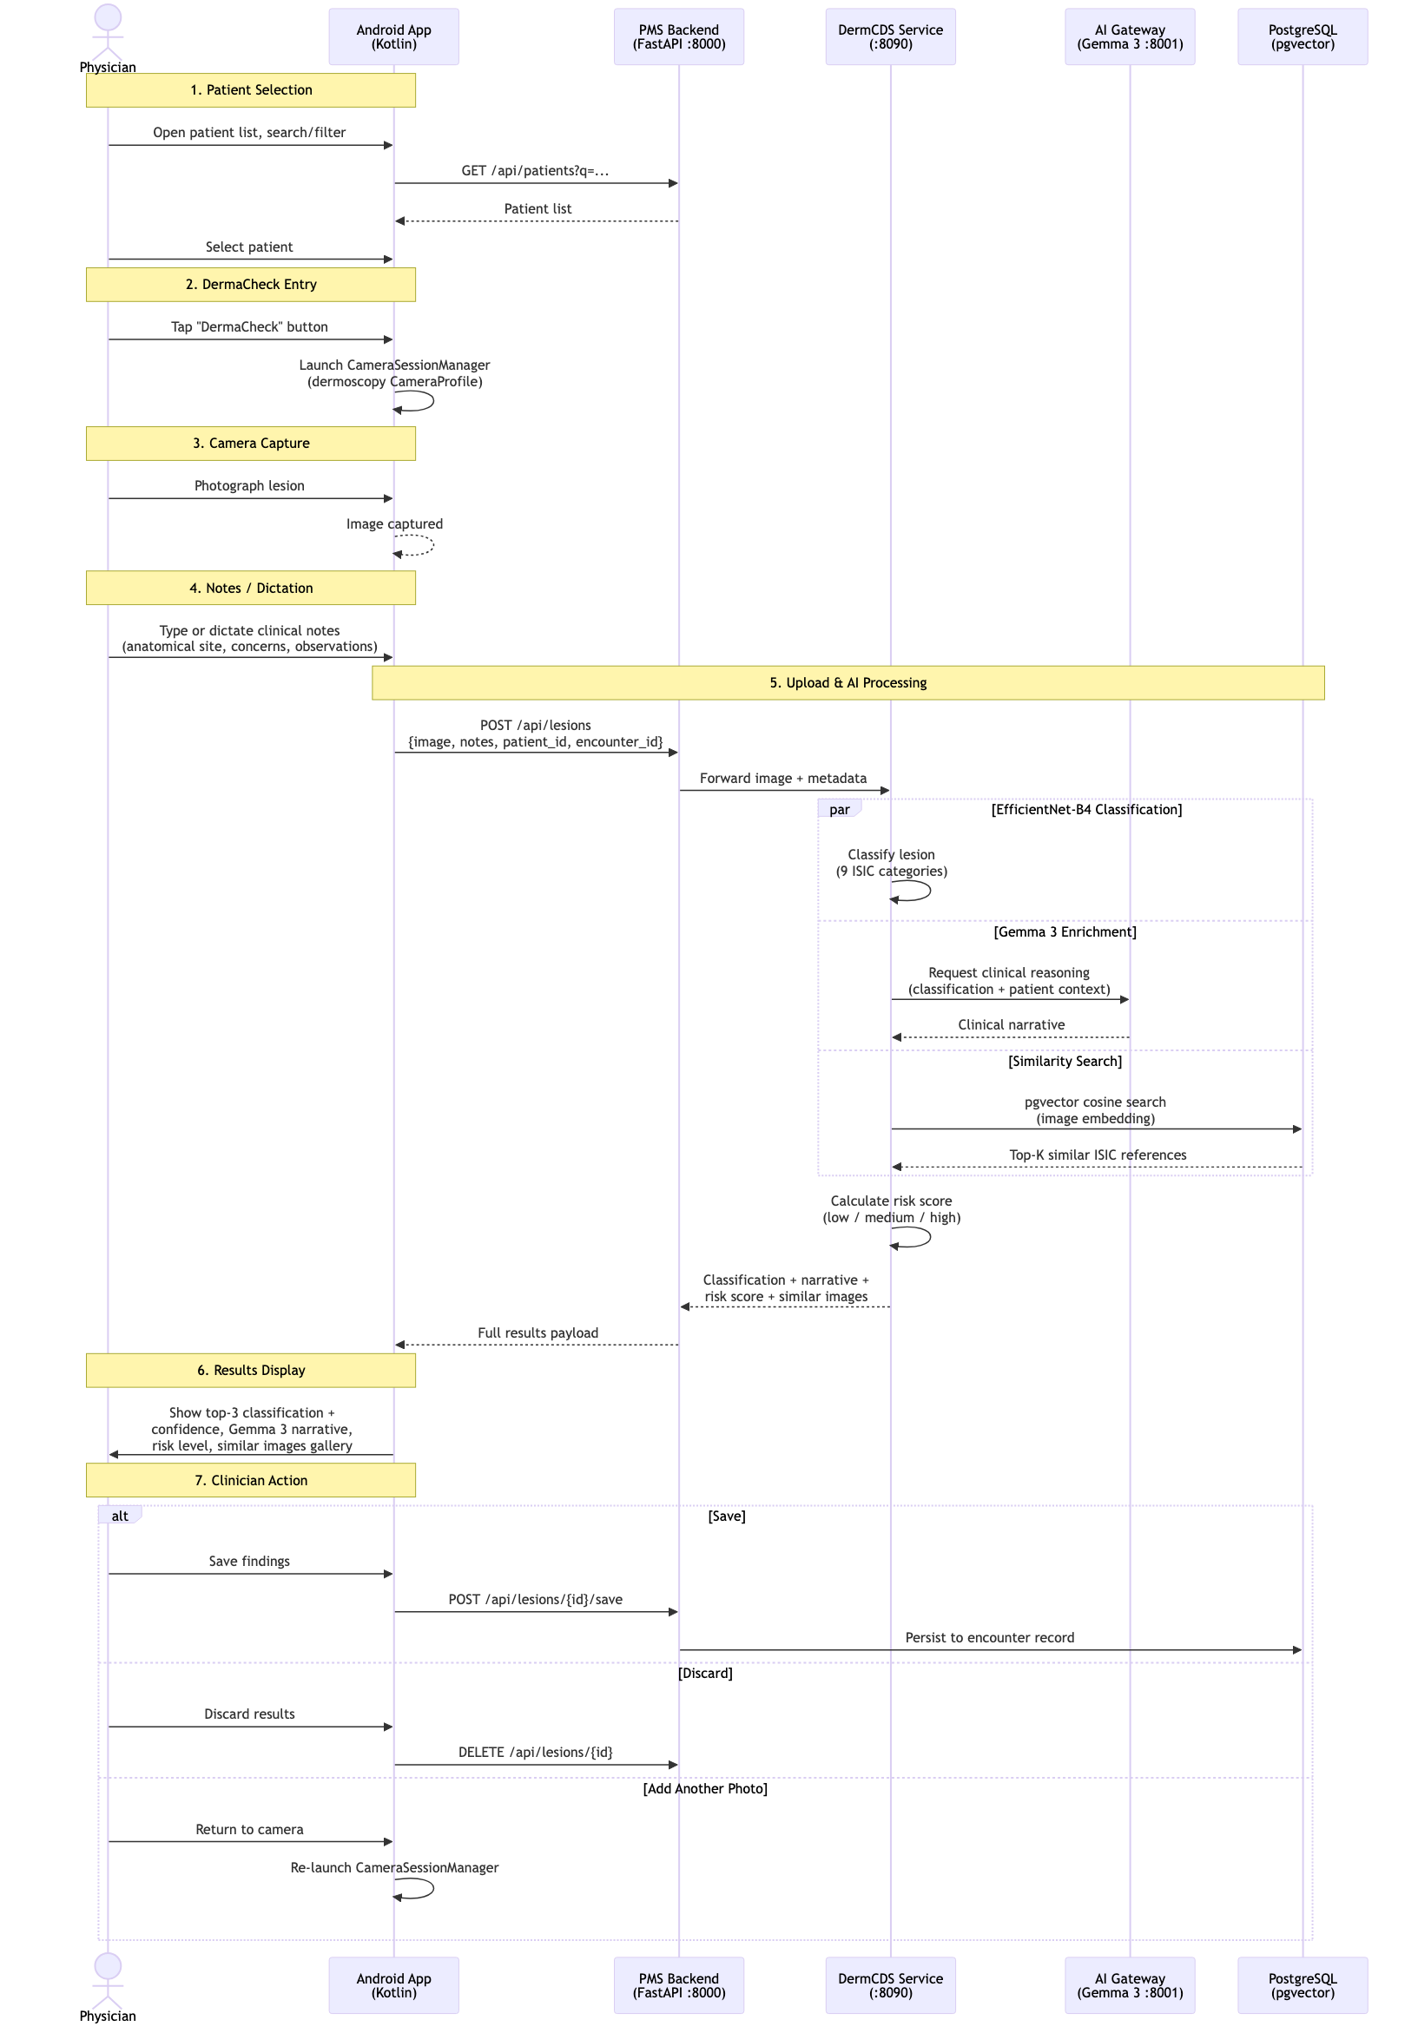
DermaCheck User Journey — Skin Lesion Capture, Classification, and Review

Journey 2: Longitudinal Lesion Monitoring — Change Detection Over Time
Persona: Physician (follow-up visit)
Platform: Android
PRD Reference: Phase 2 (Lesion Timeline component), Phase 3 (lesion change detection via embedding comparison), Section 6.4 Risk Score Calculator (lesion change history input)
The longitudinal monitoring workflow enables physicians to track how a lesion evolves between visits by comparing current and prior dermoscopic images using embedding distance:
- Open Patient with Prior History — Physician opens a patient who has existing DermaCheck records from prior visits.
- Navigate to Lesion Timeline — From the patient record, the physician opens the Lesion Timeline view showing all prior captures with dates, classifications, and risk levels.
- Select Prior Lesion & Re-assess — The physician selects a specific prior lesion record, reviews the previous image and classification, and taps "Re-assess" to capture a new image of the same lesion.
- Camera Capture (Same Lesion) — The camera opens via CameraSessionManager and the physician photographs the same lesion for comparison.
- Upload & Comparison Processing — The new image uploads to the Backend with a reference to the prior lesion ID. The DermCDS Service runs the current classification in parallel with an embedding comparison against all prior images of that lesion stored in PostgreSQL.
- Results Display — The app presents: current classification with confidence percentages, change indicators (size/shape/color delta), trend direction (stable/improving/worsening), updated risk score incorporating longitudinal context, and a timeline chart.
- Save to Encounter — The physician reviews the longitudinal trend and saves the new assessment linked to the prior record in the encounter.
Note: Embedding distance is computed as cosine distance between the new image's 512-dim feature vector and all prior embeddings for the same lesion. A distance increase above a configurable threshold triggers the "worsening" trend indicator and may elevate the risk score.

Sequence Diagram
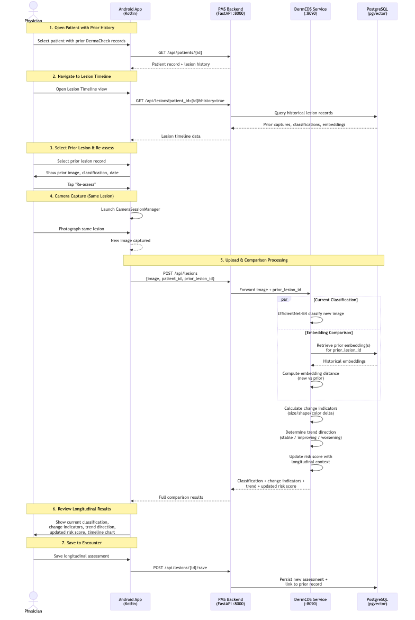
Longitudinal Lesion Monitoring — Change Detection Over Time

Journey 3: Specialist Referral Workflow — High-Risk Lesion to Dermatology
Persona: Primary care physician → Dermatologist
Platform: Android + PMS Backend
PRD Reference: Section 6.4 Risk Score Calculator (referral urgency output), Section 9 Success Metrics (unnecessary referral reduction), Section 10 Risks (patient safety)
When DermaCheck identifies a high-risk lesion, this workflow enables structured specialist referral with full AI-assisted context:
- High-Risk DermaCheck Result — After completing Journey 1, the physician receives a classification with high melanoma suspicion (confidence > 70%). The Risk Score Calculator outputs referral urgency: urgent.
- Initiate Referral — The physician taps "Refer to Dermatology" from the results screen.
- Generate Referral Package — The system assembles a comprehensive referral package containing classification results, confidence scores, risk assessment, Gemma 3 clinical narrative, original lesion image, similar ISIC reference images, and patient dermatology history.
- Referral Confirmation — The referral is submitted via /api/encounters with linked lesion data. The physician receives confirmation with the urgency priority.
- Dermatologist Receives Referral — The dermatologist receives a notification with the full AI-assisted referral package.
- Dermatologist Review — The dermatologist opens the referral, reviews the lesion image alongside the AI classification, clinical narrative, risk assessment, similar reference images, and patient history.
- Outcome & Feedback Loop — The dermatologist records their outcome (confirm or override AI classification). This outcome is stored for model feedback tracking, and the referring physician is notified.
Note: The referral feedback loop (dermatologist confirms/overrides AI) is critical for tracking the Success Metric "unnecessary referral reduction" (Section 9) and for future model improvement. Override rates are surfaced in the Dermatology Dashboard (Journey 8).

Sequence Diagram
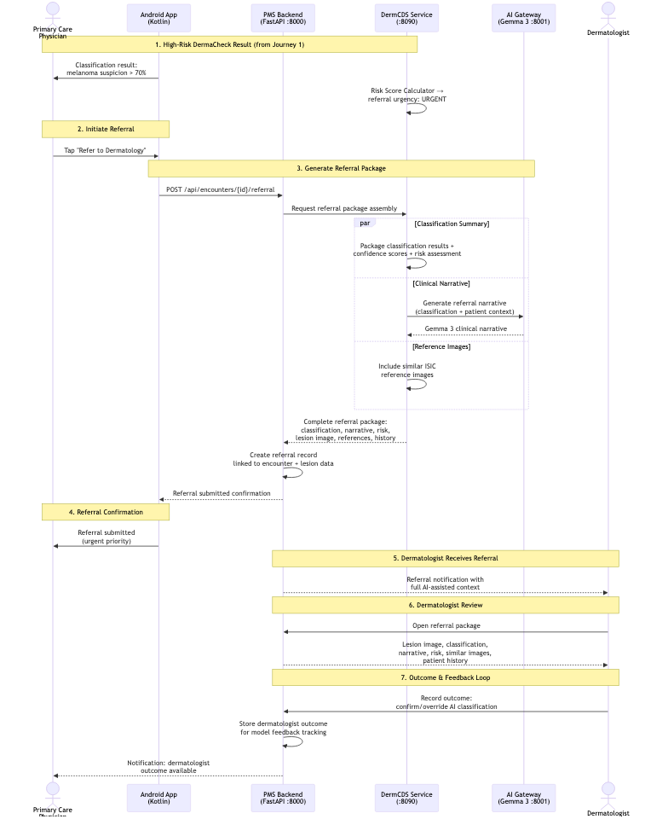
Specialist Referral Workflow — High-Risk Lesion to Dermatology

Journey 4: Similar Lesions Comparison — Visual Evidence for Clinical Confidence
Persona: Physician (during or after classification)
Platform: Android or Next.js
PRD Reference: Section 6.3 Similarity Search Engine (pgvector cosine distance, Top-K), Section 6.5 ISIC Reference Cache
This workflow allows physicians to examine visually similar confirmed ISIC reference images to build clinical confidence in the AI classification:
- Classification Results Displayed — After DermaCheck (Journey 1), the physician sees the top-3 classification with confidence scores and risk level.
- Request Similar Lesions — The physician taps/clicks "View Similar Lesions" to expand the similar lesions gallery.
- Similarity Search — The system retrieves the Top-K most similar ISIC reference images via pgvector cosine distance search against the lesion's 512-dim embedding vector.
- Gallery Display — The Similar Lesions Gallery shows each reference image with confirmed diagnosis, similarity score, and metadata (patient age, sex, anatomical site).
- Detailed Reference View — The physician taps any reference image to see the full-size image, complete metadata, and diagnostic history.
- Clinical Comparison — The physician visually compares the patient's lesion against confirmed ISIC examples to either confirm or question the AI classification.
- Update Clinical Notes (Optional) — The physician can adjust clinical notes based on the visual comparison.
Note: The similarity search uses the same embedding vector generated during classification (Section 6.2), so there is no additional inference cost. The ISIC Reference Cache (Section 6.5) stores pre-computed embeddings for 50,000 representative images, enabling sub-200ms similarity queries (Section 7.2).

Sequence Diagram
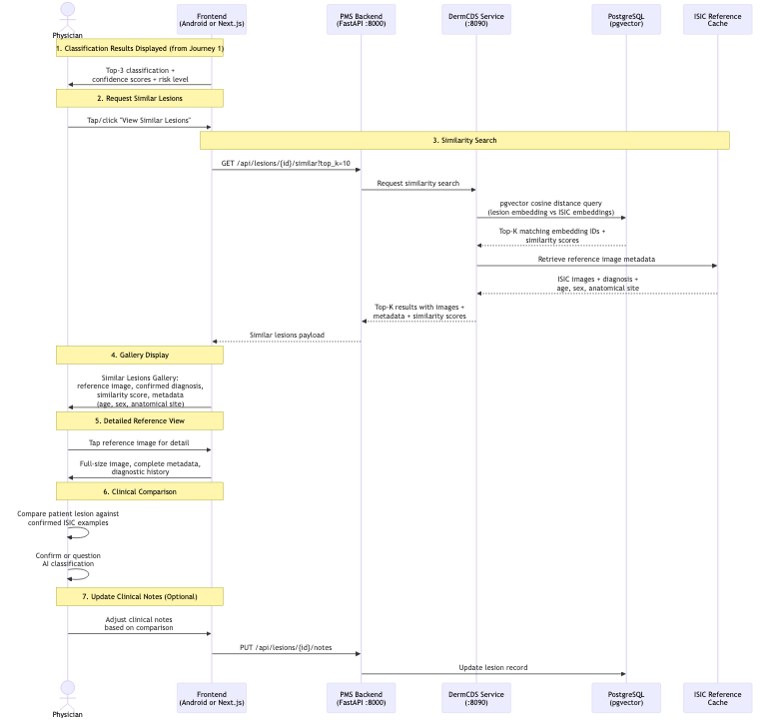
Similar Lesions Comparison — Visual Evidence for Clinical Confidence

Journey 5: Multi-Lesion Body Map Session — Full Body Region Assessment
Persona: Physician (comprehensive skin exam)
Platform: Android
PRD Reference: Phase 3 (multi-image support, photograph full body region, classify all lesions), Phase 2 (anatomical site body map)
This workflow supports comprehensive skin examinations where a physician needs to capture and classify multiple lesions across different body regions in a single session:
- Enter DermaCheck (Comprehensive Exam) — The physician taps "DermaCheck" for the patient to begin a comprehensive skin assessment.
- Select Body Map Mode — From the DermaCheck entry screen, the physician selects "Body Map" mode (as opposed to single-lesion mode).
- Select Body Region — An anatomical body map is displayed. The physician taps a body region (e.g., "left forearm").
- Camera Capture & Pin — The camera opens, the physician photographs the first lesion, and the image is pinned to the selected region on the body map.
- Next Lesion — The physician taps "Next Lesion", selects another region on the body map, and photographs the next suspicious lesion.
- Repeat — Steps 3–5 repeat until all suspicious lesions are captured in the batch session.
- Batch Upload — The physician taps "Submit All" — all captured images upload to the Backend as a batch request.
- Parallel Classification — The Backend forwards the batch to the DermCDS Service, which processes each image in parallel through the full pipeline (classification + embedding + similarity + risk score).
- Results Summary — The app displays the body map with pins color-coded by risk level (green = low, yellow = medium, red = high). The physician can tap any pin to see individual classification details.
- Save Batch to Encounter — The physician reviews all results and saves the entire batch to the encounter record.
Note: Batch processing leverages parallel inference to maintain acceptable latency. For N lesions, total processing time targets N × 5s with up to 5 concurrent classification requests (Section 7.2). The body map UI component is introduced in Phase 2 with multi-image support in Phase 3.

Sequence Diagram
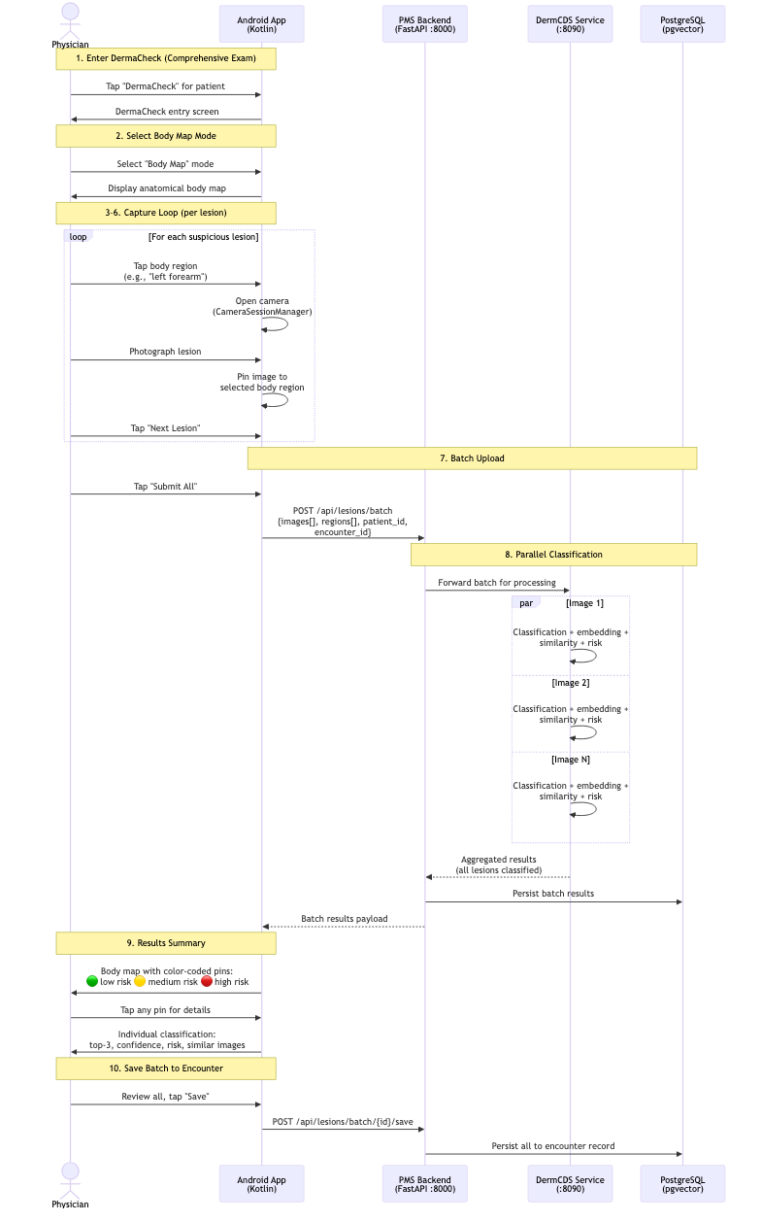
Multi-Lesion Body Map Session — Full Body Region Assessment

Journey 6: Offline Field Triage — On-Device Inference Without Connectivity
Persona: Physician (rural clinic / mobile setting)
Platform: Android (TFLite)
PRD Reference: Section 3.2 (edge inference, TFLite on-device), Section 7.2 Performance (Android on-device inference < 3s), Phase 2 (TFLite on-device inference)
This workflow enables skin lesion triage in environments with no or poor network connectivity, using on-device TFLite inference with deferred server-side processing:
- Offline Detection — The physician opens DermaCheck. The app detects that it has no network connectivity and displays an "Offline Mode" indicator.
- Camera Capture (Normal) — Camera capture proceeds normally via CameraSessionManager. The physician photographs the skin lesion.
- On-Device TFLite Inference — The app loads the quantized TFLite model (~15 MB, MobileNetV3) and runs local classification on the captured image. Inference completes in < 3s (Section 7.2).
- Preliminary Results — The app displays results labeled as "Preliminary Triage" (per SUB-PR-0013-AND): top-3 classification only, no Gemma 3 narrative, no similarity search, no full risk score.
- Save Locally — The physician saves the preliminary results. The image and results are queued in local storage on the device.
- Connectivity Restored — Sync — When network connectivity is restored, the app automatically syncs all queued images and preliminary results to the Backend.
- Full Server-Side Processing — The Backend runs each queued image through the complete DermCDS pipeline: EfficientNet-B4 classification, Gemma 3 clinical narrative, pgvector similarity search, and full risk score calculation.
- Review Updated Assessment — The physician receives a notification that full results are available and can review the updated assessment with complete classification, narrative, risk score, and similar images gallery.
Note: Preliminary triage results from on-device inference use MobileNetV3 (lighter model), while server-side processing uses EfficientNet-B4 (higher accuracy). Classifications may differ between preliminary and final results. The app clearly labels preliminary results and notifies the physician when full results supersede them.

Sequence Diagram
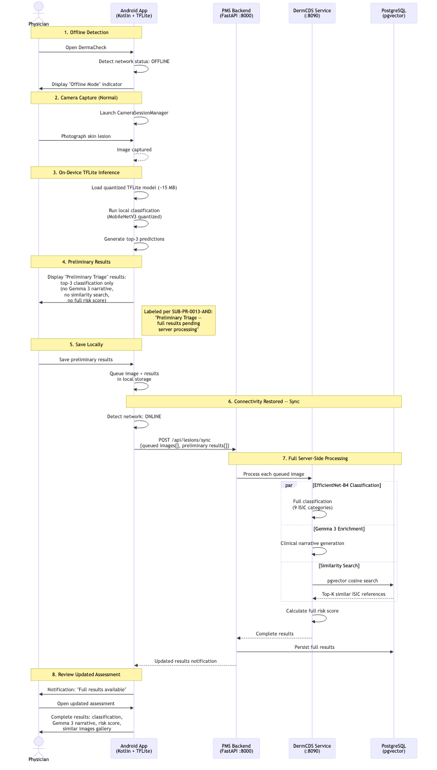
Offline Field Triage — On-Device Inference Without Connectivity

Journey 7: Web-Based Lesion Review — Desktop Clinical Workflow
Persona: Physician (desktop/web)
Platform: Next.js frontend (:3000)
PRD Reference: Section 3.1 Architecture (Frontend components: Capture Widget, Classification Results Panel, Similar Lesions Gallery, Lesion Change Timeline), Phase 1 (basic classification results panel in Next.js)
This workflow provides the full DermaCheck experience through the web-based PMS interface for physicians working at a desktop:
- Login & Navigate to Patient — The physician logs into the PMS web interface and navigates to the patient record.
- Open Dermatology Tab — The physician clicks the "Dermatology" tab, which loads the patient's prior DermaCheck history (if any).
- New Lesion Assessment — The physician clicks "New Lesion Assessment" to open the Lesion Image Capture Widget.
- Image Upload — The physician uploads a dermoscopic image from a USB dermoscope, file upload, or connected camera.
- Metadata Entry — The physician selects the anatomical site from a dropdown and adds clinical notes.
- Submit for Processing — The image and metadata submit to /api/lesions. The Backend forwards to the DermCDS Service for the full pipeline: classification, Gemma 3 narrative, similarity search, and risk scoring.
- Results Display (Three Panels) — The web interface renders three synchronized panels: Classification Results Panel (top-3 predictions, confidence chart, risk level), Similar Lesions Gallery (ISIC reference images with metadata), and Lesion Change Timeline (longitudinal history if prior assessments exist).
- Save or Report — The physician saves the assessment to the encounter record, or generates a printable PDF report for the patient file.
Note: The web workflow mirrors the Android DermaCheck experience (Journey 1) but uses the browser-based Capture Widget instead of CameraSessionManager. Image upload supports JPEG and PNG formats with minimum resolution of 224x224px. The three-panel results layout is a Phase 1 deliverable.

Sequence Diagram
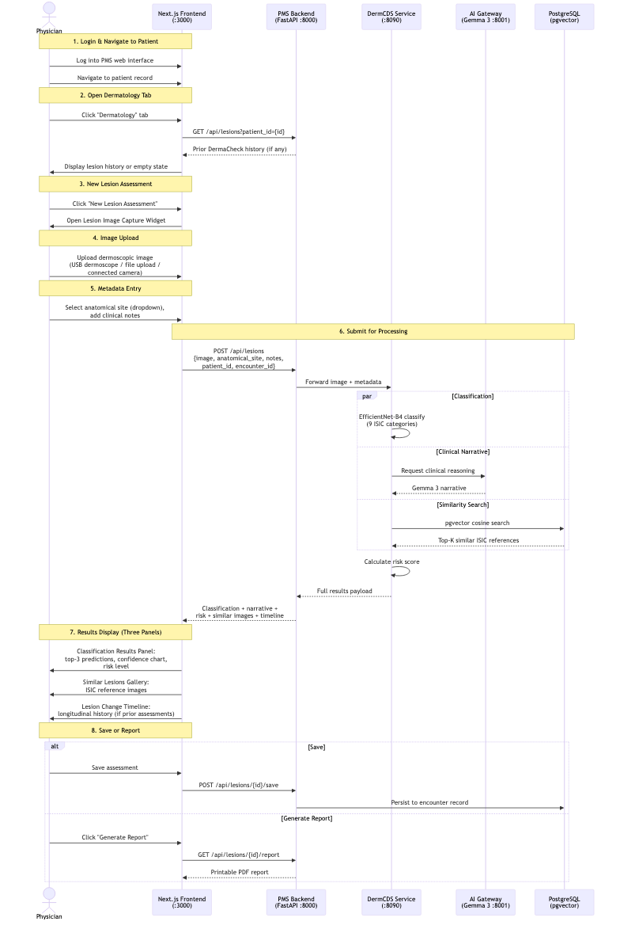
Web-Based Lesion Review — Desktop Clinical Workflow

Journey 8: Dermatology Dashboard & Reporting — Clinic-Level Analytics
Persona: Clinic administrator / Lead physician
Platform: Next.js frontend
PRD Reference: Phase 3 (dermatology dashboard in /api/reports with classification statistics), Section 5 PMS Data Sources (/api/reports — aggregate dermatology metrics), Section 9 Success Metrics
This workflow provides clinic-level analytics and reporting on DermaCheck usage, classification outcomes, and referral patterns:
- Access Dashboard — The administrator logs into the PMS and navigates to the "Dermatology Dashboard".
- Load Dashboard Metrics — The dashboard queries aggregate data across lesion_images, classifications, and encounters tables in PostgreSQL.
- Overview Metrics Display — The dashboard shows: total lesions assessed in the selected period, classification distribution (pie chart by ISIC diagnostic category), risk level breakdown (low/medium/high), and referral rates.
- Filter & Drill Down — The administrator filters by date range, physician, or patient demographic. Charts and metrics refresh with filtered data.
- Model Performance Panel — The administrator reviews: classification confidence distribution, cases where a clinician overrode the AI recommendation, and melanoma sensitivity tracking over time.
- Referral Analytics — The administrator reviews: unnecessary referral rate compared to the pre-deployment baseline, and time-to-referral trends.
- Export Report — The administrator exports the dashboard as a PDF for clinic quality review meetings.
- Audit Log Review (Optional) — The administrator can review the full audit log of all DermaCheck usage for compliance purposes.
Note: The dashboard is a Phase 3 deliverable. It directly supports the Success Metrics in Section 9: clinician adoption rate (80% target), unnecessary referral reduction (30% target), and melanoma sensitivity (> 95% target). The clinician override rate metric feeds back into model improvement priorities.

Sequence Diagram
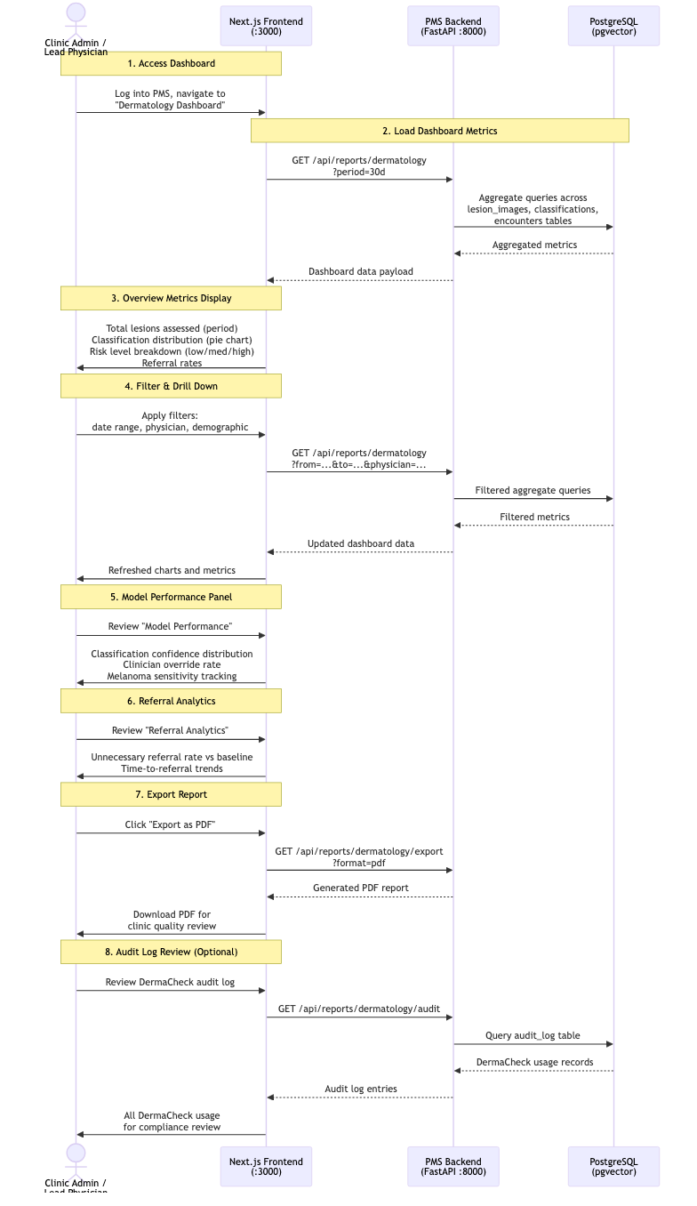
Dermatology Dashboard & Reporting — Clinic-Level Analytics

Journey 9: Model Update Pipeline — Deploying New ISIC Challenge Models
Persona: System administrator / DevOps
Platform: Docker / CLI
PRD Reference: Phase 3 (model update pipeline), Section 7.1 Security (model provenance), Section 9 Success Metrics (model update cadence — annual), Section 11 Dependencies (EfficientNet-B4, MobileNetV3)
This workflow covers the end-to-end process for deploying an improved classification model from the annual ISIC Challenge into the production PMS:
- New Model Available — New ISIC Challenge results are published (annual cycle). The system administrator identifies an improved model from the competition leaderboard.
- Download Model Weights — The administrator downloads new model weights from the public repository (Kaggle or HuggingFace).
- Model Conversion — The administrator converts the model to ONNX format (if needed) for the DermCDS Service and to TFLite for Android/edge deployment.
- Validation Suite — The administrator runs the validation suite against the ISIC held-out test set, verifying accuracy targets: top-1 > 85%, top-3 > 95%, melanoma sensitivity > 95%. If validation fails, the pipeline stops.
- Deploy Updated Container — If validation passes, the administrator updates the model weights in the pms-derm-cds Docker container and deploys via rolling update (zero downtime).
- Android OTA Model Push — The updated TFLite model is pushed to Android app instances via the OTA (over-the-air) model update mechanism.
- Register Model Version — The system logs the new model version with provenance metadata: source, version, accuracy metrics, deployment date, and model hash (Section 7.1 Security).
- Post-Deployment Monitoring (30 days) — The monitoring service tracks classification confidence distributions for 30 days post-deployment, comparing against the baseline distribution to detect drift or regression.
Note: Model provenance tracking (Section 7.1) ensures every classification result can be traced back to the exact model version that produced it. The annual update cadence (Section 9) aligns with the ISIC Challenge publication schedule. If post-deployment monitoring detects regression, the administrator can roll back to the prior model version using the same pipeline.

Sequence Diagram
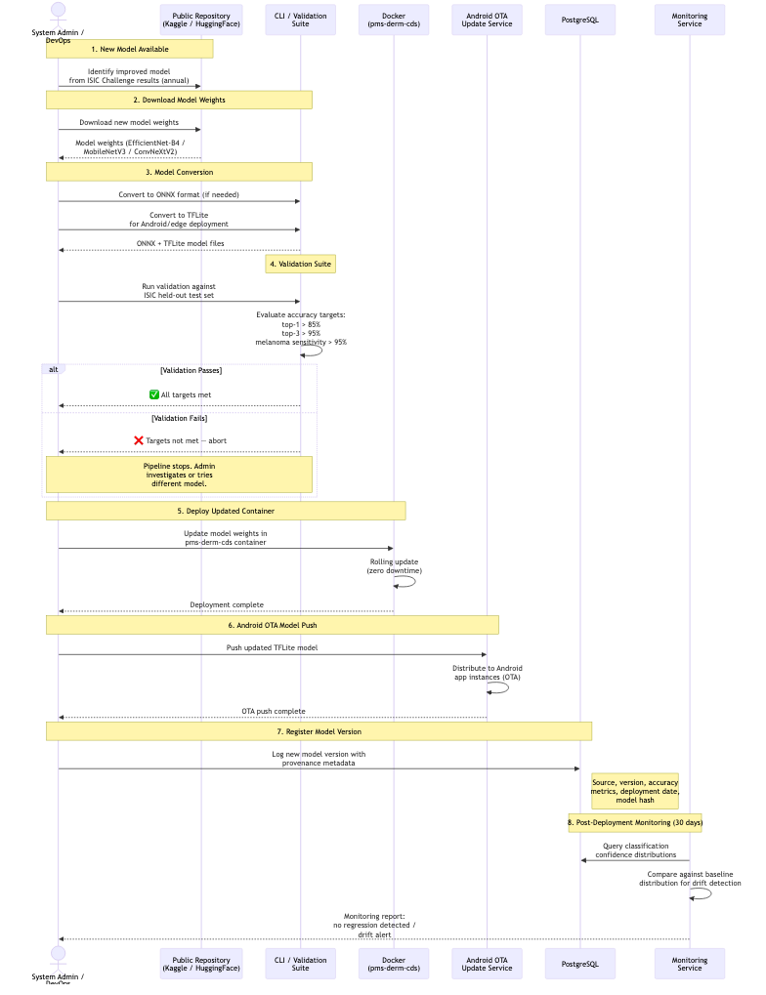
Model Update Pipeline — Deploying New ISIC Challenge Models

