IBILLS AUTO LANKA

WEBSITE

USER MANUAL

Table of Contents

1. Getting Started 1
2. Registering an Account 2
3. About 3
4. Booking a Vehicle Service 3
5. Services 4
6. Managing My Bookings 5
7. Viewing Job Cards 6
8. Live Chatbot Support 7
9. Using the AI Diagnostic Tool 7
10. Need Help? 8

# Getting Started

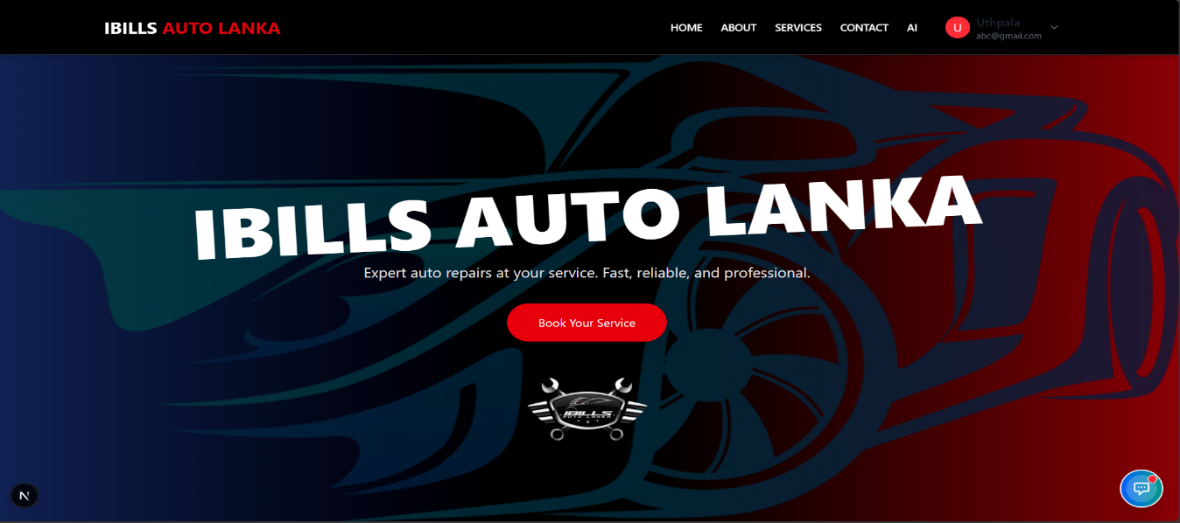Home page

**4**

# 

**5**

**2**

# 

**1**

# 

**3**

When you open the IBILLS Auto Lanka website, you will land on the **Home Page**, where you can:

1. Explore services
2. Login or register
3. Access the chatbot
4. Use AI diagnostics
5. Contact us

# How to Sign up

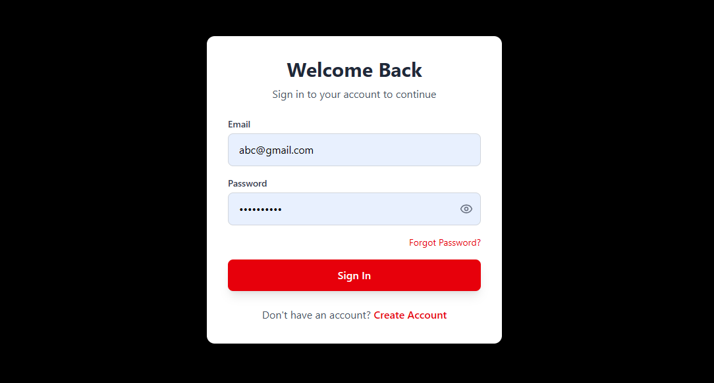

Click

# 

If you already have an account:

1. Click **Login**.
2. Enter your **username** and **password**.
3. Click **Sign In**.

# Registering an Account

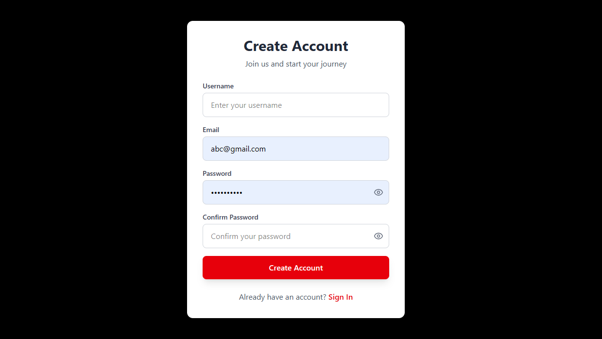

If you're new:

1. Click **Create Account** on the homepage or login page.
2. Fill in your details (name, contact, password, etc.).
3. Click **Create Account**.

*You're now ready to book your first service!*

After the login

# About

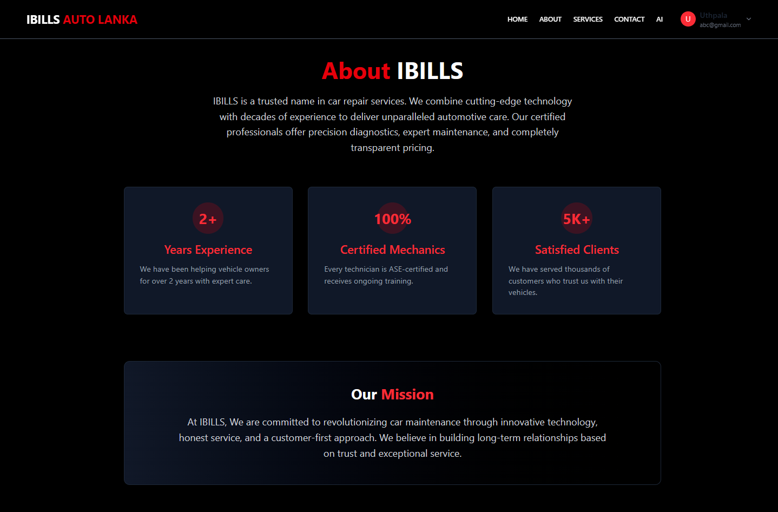

# Booking a Vehicle Service



Click

Or

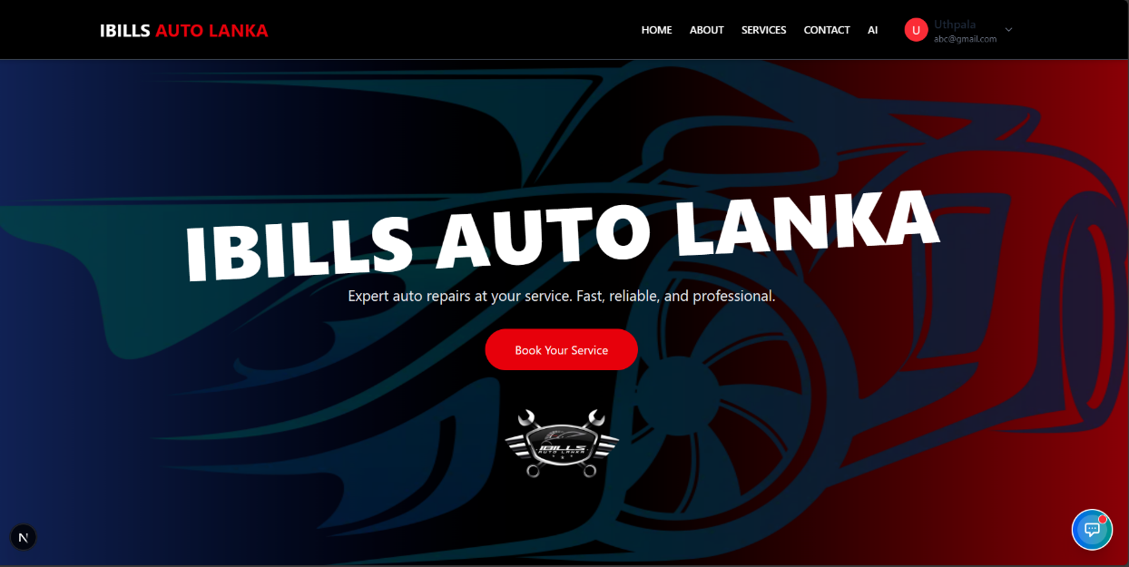

Click

Services Page

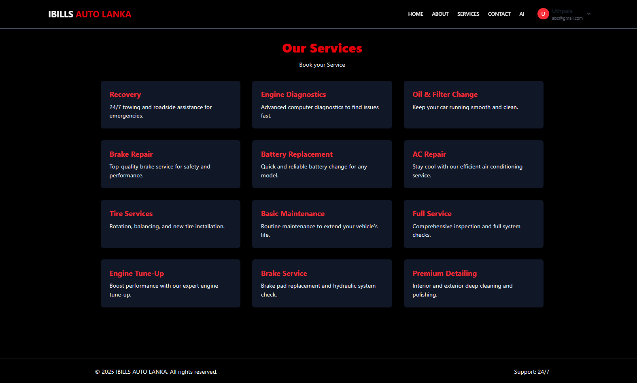

Click

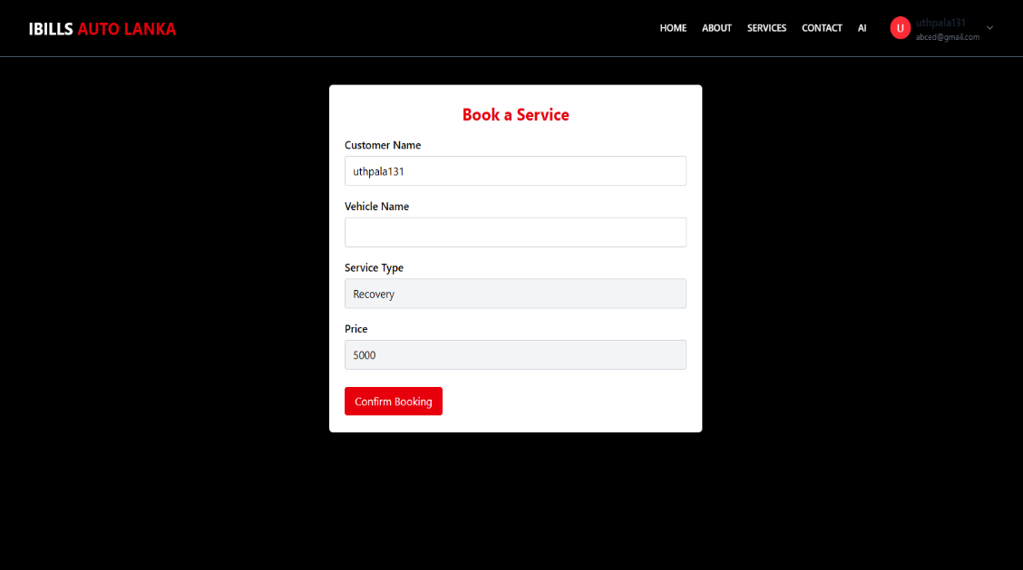

To schedule a service:

1. Click on **Services**.
2. Browse available services.
3. Select the desired service.
4. Click **Book Service**.
5. Fill in booking details (vehicle, time, date, etc.).
6. Click **Confirm Booking**.

*You’ll receive confirmation and booking ID.*

Click

# Managing My Bookings

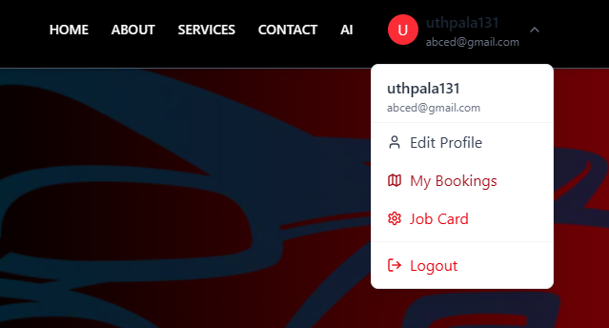

Click

To view or manage your bookings:

1. After login, click **My Bookings**.
2. You'll see a list of your scheduled services.
3. Click on a booking to view or manage its details.

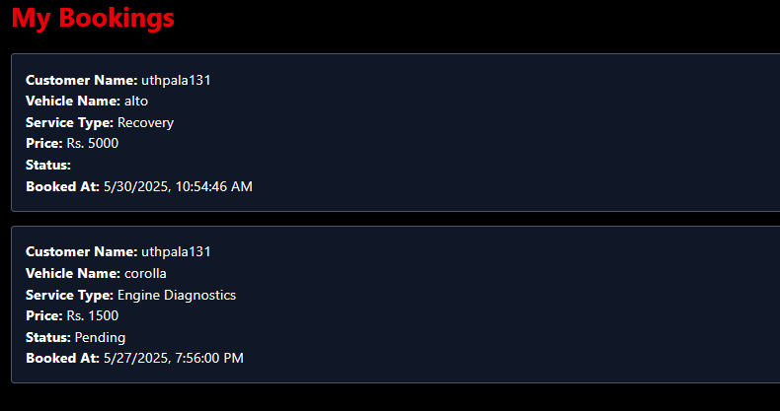

# Viewing Job Cards

Click



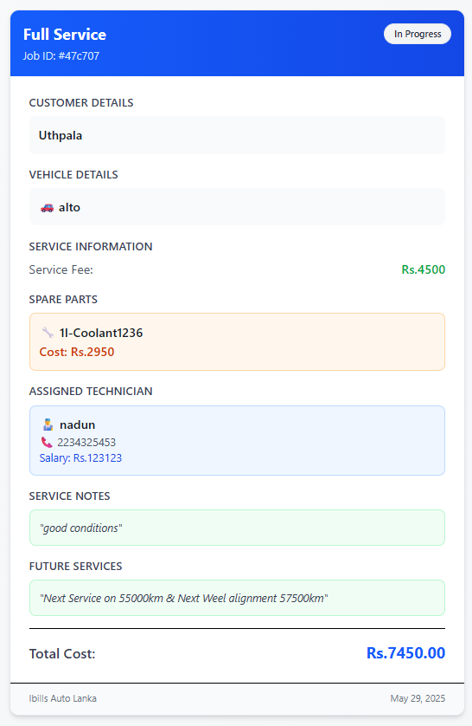

* **Every completed service generates a Job Card:**
* Click the Job Card from the dashboard.
* View detailed job info, including:

1. Service Type
2. Customer Name
3. Vehicle Details
4. Service Fee
5. Spare Parts & Prices
6. Technician Details
7. Technician’s Comments
8. Recommended Future Services
9. Total Cost

*Great for reviewing your service history.*

**1**

**2**

**3**

**v**

**4**

**5**

**6**

**7**

**8**

**9**

# Live Chatbot Support

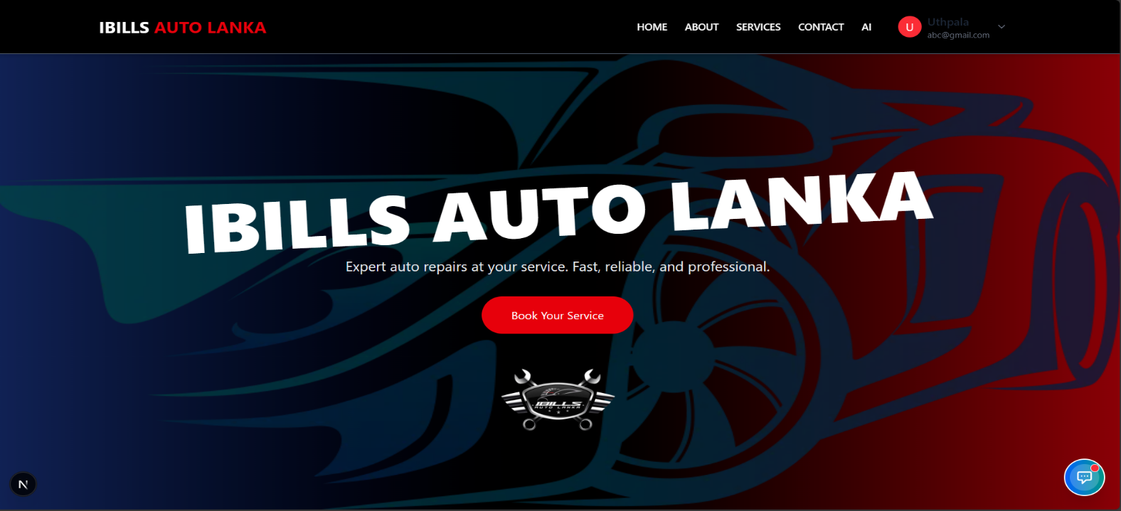

Click

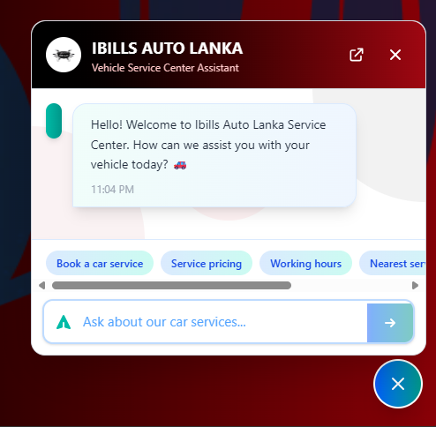

Have a question? Talk to our AI Chatbot:

* Click the Chatbot icon.
* Ask questions about services, bookings, or diagnostics.
* Get instant responses 24/7.

*Great for reviewing your service history.*

# Using the AI Diagnostic Tool

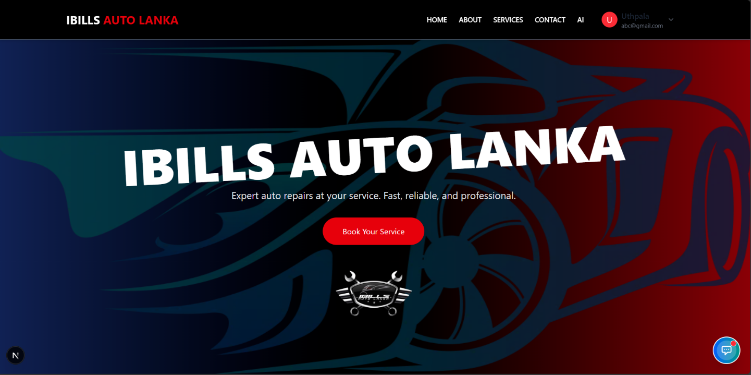

Click

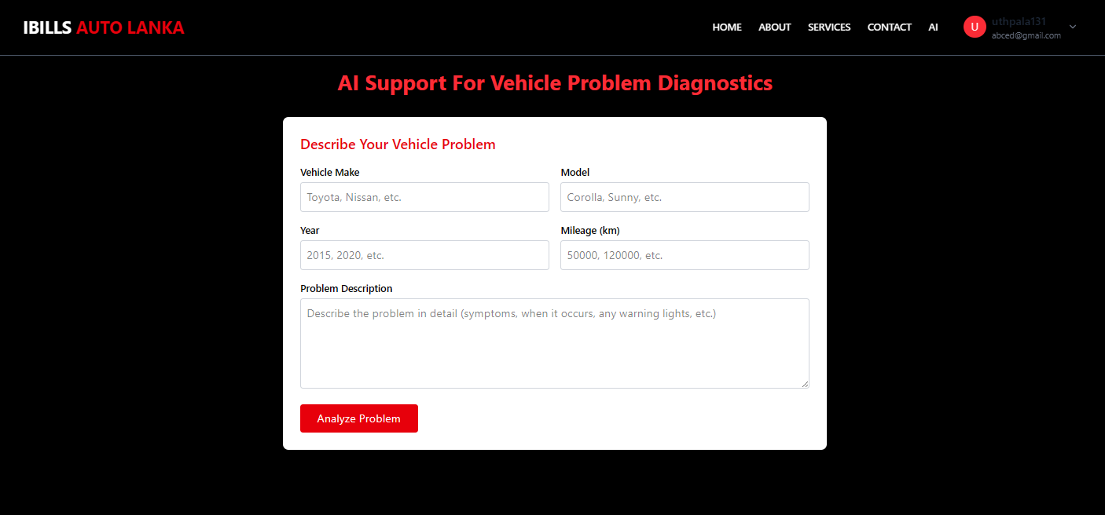

Want to get a quick diagnosis before booking?

1. Click the AI Diagnostic button on the homepage.
2. Fill out the form about your vehicle issue.
3. Click Analyze Problem.
4. Receive AI-generated suggestions and possible issues.

*Smart solutions at your fingertips!*

Click

# Need Help?

Can’t find what you need?

* Visit the **Contact Us** page.
* Reach out via phone or email.
* Our support team is ready to assist!

**Thank you for choosing IBILLS Auto Lanka**

*Your vehicle, our responsibility.*