Kevin Gonzalez

Professor Chovanec

English Literature

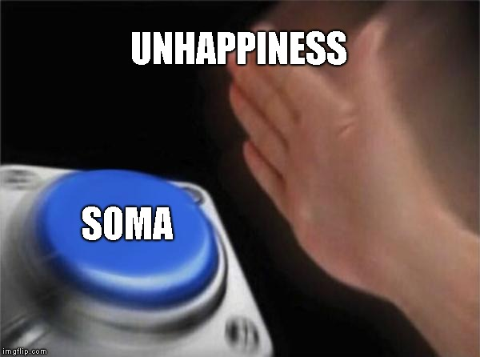8 February 2018

Drugs equate to Happiness Meme Critique

In the society we live in today, memes are a way of expression towards a particular situation. Modern memes aim towards being humorous by showing a depiction, such as a picture, of current events. More often then not, memes appear on anything ranging from social media to live television. “Drugs equate to Happiness” meme is aimed to show the crisis of people becoming too dependent on a drug, to get a “feel good state.” Some would even argue that drugs become a part of a person, that is to say that the dependency becomes too great to the point where a person may not be able to live without said drug. An example of a drug like this in modern society, would be something like heroin or meth, where if a person stops “cold turkey” they may be faced with serious life-threatening issues. In Brave New World there is a depiction that drugs, specifically soma, brings joy and happiness when everything else does not. “Drugs equate to Happiness” is a play on how quick the characters in Brave New World are to take soma, even when it is not needed.

"Now–such is progress–the old men work, the old men copulate, the old men have no time, no leisure from pleasure, not a moment to sit down and think–or if ever by some unlucky chance such a crevice of time should yawn in the solid substance of their distractions, there is always soma, delicious soma, half a gramme for a half-holiday, a gramme for a week-end, two grammes for a trip to the gorgeous East, three for a dark eternity on the moon… (chapter 3).” The World State came up with the “perfect drug,” that yields happiness to anyone who takes the drug. This is not necessarily a reference to the meme itself, but it shows the clear depiction of reliance. This “perfect drug” allows those to feel comfort in their life, in a way related to addiction.

This heavy reliance of soma and unhappiness is clearly depicted with the confrontation of Benito and Bernard in Chapter 4. "you do look glum! What you need is a gramme of soma… diving into his right-hand trouser-pocket, Benito produced a phial. One cubic centimetre cures ten gloomy." Bernard, the odd one out, ran away from the situation. There is this fabrication of happiness with soma constantly occurring in Brave New World, immediately if you are in a state of unhappiness, you take soma. The World State created this “perfect drug” with the intention to bring happiness, but Bernard shows opposite views of that of the World State, where he does not want to become dependent.

After multiple attempts at convincing Bernard to take soma, he finally takes it and has sex with Lenina. After his affair with Lenina that night, Bernard stated that he would have preferred to be an “adult.” This is to show that soma is just a fabrication of happiness, it is not really needed to perform something like sex. John, a member of the reservation, shows opposite views of that of the World State like Bernard. The World State’s “perfect drug” ultimately believes that soma has this power over the people that can help dictate one’s life. The meme also contradicts with John’s life, where he isolates himself from society, the World State. After his incident with soma, he decided that that is not a way that he wants to live. This is to show that “happiness” is not easily attainable through drugs, or soma in this case. Drugs in fact, do not equate to happiness.

Through the depiction of characters like John and Bernard, we can see that soma does not bring happiness. At the end of the day, drugs are used for temporary comfort, not for life long happiness. “But aren't you shortening her life by giving her so much? In one sense, yes…But in another we're actually lengthening it…soma may make you lose a few years in time…but think of the enormous, immeasurable durations it can give you out of time. Every soma-holiday is a bit of what our ancestors used to call eternity (chapter 11).” Unhappiness and soma, do not equate to long life happiness.