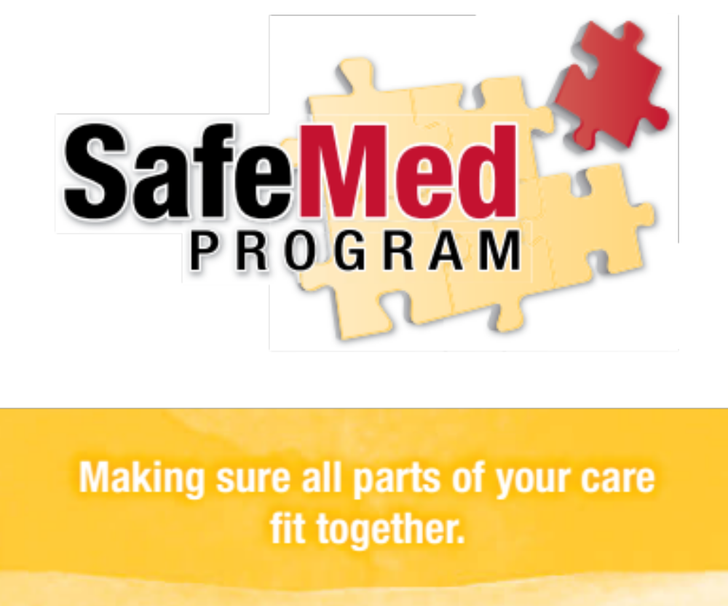

Protocols and Procedures

February 2, 2015

Table of Contents
I. SafeMed Program Inpatient Protocol 3
A. Screening 3
B. Enrollment 5
C. Comprehensive Medication Review (CMR/ MTM) 8
D. Enhanced Discharge Planning and Coordination of Care 8
E. Final Medication Reconciliation 10
F. Complete the SafeMed Discharge Note/Continuity of Care Document 10
G. Modified “Quick” Discharge Protocol 11
H. Readmission Protocol 12
II. Overview of SafeMed Outpatient Interventions 13
A. Assessment of SafeMed Participant Needs and Program Tailoring 13
B. Schedule of Core Activities for Initial 45-day Program Participation 14
C. Schedule of Core Activities for 3-month Ongoing Program Participation 14
D. SafeMed Maintenance Phase 14
III. SafeMed Program Home Visit Protocol 15
A. Overview 15
B. Assessment of Condition-Related Signs and Symptoms (LPN) 17
C. Documentation of Current Medication Use and Side Effects 19
D. Cerner Documentation of Home Visit (LPN & CPhT with NP Assistance) 20
E. Drug Disposal (CPhT) 21
F. Teach Back of Discharge Materials for Driving Diagnosis (LPN) 22
G. Implement Simple Medication Adherence and Symptom Monitoring Aids (CPhT/LPN) 24
H. Goal Setting and Problem Solving (LPN/CPhT) 26
I. Identification of Appropriate Community-based Services for Referral 27
J. Follow-up Phone Visits 28
IV. SafeMed Program Outpatient Care Coordination Protocol 29
A. Linkage to Primary Care 29
B. Communication with Primary Care 29
C. Linkage to Appropriate Care for Zone Changes 30
Appendix 32

SafeMed Program Inpatient Protocol

The process for all SafeMed Program activities occurring in the hospital prior to discharge including eligibility screening, enrollment, comprehensive medication review, enhanced discharge planning and coordination of care, and final medication reconciliation is detailed below:

Screening

- Screening of all eligible patients for inclusion/exclusion criteria –NP/RN

  - Review daily SafeMed Program Eligibility Report –NP/RN
    - View Meets All Criteria Tab
    - Arrange candidates within each hospital in order of birthdate starting with the eligible patient with the earliest birthdate using month and day only

  - Exclude those previously screened and enrolled as full participants in the past 9 month period –NP/RN
    - Compare eligibility report to the list of persons previously screened and enrolled as full participants on a daily basis to make sure no eligible patients already enrolled as full participants are re-enrolled within 9 months
People previously screened and enrolled as controls may be rescreened and enrolled as full participants, if interested
SafeMed Program Inclusion Criteria
- 2+ hospital admissions OR 1 inpatient admission and 2+ prior emergency visits in the last 6 months prior to the current admission
- Diagnosis of two different chronic conditions (HTN, CHF, CAD, DM, CLD) in the last 6 months
- A targeted chronic condition serves as a driving diagnosis significantly contributing to majority of IP/ED utilization
- Medicare or Medicaid insurance
- Residence in targeted zip codes or within an approximately 30 minute drive of Methodist North, South, or University Hospital
- Age > or = 18 at the current admission
- 6 or more medications or presence of a high-risk medication
  - Complete SafeMed Program Screening Form –NP/RN/MSW or LPN/CPhT with assistance of NP/RN/MSW
    - Complete Section 1 (Inclusion Criteria) of the Screening Form using existing information (e.g. Powerchart, case management).
      - If the patient does not meet SafeMed inclusion criteria stop and note that the patient is ineligible in the SafeMed Database.
      - If the patient meets all SafeMed inclusion criteria in Section 1 proceed to Section 2.
    - Complete Section 2 (Exclusion Criteria) of the Screening Form using both existing information (e.g. Powerchart, case management) where possible and patient self-report.
      - Let patient know that this screening and patient assessment process is a new process provided by Methodist at the North, South and University Hospitals to help provide better care for patients who have certain health conditions and who have multiple admissions to the hospital in the past six months.
      - Complete the entire self-report portion of Section 2 in in order to document all reasons for exclusion.
SafeMed Program Exclusion Criteria
- Primary reason for admission(s) related to cancer, pregnancy, or surgical procedure for an acute problem
- Currently experiencing or at high risk for psychosis or suicidal ideation
- Homeless or at imminent risk of homelessness in the past 30 days
- Repeated history of current illicit drug use (e.g., crack/cocaine, methamphetamines, hallucinogens or opioids) multiple times per week over consecutive months within the past 6 months as identified through ED triage, case management assessment, positive urinary drug screens, and/or other medical record documentation
- Severe substance abuse disorder as identified through ED triage, case management assessment, positive urinary drug screens, and/or other medical record documentation.
- End-stage condition (Life expectancy < 6 months)
- Discharge status is to another location other than home
- Severe cognitive difficulties AND lack of caregiver to assist SafeMed Program participation

  - Enter “Driving Diagnosis” in SafeMed Program Intake Form –NP/RN

Enrollment

- Offer SafeMed Program participation -Once screening is completed for the first eligible patient, offer that patient participation and proceed to complete the enrollment process as detailed below prior to screening other patients –NP/ RN

  - Give patient SafeMed Program flyer and assess patient interest in program
    - Describe the benefits of the SafeMed Program individualized to the patient’s condition and needs
    - If patient isn’t interested, thank them for their time, then move on to next patient
    - Document enrollment status on SafeMed Program Enrollment Form
  - Continue to offer participation to eligible patients in order of birthdates by month and day.
    - Offer participation to eligible patients in order of birthdate starting with the eligible patient with the earliest birthdate using month and day only
    - Continue to offer participation in birthdate order until recruitment goal for day at hospital is reached (typically the recruitment goal for each hospital will be 1 or 2 patients per day; recruitment goals are set daily by the SafeMed Program recruitment team leader for each location and should be set for each location –the NP/RN
    - Once the daily participant recruitment goal for the day is reached, the next eligible patient should be screened in birthdate order if possible and enrolled as a control/low intensity intervention participant. (In general, the recruitment goal for control/low intensity intervention participants should match or exceed the full participant recruitment goal for the day so that at least one control/low intensity participant is recruited for each full participant).
    - Enroll eligible patients who decline enrollment as control/low intensity intervention participants
    - Control/low intensity participants will benefit from the following enhancements beyond the “usual care” received by patients prior to the initiation of the SafeMed Program:
      - Other concurrent readmission reduction initiatives of Methodist Le Bonheur Healthcare (e.g. provision of enhanced chronic disease self-management educational materials, targeting of eligible patients for enhanced case-management services)

- Complete SafeMed Intake Form –NP/RN

  - Confirm that patient has reviewed the brochure and read the informed consent statement. Answer any questions patients have regarding SafeMed Program participation (NP/RN)
    - If patient chooses not to participate, thank them for their time and assign them to the control/low-intensity intervention group
  - If patient chooses to participate, begin enrollment. NP/RN should then notify other SafeMed staff a patient has been enrolled.
  - Add screening information for both full SafeMed Program participants and control/low intensity participants to SafeMed Program Database (NP/RN)
  - Complete SafeMed Program Intake Form for all patients enrolled as full participants in the SafeMed Program (NP/RN)
  - Complete Additional Risk Factors Form (formerly Part 3 of screening form) (MSW/NP/RN/PharmD).
  - Complete the PCCQ Questionnaire. (LPN/CPhT)
  - Visit patient room to introduce themselves –NP/PharmD/MSW/RN/LPN/CPhT

- Complete intake pharmacy assessment (for all patients enrolled in SAFEMED in Cerner and OUTCOMES medication therapy management [MTM] system) –PharmD/CPhT

  - Obtain home medication list:
    - Print out Cerner Home Medication List under the “Document Med Hx” tab found under the Medications tab on the Cerner Menu–CPhT/PharmD
    - Interview patient to verify Cerner Home Medication List and to identify additional prescription, OTC, and herbal medications – CPhT/PharmD/LPN/NP
    - Contact outpatient pharmacy for additional med information – obtain last 6 month’s worth of med history from outpatient pharmacy on each patient - CPhT/PharmD/LPN
  - Update home medication list – CPhT
    - Obtain pharmacy location information from patient or Intake form and call pharmacy(ies) to get baseline outpatient medication list including all prescriptions filled in past six months – CPhT
    - Pull up Cerner Home Medication List and calls pharmacy(ies) to check for additional medications including all prescriptions filled in past six months – CPhT
      - Ask pharmacy(ies) for a list of all medications filled in the last 6 months
      - Obtain name, strength, dosing instructions, and the last refill date for all medications and copay information for suspected expensive medications filled in the last 6 months
    - If no additional med information is gathered from pharmacy(ies), go to next patient that needs med list work or to other duties
    - If additional med information is gathered from pharmacy(ies) clarify discrepancies with patients, reconcile meds that are on list but haven’t been filled within last two months (ask them if doctor told them to stop taking the medication), to create updated outpatient med list (also can have patient call home and have someone look at bottles, or bring meds in to hospital)
  - Update Cerner Home Medication List with new med info (PharmD)
    - Notify Attending Physician regarding key changes made to Cerner Home Medication List – PharmD/NP

- Complete Cerner Intake Note –PharmD
  - Add patient info to OutcomesMTM database (CPhT/PharmD)
  - Add Contact info, Health conditions, Allergies, Med list

- Complete Selected Sections of SafeMed Program Discharge Checklist –MSW/NP/RN/PharmD/CPhT
  - Inform case management when a SafeMed participant is enrolled –MSW/NP/RN
  - Complete remaining relevant sections –NP/RN/MSW/PharmD
  - Identify case management and/or social work needs using readmission risk factors (Additional Risk Factors Form) identified in Intake with particular attention to issues of homelessness, substance abuse, and /or mental illness –MSW/NP/RN/PharmD
    - Follow predefined social work protocols for addressing these needs with assistance from social work as needed
    - Have NP put in order for Behavioral health consult as needed
    - Contribute to discharge planning notation and unit discussions as needed to help communicate findings
    - Discuss patients with complex special needs with social work for assistance.

Comprehensive Medication Review (CMR)

- Complete comprehensive medication review (CMR)/Medication Reconciliation – PharmD
  - Complete CMR, and notify doctor of any opportunities to improve drug therapy
    - Review updated Cerner Home Medication List
    - Get relevant blood work info from Cerner (Na, K, Scr, LDL, Glucose, etc)
    - Evaluate Med List to identify drug-therapeutic-problems (DTPs) and formulate recommendations (document interventions via Cerner)
      - Assess each drug for Indication-Efficacy-Safety-Convenience-Cost)
      - Assess for the presence of contraindicated drugs (i.e., Beer’s list, Drug-Drug interactions, allergies, etc.)
      - Assess whether patient has access to all prescribed drugs (not on formulary or high cost issues)
      - Medication regimen is aligned with evidence-based guidelines –PharmD
      - Document any drug therapy problems found and recommendations to resolve DTPs
    - Discuss DTPs with attending and resolve any Drug Therapy Problems

Enhanced Discharge Planning and Coordination of Care

- Schedule home visit –CPhT/LPN
  - Create patient visit calendar and provide to patient prior to discharge. Be sure to verbally reinforce calendar with patient and may want to prominently place this in the patient’s folder.
- Provide patient with patient-friendly symptom triage tool (i.e. stoplight tool) for Driving Diagnosis prior to discharge (NP/RN/LPN)

  - Check with patient to determine if nurse spoke to the patient about their disease states
  - Check with patient to determine if nurse dropped off any disease management brochures/tools (CHF, DM, HTN, CLD, CAD)
  - If disease management brochures/tools have been given to patient
    - Discuss self-management of disease and use of symptom trackers
    - Review symptom triage tool and patient specific instructions with patient/family member/caregiver (NP/RN)
    - Review patient education checklist with abbreviated teach back method (NP/RN)
  - If disease management brochures/tools have not been given to patient
    - Get materials and provide them to patient
    - Discuss self-management of disease and use of symptom trackers
    - Review symptom triage tool and patient specific instructions with patient/family member/caregiver (NP/RN)
    - Review patient education checklist with abbreviated teach back method (NP/RN)
    - Remind nurses to continue to teach patient and provide disease state management brochures/tools

- Monitor daily progress of patient via CERNER (PharmD/NP/RN/LPN/CPhT/MSW)

- Coordinate Care with PCP -Coordinate care with outpatient PCP and/or specialty care providers (LPN –see Outpatient plan for additional details)

  - For patients with PCP
    - Notify PCP office that patient is in SafeMed Program and schedule patient visit within two weeks – LPN
  - For patients without PCP
    - Assist patient in identifying and choosing a PCP in their area who accepts their insurance for follow-up
    - As needed, notify Case Manager of patients in need of PCP and follow-up visit within two weeks (one week) –NP

- Patient Discharge Medication Education -Review patient-friendly comprehensive discharge medication list with patient/family member/caregiver using teach-back method (PharmD/ CPhT )

  - Review each medication with patient, what they are for and how to take them, potential side effects, missed dose actions and proper storage requirements. (PharmD)
  - Confirm that each SafeMed Program participant has access to all prescribed drugs (PharmD/ CPhT)
    - Check for formulary and cost issues
  - Coach patient to pick up any new medications ASAP upon discharge. Help patient conceptualize a plan to get their medications filled and obtained prior to discharge. (PharmD, CPhT)
  - Reinforce disease state information and stoplight tool as needed.

Final Medication Reconciliation

- Perform final Medication Reconciliation prior to discharge -once discharge orders are written, a preliminary discharge medication list has been drafted, and basic discharge medication education has been completed (PharmD/CPhT)
  - MedRec-Make sure appropriate home meds that were DC’d during admission are on discharge med list. Discuss issues with attending if necessary. (CHP)
    - Perform Med Review on original discharge med list to identify DTPs -PharmD
    - If DTPs found, formulate recommendations and contact inpatient and outpatient providers to help facilitate needed and recommended changes – PharmD
    - Obtain discharge med list from patient discharge materials or from the electronic discharge medication reconciliation section in Cerner
    - Construct patient-friendly medication list (PFML) to give to patient before discharge or at first home visit. (PharmD/ CPhT)
    - Document problems/interventions and results in CERNER-PharmD
Document Intervention data from CERNER into Outcomes system -CPhT

Complete the SafeMed Discharge Note/Continuity of Care Document

- Draft personalized outpatient post-discharge care plan to address most likely causes of readmission and include Final Medication Reconciliation –NP/RN
- Review draft personalized post-discharge care plan with key SafeMed team members and finalize details -NP/RN
- Complete a condition-specific symptom triage plan with specific care instructions/referral numbers –NP/RN
- Send the completed SafeMed Discharge Note/Continuity of Care Document to patient’s PCP along with the discharge summary if available via HIM –NP/RN

Modified “Quick” Discharge Protocol

- “Quick” discharge prior to completion of inpatient tasks. In the event the discharge of a screened SafeMed patient occurs prior to completion of all required inpatient tasks, the following protocol is put into effect.
  - NP, RN, PharmD, and/or MSW will assess what information is left to be acquired.
  - NP, RN, PharmD, or MSW will contact patient by phone to offer enrollment, if it was not completed prior to discharge.
    - Informed consent will be read to patient over the phone
  - After enrollment, the NP, RN, PharmD, and/or MSW will determine whether remaining intake information needs to be acquired through an intake home visit or an intake follow-up phone call.
  - LPN or CPhT will call the SafeMed patient and discuss the following:
    - Remaining information left to be gathered
- Plan on how the remaining information will be obtained Set-up up an intake phone follow-up or an intake home visit time with the patient, if the patient does not agree to complete intake information during the current phone call
  - In the event the intake phone follow-up occurs for information gathering, this will occur within 24 business hours of discharge.
  - If the required information was unable to be obtained with a phone follow-up call, an intake home visit will be scheduled.
  - In the event an intake home visit occurs, this visit will occur within 72 business hours of discharge.
  - The regularly scheduled home visit that would have occurred within 72 business hours of discharge, will now occur within 72 business hours from the intake home visit.
  - After completion of this protocol, the SafeMed patient will then continue on with the primary SafeMed protocol for the remainder of the study period.

Readmission Protocol

- Complete SafeMed Program Readmission Assessment Form –LPN/RN/NP
- Conduct enhanced discharge planning and coordination of care as needed and described in Section D above –NP/RN/PharmD/MSW with assistance of LPN/CPhT
- Coordinate with outpatient case management services (if patient has case management at enrollment) (MSW)
  - Discuss needs and available resources with Case Manager and/or designated Social Worker
  - Facilitate a plan to meet needs with patient and Case Manager and/or designated Social Worker
- Refer to behavioral health and/or substance abuse services if needed (inform primary care of referrals) (MSW)
  - Assess patient for behavioral health concerns and needs
  - Identify triggers, and signs and symptoms list
    - Patient currently on pyschotropic meds with alterations and mental status changes
    - Patient discusses depression, and other mood changes
  - Notify PCP
  - Request Behavioral Health consult
  - Document actions taken
- SafeMed Team Huddles –
  - Day to day contact with LPN/CPhT/ PharmD/ NP/ RN/ MSW
  - Weekly interdisciplinary team huddles to review current patients and opportunities for ongoing coordination
- Conduct final medication reconciliation as described in Section E above if CMR performed –PharmD
- Complete SafeMed Discharge Note/Continuity of Care Document as described in Section F above

Overview of SafeMed Outpatient Interventions

An overview of the process for all SafeMed Program outpatient interventions occurring following hospital discharge, including home visits, telephone follow-up, coordination with primary care providers, comprehensive medication review and medication therapy management, and participation in SafeMed Support Sessions is detailed below:

Assessment of SafeMed Participant Needs and Program Tailoring

Upon initiation of program participation, the SafeMed Team will assess each patient with regard to their level of medical and social complexity to assess participant needs for intensive social work and medical problem solving and support. This needs assessment will be conducted collaboratively by the SafeMed NP, PharmD, RN, and MSW for each patient upon intake according to the following schema:

 |  | Increasing Social Complexity ➔
Increasing Medical Complexity   ⬇ |  | Low | High
Increasing Medical Complexity   ⬇ | Low | No additional medical and social support provided | Additional social support provided
Increasing Medical Complexity   ⬇ | High | Additional medical support provided | Additional medical and social support provided

Additional medical support provided to selected participants may include:
- Accompanying patient to PCP and/or specialist visits
- Assisting patients in arranging transportation to PCP visits
- Calling PCP and/or specialist provider to coordinate care
- Providing SafeMed outpatient visits to provide patients with additional focused training in disease self-management (NP)
- Providing additional CMR/MTM visits to assist patients in resolving medication-related problems
Additional social support provided to selected participants may include:
- Telephone outreach and follow-up by MSW
- Participation in home visits by MSW
- Assistance with and linkage to appropriate community-based services

Schedule of Core Activities for Initial 45-day Program Participation

Week | 1 | 2 | 3 | 4 | 5 | 6
Activities | 1st Home Visit within 72 hours of discharge | Telephone Follow-up (and/or accompanying patient to PCP visit) to insure PCP follow-up within 14 days | 2nd Home Visit | 30-day Telephone Follow-up | Comprehensive Medication Review (target window 30-45 days following enrollment) | SafeMed Support Session
Responsibility | LPNs and CPhTs | NP,LPNs, and CPhTs | LPNs and CPhTs | LPNs and CPhTs | PharmD (CPhTs to schedule) | All SafeMed staff
Measurement |  |  |  | Complete Patient-Centered Care Questionnaire (PCCQ) anytime within weeks 4-6 (CPhTs/LPN)

Schedule of Core Activities for 3-month Ongoing Program Participation

After the first 45 days of SafeMed Program participation, patients may decide to continue participating in the SafeMed Program for an additional 3 months. During this period, participants may continue to attend SafeMed Support Sessions and receive the following services:

•Bi-monthly to Monthly telephone follow-up and/or accompanying patient to PCP visits to insure PCP follow-up
• Answering participant questions by phone
• Assisting with arranging office visits to outpatient providers as needed

The offer to continue to Phase 2 of the program will be offered during outpatient CMR session and only if other SafeMed members deem patient appropriate to continue (aka, has completed most other components of Phase 1 within reason)

SafeMed Maintenance Phase

Once program completion is reached, patient will be invited to attend their Graduation presentation at the next SafeMed support meeting. If unable to attend, their certificate of completion will be mailed to their house. Ongoing support group attendance is welcomed.

SafeMed Program Home Visit Protocol

The process for all SafeMed Program activities occurring in the home at initial and follow-up home visits including assessment of condition-related signs and symptoms, documentation of current medication use and side effects, drug disposal, teach back of discharge materials, goal setting and problem solving, and identification of appropriate community based services is detailed below:

Overview

Teams of two SafeMed Community Health Workers (CHWs) consisting of one CHW with a licensed practical nurse (LPN) background and one CHW with a pharmacy technician ( CPhT) background will conduct all home visits. After the hospital discharge, the first home visit will occur within three business days. The estimated time for an initial home visit is 90 minutes. The estimated time for each element is ~ 15 minutes. The second home visit will occur approximately two weeks after the initial visit. Any additional home visits will be at the discretion of the supervising PharmD and NP/RN. The CHWs will be responsible for phone follow-ups. The CHWs will update any contact information in the SafeMed database at each in-person or phone-follow up visit.

SafeMed Program PharmD and NP will supervise LPNs and CPhTs in performance of their home visit functions in the following ways:
- Periodic real-time communication between using cell phones or iPads during home visits when questions arise requiring SafeMed PharmD and/or NP guidance or input

- Occasional communication of SafeMed PharmD and/or NP directly with SafeMed Program participants during home visits using cellphones or iPads when questions arise requiring SafeMed PharmD and/or NP guidance or input (as above)

- Review of all SafeMed Home Visit Notes entered by the PharmD or NP in the MLH/Cerner electronic health record, and provision of regular feedback and guidance to CHWs, and occasionally to program participants, when questions arise requiring SafeMed PharmD and/or NP guidance or input

A SafeMed Program PharmD and NP, will perform periodic direct observation of CHWs conducting home visits to make sure that all home visit protocols and procedures are correctly followed for information gathering, education, and SafeMed Program participant assistance

Home Visit Checklist:

- Home Outreach Process Sheet - 2
- Home Visit Template - 2
- Patient Friendly Med List -2
- Driving Diagnosis Toolkit - 3
- Drug Disposal Handout - 2
- “Record of In-Home Medication Disposal” document - 1
- Blood pressure cuff -1
- Stethoscope - 1
- Watch with second hand -1
- O2 Sat machine - 1
- Large Red Marker and sharp scissors -1
- Large Zip-lock bags -10
- Small container of dishwashing soap-1
- iPad

Before Leaving For The Home Visit

- Get all items on Home Visit Checklist above

- Fill out the top of this form (Home Outreach Process Sheet)

- Fill out top part of Home Visit Template (Down to Driving Diagnosis-But excluding “Caregiver present” and “Date Last Seen” fields

- CPhT – Verify Discharge Med List, and Patient Friendly Med List all have the same med information

  - If there are any discrepancies – contact PharmD

- Get directions to patient’s house using iPad or computer

  - Using iPad,
    - Go into settings and turn on Cellular Data
    - Go to Google Maps and search for patient’s address, and get directions
  - Using computer
  - Bring up web browser and go to maps.google.com
  - Type in patient’s address and get directions
  - Print out directions to take with you

Assessment of Condition-Related Signs and Symptoms (LPN)

1. Conduct a brief condition-specific assessment of signs and symptoms for deterioration of diagnosis specific health (LPN with NP back-up)
- Conduct the Brief LPN Home Visit Assessment for –Symptoms and –Signs (Appendix) to determine whether patient exhibits signs and symptoms in the red or yellow referral zones and follow the protocol for notification of the NP
- Document findings from above assessment using the Cerner Home Visit Note Template (Appendix)

2. Triage Patients with Potentially Life Threatening RED ZONE Signs or Symptoms
  - If the patient exhibits signs or symptoms of life-threatening illness (i.e., severe chest pain or difficulty breathing), according to the toolkit protocol, the LPN will contact 911 for transport to the Methodist ED followed by an alert call to the NP
  - The LPN, with assistance from the CPhT, will continue to monitor the patient’s vital signs and perform CPR measures, if needed
  - Following resolution of the emergency, the LPN will complete the documentation of home visit termination
  - Termination of the home visit will be indicated by clicking the ‘yes’ box to questions #1 (see below). The check box heading ‘Assessment of condition-related signs and symptoms’ is on the SafeMed database Home Visit tab. Click the checkbox next to the heading

- Triage Patients with Non-Life Threatening RED ZONE Signs or Symptoms
  - the LPN will contact the NP using the phone or SKYPE technology on the Ipad
  - The LPN should document the NP recommendations in the Plan [“P”] section of the CERNER system’s home visit note
  - The LPN should complete remaining questions under Question 1: ‘Assessment of condition-related signs and symptoms’ upon completion of assessment and documentation.

- Triage Patients with YELLOW ZONE Signs or Symptoms
  - Same as triage protocol for #3 above

- Complete the “Assessment of Condition-Related Signs And Symptoms Checklist” in SafeMed database (below)
Assessment of Condition-Related Signs And Symptoms Checklist

1. The patient shows signs/symptoms of a life threatening condition during today’s visit.
Yes No
If yes, contact 911, NP. (If no, continue to question #2 )

2. The patient shows evidence of signs/symptoms in the red zone during today’s visit. Yes No
If yes, contact NP for ‘RED’ on-site consult. (If no, continue to question #3)
If yes, did the NP provide on-site consult? Yes No Not available

- The patient shows evidence of signs/symptoms in the yellow zone during today’s visit.
Yes No
If yes, assist patient with urgent PCP appointment. (If no, continue to question #3)
If yes, did patient get appt with PCP in the next 24 to 48 hours? Yes No
If no, contact NP for ‘YELLOW’ on-site consult.

- The patient shows no signs that indicate condition deterioration (green zone) during today’s visit. Yes No

- Does the patient have any questions about signs or symptoms that require NP follow up at a later time? Yes No
If yes, alert NP via text/email.

Documentation of Current Medication Use and Side Effects (CPhT with PharmD telephone backup)
- Use Safemed Home Visit “Documentation Of Medication Use And Side Effects” Script (Appendix) to guide home visit communication

- Compare medications the patient/caregiver indicates they are currently taking to the current discharge medication list using current medication list filled out by CPhT prior to visit

  - If the medication the patient reports they are taking exactly matches the discharge medications, the CPhT will click the ‘yes’ box to question #1 (see below) under the check box heading ‘Home-based Medication Reconciliation’ on the Home Visit tab of the SafeMed database.
  - If the essential/chronic medications the patient reports taking matches the discharge medications, then select ‘yes’ to question #2.
    - Essential/chronic medications are defined as those medications instrumental in keeping patients healthy
      - This does not include PRN pain medications, PRN nitroglycerin, smoking cessation medications, stomach protectants such as PPIs, H2As, or over the counter products
      - This DOES include scheduled daily scheduled 325mg or 81mg Aspirin and high dose (50,000 unit) Vitamin D.
      - This DOES include rescue inhalers for COPD/asthma patients. Rescue inhalers for non-COPD/asthma patients are considered non-essential medications.
    - If there is any doubt if a medication should or should not be considered as a essential/chronic medication, CPhT is to enlist PharmD support in clinical decision making.
  - If there are any discrepancies between what the patient reports taking and the discharge medication list, the pharmacy technician will answer questions 3 and 4 noting how many and which medications have been inappropriately taken (or omitted).
    - Note discontinued meds and reason, on Page 3 of Cerner Home Visit Note Template
  - Ask and record patient responses to Medication Use Survey included in the Cerner Home Visit Template (Appendix)

- Complete the “Home-based Medication Reconciliation Checklist” in SafeMed database
Home-based Medication Reconciliation
1. Do the medications the patient reports taking exactly match the discharge medication list?
Yes No
[If yes, skip sequence for 2,3, &4]

2. Do the medications the patient reports taking include all essential acute and chronic disease medications (not including prn medications)?

3. Is the patient taking any prescription medications that are not on the medication list? Yes No
If yes, how many?
List:
*Notify CHP of discrepancies
4. Are there medications on the discharge medication list that the patient is not taking? Yes No
If yes, how many?
List:
*Notify CHP
5. Has the patient experienced a change in any of the following symptoms since starting any new medications?
Headache/pain Problems with sleep Change in mood
Muscle aches Fatigue Dizziness/balance problems
Hives/rash Stomach or gastrointestinal Incontinence/urinating problems
Nausea Irregular heartbeat Sexual problems
Other, what? No symptoms reported
*If yes, notify CHP
6. Is the patient taking any over-the-counter medications or herbal supplements? Yes No
If yes, list:
*Notify CHP if OTC/herbal supplement was started after discharge or if patient reports symptoms.
7. Was the CHP available during the home visit for on-site consultation if needed? Yes No
8. If the medications the patient reports taking does not match the discharge medication list, document the reasons why using the following answer choices. Please select all answer choices that apply"

Could not afford co-pays at this time
Lack of transportation/no one available to pick up yet
Visit is less than 72 hours, prescription being filled/is filled and has plans to pick/up
Prior authorization required and authorization not obtained
Patient was not given all of the necessary prescriptions before discharge from hospital
Patient wants to see PCP before filing new prescriptions
PCP changed the medications
Patient does not want to take the medication
Other
If other, please describe reasons:

Cerner Documentation of Home Visit (LPN & CPhT with NP Assistance)

- Complete the Cerner Home Visit Note Template (See Appendix)
- The LPN and CPhT should each create a separate home visit note in Cerner using the Cerner Home Visit Note Template with the portions that apply to each discipline and then sign their note(Appendix)
- The NP will review all LPN documentation in the home visit note and approve the final plan and cosign the note
- The PharmD will review and approve all CPhT home visit documentation and cosign the note
2. Complete the 2nd Home Visit checklist for 2nd home visit
a. LPN and CPhT to each create separate note pertaining to their discipline and sign note. NP and PharmD to then cosign these notes as well.
b. Conduct GAD and PHQ scores at 2nd HV (LPN)
i. If score is >15, report score immediately to NP/RN for additional action. If less than 15, can notify NP/RN later.

Drug Disposal (CPhT)

- Use SafeMed Home Visit “Drug Disposal” Script (Appendix) to guide home visit communication
- Complete the “Record of In-Home Medication Disposal” document (Appendix)
  - The CPhT should use the counting tray provided to obtain an accurate number of each pill form medication to be disposed
  - The CPhT should document the approximate amount of liquid medication disposed of based on the container holding the medication

- Complete the “Drug Disposal Checklist” in SafeMed database (below)
Drug Disposal Checklist

1. Has the patient identified any unused or expired medications that are not on the current discharge medication list? Yes No
2. Has the patient been warned of dangers associated with keeping unused or expired medications on hand?
Yes No
3. The patient has given permission for in home drug disposal. Yes No
If yes, the patient was assisted with in-home drug disposal today. Yes No
If no, all old or expired medications have been properly separated and marked. Yes No
4. The patient has been given a flyer on appropriate drug disposal. Yes No

Teach Back of Discharge Materials for Driving Diagnosis (LPN)

- Assess Patient Understanding of Material In Disease Tool Kit –LPN
  - Review availability and knowledge SafeMed Program and primary care phone numbers and whom to call if patient has RED or YELLOW ZONE symptoms
    - If the patient has an established primary care provider, the participant should attempt to contact that provider for mild to moderate symptoms.
    - If the patient cannot access the provider in a timely manner, the patient is instructed to call the SafeMed Program APN for mild to moderate symptoms.

- Assess patient understanding of condition-specific self-care recommendations for the driving diagnosis

  - Ask patient to state as many self-management goals for their driving diagnoses, as they can
  - Ask patient to state basic information about their disease process

Good | Fair | Poor
The patient/caregiver can state the majority of self-management goals for their disease process  they are able to state a majority (more than 4 items) of the basic information about their disease process upon prompting | The patient/caregiver can state a couple of the self-management goals for their disease process  they are able to state a moderate amount (3 to 4 items) of basic information about their disease process upon prompting | The patient/caregiver cannot state more than one self-management goal for their disease process  cannot state more than one piece of basic information about their disease process upon prompting

- Document assessment of the patient’s comprehension of educational materials in SafeMed Database Teach-back Checklist (below)

- Spend additional time reviewing the materials for any assessment deemed fair or poor and allow the patient/caregiver to ask questions

  - If the patient has any questions about specific care recommendations that require interpretation of the patient’s condition or advanced knowledge of disease management, the LPN/ CPhT should contact the NP/PharmD for a consultation during the visit to respond to the patient’s inquiry
  - In addition, if the patient/caregiver comprehension is rated as “poor” during teach back of any areas of self-management, the LPN/ CPhT should notify the PharmD/NP for identification and referral to additional sources of patient education or assistance

- Document completion of patient teach-back activities in SafeMed Database Teach-back Checklist (below)

Teach-back Checklist

1. The patient has (poor, fair, good) comprehension of their medication regimen.
If poor, does the patient’s carer comprehend the medication regimen?
Yes No Not available
2. The patient has (poor, fair, good) comprehension of the appropriate person/place to call when symptoms occur.
If poor, does the patient’s carer comprehend the symptom triage?
Yes No Not available
3. The patient has (poor, fair, good) comprehension of self-care management guidelines.
If poor, does the patient’s carer comprehend self-care management guidelines?
Yes No Not available
4. Does the patient/caregiver have any questions requiring PharmD/NP consult?
Yes No
If yes, did the PharmD/NP provide on-site consult? Yes No Not available
5. Does the patient have any questions about self-care management that require PharmD/NP follow up at a later time? Yes No
If yes, document question at end of SOAP note in Cerner system and alert PharmD/NP via text/email.
6. Does the patient/caregiver require referral for additional patient education or assistance? Yes No
If yes, document assessment in the SOAP note in Cerner system and alert PharmD/NP/MSW via text/email.

Implement Simple Medication Adherence and Symptom Monitoring Aids (CPhT/LPN)

- Use SafeMed Home Visit “Medication Adherence Monitoring Aids” Script (Appendix) to guide home visit communication

- Provide simple medication adherence and symptom monitoring aids –LPN/ CPhT

  - Provide a data collection (wt, BP, peak flow, glucometer, etc) log and symptom tracker tool for use (see Appendix)
  - Ensure that the patient/caregiver can accurately use all condition-specific monitoring equipment by having the patient demonstrate proper use. The LPN will also make sure the patient knows how to complete the log and symptom tracker.
  - Give patient a folder/binder to keep the tracker log in
  - Encourage the patient/caregiver to bring the tracker log to all follow-up visits with the patient’s regular doctor(s)
  - Encourage the patient to have the tracker log on hand to review during the next home visit and/or phone follow-up calls with SAFEMED PROGRAM staff.
  - If the patient experiences any difficulty in self-monitoring (i.e., can’t see numbers on scale) or recording information and the caregiver is not present during the home visit, the LPN should follow up with the caregiver to assess ability and willingness to assist the patient.
    - If the caregiver is unable or unwilling, the MSW should find alternates (i.e., home health, Congregational Health Network volunteer, Senior Companion, homemaker services) to assist the patient.
  - If the patient does not have the proper equipment (i.e., scales, matching glucometer/strips, etc.), the referral guide and/or case management should be contacted to secure resources for the patient. (NP/PharmD/RN/LPN)

- Assess Patient Understanding of simple medication adherence and symptom monitoring aids –LPN/ CPhT

  - If the patient does not know how to fill the pillbox and the caregiver is not present during the home visit, the CPhT should demonstrate how to fill the example candy pillbox based on the candy patient friendly medication list alongside the patient as the patient fills their own pillbox with their patient friendly medication list and contact the patient’s caregiver following the home visit.

- Inform the PharmD/NP of all needs for referrals and may coordinate the referral upon direction of the PharmD/NP/MSW/CM
  - Document all referrals in the referral section of the SafeMed database (see Identify appropriate community based services for referral) section for more detail.
  - The LPN/CPhT may contact the NP/PharmD as needed for consultation.

- Spend additional time reviewing the aids as needed
Medication Adherence And Symptom Monitoring Aids Checklist
1. The patient has successfully demonstrated the ability to fill the pillbox. Yes No
If yes, skip questions 2 through 4
2. The patient’s caregiver has successfully demonstrated the ability to fill the pillbox. Yes No Not present
4. The patient will likely need additional assistance filling the patient’s pillbox. Yes No
* Inform PharmD by text or email.
5. The patient has successfully demonstrated the ability to self-monitor and record information into the tracker log. Yes No
If yes, skip questions 5 through 9
6. The patient’s care giver has successfully demonstrated the ability to self-monitor and record information into the tracker log. Yes No Not present
* Follow up with caregiver via phone.
7. The patient will likely need additional assistance with self-monitoring and recording information into the tracker log. Yes No
* Inform NP to identify additional sources of self-monitoring assistance by text or email.

Goal Setting and Problem Solving (LPN/ CPhT)

- The LPN and/or CPhT will engage the patient in the patient’s own personal goal setting and problem-solving for high-priority self-management needs through completion of the Action Plan.
- Using the Self-Care Recommendations in the disease toolkit associated with the driving diagnosis, the patient will choose the goal(s) they would like to focus on initially from within toolkit or other goal of patient’s
- Note – behaviors encouraged in previous portions of the home visit (i.e., keeping medicines in a pillbox, recording daily weight) should not be the focus of patient goal setting.
- The LPN/CPhT may negotiate and assist the patient in setting goals based on the post-discharge care plan developed by the NP and PharmD in consideration of risk factors identified during screening as well as prior patient experience of symptom exacerbations leading to hospitalization; however, the ultimate decision is the patient’s choice.
- It is advised that the patient choose one goal. If the patient does not choose a goal, work to raise awareness of problem areas and impact on condition management.
- The LPN/CPhT will document the category of the goal area in the SafeMed database (see Patient Goal Setting Checklist below).
- Following the identification of the goal area, the LPN/CPhT and patient will discuss what makes it difficult for the patient to achieve listed behaviors related to the goal focusing on environmental, social, and psychological barriers.
- The LPN/CPhT should document any significant barriers to self-management behaviors discussed or reported by the patient by checking the barrier category(s) (see Q#2 below).
- In addition, an example of a specific barrier (the primary barrier if more than one) should be entered in open text for each category indicated.
- The LPN/CPhT will assist the patient/caregiver in brainstorming possible solutions to identified barriers. Program staff should avoid temptations to ‘jump in’ and solve the patient’s problem. Provider-based solutions are less likely to fit into the patient’s lifestyle and therefore, less likely to be adopted by the patient.
- If no solutions can be generated to address a barrier, additional SAFEMED PROGRAM team members or advisors (PharmD/NP) should be consulted either during the home visit or following the visit to discuss.
- The patient (with caregiver/staff assistance if required) should complete the Action Plan Clipboard tool in Appendix X and document completion (Q#4 below).
Patient Goal Setting Checklist
1. The patient has chosen a goal area related to self-management of driving diagnosis. Yes No
If yes, identify category of goal: [ADD OTHER CATEGORIES FROM ALL CONDITIONS]
Doctor follow up Diet Alcohol Fluid intake
Smoking Activity Medicines Self monitoring
Prevention (primary/secondary) Environmental Irritants (COPD/asthma)
Treatments (COPD/asthma) Other, specify:
2. The patient has identified barriers to recommended self-management behaviors. Yes No
If yes, identify barrier type and one primary example: (check all that apply)
Environmental (i.e., access, home conditions), specify:
Social (i.e., what other people do or say), specify:
Psychological (i.e., feelings, thoughts), specify:
Other, specify:
3. The patient/caregiver/staff have brainstormed possible solutions to barriers. Yes No
If no, why
4. The patient has developed an action plan based on chosen solution. Yes No
If no, why
If yes, staff should use Ipad camera function to capture action plan for future monitoring.
5. Staff will follow up by (home visit, phone) to assess progress in (one, two) weeks.
- The LPN/CPhT should also establish follow up contact for monitoring goal progress (Q#4) and check the box next to the Patient goal setting heading to complete documentation.

Identification of Appropriate Community-based Services for Referral

- Use the Community Resource Information Guide to Identify Resources to Meet Patient Needs

  - A large amount of community resource information has been compiled as a guide to be used during home visits. This resource guide includes information about home health agencies and skilled nursing facilities. Also included in the community guide is information for free or reduced meal assistance and food banks, low cost prescription services and local pharmacy lists, support groups for stroke, CHF, diabetes, and COPD, and non-emergent transportation assistance. Outreach staff should contact Social Work as a first line of resource acquisition during the home visit. If no resources are available to address a patient need, staff should follow up with SafeMed MSW.

- Document All Referrals Made in SafeMed Database

  - All referrals must be documented in the SafeMed database under the REFERRAL tab (not HOMEVISIT).

- Use SafeMed Home Visit Closing Script (Appendix) to guide home visit communication

Follow-up Phone Visits

- Phase I phone calls begin during the second and fourth weeks from the hospital date of discharge and are documented on the Phase I Follow-up form in the SafeMed database.
  - Bi-Monthly and/or Monthly monitoring of medication use and symptoms associated with condition exacerbations
  - CPhT, supported by PharmD, will contact patients by telephone every month to assess for medication problems and medication changes
  - LPN, supported by NP, will contact patients by telephone every month to assess for symptoms associated with condition exacerbations
  - LPN, supported by NP will review patient’s tracker log weekly
  - Monitor patient’s progress in the program
  - Discuss with patient any barriers and side effects of meds
  - Provide PCP an electronic update of patient’s progress
  - Document actions taken
- Phase II phone calls will occur once monthly during the 3 months of Phase II participation and are documented on the Phase II Follow-up form in the SafeMed database.
  - Refer to Section I. 1. a-h.
- Interim phone follow-ups may occur between monthly follow ups depending on patient needs. All interim phone contacts (excluding scheduling appointments/reminders) will be documented in a similar manner. There will not be documentation when unable to reach the patient/caregiver or of appointment scheduling/reminder calls.
  - Refer to Section I. 1. a-h.

SafeMed Program Outpatient Care Coordination Protocol

The process for all SafeMed Program outpatient care coordination activities is detailed below:

Linkage to Primary Care

- Linking every patient to a primary care provider (PCP) and specialty-care provider as needed –LPN/NP/RN
  - Schedule PCP appointment for patient (and specialty-care provider if needed) prior to discharge if possible and within 72 business hours of either discharge or identifying that patient does not have a primary care provider –NP/RN
    - develop list of PCPs with availability and willingness to care for SafeMed Program participants
    - For every patient, including those that do not have PCP access at enrollment, contact provider(s) and collaborate with SafeMed Program participant to schedule first post-discharge appointment within 7 days if possible and no more than 2 weeks.
  - Confirm plans for primary care appointment (and specialty-care appointment(s) if needed), post-discharge at 1st home visit, and by telephone within 48 hours of scheduled visit(s). Ensure a transportation plan is in place for appointment(s)

Communication with Primary Care

- Communicate changes in medication regimen and self management needs to PCP, and specialty-care provider(s) if needed, for post-discharge follow-up within 2 weeks –NP/PharmD
  - Review/discuss the post-discharge care plan or changes to the post-discharge care plan with the attending physician prior to discharge to identify crucial follow-up issues –NP/RN/PharmD/MSW

  - Engage PCPs
    - Develop list of PCPs with availability and willingness to care for SafeMed Program participants

  - Update PCP -provide an update to the PCP through direct telephone conversation if possible, and specialty-care provider(s) as needed, on the post-discharge care plan (including any medication management changes) prior to discharge if possible and at least within 72 hours of either discharge or major post-discharge plan changes [in conjunction with scheduling PCP f/u visit above]
    - Update PCP regarding any needed medication changes or needed follow-up related to medication changes –PharmD
    - Update PCP regarding any major changes in management needs or recommendations if the home visit team finds problems –NP/RN/MSW
    - Document notification of changes to PCP

  - Provide PCP, and specialty-care provider if needed, with SafeMed Discharge Note/Continuity of Care Document, and the Discharge Summary and other discharge materials (e.g. Depart Summary) if available.
    - The SafeMed Discharge Note will summarize the post-discharge care plan, including medication changes, within 72 hours of either discharge or major post-discharge plan changes

Communication with Providers
  - SafeMed Staff can offer to attend PCP/specialist provider appointments for patients of whom would benefit most as determined by all of SafeMed staff (NP, RN, LPN, PharmD)
    - Staff can meet patient at provider’s office and accompany them at scheduled time of appointment
    - Staff should be able to help advocate for patient
      - Should be familiar with social issues identified during home visits.
      - Should be familiar with PharmD medication recommendations from intake/CMR notes
    - SafeMed Staff should help facilitate clear communication between patient and provider and prompt patient/provider for other issues that exist that may be forgotten during the visit.
    - SafeMed Staff should then document medication issues/changes or other issues elicited from provider visit in a note in Cerner
    - SafeMed staff should also document both patient contact and care coordination activities in SafeMed database.

Linkage to Appropriate Care for Zone Changes
- Refer SafeMed Program participants who present to the ED following enrollment to SafeMed Outpatient Center –ED
  - Identify patient as SafeMed participant upon arrival in the ED using notification/alert system to NP/RN/PharmD/MSW/LPN/CPhT
  - Identify whether reason for ED visit matches SafeMed chronic condition(s)
  - Notify PCP of patient’s ED visit –NP/RN/PharmD/MSW
  - Schedule follow-up appointment with PCP within 24 business hrs of ED discharge –NP/RN/PharmD/MSW/LPN
  - Document actions taken
3. Encourage patient self-referral to ED and/or PCP for late signs of condition exacerbation (e.g. red stop light) or refer to SafeMed Outpatient Center for follow-up.
  - Patients will be instructed to call 911, go to the ED, or contact their PCP immediately for all “red zone” complaints
b. Care will be coordinated for patients seen by ED or PCP for “red zone” symptoms
i. LPN will establish telephone outreach to patients within 24 business hours of a “red zone” evaluation, to assess for improvement
ii. Any necessary changes to medications or care plan per ED or PCP will be noted in the outpatient record and outcomes System by SafeMed Program staff , and any further actions taken documented
iii. Any medication or care plan changes per ED, and noted by SafeMed Program staff, will be communicated to PCP
iv. Any patient seen in the ED for “red zone” complaints will be referred to their PCP for follow-up within 1 week.
  - NP/RN/PharmD will communicate medication changes with PCP/providers.
  - Documentation will be made of any changes to medication regimen
- Review Readmission Alert Notification for any subsequent admissions or ED visits after enrollment
  - LPN will alert PCP, and specialty-care provider if necessary, within 24 business hours of ED visit
  - NP will provide a discharge continuity-of-care document (CCD) summarizing the post-discharge care plan (including any medication changes) within 1 week of readmission to the PCP, and specialty care provider, if necessary.
  - NP/PharmD/MSW will review the revised post-discharge plan to discuss changes within 1 week of readmission discharge

Appendix
SAFEMED HOME VISIT INTRODUCTION SCRIPT
LPN-Good Morning/Afternoon we are the Home Visit Outreach Team from the Methodist Health Care and University of Tennessee Health Science Center’s SAFEMED Program.
LPN-We have an appointment with Mr./Mrs. _________________. Is he/she here?
If person answering the door is the patient:
LPN-Wonderful! We are so happy to be able to come out to see you as part of the SAFEMED program. I’m ____________ the SAFEMED nurse and this is _________________the SAFEMED Community Health Pharmacy Technician. Can we come in?
If they go get the patient:
LPN-Good Morning/Afternoon we are the Home Visit Outreach Team from the Methodist Health Care and University of Tennessee Health Science Center’s SAFEMED Program. We are so happy to be able to come out to see you as part of the SAFEMED program. I’m ____________ the SAFEMED nurse and this is _________________the SAFEMED Community Health Pharmacy Technician. Can we come in? (skip Can we come in, if you are already in the residence)
LPN- First off, I want to thank you again for enrolling in the SAFEMED Program. We are excited to be here to help you. May we take a seat?
LPN-Just to let remind you, this visit will take up to 90 minutes. Is that okay?
LPN-Before we get started, can we take a look at your hospital discharge packet and your medications?
Once patient provides them to you;
CPhT-Great. Thanks. I just want to double check. Are these all of the medications you are taking now or sometimes take, including OTC, herbal medicine, or weight-loss products.
Once you have everything-
CPhT- Great. Thanks. So which of these medications have you taken in the past week?
CPhT-Okay. Thanks. The nurse is going to do an assessment now.
(LPN does assessment)
(Tech goes to Step 2 of Before Leaving For The Home Visit, to complete steps 1a,b,and c.)
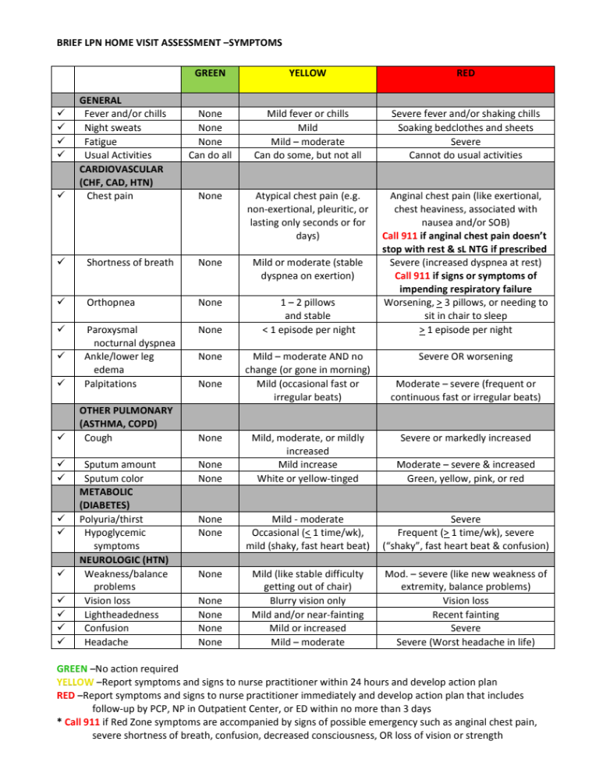
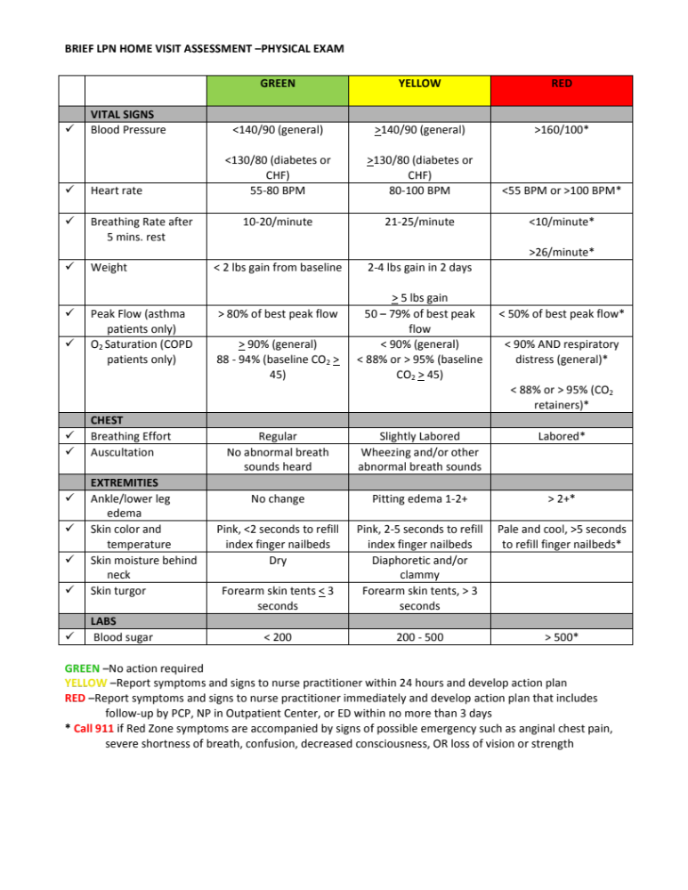
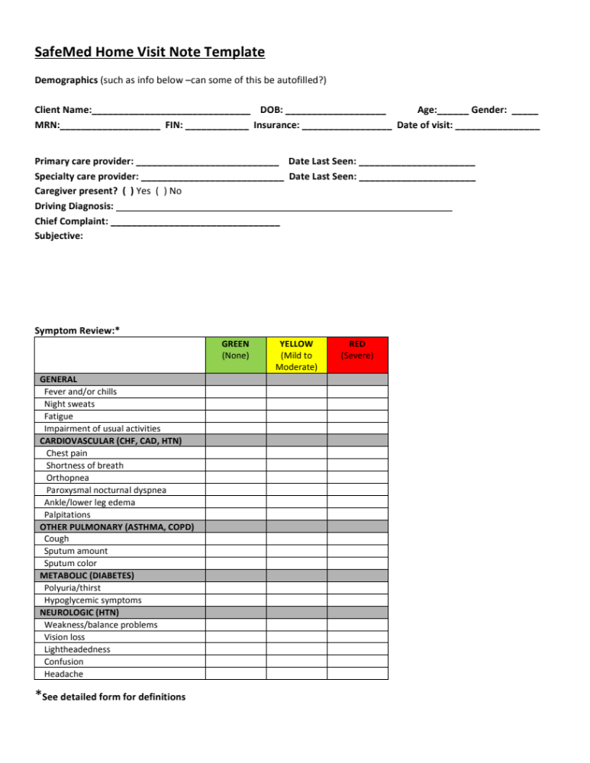
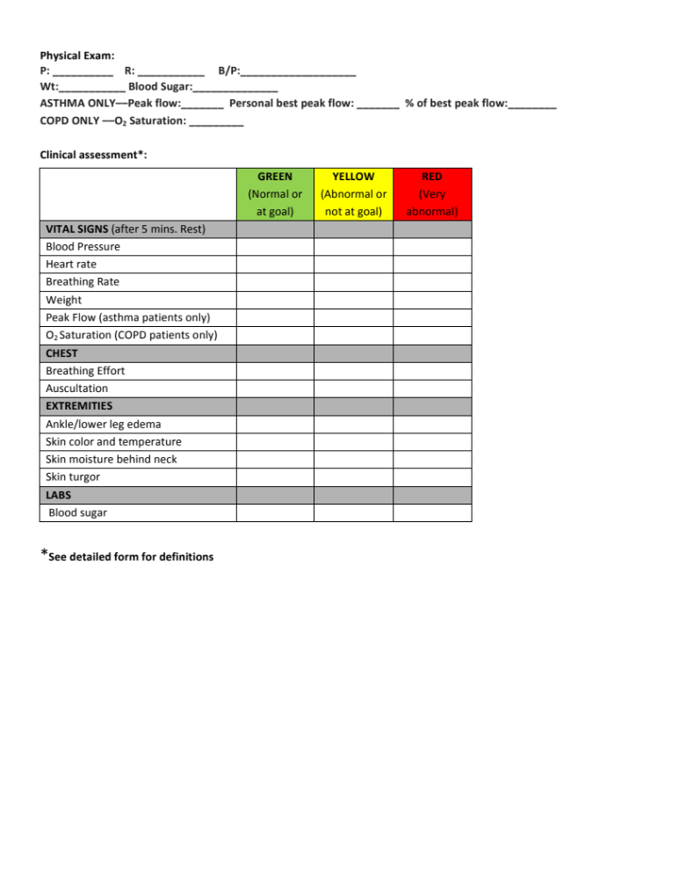
Medication Use:
Current Medications: Directions: Knows Reason (Y/N) | Missed Doses  (Y/N) | Med Working  (Y/N)
1.
2.
3.
4.
5.
6.
7.
8.
9.
10.
11.
12.
13.
14.
15.
16.
17.
18.
19.
20.

Discontinued Medications*: | Reason:
1.
2.
3.
4.
5.
6.
7.
8.
9.
10.
11.
12.
13.
* Include medications stopped by patient and those stopped by a health care provider
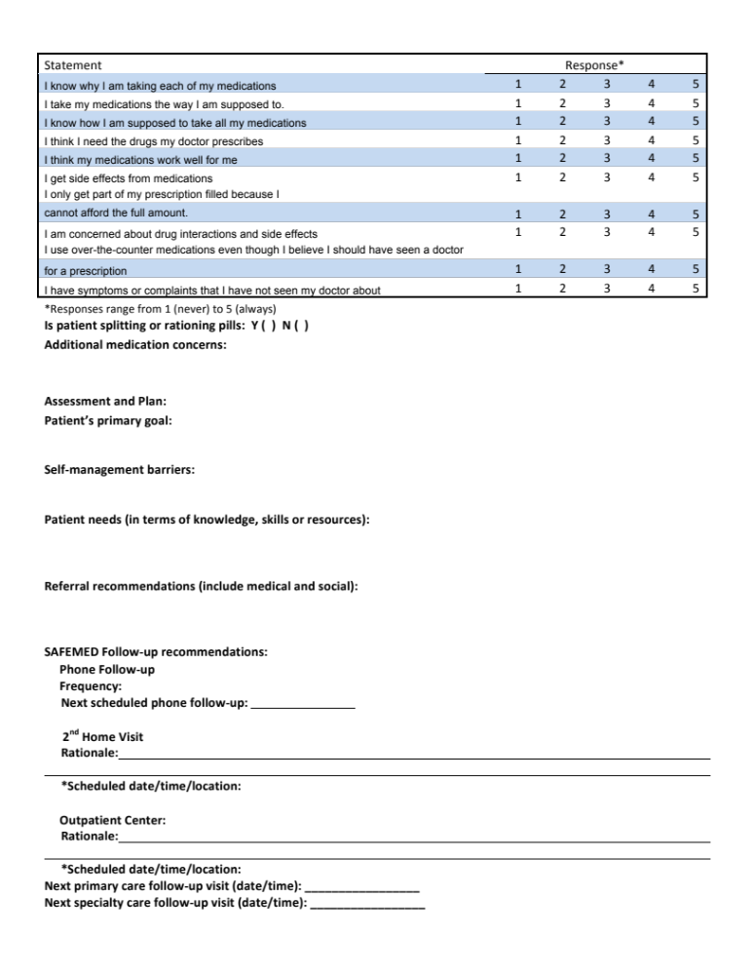
SAFEMED HOME VISIT “DOCUMENTATION OF MEDICATION USE AND SIDE EFFECTS” SCRIPT

- Med Assessment-
  - “Okay Mr./Mrs.____________, part of the value of the SAFEMED program is helping patients know more about their medications and being on the look-out for any possible opportunities to improve their medication regimen. ---I’m going to spend about 15 minutes with you going over your medications. ---I will be giving all of this information so that she can address any issues that come up. It is important that you know that State Law does not allow me to answer any medication related questions unless it has already been reviewed with you by the Community Health Pharmacist. ---But don’t worry if you have more questions or concerns, the SAFEMED Community Health Pharmacists Dr. Jones or Dr. Keough are available to answer any questions or concerns you might have about any of your medications. ----I will just give one of them a call at the end of our visit today so they can talk with you.”
- Go through Current Med List
  - “Okay, first I am going to go through the list of medications you are currently taking and ask you a few questions about each of them.”
  - Medication questions:
    - “Your first/next medication is __________, do you remember how you take that medication?”
      - If they state the correct directions- say That’s great
      - If they don’t know – say that’s okay, the directions are ___________
      - If they state the directions incorrectly, say – the directions here say__________, did the doctor tell you take the medication differently?
        - If they say yes- “Okay, I’ll make a note of those different directions on my sheet here”
        - If they say no, ask them -what caused you to start taking it differently (and write down what they say)
    - “And what do you take the ___med name___ for?”
    - “How many doses have you missed since you got out of the hospital?”
    - “Does the medication seem to be working for you?”
  - Go back to b.i. and repeat until you have asked about all of their medications
- “Have you had any changes in symptoms or any side effects since starting the new medications you got prescriptions for when you were discharged from the hospital?”(Q #4)
- “Are you currently using any over-the-counter medications and/or herbal supplements.”
SAFEMED HOME VISIT DRUG DISPOSAL SCRIPT
- “Mr./Mrs. __________, one of the services that is included in the SAFEMED Program is assistance with Drug Disposal. We know that it is dangerous to have expired or unused medications in the house. ---You or someone might take an old medication that causes a drug interaction with another medication; it might cause more severe side effects, and might even cause an accidental poisoning in the home. ---But we also know that it isn’t safe to just throw all of your unused or expired medications into the toilet or down the sink, unless the label on the bottle says it is okay to do so. ---Fortunately, there is a way to dispose of medications safely and easily. ----Let’s take a quick look at your medications.”

- Using the current discharge medication list, assist the patient/caregiver in separating current medications from the old or expired medications.

- “It looks like you have some/several medications that you no longer use or are expired. Would you like us to assist you with disposing of these medications?”

  - If the patient provides permission – “Okay, I think you will find this to be a really easy and safe way to dispose of your medications. ---What we need is a zip-lock bag, some dishwashing detergent or some coffee grounds, and some water.--- With you watching, we will open each of your medicine bottles/liquid containers, count the number of pills/estimate the amount of liquid, pour the counted pills back in the original bottle and then you can pour them into the zip-lock bag. You can also dispose of old insulin by drawing all of the insulin into a needle and squirting it into the zip-lock bag and then throw the empty insulin bottle in the trash. then we add a little dishwashing liquid and some water and zip up the bag (do so) --mix it all up, let it sit for a while then you can throw it in your trash. ----The liquids help to turn the medicines into a messy substance and keeps someone from just picking the tablets out of the bag. ---If you don’t have zip-lock bags, you can use an old coffee can. You can also get rid of old inhalers by simply throwing them in the trash.-- It’s just that easy.”
    - “Please sign here acknowledging you agreed to the drug disposal by the SafeMed staff in your residence.” (have patient sign the drug disposal document and make sure both SafeMed staff sign it then too)

  - If patient doesn’t provide consent—“That’s fine. We understand. Basically all you need to do is get a zip-lock bag, some dishwashing detergent or some coffee grounds, and some water.--- You just open all of your medicine bottles and dump them in the bag, and you can draw up all of your old insulin in a syringe and squirt it into the zip-lock bag too. ---then you add a little dishwashing liquid and some water and zip up the bag --then just shake it all up and let it sit for a while then throw it in the trash. ----The liquids help to turn the medicines into a messy substance and keeps someone from just picking the tablets out of the bag. ---If you don’t have zip-lock bags, you can use an old coffee can. -- It’s just that easy.---
And one other thing we can do to help you out is to mark all of your unused and expired meds with a red marker. That way it will make it easier for you to know which ones you should get rid of. Is it okay if we do that? It should only take a minute.”

    - If patient agrees:
      - Gather expired meds or old meds in a bag and mark for disposal and provide a patient flyer on how to dispose of meds.
      - Under no circumstances should the outreach staff leave with any medications, particularly narcotic prescriptions, from the home.

- Emphasize the importance of checking with the pharmacist or provider before using any medications not on the current medication list.

SafeMed Program: Methodist Le Bonheur Healthcare
Record of In-Home Medication Disposal
The following amount(s) of medication (Prescription, OTC, and/or Herbal) are being disposed of at the patient’s request in their residence with this form:
Medication Disposed | Dispensing Pharmacy | RX Number or Lot Number | Quantity

Method of disposal: ____________________________ (example: mixed with used coffee grounds or liquid soap and water)
Disposed by: _________________________________, SafeMed Outreach Worker

Witnessed by: ________________________________, SafeMed Outreach Worker

The signature below represents the authorization of medication disposal by SafeMed Program associates in my residence.
SafeMed Patient or Caregiver: ____________________________________ Date:_____________
SAFEMED HOME VISIT “MEDICATION ADHERENCE MONITORING” SCRIPT

CPhT- “One of the other benefits of the SAFEMED Program is a weekly pillbox.---“Do you already use a pillbox?”
  - If they say YES: “That’s great, I hope you continue to use it.”
  - If they say NO: The pharmacy technician may supply the patient with a pillbox, if not already done by the CHP in the hospital, and reinforce with the patient/caregiver how to fill the pillbox with medications on the current medication schedule as described above with the candy pillbox and candy patient friendly medication list. The CHP performed the initial pillbox education while hospitalized.
“Filling a pillbox is quite easy and it is even easier if you use your SAFEMED Program Medication List. The pill box has four compartments for each day. That way you can use the pillbox even if you take a medication 4 times a day. If you look here, you will see that the top compartment is for you’re the medications you take in the morning, so if we look at your SAFEMED Program Medication List you’ll see that these are the medications you take in the morning. So we just look at how many of each medication you will be taking and put those in the first compartment for each of the 7 days. As you fill your pillbox, I will show you how to fill an example pillbox using candy and a medication list similar to yours. Per TN state law, I am not allowed to fill your pillbox.”
**(continue the same way, for the noon, evening, and bedtime compartments when needed)

SAFEMED HOME VISIT CLOSING SCRIPT

CLOSING SCRIPT (if Pharmacist or Nurse Practitioner need to be called.)
LPN-“We have completed everything we need to for this visit, but before we go we are going to call the Community Health Pharmacist/Nurse Practitioner so she can answer your questions.
Make call, and when they answer say: “This is _________ and we just completed our visit with Mr./Mrs.______ and he/she has some questions for you. (hand patient the phone)
After phone call is complete say: “Thanks again for being a part of the SAFEMED Program. We really enjoyed visiting with you today and we hope you found our visit to be helpful.---As a reminder, we will be calling you in a week to follow-up with you. That call should only take a few minutes. When is a good time to call you? We have your phone number as:___________________, is that still the number where we can reach you?
Date of follow-up call:______________ Time of follow-up call:____________________
Thanks again. We look forward to taking care of you during your participation in the SafeMed Program.

