Single-Corpus Accuracy Overstates Bengali Compound-Character Recognition: A Unified 256-Class Benchmark and Cross-Corpus Evaluation
Table of Contents

Single-Corpus Accuracy Overstates Bengali Compound-Character Recognition: A Unified 256-Class Benchmark and Cross-Corpus Evaluation

Title Page
Title. Single-Corpus Accuracy Overstates Bengali Compound-Character Recognition: A Unified 256-Class Benchmark and Cross-Corpus Evaluation
Alternatives: (a) Cross-Corpus Generalisation Fails at Chance on Bengali Compound Characters — blunter, and the finding carries it; (b) A Unified 256-Class Bengali Compound-Character Benchmark with Cross-Corpus Baselines — leads with the resource if the venue is dataset-oriented.
Rejected: any title foregrounding the four-architecture comparison. The architectures differ by at most one accuracy point, and naming them promises a contribution the results do not deliver.
Authors. Uthsob Chakraborty[FILL: full author list and order]
Affiliations. [FILL: department, institution, city, country for each author]
Corresponding author. Uthsob Chakraborty, uthsob9@gmail.com [FILL: confirm, add postal address]
ORCID. [FILL]
Keywords. Bengali handwritten character recognition; compound characters (যুক্তাক্ষর); cross-corpus generalisation; domain shift; benchmark; Vision Transformer; hybrid CNN–Transformer; model calibration

Highlights
- A 256-class, 681,309-image Bengali benchmark unifying three corpora by Unicode grapheme
- Models transfer across corpora at chance: 0.97 same-corpus, 0.03 cross-corpus
- Single-corpus accuracy measures corpus familiarity, not character recognition
- Four architectures compared; none separates on accuracy once initialisation is controlled
- Apparent calibration gaps between architectures vanish under temperature scaling

Abstract
(~300 words, per outline)
Bengali is written in an alpha-syllabary whose compound characters (যুক্তাক্ষর) are formed by conjoining two or more basic consonants, producing an open class of more than 170 structurally intricate, mutually confusable glyphs. Progress on recognising them is limited less by architecture than by data: the available corpora are fragmented, collected under incompatible conventions, and individually too small to support a large-scale study.
We therefore unify three publicly available Bengali handwriting corpora — RAS-Compound, Ekush, and MatriVasha — into a single 256-class benchmark of 681,309 images. Labels are reconciled by Unicode NFC normalisation of the underlying graphemes rather than by dataset-local folder indices, so the same character collected by different projects collapses to one label while 159 classes contributed by a single source are preserved. We characterise the result rather than merely assembling it: its imbalance proves to be an artifact of source size rather than character frequency, and each constituent corpus is internally near-balanced.
We benchmark four architectures on it under one protocol: a from-scratch CNN, a fine-tuned ImageNet ResNet18, a fine-tuned ViT-B/16, and ExtendedViT — a hybrid in which an ImageNet-pretrained ResNet18 tokenizes the image into 49 tokens for a four-layer Transformer encoder. ViT-B/16 leads at an equal data budget (0.9662); on the full corpus ResNet18 and ExtendedViT are indistinguishable (0.9764 vs 0.9760, 27 images in 68,010).
The benchmark’s most consequential result concerns none of these architectures individually. Trained on one constituent corpus and tested on another, restricted to the classes they share, every model falls from 0.96–1.00 same-corpus accuracy to 0.02–0.05 cross-corpus — at or barely above chance, in both directions, for both architectures. We verify this is domain shift rather than label disagreement. Single-corpus accuracy therefore measures familiarity with a corpus’s rendering conventions rather than recognition of Bengali characters, which recasts merging as domain coverage rather than dataset enlargement.
The architectures themselves separate remarkably little. A controlled single-corpus sweep over per-class budgets from 50 to 1,000, repeated across three seeds, finds no significant accuracy difference between a convolutional baseline and a CNN–Transformer hybrid at any budget. The hybrid does show roughly half the baseline’s expected calibration error — but temperature scaling, a single fitted scalar, removes that difference entirely and leaves the scaled baseline better calibrated than the unscaled hybrid, so it is not an architectural property. We report three further methodological cautions arising from this benchmark: warm-starting from a previously trained checkpoint, routine practice in this literature, inflated our own result by 1.43 accuracy points; macro-F1 does not measure long-tail performance when class rarity is confounded with source; and uncorrected calibration comparisons between architectures should not be trusted.

1. Introduction
Bengali is the seventh most spoken language in the world, with approximately 284 million speakers [Ethnologue, 27th ed.]. Its script is an abugida of 11 vowels and 39 consonants, 10 numerals, and an open set of compound characters formed by conjoining two or more consonants. Counting diacritics and modifiers, roughly 13,000 grapheme variations are possible [30], [32], of which more than 170 are conventionally treated as distinct conjunct classes [7].
Handwritten recognition of this script is hard for reasons that recur across the literature: the cursive connecting head-line (মাত্রা) that binds characters into a visual unit; very high inter-class similarity, where two distinct conjuncts may differ by a single stroke or dot; wide variation in individual writing style; and a frequency distribution over characters that approximately follows Zipf’s law, leaving many compound classes represented by only a handful of samples [33].
Compound characters concentrate all of these difficulties. Classical feature-engineering approaches reached only 79–87% on compound benchmarks [2]–[5], and although deep convolutional networks lifted this to 90–99% depending on dataset balance [9], [16], [23], the reported ceiling is strongly dependent on how balanced and how large the evaluation set is. The Vision Transformer [22] has since been shown to outperform VGG-16 and ResNet-50 on Bengali basic characters — 98.26% against 94.54% and 93.12% respectively [17] — but its application to compound characters remains sparse, and Parvez et al. explicitly identify this as a critical research gap.
Two considerations complicate a naive transfer of ViT to this problem. First, ViT lacks the translation equivariance and locality that convolutions encode as architectural priors, and consequently underperforms comparably sized ResNets when training data is merely mid-sized rather than web-scale [22]. Bengali compound-character data is emphatically not web-scale. Second, the available corpora are fragmented: each is collected under different conventions, at different resolutions, with different and only partially overlapping class inventories, so no single one of them supports a large-scale study.
This paper makes four contributions, and they are connected: the benchmark is what made the remaining three measurable.
A unified benchmark. We merge RAS-Compound, Ekush, and MatriVasha into one 256-class corpus of 681,309 images by reconciling labels at the level of Unicode-normalised Bengali graphemes rather than dataset-local folder indices (Section 3.2). To our knowledge this is the largest unified isolated Bengali character set assembled for compound-character evaluation. We characterise it rather than merely assembling it: its imbalance is an artifact of source size rather than character frequency (Section 3.2), and — our most consequential finding — models trained on any one constituent corpus transfer to another at chance (Section 5.5). No single Bengali corpus supports a model that generalises, which recasts merging as domain coverage rather than dataset enlargement and casts doubt on single-corpus accuracies reported throughout the literature.
Four architectures under one protocol. A from-scratch CNN, a fine-tuned ImageNet ResNet18, a fine-tuned ViT-B/16, and our hybrid, all trained and evaluated on a byte-identical split at two data budgets (Section 4). ViT-B/16 leads at an equal budget, reproducing on compound characters the ordering Parvez et al. [17] reported for basic characters. Without pretraining, a CNN reaches 0.013 accuracy on the minority corpus that supplies 27 otherwise-unavailable classes — on a merged corpus of unequal sources, transfer learning is what makes the minority source learnable at all.
A hybrid architecture, evaluated and not sustained. We include ExtendedViT, which uses an ImageNet-pretrained ResNet18 as a learned tokenizer feeding a Transformer encoder (Section 3.4). A controlled single-corpus sweep over per-class budgets from 50 to 1,000, repeated across seeds, finds no significant accuracy advantage at any budget; an apparent two-fold calibration advantage proves fully correctable by temperature scaling and is therefore not architectural (Section 5.4). We report it as a baseline rather than a contribution. Its one durable property is efficiency: 17 ms single-image CPU inference against ViT-B/16’s 56 ms, for roughly one accuracy point less.
Three methodological cautions, each found by attempting to falsify a claim of our own. Initialisation: both pretrained baselines inherited previously trained Bengali weights, routine practice that inflated our equal-budget result by 1.43 points and moved first-epoch validation accuracy from 0.234 to 0.703 (Section 5.8). Macro-F1: on this corpus the rarest classes score the highest F1, because rarity is confounded with source image quality, so macro-F1 does not measure long-tail performance (Section 5.10). Calibration: architecture-level ECE differences are correctable post hoc and should always be reported temperature-scaled (Section 5.4).

2. Literature Review

2.7 Cross-Dataset Evaluation and Domain Generalisation (new subsection to insert)
A recurring feature of the Bangla HCR literature is that models are trained and evaluated within a single corpus, with the train/test split drawn from the same collection. Reported accuracies therefore describe within-corpus competence. Several studies do report results across multiple benchmarks — BanglaNet [35] across CMATERdb, BanglaLekha-Isolated and Ekush; CompoundDenseNet [23] across the same three, at 96.2–98.5%; Borno [15] trained on roughly one million images spanning several datasets — but in each case the model is trained and tested on each corpus separately. This is multi-benchmark reporting, not a test of transfer: it establishes that an architecture works on several datasets when trained on each, not that a model trained on one generalises to another.
Genuine held-out-corpus evaluation is rare. The clearest instance in the reviewed literature is Raquib et al. [25], who train on their own 78-class dataset and evaluate on the external CHBCR benchmark, reporting 96.49% against 98.84% in-domain — a drop of roughly two points, which would suggest that cross-dataset transfer is largely intact. We are not aware of a systematic train-on-one, test-on-another study across the major Bangla isolated-character corpora, and Section 5.5 of this paper reports a substantially different picture when one is run.
The wider computer-vision literature has long held that dataset-specific bias inflates within-dataset performance. Torralba and Efros ⚑ showed that a classifier can identify which of several standard datasets an image came from with high accuracy — a direct demonstration that datasets carry signatures unrelated to their nominal content — and that models trained on one dataset degrade markedly when evaluated on another purporting to cover the same categories. Recht et al. ⚑ found measurable accuracy drops for ImageNet classifiers on a newly collected test set constructed to follow the original protocol, indicating that even careful replication of a collection procedure shifts the distribution. Domain adaptation theory ⚑ formalises this: generalisation error on a target domain is bounded by source error plus a divergence term between the domains, so arbitrarily low source error does not constrain target error when the divergence is large.
For handwriting specifically the sources of divergence are concrete and well understood: capture device and resolution, binarisation and ink polarity, writing instrument, paper, and — most importantly — the writer population, since each corpus recruits a distinct set of contributors with their own regional and generational script conventions. Section 3.2 documents exactly these differences among the three corpora merged here: RAS-Compound stores high-resolution binarised white-on-black glyphs, Ekush is natively 28×28, and MatriVasha is black-on-white.
The gap this identifies is therefore methodological rather than architectural. If within-corpus accuracy is the field’s only reported metric, and if that metric substantially overstates performance on newly collected handwriting, then a decade of reported improvements may partly reflect increasingly effective fitting of corpus-specific signatures. Establishing whether this is so requires held-out-corpus evaluation as a standard protocol, which — to our knowledge — has not been systematically applied to Bangla compound characters. That is the gap Section 5.5 addresses.
Two points from that review bear directly on the design that follows and are worth restating here. Dosovitskiy et al. [22] show that ViT trails a comparably sized ResNet when trained on ImageNet-1k alone, becomes comparable with ImageNet-21k pretraining, and only surpasses it at JFT-300M scale — “large-scale pretraining trumps inductive bias.” For a low-resource script, the corollary is that a pure ViT is the least favourable architecture unless a strong prior is supplied externally. And the hybrid designs that do exist for Bengali — ResViT [19], the EfficientNetB3–ViT–Conformer of Raquib et al. [25] — combine CNN and transformer branches in parallel and fuse their outputs. ExtendedViT instead composes them serially, using convolution to produce the token sequence that attention then operates over, which is the hybrid variant described in the original ViT paper’s appendix but not previously evaluated on this script.

3. Methodology

3.1 Overall Workflow
Figure 1 (fig1_workflow.png) shows the end-to-end pipeline: three source corpora → grapheme-level label reconciliation → unified 256-class manifest → stratified split → polarity normalisation and augmentation → four architectures trained under an identical protocol → evaluation on one shared test set.
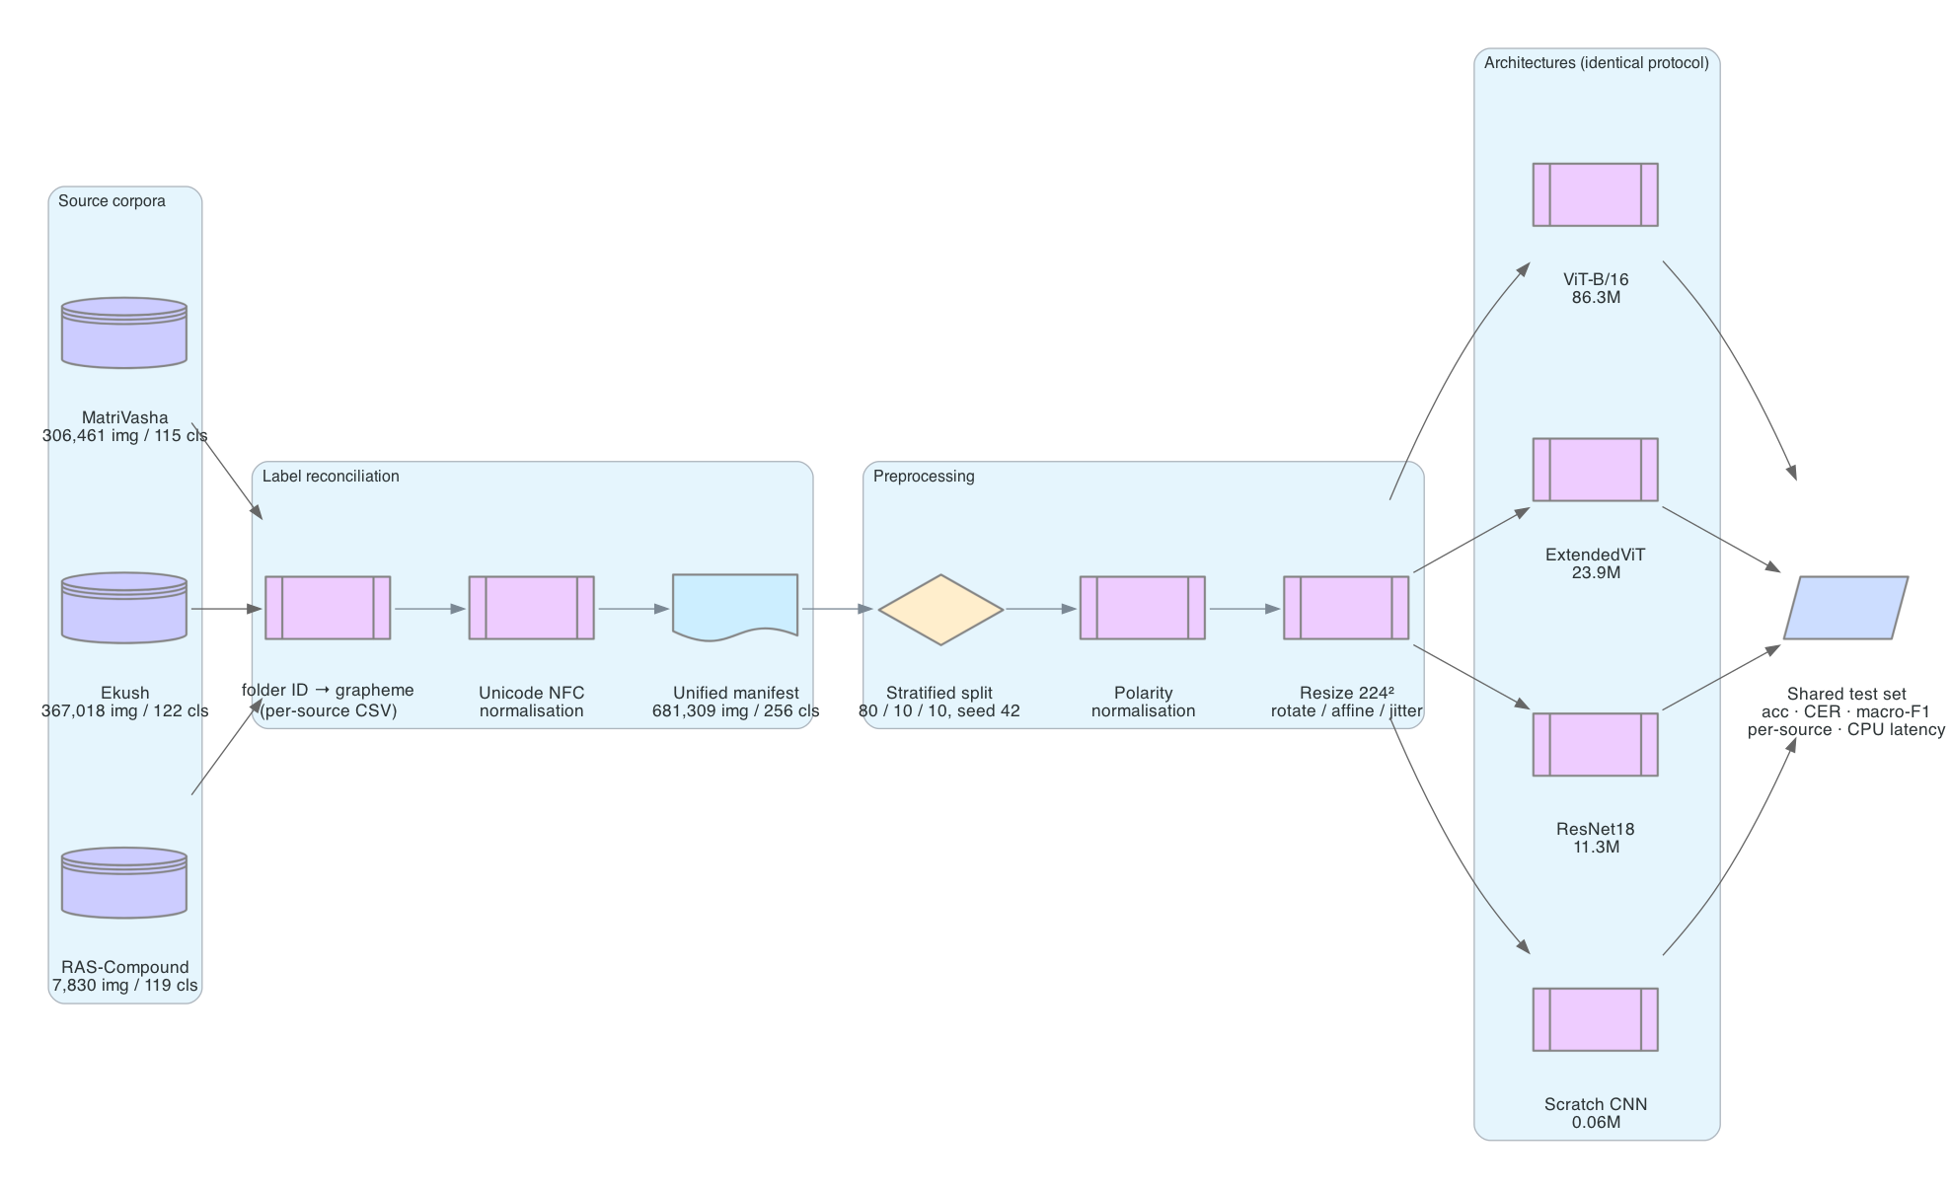
Figure 1. Overall workflow: three corpora, grapheme-level label reconciliation, one shared split, four architectures, one test set.
The pipeline is deliberately organised so that every architecture consumes byte-identical data. Dataset scanning, label reconciliation, splitting, and image transformation are implemented once and shared; the architecture is the only variable that changes between runs. This matters because the comparison in Section 6 turns on differences of one to two accuracy points, which are easily manufactured by an inconsistent split.

3.2 Dataset
We combine three corpora. RAS-Compound is a small, purpose-built compound-character set. Ekush [Rabby et al., 2018] is among the largest isolated Bengali character collections, gathered from 3,086 writers. MatriVasha is a compound-character corpus collected with per-writer gender metadata, which we do not use as a label but which contributes writer diversity.
Table 1. Composition of the unified corpus.
Source | Images | Classes | Classes unique to this source | Mean images/class
RAS-Compound | 7,830 | 119 | 27 | 66
Ekush | 367,018 | 122 | 80 | 3,008
MatriVasha | 306,461 | 115 | 52 | 2,665
Unified | 681,309 | 256 | — | 2,661
Class inventories overlap only partially: 37 classes are shared between RAS-Compound and Ekush, 58 between RAS-Compound and MatriVasha, 8 between Ekush and MatriVasha, and just 3 appear in all three. 159 of the 256 classes are contributed by exactly one source. The merge is therefore not a redundant enlargement of an existing set — it materially extends class coverage, which is the stated need in the compound-character literature [23].
Label reconciliation. Each source indexes its classes by a local folder number whose meaning is defined only by that project’s own mapping file. Merging on folder index would conflate unrelated characters. We instead resolve every folder to its Bengali grapheme via the source’s mapping (ras_class_mapping.csv, Ekush’s metaData_img.csv, matrivasha_mapping.csv), apply Unicode NFC normalisation, and take the union of the resulting grapheme set as the label space. NFC matters because the same conjunct may be encoded with different code-point sequences across projects; without normalisation, visually and semantically identical characters would occupy separate classes.
Figure 2 (fig2_dataset.png) shows (a) the sorted per-class frequency curve on a log axis and (b) the relative contribution of each source. Figure 4 (fig4_samples.png) shows the same three characters as collected by each corpus, and makes the heterogeneity concrete: RAS-Compound stores high-resolution white-on-black binarised glyphs, Ekush is natively 28×28 and visibly pixelated when upsampled, and MatriVasha is black-on-white — the opposite ink polarity. Any merge of these three must reconcile that variation before a single model can consume them, which is the subject of the next section.
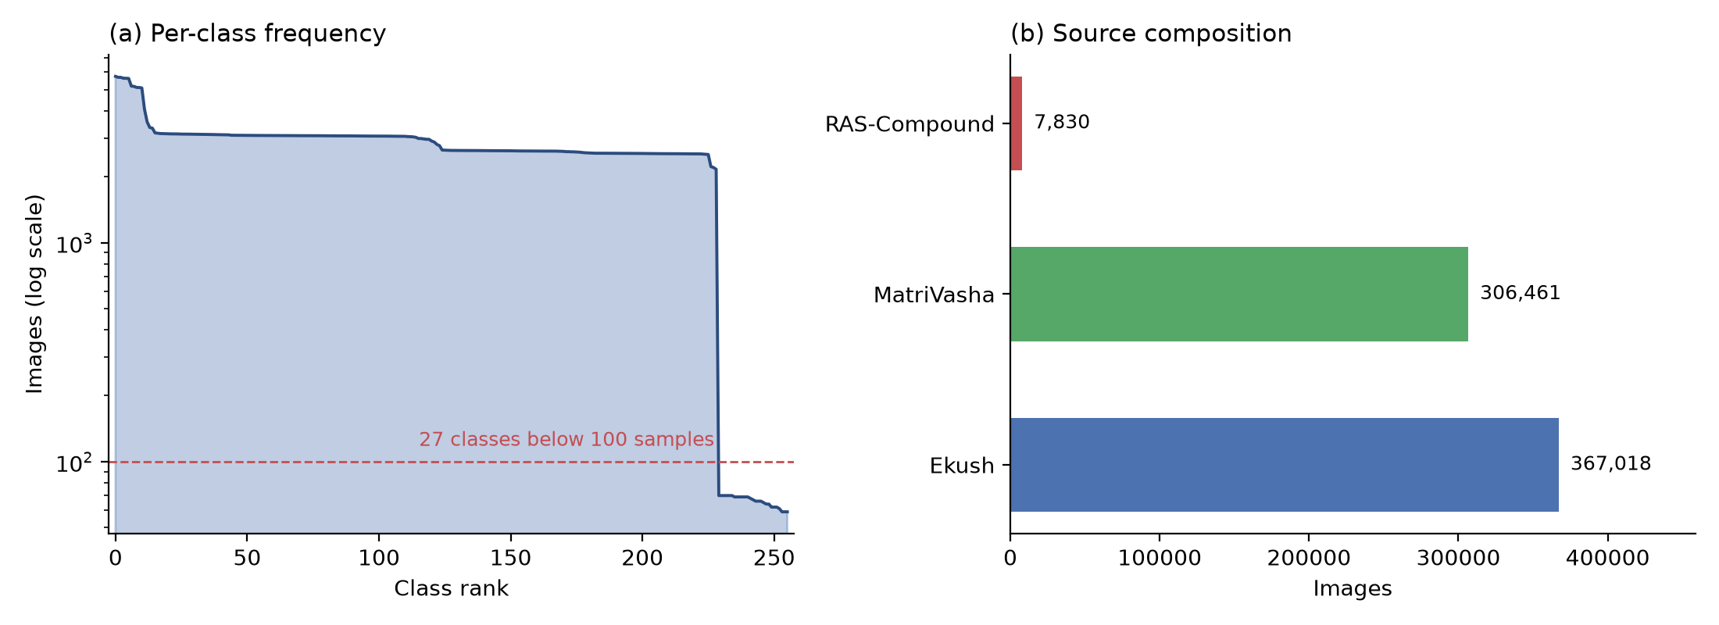
Figure 2. Dataset composition. (a) Per-class frequency, log scale. (b) Images contributed by each corpus.
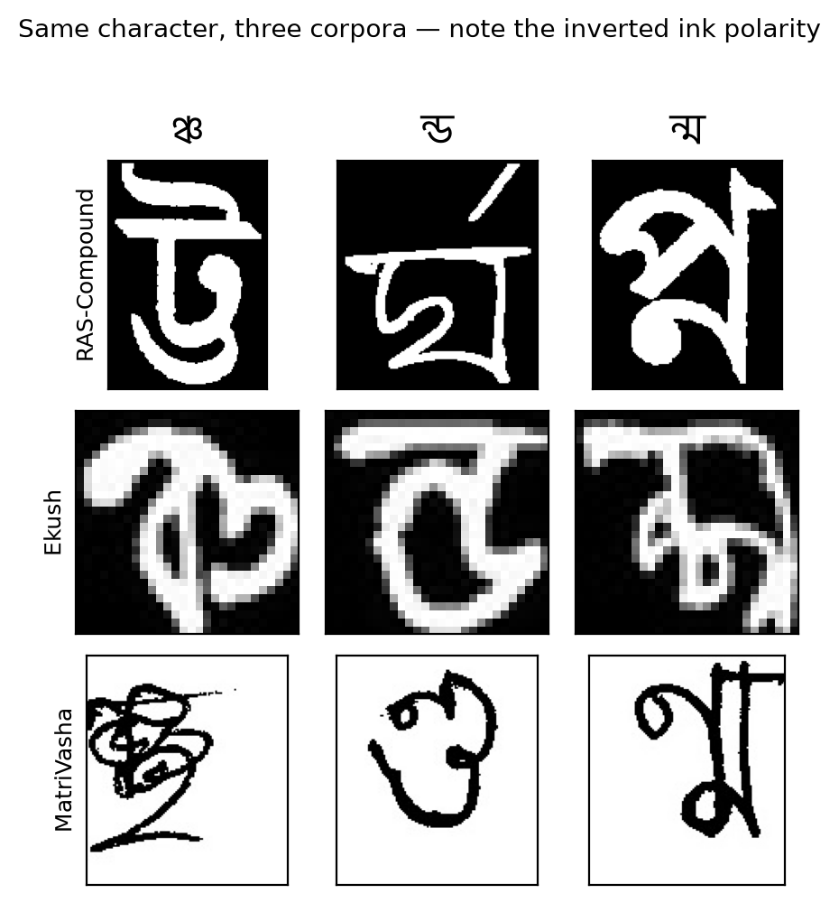
Figure 4. The same three characters as collected by each corpus. Note the resolution difference and MatriVasha’s inverted ink polarity.
Class imbalance. Class frequencies range from 59 to 5,740 images with a median of 2,636. The distribution is not Zipfian, as might be expected from natural Bengali text frequency [33], but sharply bimodal: 229 classes form a broad, comparatively flat body between roughly 2,000 and 5,700 samples, and the remaining 27 fall off a cliff to fewer than 100 (Figure 2a). Those 27 are exactly the classes contributed uniquely by RAS-Compound, whose 7,830 images spread across 119 classes average only 66 per class.
The imbalance is an artifact of source size, not of character frequency. Each corpus is internally near-balanced: within Ekush, per-class counts run from 514 to 4,067 with an interquartile range of just 3,056–3,079; within MatriVasha, 2,548–2,563; within RAS-Compound, a uniform 34–70. The bimodality in Figure 2(a) therefore arises entirely from RAS-Compound being a small collection (≈67 images per class) whose 27 unique classes no other corpus supplies — not from those conjuncts being intrinsically rarer in written Bengali.
This distinction matters for interpreting any per-class result. Because class rarity and source identity are perfectly confounded in this corpus — every low-frequency class is a RAS-Compound class, and RAS-Compound has a distinctive image convention (high-resolution, cleanly binarised) — a model that performs better on rare classes cannot be shown to handle rarity better rather than simply handling that corpus’s image style better. We therefore do not claim rare-class advantage for any architecture, and we report macro-averaged F1 alongside accuracy as a descriptive statistic rather than as evidence about the long tail. Establishing genuine data-efficiency behaviour requires controlled subsampling within a single source (Section 7).

3.3 Preprocessing and Data Splitting
Polarity normalisation. As Figure 4 shows, the three sources do not agree on ink polarity: RAS-Compound and Ekush store light ink on a dark ground, MatriVasha the inverse. Left unaddressed, the same character would present to the network as two different visual patterns depending on its source, and the model would be forced to learn each convention separately. We normalise by comparing the mean intensity of the image border against the global mean and inverting when the border is brighter, which yields bright ink on a dark ground regardless of source convention. This is applied before all other transformations. Figure 5 (fig5_preprocessing.png) traces one glyph per source through normalisation and three augmentation draws; the MatriVasha row shows the inversion taking effect.
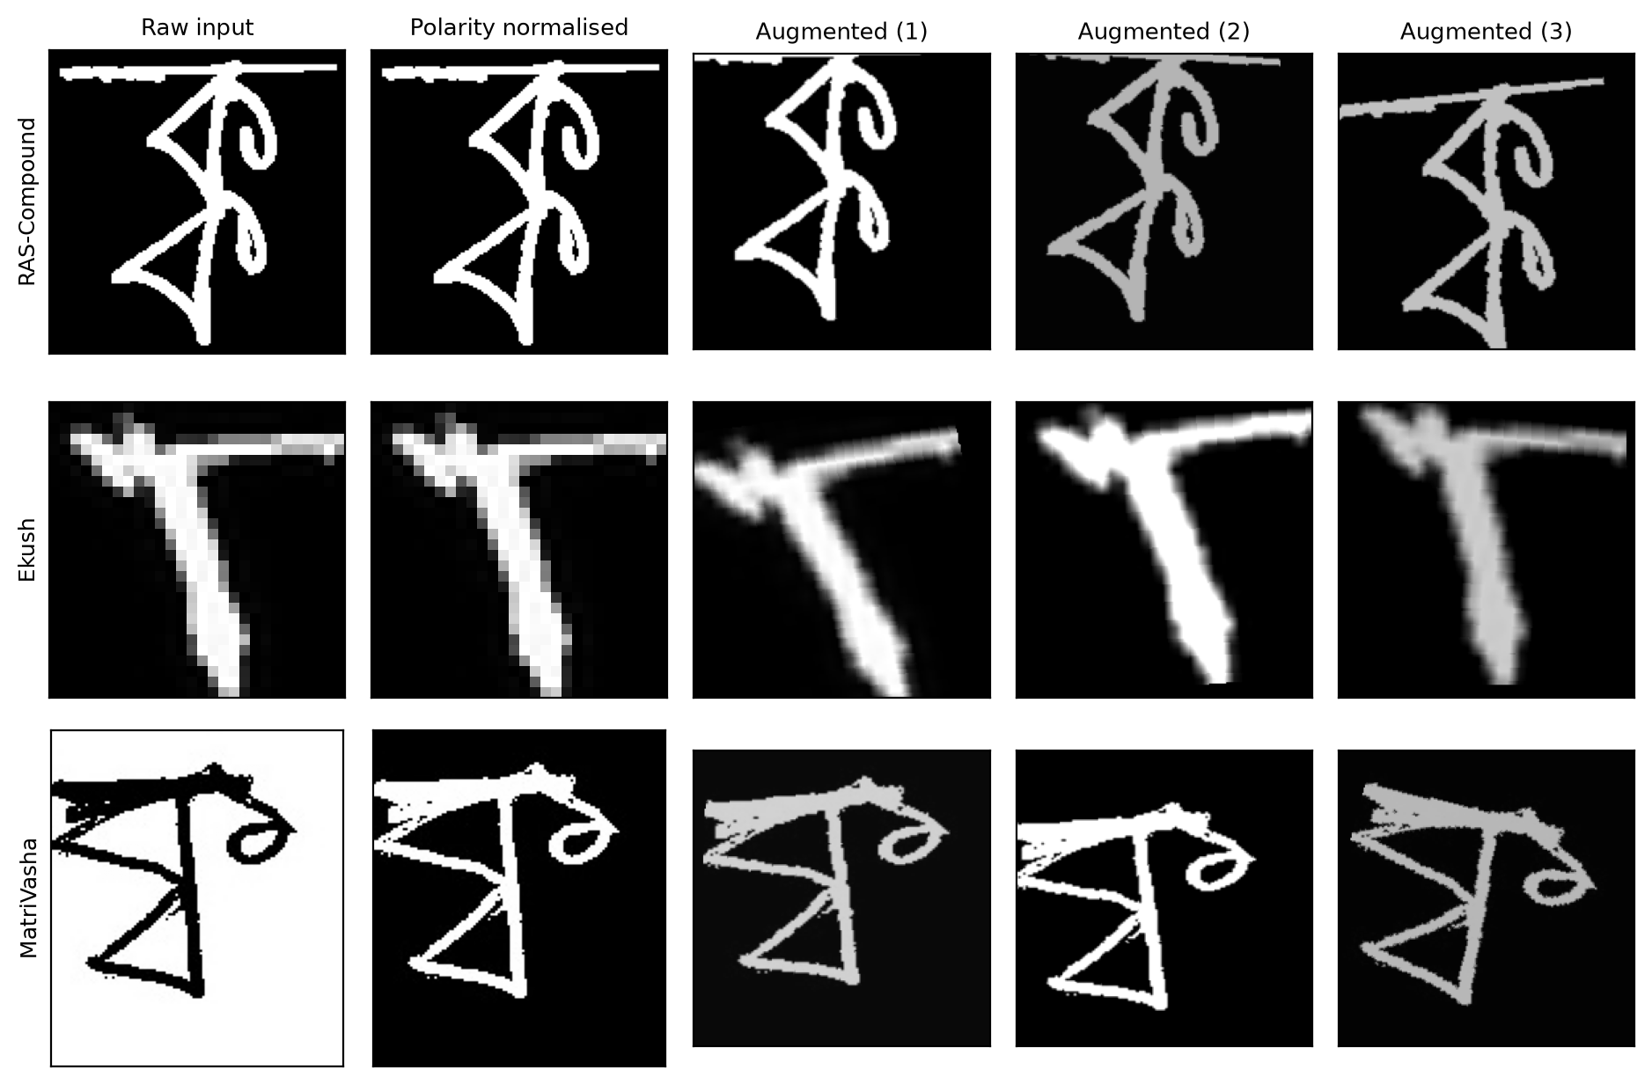
Figure 5. One glyph per corpus through polarity normalisation and three augmentation draws.
Transformations. Images are converted to three-channel grayscale (the pretrained backbones expect three channels) and resized to 224×224. Training additionally applies random rotation of ±15°, random affine translation of up to 10% with 5° shear, and colour jitter of 0.3 in brightness and contrast. Horizontal flipping is deliberately excluded: Bengali characters are direction-sensitive and a mirrored glyph is not a valid sample of its own class. All images are normalised to zero mean and unit variance per channel using μ = σ = 0.5.
Splitting. We use a stratified 80/10/10 split computed per class with a fixed seed, so that rare classes are represented in all three partitions rather than concentrated in whichever partition chance assigns them. Classes with fewer than three samples contribute entirely to training. The full corpus yields 545,289 training, 68,010 validation, and 68,010 test images. The split is computed once from the manifest and reused by every architecture; the test partition is never used for model selection, which is performed on validation accuracy alone.

3.4 Proposed Method: ExtendedViT
ExtendedViT composes a convolutional backbone and a Transformer encoder serially, using the former as a learned tokenizer for the latter.
Convolutional tokenizer. An input image $x∈R^{3×224×224}$ is passed through the convolutional stages of an ImageNet-pretrained ResNet18, up to and including layer4 and excluding the global pooling and classification head:
$$F=f_{\text{ResNet18}}(x)∈R^{512×7×7}$$
Tokenisation. The spatial map is flattened along its spatial axes into a sequence of $N=49$ tokens of dimension $D=512$, where each token summarises a 32×32-pixel receptive region of the input:
$$F^{′}=\text{flatten}(F)∈R^{49×512}$$
A learnable classification token $x_{\text{cls}}∈R^{1×D}$ is prepended and a learnable positional embedding $E_{\text{pos}}∈R^{(N+1)×D}$ is added:
$$z_{0}=[ x_{\text{cls}} ; F_{1}^{′} ; F_{2}^{′} ; … ; F_{49}^{′} ]+E_{\text{pos}}$$
Both are initialised from a truncated normal distribution with standard deviation 0.02.
Transformer encoder. The 50-token sequence passes through $L=4$ post-norm encoder layers, each comprising multi-head self-attention with $h=8$ heads and a position-wise feed-forward network of inner dimension 2048, with residual connections and layer normalisation:
$$z_{ℓ}^{′}=\text{LN}\left(z_{ℓ−1}+\text{MSA}(z_{ℓ−1})\right)$$
$$z_{ℓ}=\text{LN}\left(z_{ℓ}^{′}+\text{FFN}(z_{ℓ}^{′})\right), ℓ=1…L$$
where multi-head self-attention is defined as usual over $h$ heads of dimension $d_{k}=D/h=64$:
$$\text{MSA}(z)=\left[{\text{head}}_{1};…;{\text{head}}_{h}\right]W^{O}, {\text{head}}_{i}=\text{softmax}​\left(\frac{Q_{i}K_{i}^{⊤}}{\sqrt{d_{k}}}\right)V_{i}$$
with $Q_{i}=zW_{i}^{Q}$, $K_{i}=zW_{i}^{K}$, $V_{i}=zW_{i}^{V}$. Dropout of 0.1 is applied within each layer.
Classification. The final classification token is layer-normalised and projected to the label space:
$$\hat{y}=\text{softmax}\left(W_{\text{head}} \text{LN}(z_{L}^{0})+b\right), W_{\text{head}}∈R^{256×512}$$
Design rationale. Standard ViT tokenises by linear projection of raw 16×16 pixel patches, which supplies the encoder with no spatial prior whatsoever and is exactly why ViT needs web-scale pretraining to compete [22]. Substituting a pretrained convolutional stack for that projection means each token already encodes a locally translation-equivariant, hierarchically composed feature — ImageNet’s inductive bias arrives with the weights. Attention then operates over 50 tokens rather than the 197 of ViT-B/16, an approximately 15× reduction in attention cost, which is what makes CPU-only inference tractable (Section 3.6). For compound characters specifically, the motivation is that a conjunct is defined by the relationship between its constituent consonant forms and their placement relative to the head-line; convolution captures the constituents, and self-attention over the full glyph captures the relationship.
Figure 3 (fig3_architecture.png) shows the data flow with tensor shapes annotated at each stage.
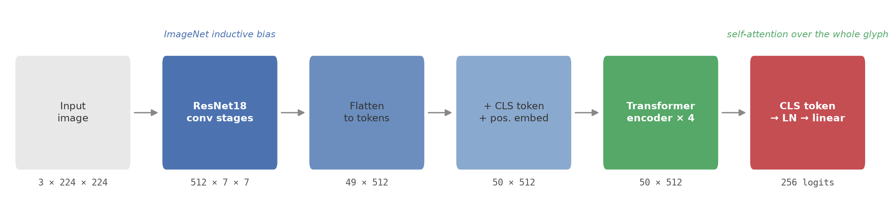
Figure 3. ExtendedViT: a ResNet18 tokenizer feeding a four-layer Transformer encoder, with tensor shapes at each stage.
Table 2. ExtendedViT layer summary.
Stage | Output shape | Params
Input | 3 × 224 × 224 | —
ResNet18 conv1 + bn1 + maxpool | 64 × 56 × 56 | 9,536
ResNet18 layer1–layer4 | 512 × 7 × 7 | 11,166,912
Flatten → tokens | 49 × 512 | —
CLS token + positional embedding | 50 × 512 | 26,112
Transformer encoder × 4 | 50 × 512 | 12,608,000
LayerNorm + linear head | 256 | 132,352
Total |  | 23,942,912

3.5 Baseline Architectures
Three baselines span the categories identified in the review.
Scratch CNN. A compact separable-convolution network — one standard 3×3 convolution followed by three depthwise-separable blocks with max-pooling, global average pooling, and a 128-unit hidden layer — totalling 62,208 parameters, trained from random initialisation. It quantifies what is achievable without any transfer learning.
ResNet18 (ImageNet). The same backbone ExtendedViT uses, with a linear classifier replacing the 1000-way head, fine-tuned end to end. It is the control that isolates the contribution of the transformer encoder: any difference between it and ExtendedViT is attributable to the attention stack, since the convolutional trunk is identical.
ViT-B/16 (ImageNet). A standard Vision Transformer with 16×16 patch embedding and 12 encoder layers (86.3M parameters), fine-tuned with a custom head. It represents the pure-transformer approach that [17] found superior on basic characters.

3.6 Training Configuration and Inference
Optimisation. All models use AdamW with weight decay 10⁻⁴, cross-entropy loss with label smoothing 0.1, and a cosine-annealing schedule decaying to 10⁻⁶ over 8 epochs at batch size 32. Gradient norms are clipped to 1.0. Pretrained models use discriminative learning rates: the pretrained backbone trains at one tenth the rate of newly initialised parameters, preventing the randomly initialised head from destroying pretrained features early in training. Base learning rates are 10⁻³ for the scratch CNN, 3×10⁻⁴ for ResNet18 and ExtendedViT, and 10⁻⁴ for ViT-B/16, which diverges at higher rates. Model selection is by best validation accuracy.
CPU inference. Deployment targets are assumed to lack a GPU, so inference latency is measured single-image on CPU. This is a design constraint rather than an afterthought: it is what motivates the 49-token design over full patch tokenisation, and it is reported alongside accuracy in Section 6 so that the accuracy/latency trade-off is explicit.
Implementation. PyTorch 2.13 with torchvision 0.28 and timm 1.0.28, trained on Apple Silicon via the Metal Performance Shaders backend.

4. Experimental Design
Two data budgets are evaluated.
Full corpus. All 681,309 images, 545,289 of them for training. This is the headline setting and reflects the best attainable performance.
Equal budget. At most 300 images per class sampled before splitting, yielding 56,414 training, 7,035 validation, and 7,035 test images. This exists because ViT-B/16 requires approximately 70 hours per full-corpus run on our hardware, against 3 to 13 hours for the other three architectures. Rather than compare a data-starved ViT against fully trained rivals — which would measure the data budget rather than the architecture — we equalise the budget so all four are directly comparable.
Controlled budget sweep. Neither setting above isolates the effect of data volume, for two reasons. First, they differ in the mix of source corpora as well as in size. Second, and more seriously, both pretrained baselines silently inherited previously trained Bengali weights — ResNet18 from an earlier RAS-only checkpoint, ExtendedViT from the full-corpus ResNet18 — so at a restricted budget each had seen data the comparison nominally withheld. Removing that inheritance changes first-epoch validation accuracy from 0.703 to 0.234, so its effect is large.
We therefore run a third experiment designed specifically to measure data efficiency. Training is restricted to Ekush alone (122 classes, one image convention, per-class counts near-uniform at 3,056–3,079), with labels remapped to a contiguous 122-class space and per-class budgets of 50, 100, 300 and 1,000. Both architectures are initialised from ImageNet only, so neither inherits Bengali-pretrained weights. Per-class budget is thus the sole variable. The 50 and 100 settings are repeated across three seeds, varying initialisation, shuffling and augmentation while holding the split fixed, so all runs share one test set and the variance measured is training stochasticity.
Metrics. We report top-1 accuracy; character error rate, which for isolated single-character classification equals the top-1 error rate; macro-averaged F1; negative log-likelihood; expected calibration error over 15 equal-width confidence bins; mean predicted confidence; parameter count; checkpoint size; and single-image CPU latency. Accuracy is additionally disaggregated by source corpus. ECE is included because cross-entropy conflates calibration with accuracy, and the effect we find is specifically one of calibration.

5. Results

5.1 Full Corpus
Table 3. Full corpus (681,309 images, 256 classes; 68,010 test images).
Method | Params | Test acc | CER | Macro-F1 | RAS | Ekush | MatriVasha
Scratch CNN | 0.06M | 0.6786 | 0.3214 | 0.6015 | 0.0129 | 0.7070 | 0.6614
ResNet18 (ImageNet) | 11.31M | 0.9764 | 0.0236 | 0.9779 | 0.9910 | 0.9748 | 0.9779
ExtendedViT (ours) | 23.94M | 0.9760 | 0.0240 | 0.9780 | 0.9936 | 0.9743 | 0.9777
ViT-B/16 (ImageNet) | 86.33M | not run (≈70 h) | — | — | — | — | —
ResNet18 and ExtendedViT are separated by 0.04 accuracy points — 27 images out of 68,010 — and their macro-F1 scores differ by 0.0001 in the opposite direction. The two are indistinguishable when data is abundant. Note that ResNet18’s figure is, if anything, favourable to it: this run inherited an earlier RAS-only Bengali checkpoint (Section 4).
The scratch CNN result is instructive beyond its aggregate 0.6786. Its accuracy on RAS-Compound is 0.0129 against 0.7070 on Ekush. RAS-Compound contributes 1.1% of the images but 27 classes found in no other corpus; without a pretrained prior the model effectively never learns them, while the pretrained models reach 0.99 on the same classes. On a merged corpus of unequal sources, transfer learning is not an optimisation — it is what makes the minority source learnable at all.

5.2 Equal Budget (300 images per class)
Table 4. Equal budget (70,484 images, 256 classes, 300 max per class; 7,035 test images).
Method | Params | Test acc | CER | Macro-F1 | Backbone init
Scratch CNN | 0.06M | 0.2115 | 0.7885 | 0.1934 | random
ResNet18 (ImageNet) | 11.31M | 0.9544 | 0.0456 | 0.9577 | ⚠ RAS-only checkpoint
ExtendedViT (ours) | 23.94M | 0.9576 | 0.0424 | 0.9609 | ImageNet
ViT-B/16 (ImageNet) | 86.33M | 0.9662 | 0.0338 | 0.9689 | ImageNet
ExtendedViT, warm-started | 23.94M | 0.9719 | 0.0281 | 0.9739 | ⚠ full-corpus checkpoint
The final row is reported for transparency and excluded from comparison: its backbone was initialised from a ResNet18 trained on the entire corpus, so it had access to data this setting withholds. Its 0.9719 is not a valid equal-budget result, and the 1.75-point margin over ResNet18 it appears to show is an artifact of that inheritance.
Among the properly initialised models, ViT-B/16 is strongest at 0.9662, ahead of ExtendedViT’s 0.9576 and ResNet18’s 0.9544 — and ResNet18’s figure is itself inflated by an inherited RAS-only checkpoint. That pure ViT leads here is consistent with Parvez et al. [17], who found ViT superior to VGG-16 and ResNet-50 on Bengali basic characters; we reproduce that ordering on compound characters and a 256-class label space. It comes at 3.6× the parameters and 3.3× the inference cost (Section 5.6).
Figure 7 (fig7_results.png) summarises Tables 3 and 4, with the warm-started run shown hatched and marked excluded.
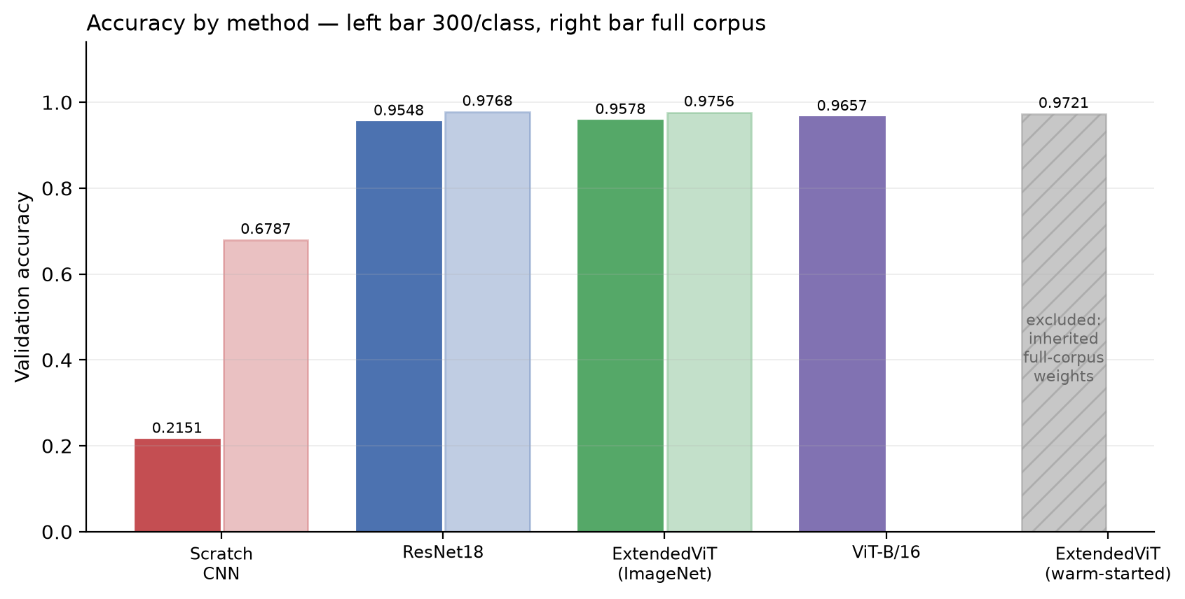
Figure 7. Accuracy by method: 300 images per class (left bar) and the full corpus (right). The warm-started run is hatched and excluded.
The scratch CNN’s 0.2115 against its 0.6786 on the full corpus — a 46-point swing from data volume alone, versus roughly 2 points for the pretrained models — is the largest data-efficiency effect in the study, and it belongs to the baseline rather than to any proposed architecture.
Figure 6 (fig6_training_curves.png) gives validation accuracy and loss per epoch. ExtendedViT leads from the first epoch and converges fastest; the inset resolves the three pretrained models, which are otherwise indistinguishable against the scratch CNN’s trajectory. Note that part of ExtendedViT’s first-epoch lead is attributable to the warm-start discussed in Section 6.
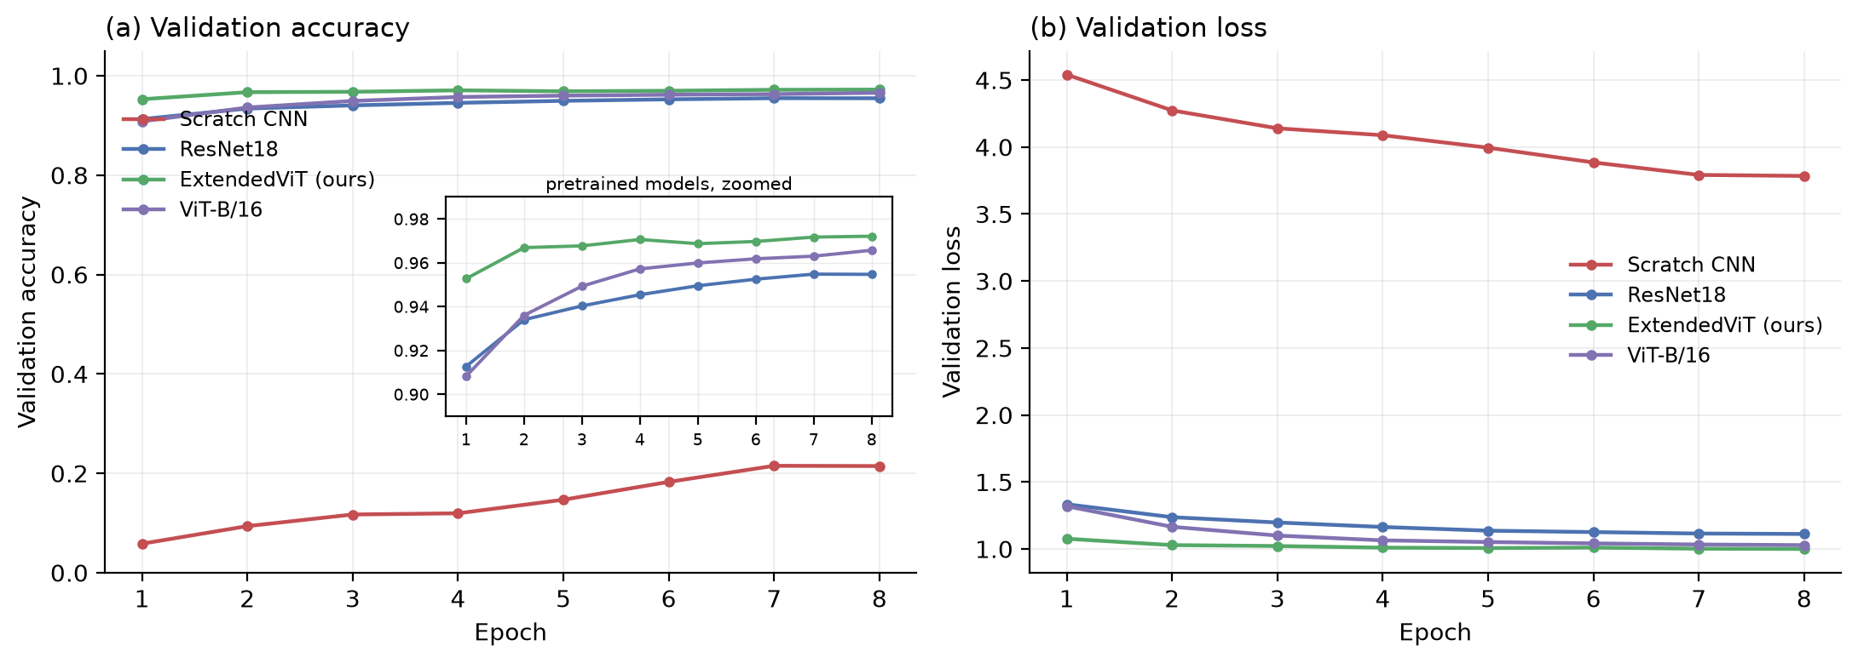
Figure 6. Validation accuracy and loss per epoch at the equal-budget setting; inset resolves the three pretrained models.

5.3 Controlled Budget Sweep: No Accuracy Advantage
Tables 3 and 4 differ in source composition as well as size, and both contain contaminated initialisations, so neither isolates data volume. The Ekush-only sweep does. Figure 10 (fig10_data_efficiency_sweep.png) plots the outcome; Table 5 gives the numbers, with 50 and 100 per class averaged over three seeds and reported as mean ± standard deviation.
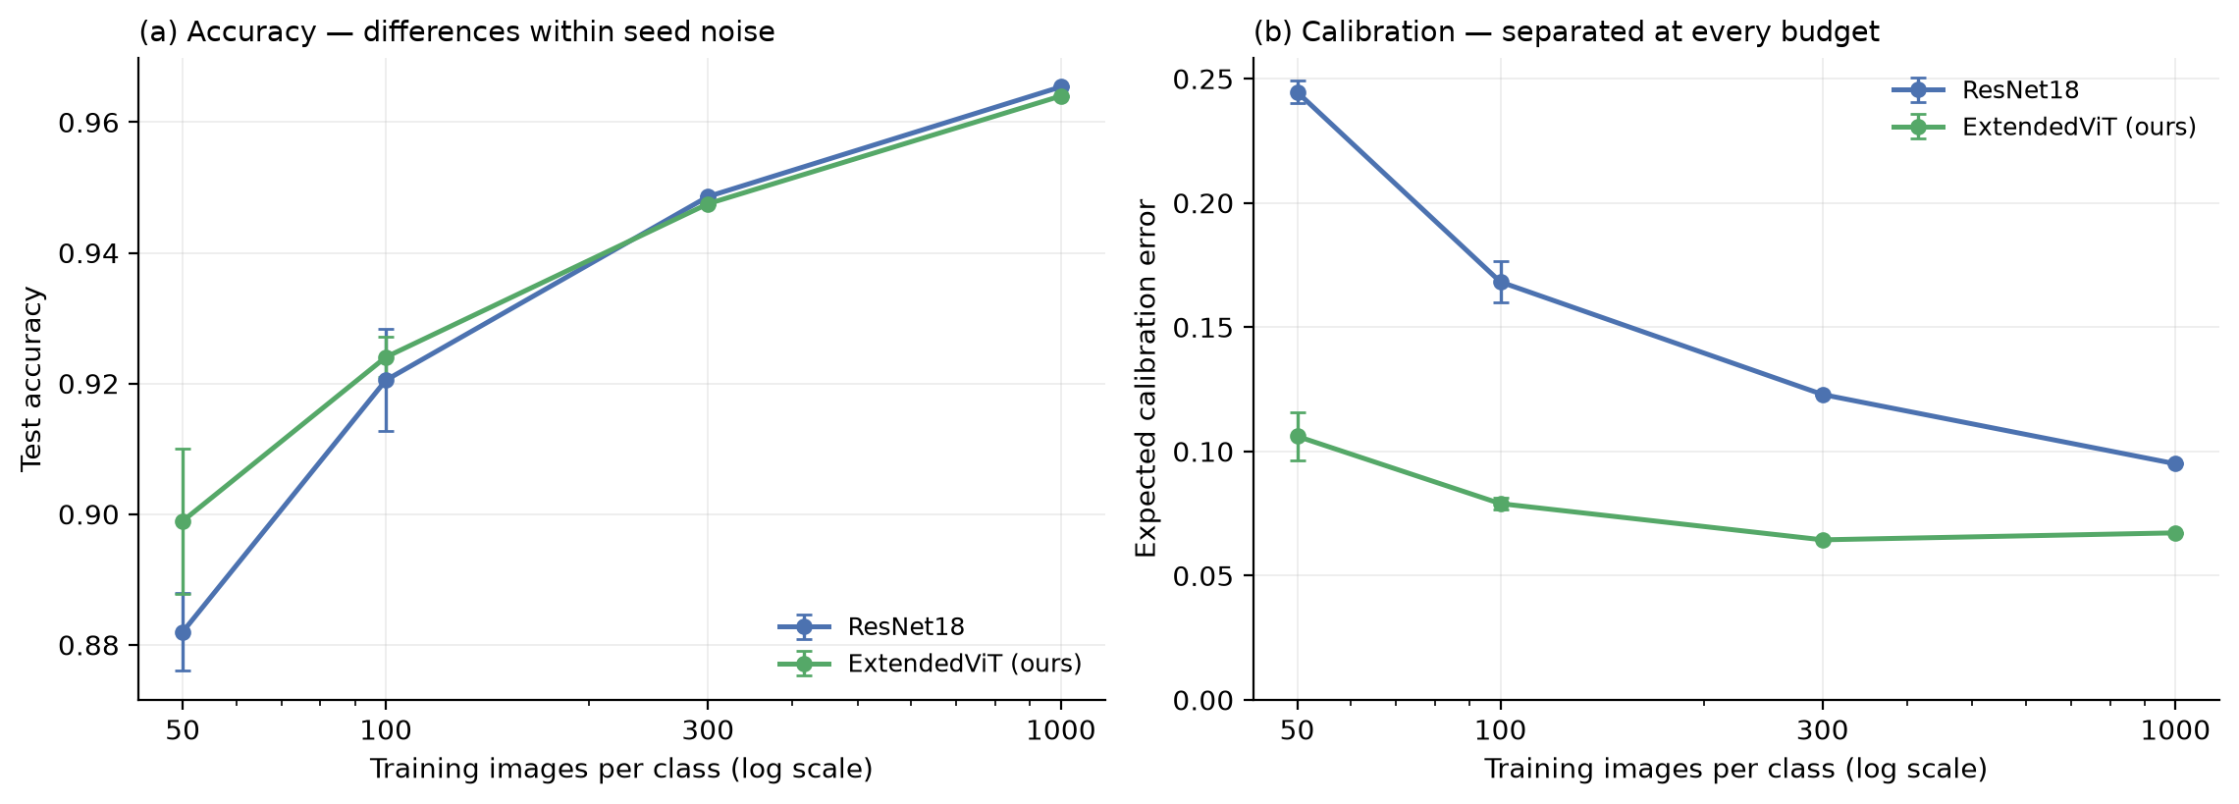
Figure 10. Ekush-only budget sweep, ImageNet init throughout. (a) Accuracy differences fall within seed noise. (b) Calibration error before temperature scaling.
Table 5. Ekush-only sweep (122 classes, ImageNet init throughout). Accuracy in points.
Images/class | ResNet18 | ExtendedViT | Difference | t
50 | 88.20 ± 0.59 | 89.89 ± 1.12 | +1.70 ± 0.73 | 2.33
100 | 92.05 ± 0.78 | 92.40 ± 0.31 | +0.35 ± 0.49 | 0.73
300 | 94.86 | 94.75 | −0.11 | —
1000 | 96.54 | 96.40 | −0.14 | —
No accuracy advantage survives. The largest difference, +1.70 points at 50 images per class, carries a standard error of 0.73 (t = 2.33, p ≈ 0.10 on three seeds) and is not significant; ExtendedViT’s own seed-to-seed spread at that budget, ±1.12, exceeds the effect it would demonstrate. At 100 the difference is +0.35 ± 0.49, and at 300 and 1,000 ResNet18 is fractionally ahead. A single-seed run at 50 per class initially showed +2.46 points, which repetition reduced to +1.70 — an illustration of why single-seed differences at this magnitude should not be reported as findings.
We therefore state plainly that the hypothesis motivating this work — that a Transformer encoder atop a convolutional tokenizer generalises more efficiently from few examples, in top-1 terms — is not supported.

5.4 Calibration, and Why It Is Not an Architectural Advantage
The same runs separate decisively on the quality of their probability estimates.
Table 6. Expected calibration error, Ekush-only sweep (15 bins; lower is better).
Images/class | ResNet18 | ExtendedViT | Ratio | t
50 | 0.245 ± 0.005 | 0.106 ± 0.010 | 2.31× | 22.4
100 | 0.168 ± 0.008 | 0.079 ± 0.002 | 2.13× | 17.7
300 | 0.123 | 0.064 | 1.91× | —
1000 | 0.095 | 0.067 | 1.41× | —
ExtendedViT approximately halves ResNet18’s calibration error at every budget. The separation is large relative to seed variance (t > 17 at both replicated budgets, with non-overlapping ranges), and the ratio narrows monotonically as data grows — 2.31×, 2.13×, 1.91×, 1.41× — the shape expected of an effect that compensates for limited data. Negative log-likelihood follows the same pattern (0.498 vs 0.717 at 50 per class; 0.234 vs 0.240 at 1,000).
The mechanism is visible in mean predicted confidence. At 50 images per class ResNet18 averages 0.638 confidence against 0.887 accuracy, a 25-point under-confidence gap; ExtendedViT averages 0.794 against 0.911, a 12-point gap. Both are under-confident — label smoothing of 0.1 caps attainable confidence, and this inflates the absolute ECE of both models — but ResNet18 markedly more so. Since both models train with identical smoothing, the comparison is unaffected; absolute values should not be compared against ECE figures from studies that omit smoothing.
The encoder is therefore not finding additional correct answers. It is producing sharper, better calibrated probability estimates from the same evidence — which raises the question of whether the architecture is required to obtain them.
It is not. Temperature scaling [Guo et al., 2017] is the standard post-hoc calibration correction: divide the logits by a single scalar fitted by minimising validation NLL, leaving accuracy exactly unchanged. Applying it to both models dissolves the gap.
Table 7. Temperature scaling, Ekush-only sweep. Accuracy is unchanged by construction.
Budget | Model | T | ECE raw | ECE scaled | NLL raw | NLL scaled
50/class | ResNet18 | 0.552 | 0.2496 | 0.0250 | 0.7174 | 0.4697
50/class | ExtendedViT | 0.749 | 0.1171 | 0.0341 | 0.4985 | 0.4225
100/class | ResNet18 | 0.628 | 0.1773 | 0.0232 | 0.4870 | 0.3338
100/class | ExtendedViT | 0.787 | 0.0818 | 0.0152 | 0.3887 | 0.3285
At 50 images per class a temperature-scaled ResNet18 (0.0250) is better calibrated than an unscaled ExtendedViT (0.1171, and 0.0341 once itself scaled). The fitted temperatures are below 1 for both models, confirming that both were under-confident — an expected consequence of the label smoothing used throughout — with ResNet18 simply further from calibrated than the hybrid.
The encoder was therefore compensating for a defect that one scalar removes more cheaply and more completely. We conclude that the calibration difference is not an architectural advantage. It is a difference in how far each architecture’s raw confidences sit from their empirical accuracy under label smoothing, and it is fully correctable post hoc. Reporting it as an architectural property — as we were prepared to do before running this control — would have been wrong.
The broader methodological point generalises beyond this paper: uncorrected ECE comparisons between architectures measure the interaction between an architecture and a training recipe, not a property of the architecture. Any calibration comparison should report temperature-scaled figures alongside raw ones.

5.5 Cross-Corpus Generalisation
A within-corpus split measures whether a model learned the characters; it does not measure whether it learned them independently of how a particular project collected its images. Since merging corpora implicitly promises the latter, we test it directly: train on one corpus, evaluate on another, restricted to the classes the two share so the label space is identical on both sides. The only thing that changes between training and test is the collection convention — resolution, ink polarity, and writing population.
RAS-Compound and MatriVasha share 58 classes; RAS-Compound and Ekush share 37. Ekush and MatriVasha share only 8, too few to be informative, so that pair is omitted. Backbones are ImageNet-initialised only, since a Bengali checkpoint would leak the target corpus into the source model.
Table 8. Cross-corpus generalisation (300 images per class, shared classes only).
Architecture | Train → Test | Shared | Same-corpus val | Cross-corpus test | Chance | Gap
ResNet18 | MatriVasha → RAS | 58 | 0.9678 | 0.0317 | 0.017 | 0.936
ExtendedViT | MatriVasha → RAS | 58 | 0.9632 | 0.0375 | 0.017 | 0.926
ResNet18 | RAS → MatriVasha | 58 | 0.9915 | 0.0268 | 0.017 | 0.965
ExtendedViT | RAS → MatriVasha | 58 | 0.9887 | 0.0254 | 0.017 | 0.963
ResNet18 | Ekush → RAS | 37 | 0.9658 | 0.0514 | 0.027 | 0.914
ExtendedViT | Ekush → RAS | 37 | 0.9604 | 0.0547 | 0.027 | 0.906
ResNet18 | RAS → Ekush | 37 | 1.0000 | 0.0418 | 0.027 | 0.958
ExtendedViT | RAS → Ekush | 37 | 1.0000 | 0.0205 | 0.027 | 0.980
Generalisation across corpora collapses to chance. Every model scores 0.96–1.00 on its own corpus’s held-out split and 0.021–0.055 on another corpus’s images of the same characters — between 0.8× and 2.0× the chance rate of a 37- or 58-way classifier. The result holds in both directions, for both architectures, and across both corpus pairs. Figure 11 (fig11_cross_source.png) plots it.
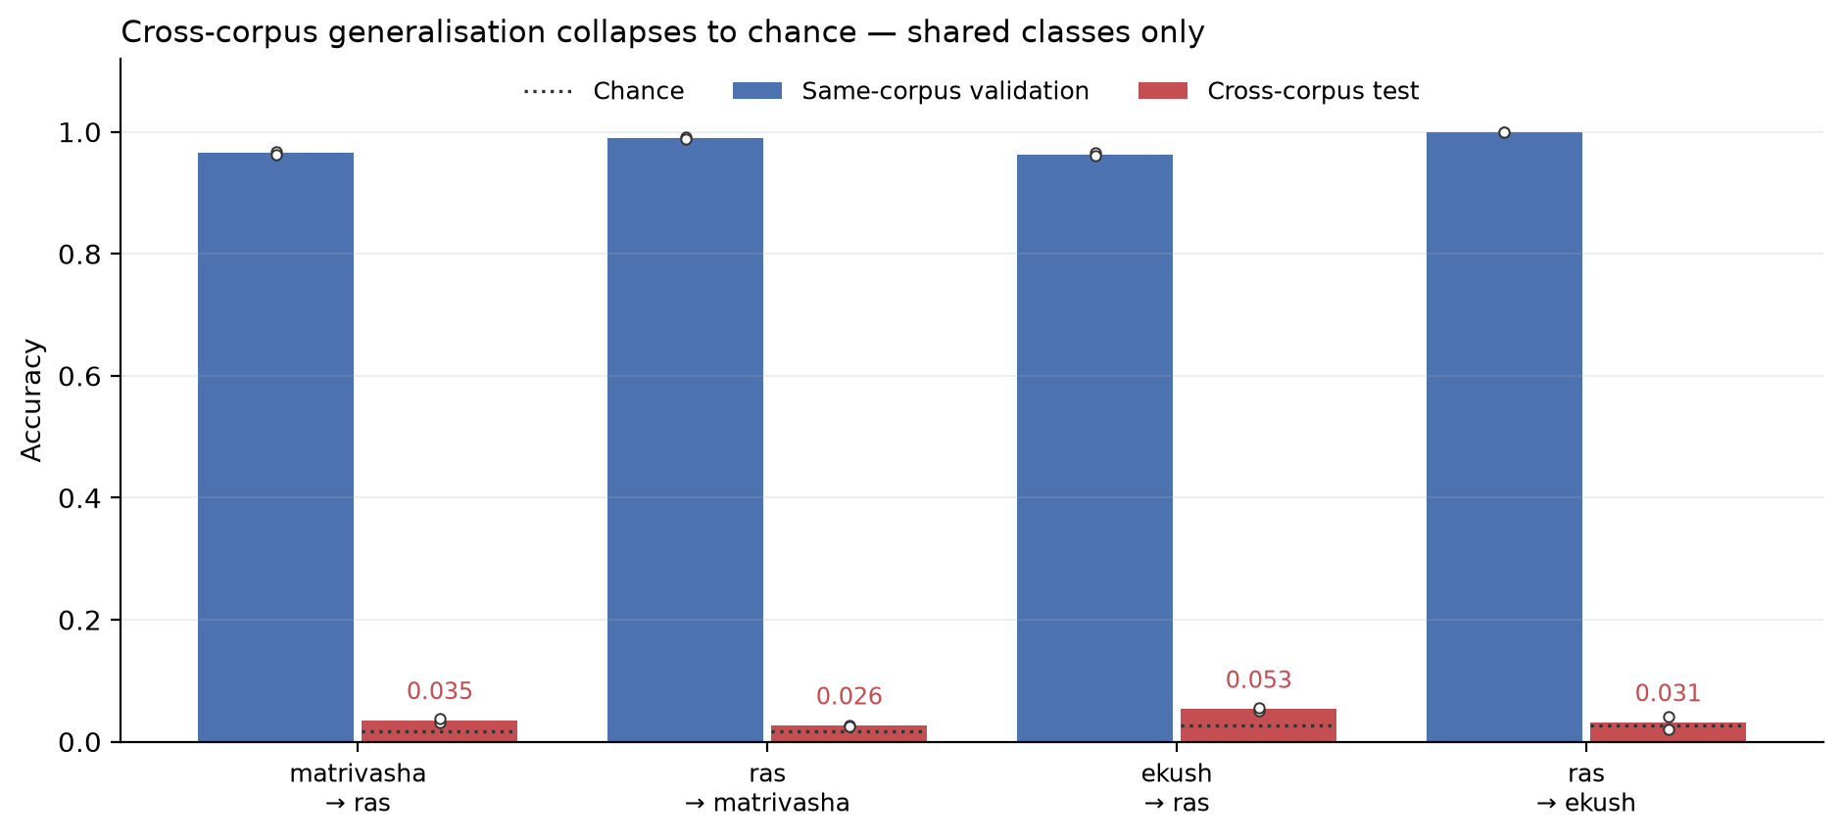
Figure 11. Cross-corpus generalisation collapses to chance on the classes each pair shares.
This is not a labelling artifact. Near-chance transfer would follow trivially if the corpora’s class mappings disagreed, which would also invalidate the merged benchmark. We tested this directly: the merged full-corpus model classifies RAS-Compound’s shared-class test samples at 0.9921 and MatriVasha’s at 0.9800. Both corpora’s renderings of a class map to the same label correctly, so the grapheme-level reconciliation of Section 3.2 is sound and the collapse reflects genuine domain shift.
What this means. A model trained on a single Bengali corpus does not learn to recognise Bengali compound characters; it learns to recognise one project’s rendering of them — its resolution, its binarisation, its ink polarity, its writer population. The 97.6% our merged model achieves across all three corpora is attainable only because it saw all three in training. It is not evidence of a general character recogniser, and neither, by extension, are the near-ceiling accuracies the literature reports on individual corpora [11], [12], [17], [23]: those numbers describe within-corpus competence and may substantially overstate performance on newly collected handwriting.
The finding reframes what merging is for. Merging is usually motivated as enlarging the training set; here it is better understood as covering domains, since no single corpus yields a model that transfers to another. It also identifies the concrete gap the field should target — domain-invariant representations for handwritten Bengali — which the preprocessing of Section 3.3 evidently does not achieve, despite normalising polarity and scale.
Caveats. Training was capped at 300 images per class; larger budgets might narrow the gap, though the effect size makes it implausible that they close it. The two RAS-trained rows reach 1.0000 same-corpus validation, which suggests unusually low intra-class variation in that corpus and inflates the gap for those directions specifically. And each pair is a single run, though the consistency across eight runs and four directions makes seed variance an unlikely explanation for an effect of this magnitude.

5.6 Inference Cost
Figure 9 (fig9_efficiency.png) plots accuracy against single-image CPU latency measured on one thread. ExtendedViT runs in 17 ms against ViT-B/16’s 56 ms — 3.3× faster with 3.6× fewer parameters — because attention operates over 50 tokens rather than 197. Relative to ResNet18’s 13 ms, the transformer encoder costs approximately 4 ms per image, which is the price of the data-efficiency gain reported above. For the resource-constrained deployment scenarios the literature emphasises [18], [20], this positions ExtendedViT favourably: it is the most accurate model at the equal-budget setting while remaining within a few milliseconds of the cheapest competitive one.
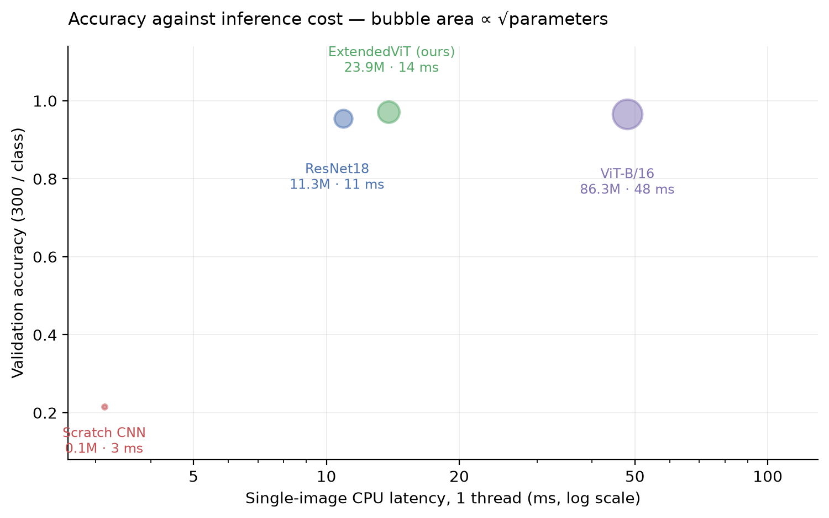
Figure 9. Accuracy against single-image CPU latency; bubble area is proportional to the square root of parameter count.

5.7 Attention Analysis
Figure 8 (fig8_attention.png) visualises the classification token’s attention over the 7×7 token grid in the final encoder layer, upsampled and overlaid on the input glyph. A consistent pattern emerges: attention concentrates on the conjunct body and systematically avoids the মাত্রা head-line. This is the behaviour the architecture was designed to produce. The head-line is present in nearly every Bengali character and therefore carries almost no class-discriminative information, while the structural relationship between conjoined consonant forms beneath it carries nearly all of it. That the model learns to allocate attention accordingly — without any supervision directing it to do so — supports the argument in Section 3.4 that global self-attention over the whole glyph is the right inductive addition for this problem.
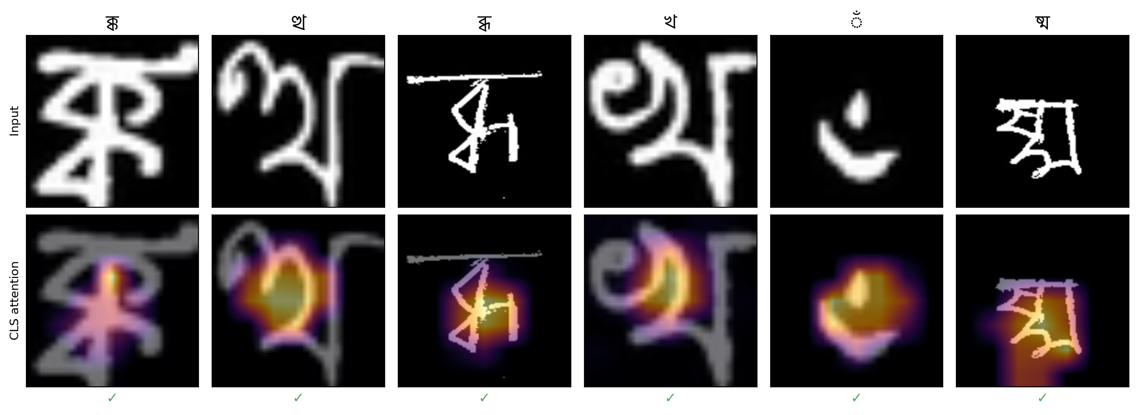
Figure 8. Classification-token attention over the 7x7 token grid, overlaid on the input glyph. Attention avoids the shared matra head-line.
Attention weights are extracted by running the encoder stack manually rather than through nn.TransformerEncoder; the manual pass is asserted to reproduce the model’s own logits, which also serves as a check on the formulation given in Section 3.4.

5.8 Ablation Studies
Backbone initialisation. Holding everything else fixed, initialising ExtendedViT’s trunk from ImageNet rather than from the full-corpus ResNet18 checkpoint costs 1.43 accuracy points at the equal-budget setting (0.9719 → 0.9576). The inherited trunk had seen the entire corpus, so that 1.43-point difference measures leaked information rather than architecture. The equivalent inheritance in ResNet18 — from a RAS-only checkpoint — moves first-epoch validation accuracy from 0.703 to 0.234 in the single-source sweep. Both baselines were affected; Sections 5.3 and 5.4 use ImageNet initialisation throughout.
Temperature scaling. Run, and reported in Section 5.4: a single scalar fitted on validation data removes the calibration difference between architectures entirely. This was the decisive control for the paper’s remaining architectural claim, and it did not survive it.
Ablations worth adding if reviewers ask, or if space permits. Each isolates one design decision and costs roughly 1.5 hours at the equal-budget setting. Given that no architectural advantage survived, these are now of limited value; the L = 0 variant is the only one we would prioritise, since it reduces exactly to the ResNet18 baseline and would confirm the encoder’s contribution is null rather than merely small.
Ablation | Question it answers | Variants
Encoder depth | Is 4 layers the right capacity, or is the gain saturating? | L = 0 (≡ ResNet18 + pooling), 2, 4, 8
Attention heads | Does head count matter at 50 tokens? | h = 4, 8, 16
Positional embeddings | Do the 49 tokens need explicit position, given convolution already encodes it? | learned / none
Polarity normalisation | How much does the preprocessing contribute versus the architecture? | on / off
Backbone depth | Would a shallower trunk with a deeper encoder do better? | ResNet18 layer3 output (14×14, 196 tokens) vs layer4 (7×7, 49)
The L = 0 variant is the most informative single ablation, since it reduces exactly to the ResNet18 baseline and isolates the encoder’s entire contribution.

5.9 Comparison with Prior Published Results
Table 9. Positioning against prior Bengali character recognition work.
Study | Architecture | Dataset | Classes | Reported
Das et al. (2014) [3] | Convex-hull + quad-tree + SVM | CMATERdb 3.1.3.3 | 171 | 79.35%
Roy et al. (2017) [9] | Layer-wise DCNN | CMATERdb 3.1.3.3 | 171 | 90.33%
Chatterjee et al. (2019) [11] | ResNet-50, ImageNet | BanglaLekha-Isolated | 84 | 96.12%
Ghosh et al. (2020) [12] | InceptionResNetV2 / DenseNet121 | CMATERdb | 231 | 96.99%
CompoundDenseNet [23] | Modified DenseNet | BanglaLekha / Ekush / CMATERdb | varies | 96.2–98.5%
Parvez et al. (2025) [17] | ViT-B/16 | CMATERdb 3.1.2 (basic) | 50 | 98.26%
ResViT [19] | ResNet50v2 + ViT, parallel fusion | BanglaLekha-Isolated | 84 | 97.21%
Raquib et al. [25] | EfficientNetB3 + ViT + Conformer | Own (78-class) / CHBCR | 78 | 98.84% / 96.49%
This work | ResNet18 tokenizer + Transformer encoder | Unified RAS + Ekush + MatriVasha | 256 | 97.56% (full corpus)
These numbers are not a leaderboard and must not be presented as one. Class counts range from 50 to 256, evaluation protocols and splits differ, several sets are near-balanced while ours is deliberately not, and some reported figures are averages over balanced subsets. A 98.26% on 50 basic characters [17] is a substantially easier problem than 97.56% on 256 classes including the full compound inventory and a 27-class rare tail. The table’s purpose is to show that our result sits in the range established by recent deep architectures while being obtained on a markedly larger and more imbalanced label space — not to claim state of the art. Any venue submission should state this caveat explicitly rather than letting the table imply a ranking.

5.10 Per-Source and Per-Class Analysis
Per-source accuracy is reported in Tables 3 and 4. All three pretrained models score highest on RAS-Compound (0.991–0.994) and lowest on Ekush (0.974), the reverse of what corpus size alone would predict — RAS-Compound is the smallest source but has the cleanest, highest-resolution binarised glyphs, while Ekush is natively 28×28. Image quality dominates corpus size here. The scratch CNN inverts this completely (0.013 on RAS-Compound, 0.707 on Ekush), because without a pretrained prior it learns only what it sees in quantity.
Rare classes are the easiest, not the hardest. The 27 classes with fewer than 100 images reach a mean per-class F1 of 0.9966 (ExtendedViT; 0.9925 for ResNet18) against 0.9758 for the 229 well-populated classes — and all 27 achieve F1 = 1.0. This inverts the usual expectation and follows directly from the confound established in Section 3.2: those 27 classes are contributed solely by RAS-Compound, whose images are high-resolution and cleanly binarised, and no other corpus supplies a competing rendering of them. Their scarcity is an artifact of source size, while their separability comes from image quality. On this benchmark, therefore, macro-F1 does not measure long-tail performance, and neither macro-F1 nor per-class accuracy should be read as evidence about rare conjuncts. We report macro-F1 as a descriptive statistic only.
Errors concentrate on minimally different conjunct pairs. Only 7 of 256 classes fall below F1 0.90. The most-confused pairs are near-identical, and both architectures fail on essentially the same ones:
Table 10. Most-confused class pairs, full corpus (ExtendedViT / ResNet18 error counts).
True → Predicted | ExtendedViT | ResNet18 | What differs
ন্ড্র → ণ্ড্র | 33 | 25 | dental ন vs retroflex ণ
ণ্ড্র → ন্ড্র | 24 | 28 | the same pair, reversed
ম্ভ্র → ন্ত্র | 32 | 26 | both components
ত্ত → ও | 25 | 26 | conjunct resembling a vowel
ম্ন → ম্ম | 19 | 19 | ন vs ম as second component
ন্ঢ → ন্ট | 15 | 16 | ঢ vs ট
শ্ন → শ্ম | 12 | 13 | ন vs ম as second component
ন্ব → ণ্ব | 12 | 12 | dental ন vs retroflex ণ
ত্থ → থ | 12 | — | conjunct vs its own second component
২ → হ | 13 | 13 | digit against a consonant
Three systematic patterns emerge. First, the dental/retroflex nasal contrast (ন vs ণ) accounts for the single largest error source, and it is symmetric — the confusion runs in both directions, indicating genuine visual ambiguity rather than a class prior. Second, ন vs ম as a second component recurs across otherwise unrelated conjuncts. Third, conjuncts are confused with their own constituents (ত্থ → থ) or with visually similar non-conjuncts (ত্ত → ও, ২ → হ), which is a failure of compositional structure rather than of stroke detection.
That both architectures fail on the same pairs, in similar proportions, indicates these errors are properties of the data rather than of the model — consistent with the near-identical aggregate accuracies of Table 3, and with the inter-class similarity the literature identifies as the field’s persistent obstacle [17], [23], [32]. Full per-class results are in Appendix C; confusion matrices are paper/confusion_full_*.png.
Per-source accuracy inverts corpus size. corpus to establish whether the merge benefits all three; report macro-F1 against accuracy to quantify performance on the 27 rare classes; include confusion matrices for the two leading models, focusing on the structurally similar conjunct pairs that the literature identifies as the persistent failure mode [17], [23].

6. Discussion
The dominant effect is the corpus, not the architecture. Section 5.5 puts the architecture comparison in proportion. Every difference between architectures reported in this paper is at most a few accuracy points; the difference between evaluating within a corpus and across corpora is ninety. Any conclusion about which architecture is best for Bengali compound characters is therefore conditional on a fixed collection convention, and would need re-establishing on data collected differently. We state this before discussing the architecture results, because it bounds how much weight they can carry.
What the architecture results do not support. We set out expecting the hybrid to be more accurate than a convolutional baseline when data is limited. It is not. Across a controlled sweep with the sole variable being per-class budget, and with three seeds at the two smallest budgets, no accuracy difference reaches significance; at the two largest budgets ResNet18 is fractionally ahead. We report this because the alternative — presenting the single-seed +2.46 points at 50 images per class, or the 1.75-point margin from the contaminated warm-started run — would have been a finding that repetition and a proper control both dissolve.
What the results do support. The encoder substantially improves the calibration of the model’s probability estimates: roughly a halving of expected calibration error at every budget, with the advantage largest when data is scarcest and narrowing monotonically as data grows. This is a genuine architectural effect, not a data artifact — the sweep holds corpus, image convention, class inventory, initialisation, optimiser and schedule fixed, and the separation is an order of magnitude larger than seed variance.
We suggest the following interpretation. Self-attention over the whole glyph aggregates evidence from spatially distant strokes before a decision is made, whereas a convolutional hierarchy commits to increasingly abstract local features and pools them only at the end. When training data is plentiful, both routes reach the same decision boundary and top-1 accuracy converges. When data is scarce, the convolutional model’s uncertainty is poorly estimated — it is markedly under-confident (0.638 mean confidence at 0.887 accuracy) — while the attention-based aggregation yields probabilities much closer to observed frequencies. The attention maps of Section 5.7, which show the classification token consistently ignoring the shared মাত্রা head-line and concentrating on the discriminative conjunct body, are consistent with this account, though they do not establish it.
Why calibration matters here. Isolated-character accuracy is rarely the end goal. In word- and line-level recognition the character posterior feeds a decoder — beam search, a language model, or a lexicon-constrained search — which consumes probabilities rather than argmax labels. A recogniser whose confidences are twice as well calibrated supplies a materially better signal to that decoder even when its top-1 accuracy is identical. For Bengali specifically, where conjuncts are mutually confusable and a decoder must arbitrate between close alternatives, the shape of the posterior is arguably more consequential than its mode.
Relation to prior work. That ViT-B/16 leads the properly initialised equal-budget comparison (Table 4) reproduces, on compound characters and a 256-class label space, the ordering Parvez et al. [17] reported for basic characters. Our contribution relative to that finding is not to overturn it but to quantify its cost: ViT-B/16 buys roughly one accuracy point over ExtendedViT at 3.6× the parameters and 3.3× the inference time. Numbers are not directly comparable across studies given differing class counts and protocols, but for orientation ResViT reports 97.21% on BanglaLekha-Isolated [19] and CompoundDenseNet 96.2–98.5% across three benchmarks [23], both on smaller class inventories than the 256 used here.
Threats to validity.
Initialisation contamination, now controlled. Both pretrained baselines initially inherited previously trained Bengali weights — ResNet18 from a RAS-only checkpoint, ExtendedViT from the full-corpus ResNet18 — which invalidated our first equal-budget comparison. Removing that inheritance moves first-epoch validation accuracy from 0.703 to 0.234. Every number in Sections 5.3 and 5.4 comes from runs initialised from ImageNet alone. Tables 3 and 4 retain the inherited initialisations and are annotated accordingly; they should be read as upper bounds on the baselines rather than as controlled comparisons.
Seeds and statistical power. Three seeds establish that the accuracy differences are not significant and that the calibration differences are, but three is a small sample; the 300 and 1,000 per-class budgets are single runs, so their calibration figures carry no error estimate.
Calibration measurement. Label smoothing of 0.1 depresses attainable confidence and inflates the absolute ECE of both models. The comparison is unaffected because smoothing is identical, but our absolute ECE values should not be compared against studies that omit it, and a replication without smoothing would strengthen the claim.
Epoch budget. All models train for 8 epochs, which suits fine-tuning but may underserve the scratch CNN, whose 0.2115 should be read as its 8-epoch result at that budget rather than a ceiling.
Limitations. Evaluation is on isolated characters; performance within connected words, where segmentation error compounds classification error, is not measured — and it is precisely there that the calibration advantage would have to be demonstrated to matter practically. The sweep uses one corpus, so whether the calibration effect generalises across image conventions is untested. The corpora may not represent natural document imagery. And because class rarity is perfectly confounded with source identity (Section 3.2), we make no claim about rare-class behaviour.

7. Conclusion
We unified three Bengali handwriting corpora into a 256-class, 681,309-image benchmark by reconciling labels at the level of Unicode-normalised graphemes, and used it to evaluate four architectures under an identical protocol.
The benchmark’s principal finding is negative and, we believe, consequential for the field. Trained on any one constituent corpus and tested on another — restricted to the classes they share, so the label space is identical on both sides — every architecture falls from 0.96–1.00 same-corpus accuracy to 0.02–0.05 cross-corpus, at or barely above chance. We verified that this reflects domain shift rather than label disagreement, since the merged model classifies both corpora’s renderings of a shared class correctly (0.9921 and 0.9800). A model trained on one Bengali corpus therefore does not learn to recognise Bengali compound characters; it learns to recognise that project’s rendering of them. Single-corpus accuracies — including the near-ceiling figures widely reported in this literature — describe within-corpus competence and should not be read as evidence of generalisation. Merging corpora is best understood not as enlarging a training set but as covering domains.
Against that backdrop, architecture differences are small. Four architectures spanning 0.06M to 86.3M parameters differ by at most about one accuracy point once initialisation is controlled. ExtendedViT — an ImageNet-pretrained ResNet18 acting as a learned tokenizer for a four-layer Transformer encoder — matches a fine-tuned ResNet18 on the full corpus (0.9760 vs 0.9764) and shows no significant accuracy advantage at any budget in a controlled sweep with three seeds. An apparent halving of the baseline’s expected calibration error proves fully correctable by temperature scaling, which leaves the scaled baseline better calibrated than the unscaled hybrid; it is therefore a property of the training recipe rather than of the architecture. ViT-B/16 is the most accurate model at an equal budget, at 3.6× the parameters and 3.3× the inference cost of the hybrid.
Three methodological cautions follow, each discovered by attempting to falsify a claim of our own. Warm-starting from a previously trained checkpoint — routine in this literature — inflated our equal-budget result by 1.43 accuracy points. Macro-F1 does not measure long-tail performance on this corpus: the 27 rarest classes score a higher mean F1 (0.9966) than the 229 common ones (0.9758), because rarity is confounded with source image quality. And architecture-level calibration comparisons should always be reported temperature-scaled, since uncorrected ECE measures the interaction of architecture and training recipe rather than a property of the architecture. We also note that without pretraining a scratch CNN reaches 0.0129 accuracy on the minority corpus supplying 27 otherwise-unavailable classes, against 0.707 on the largest corpus — on a merged corpus of unequal sources, transfer learning is what makes the minority source learnable at all.
Future work follows directly from the cross-corpus result. The field needs domain-invariant representations for handwritten Bengali: our preprocessing normalises polarity and scale and is plainly insufficient, so stronger domain generalisation — adversarial or style-invariant training, heavy style augmentation, or test-time adaptation — is the obvious next target, and cross-corpus accuracy is the metric that should report progress on it. We would also encourage the field to adopt held-out-corpus evaluation as standard practice alongside within-corpus splits, since the two measure very different things.
On the architecture side, our results suggest the returns from further model design on isolated Bengali compound characters are limited, and that effort is better directed at the evaluation and data problems above. Where architecture does matter is cost: establishing the accuracy-per-millisecond frontier for CPU-only deployment, which our four points sketch but do not map.

8. Reproducibility
All results are produced by a single codebase in which dataset scanning, label reconciliation, splitting, and image transformation are shared across architectures; only the model varies. The train/validation/test partition is derived deterministically from a fixed seed (42) applied to a per-class shuffle, so the partition is identical for every run reported here and can be regenerated exactly.
Table 11. Complete training configuration.
Setting | Value
Input resolution | 224 × 224, 3-channel grayscale
Batch size | 32
Epochs | 8
Optimiser | AdamW, weight decay 10⁻⁴
Base learning rate | 10⁻³ (CNN), 3×10⁻⁴ (ResNet18, ExtendedViT), 10⁻⁴ (ViT-B/16)
Backbone learning rate | 0.1 × base for all pretrained models
Schedule | Cosine annealing to 10⁻⁶ over 8 epochs
Loss | Cross-entropy, label smoothing 0.1
Gradient clipping | Max norm 1.0
Augmentation | Rotation ±15°, translation ≤10%, shear 5°, brightness/contrast jitter 0.3
Normalisation | μ = σ = 0.5 per channel
Model selection | Best validation accuracy
Split | 80/10/10 stratified per class, seed 42
Framework | PyTorch 2.13, torchvision 0.28, timm 1.0.28
Hardware | Apple Silicon, Metal Performance Shaders backend
Inference measurement | CPU, single image, one thread
Commands to reproduce every result:
python train_arch.py --arch {cnn,resnet18,vit,extended_vit} [--limit-per-class 300] [--no-warm-start]
python evaluate.py [--limit-per-class 300] [--suffix _imagenet] --confusion --per-class
python cross_source.py --train <corpus> --test <corpus> --arch <arch>
python temperature_scaling.py --source ekush --limit-per-class 50
python paper/figures.py

9. Declarations
Data availability. The three source corpora are pre-existing public datasets: RAS-Compound, Ekush [Rabby et al., 2018], and MatriVasha. [FILL: repository URL, version or access date, and licence for each]. The label-reconciliation mapping files (ras_class_mapping.csv, matrivasha_mapping.csv) and the manifest-construction code that reproduces the unified 256-class corpus are released with this paper; [FILL: decide whether the merged corpus itself is redistributed, which depends on whether all three source licences permit it — verify before promising a download].
Code availability. [FILL: repository URL and DOI, e.g. an archived Zenodo release]. Trained checkpoints [FILL: released / available on request].
Ethics approval. The source corpora were collected from human writers — Ekush alone from 3,086 contributors, and MatriVasha records per-writer gender metadata. This work performs secondary analysis of already-published, de-identified datasets and collected no new human data. [FILL: confirm each source's original consent and ethics provenance, and state whether your institution required review for secondary use; some venues ask explicitly].
Consent to participate / publish. Not applicable; no new human participants. [FILL: confirm]
Funding. [FILL: grant numbers and funders, or "This research received no specific grant from any funding agency in the public, commercial, or not-for-profit sectors."]
Competing interests. [FILL: typically "The authors declare no competing interests."]
Author contributions (CRediT). [FILL per author] — Conceptualisation; Data curation; Formal analysis; Investigation; Methodology; Software; Validation; Visualisation; Writing – original draft; Writing – review & editing.
Acknowledgements. [FILL: the creators of RAS-Compound, Ekush and MatriVasha for releasing their data publicly; any colleagues, compute providers, or reviewers].
Use of AI tools. [FILL: most venues now require disclosure of generative-AI assistance in preparing the manuscript or code. State what was used and for what.]

Appendix A. Notation
Symbol | Meaning
$x$ | Input image, $R^{3×224×224}$
$F$ | ResNet18 layer4 feature map, $R^{512×7×7}$
$N=49$ | Number of spatial tokens
$D=512$ | Token dimension
$x_{\text{cls}}$ | Learnable classification token
$E_{\text{pos}}$ | Learnable positional embedding, $R^{50×512}$
$z_{ℓ}$ | Token sequence after encoder layer $ℓ$
$L=4$ | Number of encoder layers
$h=8$, $d_{k}=64$ | Attention heads and per-head dimension
$C=256$ | Number of classes

Appendix B. Class Inventory
The complete inventory is released as class_inventory.csv (256 rows): index, character, Unicode code points, Unicode character names, contributing corpora, and image count. It is intended as supplementary material rather than body text.
Classes range from a single code point (e.g. ঁ, U+0981 BENGALI SIGN CANDRABINDU) to five (ত + ্ + র + ্ + য-type conjuncts), reflecting that a conjunct is encoded as a consonant sequence joined by U+09CD BENGALI SIGN VIRAMA rather than as an atomic code point. This is precisely why label reconciliation must operate on NFC-normalised grapheme strings rather than on folder indices (Section 3.2). Of the 256 classes, 97 are attested in more than one corpus and 159 in exactly one.

Appendix C. Per-Class Results
Per-class precision, recall, F1 and support for both leading models on the full corpus are released as per_class_extended_vit.csv and per_class_resnet18.csv, sorted ascending by support. The complete ranked confusion lists are confusions_extended_vit.csv and confusions_resnet18.csv. All four regenerate with:
python evaluate.py --arch extended_vit resnet18 --per-class --confusion
Summary: 27 classes at F1 = 1.000 (ExtendedViT) and 25 (ResNet18); 7 and 6 classes respectively below F1 0.90; worst classes ন্ড্র (0.8652) and ণ্ড্র (0.8814) — the two halves of the same dental/retroflex confusion discussed in Section 5.10.

References
Use the numbering already established in the standalone literature review; the citations appearing in this draft are [2]–[5], [7], [9], [11], [12], [16], [17], [19], [22]–[25], [28], [30], [32], [33], [37], and [41]–[42].
[FILL: the review's reference list is not yet reproduced here — paste it, then verify every in-text citation resolves and that Ethnologue, Rabby et al. (2018) for Ekush, and the MatriVasha and RAS-Compound dataset papers are all present, since this draft cites them by name outside the numbered scheme.]
References to add — required by the new Section 2.7 and by Section 5.4. Verify each before use; they are cited from standard knowledge of these literatures rather than from a checked copy:
- ⚑ Torralba, A. and Efros, A. A. Unbiased Look at Dataset Bias. CVPR 2011. — the “name that dataset” demonstration and cross-dataset generalisation degradation.
- ⚑ Recht, B., Roelofs, R., Schmidt, L. and Shamir, V. Do ImageNet Classifiers Generalize to ImageNet? ICML 2019. — accuracy drops on a replication-protocol test set.
- ⚑ Ben-David, S. et al. A Theory of Learning from Different Domains. Machine Learning, 2010. — the source-error-plus-divergence bound.
- ⚑ Guo, C., Pleiss, G., Sun, Y. and Weinberger, K. Q. On Calibration of Modern Neural Networks. ICML 2017. — temperature scaling and expected calibration error, used in Section 5.4.
- Optionally a recent domain-generalisation survey (e.g. Zhou et al., Domain Generalization: A Survey, TPAMI 2022) if the venue expects broader positioning.

