**“Calorie Intake Recommender”**

PROJECT REPORT

FOR THE DEGREE OF

**BACHELOR OF TECHNOLOGY**

*IN*

**INFORMATION TECHNOLOGY** 

BY

Sulyab T V (IIT2014125)

Utkarsh Srivastava (IIT2014507)

Mohd. Abdullah (ISM2014004)

Submitted To:

Dr. K. P. Singh

Assistant Professor

IIIT-ALLAHABAD

**INDIAN INSTITUTE OF INFORMATION TECHNOLOGY, ALLAHABAD**

(A UNIVERSITY ESTABLISHED UNDER SEC.3 OF UGC ACT, 1956 VIDE NOTIFICATION NO. F.9-4/99-U.3 DATED 04.08.2000

OF THE GOVT. OF INDIA)

A CENTRE OF EXCELLENCE IN INFORMATION TECHNOLOGY ESTABLISHED BY GOVT. OF INDIA

**CANDIDATE’s DECLARATION**

We hereby declare that the work presented in this project report entitled “**Calorie Intake Recommender**”, submitted mid-semester report of 5th Semester report of B. Tech. (IT) at Indian Institute of Information Technology, Allahabad, is an authenticated record of our original work carried out from July 2016 to December 2016 under the guidance of **Dr. K. P. Singh**. Due acknowledgements have been made in the text to all other material used. The project was done in full compliance with the requirements and constraints of the prescribed curriculum.

Place: Allahabad Sulyab T V(IIT2014125)

Date: 30 November, 2016 Utkarsh Srivastava (IIT2014507)

Mohd. Abdullah (ISM2014004)

**CERTIFICATE**

This is to certify that the above statement made by the candidate is correct to the best of my knowledge.

Date : Dr. K.P Singh

Place : Allahabad IIIT-Allahabad

**Table of Contents**

|  |  |
| --- | --- |
| Introduction | Page No. 4 |
| Problem Description | Page No. 6 |
| Implementation | Page No. 7 |
| Rules | Page No. 7 |
| Snapshots | Page No. 10 |
| Hardware and software requirements | Page No. 11 |
| Conclusion | Page No. 11 |
| References | Page No. 12 |

Fuzzy Logic

**Fuzzy Logic** (FL) is a method of reasoning that resembles human reasoning. The approach of FL imitates the way of decision making in humans that involves all intermediate possibilities between digital values YES and NO.

The conventional logic block that a computer can understand takes precise input and produces a definite output as TRUE or FALSE, which is equivalent to human’s YES or NO.

The inventor of fuzzy logic, **Lotfi Zadeh**, observed that unlike computers, the human decision making includes a range of possibilities between YES and NO, such as −

* CERTAINLY YES
* POSSIBLY YES
* CANNOT SAY
* POSSIBLY NO
* CERTAINLY NO

The fuzzy logic works on the levels of possibilities of input to achieve the definite output.

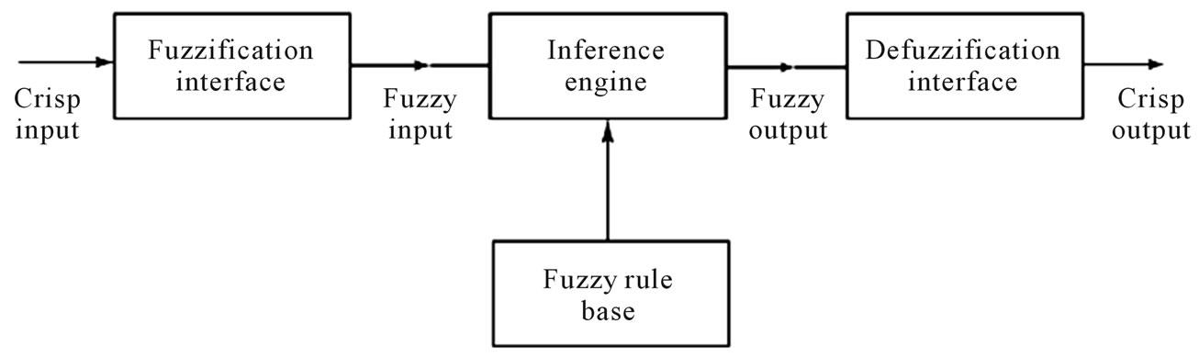

**Advantages of Fuzzy Logic:**

* Fuzzy logic is conceptually easy to understand.
* Fuzzy logic is tolerant of imprecise data.
* Fuzzy logic is flexible.
* Fuzzy logic is based on natural language.
* It may not give accurate reasoning, but acceptable reasoning.
* Mathematical concepts within fuzzy reasoning are very simple.
* You can modify a FLS by just adding or deleting rules due to flexibility of fuzzy logic.
* Fuzzy logic Systems can take imprecise, distorted, noisy input information.
* FLSs are easy to construct and understand.
* Fuzzy logic is a solution to complex problems in all fields of life, including medicine, as it resembles human reasoning and decision making.

**Disadvantages of Fuzzy Logic:**

* There is no systematic approach to fuzzy system designing.
* They are understandable only when simple.
* They are suitable for the problems which do not need high accuracy.

**Terminologies**:

**Membership Function**: It is a graphical representation of fuzzy sets. Membership functions allow you to quantify linguistic term and represent a fuzzy set graphically. A membership function for a fuzzy set A on the universe of discourse X is defined as µA:X → [0,1].

**Fuzzy Rules**: In a FLS, a rule base is constructed to control the output variable. A fuzzy rule is a simple IF-THEN rule with a condition and a conclusion.

**Knowledge Base**: This is the storage for the fuzzy rules.

**Inference Engine**: It simulates the human reasoning process by making fuzzy inference on the inputs and rules.

**Fuzzification Module**: It transforms the system inputs, which are crisp numbers, into fuzzy sets.

**Defuzzification Module**: It transforms the fuzzy set obtained by the inference engine into a crisp value.

**Problem Description:**

The objection of this project is **"Calorie Intake Recommender**". It takes in input:

* Height of the person
* Weight of the person
* Type of activity the person is associated with.

Now, with the help of height and weight, it calculates the **BMI** (Body Mass Index) and using this information along with the type of activity the user performs (on a scale of 0 to 10), it recommends the amount of calories the person should be taking every day.

**How is BMI calculated?**

BMI is your weight (in kilograms) over your height squared (in meters).

**Step 1** : Convert the weight into kilogram units.

**Step 2** : Convert the height into meter units.

**Step 3** : Square the height (obtained in Step 2).

**Step** **4** : Divide the weight (obtained in Step 1) by the result obtained in step 3. This is the BMI of the person.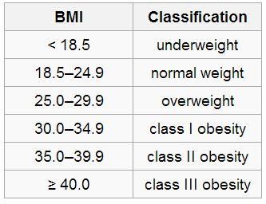

**BMI** is an important parameter in determining the diet of a person. Moreover, activity too plays an important part in the same. For an example, consider 2 people: One has a desk job and another is a Gym trainer. Assuming both have the same BMI, both of them will certainly have different diet charts. The former should intake lesser calorie than the latter to avoid obesity, since the latter spends most of the calories in exercises.

**Implementation** :

We have implemented our program in **Python** using **skfuzzy library**.

The inputs are:

* Height of the person
* Weight of the person
* Type of activity the person is associated with.

The output is:

* Recommended Calorie intake

The defined rule-base for the above will be:

* rule1 : if bmi is'underweight' and height is 'very low' or height is 'low' and activity is 'poor'then calorie intake should be 'mediocre'
* rule2 : if bmi is'underweight' and height is 'very low' or height is 'low' and activity is 'average'then calorie intake should be 'average'
* rule3 : if bmi is'underweight' and height is 'very low' or height is 'low' and activity is 'good'then calorie intake should be 'decent'
* rule4 : if bmi is'underweight' and height is 'medium' and activity is 'poor'then calorie intake should be 'average'
* rule5 : if bmi is'underweight' and height is 'medium' and activity is 'average'then calorie intake should be 'decent'
* rule6 : if bmi is'underweight' and height is 'medium' and activity is 'good'then calorie intake should be 'good'
* rule7 : if bmi is'underweight' and height is 'high' and activity is 'poor'then calorie intake should be 'decent'
* rule8 : if bmi is'underweight' and height is 'high' and activity is 'average'then calorie intake should be 'good'
* rule9 : if bmi is'underweight' and height is 'high' and activity is 'good'then calorie intake should be 'excellent'
* rule10 : if bmi is'underweight' and height is 'very high' and activity is 'poor'then calorie intake should be 'good'
* rule11 : if bmi is'underweight' and height is 'very high' and activity is 'average'then calorie intake should be 'excellent'
* rule12 : if bmi is'underweight' and height is 'very high' and activity is 'good'then calorie intake should be 'excellent'
* rule13 : if bmi is'normal weight' and height is 'very low' or height is 'low' and activity is 'poor'then calorie intake should be 'poor'
* rule14 : if bmi is'normal weight' and height is 'very low' or height is 'low' and activity is 'average'then calorie intake should be 'mediocre'
* rule15 : if bmi is'normal weight' and height is 'very low' or height is 'low' and activity is 'good'then calorie intake should be 'average'
* rule16 : if bmi is'normal weight' and height is 'medium' and activity is 'poor'then calorie intake should be 'mediocre'
* rule17 : if bmi is'normal weight' and height is 'medium' and activity is 'average'then calorie intake should be 'average'
* rule18 : if bmi is'normal weight' and height is 'medium' and activity is 'good'then calorie intake should be 'decent'
* rule19 : if bmi is'normal weight' and height is 'high' and activity is 'poor'then calorie intake should be 'average'
* rule20 : if bmi is'normal weight' and height is 'high' and activity is 'average'then calorie intake should be 'decent'
* rule21 : if bmi is'normal weight' and height is 'high' and activity is 'good'then calorie intake should be 'good'
* rule22 : if bmi is'normal weight' and height is 'very high' and activity is 'poor'then calorie intake should be 'decent'
* rule23 : if bmi is'normal weight' and height is 'very high' and activity is 'average'then calorie intake should be 'good'
* rule24 : if bmi is'normal weight' and height is 'very high' and activity is 'good'then calorie intake should be 'excellent'
* rule25 : if bmi is'overweight' and height is 'very low' or height is 'low' and activity is 'poor'then calorie intake should be 'dismal'
* rule26 : if bmi is'overweight' and height is 'very low' or height is 'low' and activity is 'average'then calorie intake should be 'poor'
* rule27 : if bmi is'overweight' and height is 'very low' or height is 'low' and activity is 'good'then calorie intake should be 'mediocre'
* rule28 : if bmi is'overweight' and height is 'medium' and activity is 'poor'then calorie intake should be 'poor'
* rule29 : if bmi is'overweight' and height is 'medium' and activity is 'average'then calorie intake should be 'mediocre'
* rule30 : if bmi is'overweight' and height is 'medium' and activity is 'good'then calorie intake should be 'average'
* rule31 : if bmi is'overweight' and height is 'high' and activity is 'poor'then calorie intake should be 'mediocre'
* rule32 : if bmi is'overweight' and height is 'high' and activity is 'average'then calorie intake should be 'average'
* rule33 : if bmi is'overweight' and height is 'high' and activity is 'good'then calorie intake should be 'decent'
* rule34 : if bmi is'overweight' and height is 'very high' and activity is 'poor'then calorie intake should be 'average'
* rule35 : if bmi is'overweight' and height is 'very high' and activity is 'average'then calorie intake should be 'decent'
* rule36 : if bmi is'overweight' and height is 'very high' and activity is 'good'then calorie intake should be 'good'
* rule37 : if bmi is'obese' and height is 'very low' or height is 'low' and activity is 'poor'then calorie intake should be 'dismal'
* rule38 : if bmi is'obese' and height is 'very low' or height is 'low' and activity is 'average'then calorie intake should be 'dismal'
* rule39 : if bmi is'obese' and height is 'very low' or height is 'low' and activity is 'good'then calorie intake should be 'poor'
* rule40 : if bmi is'obese' and height is 'medium' and activity is 'poor'then calorie intake should be 'dismal'
* rule41 : if bmi is'obese' and height is 'medium' and activity is 'average'then calorie intake should be 'poor'
* rule42 : if bmi is'obese' and height is 'medium' and activity is 'good'then calorie intake should be 'mediocre'
* rule43 : if bmi is'obese' and height is 'high' and activity is 'poor'then calorie intake should be 'poor'
* rule44 : if bmi is'obese' and height is 'high' and activity is 'average'then calorie intake should be 'mediocre'
* rule45 : if bmi is'obese' and height is 'high' and activity is 'good'then calorie intake should be 'average'
* rule46 : if bmi is'obese' and height is 'very high' and activity is 'poor'then calorie intake should be 'mediocre'
* rule47 : if bmi is'obese' and height is 'very high' and activity is 'average'then calorie intake should be 'average'
* rule48 : if bmi is'obese' and height is 'very high' and activity is 'good'then calorie intake should be 'decent'
* rule49 : if bmi is'very obese' and height is 'very low' or height is 'low' and activity is 'poor'then calorie intake should be 'dismal'
* rule50 : if bmi is'very obese' and height is 'very low' or height is 'low' and activity is 'average'then calorie intake should be 'dismal'
* rule51 : if bmi is'very obese' and height is 'very low' or height is 'low' and activity is 'good'then calorie intake should be 'dismal'
* rule52 : if bmi is'very obese' and height is 'medium' and activity is 'poor'then calorie intake should be 'dismal'
* rule53 : if bmi is'very obese' and height is 'medium' and activity is 'average'then calorie intake should be 'dismal'
* rule54 : if bmi is'very obese' and height is 'medium' and activity is 'good'then calorie intake should be 'poor'
* rule55 : if bmi is'very obese' and height is 'high' and activity is 'poor'then calorie intake should be 'dismal'
* rule56 : if bmi is'very obese' and height is 'high' and activity is 'average'then calorie intake should be 'poor'
* rule57 : if bmi is'very obese' and height is 'high' and activity is 'good'then calorie intake should be 'mediocre'
* rule58 : if bmi is'very obese' and height is 'very high' and activity is 'poor'then calorie intake should be 'poor'
* rule59 : if bmi is'very obese' and height is 'very high' and activity is 'average'then calorie intake should be 'mediocre'
* rule60 : if bmi is'very obese' and height is 'very high' and activity is 'good'then calorie intake should be 'average'

**Snap shots:**

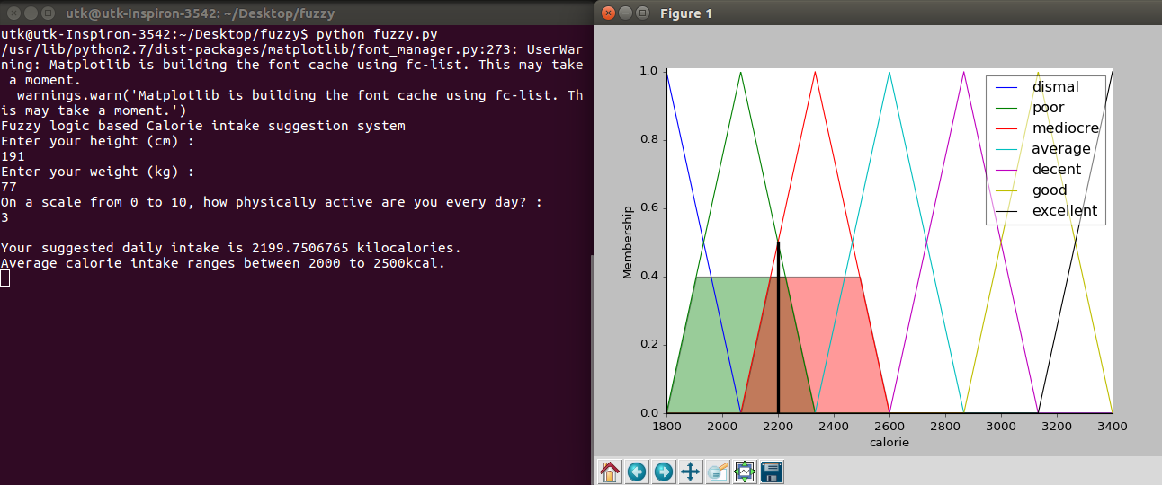

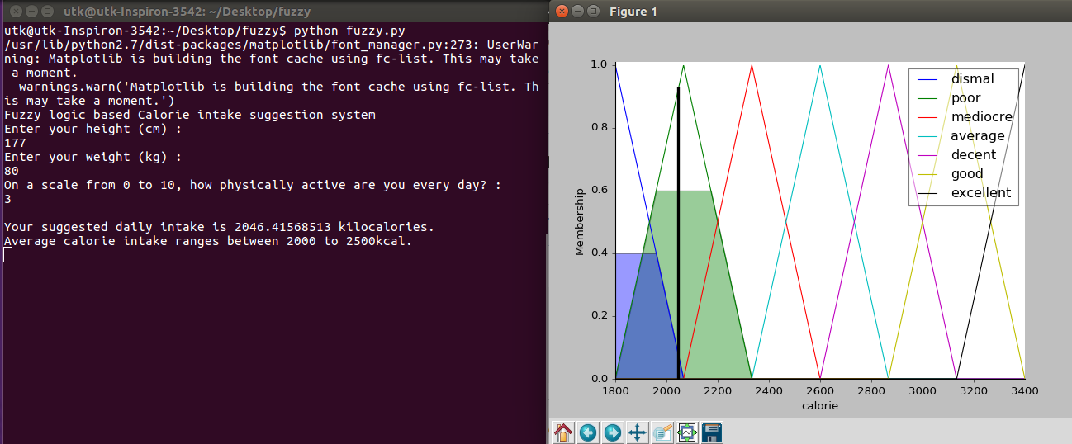

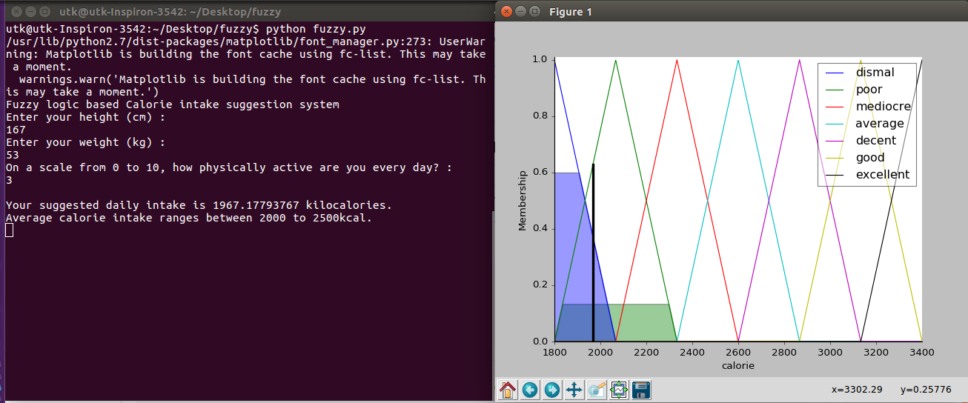

**Hardware and Software Requirements :**

**Operating System**: Linux, Windows

**Software** : Python with skfuzzy library

**Conclusion :**

We successfully created this fuzzy logic application with the help of concepts learnt in fuzzy logic classes. We accomplished this task of building the application using **skfuzzy library** in **Python**. In our application, we are helping the users to come up with the required calories they should be consuming every day. In the future application, we can come up with a proper diet chart on what food items they should be consuming so as to have a rich and proper diet.

**References :**

1. <https://in.mathworks.com/help/fuzzy/>
2. <http://access.feld.cvut.cz/view.php?cisloclanku=2012080002>
3. <http://cs.bilkent.edu.tr/~zeynep/files/short_fuzzy_logic_tutorial.pdf>
4. <https://www.youtube.com/watch?v=-42QUDfdb9I>
5. <http://www-rohan.sdsu.edu/doc/matlab/toolbox/fuzzy/fuzzytu5.html>