Motion Detection Using IR Sensor
Project Report Submitted
wto

MANIPAL ACADEMY OF HIGHER EDUCATION

For Partial Fulfillment of the Requirement for the

Award of the Degree

Of

Bachelor of Technology

in

Computer and Communication Technology

By

Utkarsh Shukla

 | Reg.no: 210953350
 | Rounak Shankar
 | Reg.no: 210953344
 | Varchasav kumar
Reg.no: 210953346
Shreyansh Sankrit
Reg.no: 210953352
 | Date: - 20/11/2023
 | Under the guidance of
Dr. Manoj Tolani | Dr.Sameena Begum Pathan
Assistant Professor | Assistant Professor – Senior Scale
Department of I&CT | Department of I&CT
Manipal Institute of Technology | Manipal Institute of Technology
Manipal, Karnataka, India | Manipal, Karnataka, India


April 2024

Index

Sr. No | Title | Page No
1 | Abstract | 3
2 | Introduction | 3-4
3 | Working Principle | 4-6
 | (With circuit Diagram)
4 | Embedded C Code | 6-11
5 | Demonstration of the | 12
 | project
6 | Conclusion | 12
7 | Future Scope | 12-13
8 | References | 13
9 | Submitted By | 13

1. Abstract

This project aims to integrate the LPC1768 microcontroller with an IR sensor for motion detection, intended for implementation in a Home Automation System. The LPC1768, equipped with an ARM Cortex-M3 processor, serves as the central processing unit, providing robust computational capabilities. The chosen motion sensor is an IR sensor, recognized for its cost-effectiveness, low energy consumption, and reliability. This system incorporates the IR sensor, a lighting element, and a recording setup consisting of a webcam and necessary software for video storage, addressing various security concerns. IR sensors are specifically designed to detect alterations in infrared radiation within their field of vision. Upon detecting movement of a warm object, such as a human or animal, within its detection range, the sensor initiates a response. This PIR sensor is engineered to function with all Parallax microcontrollers operating at either 3.3V or 5V. It boasts high energy efficiency, drawing less than 100 microamperes of current, ensuring compatibility with a wide array of microcontrollers while minimizing power consumption.

2. Introduction

Objective:

The objective of this project is to utilize infrared sensors (IR) for motion detection, enhancing security measures across various settings including homes, offices, industries, and banks. The aim is to deliver a reliable and cost-effective system that leverages advancements in technology to detect movement based on changes in object speed or vectors within the field of view, given the increasing incidence of crimes. The proposed system utilizes a PIR sensor in conjunction with a microcontroller to detect body temperature, triggering alerts and notifying owners of unauthorized individuals in restricted areas. Additionally, the study explores the versatility of infrared sensors beyond security applications, such as their integration into energy-saving devices and home automation systems. The objective is to develop a robust system that accurately detects motion, providing a practical and efficient solution to security concerns. Initial testing indicates that the system can meet anticipated performance criteria.

Scope:

This project entails the design and implementation of an intelligent lift control system utilizing LPC1768, Keil uVision, and Flash Magic. Its primary objective is to develop a motion detection system using infrared (IR) sensors to enhance security in various types of buildings such as banks, industries, offices, and residences. The focus is on leveraging technological advancements to detect motion by measuring changes in object speed or vectors within the field of view. The device, equipped with an integrated microprocessor and PIR sensor, identifies thermal signatures and triggers alerts when unauthorized access to restricted areas is detected. Additionally, the project explores energy-saving techniques and applications in home automation. Its overarching goal is to deliver a cost-effective, reliable, and energy-efficient solution validated through preliminary testing. The project encompasses design, development, and real-world deployment phases.

Project Description:

Our project entails integrating an IR sensor with the LPC1768 microcontroller. The goal is to trigger a buzzer upon motion detection. Moreover, we're leveraging the Analog-to-Digital Converter (ADC) output to enhance the system's motion detection capabilities. The ADC output helps detect environmental changes, thus improving the robustness of the motion detection system. This integration with the LPC1768 microcontroller offers a flexible and programmable solution, extending the functionality beyond basic motion sensing. The project's execution involves coordinating the IR sensor, ADC, and buzzer, culminating in a comprehensive motion detection system with the LPC1768 serving as the central control unit.
Hardware Requirements:

LPC1768 Development board
Ultrasonic Sensor (HC-SR04)
LED (for light simulation),

Buzzer (for alarm)
Wires

Power Supply

Software Requirements:

Language: Embedded C

Software: Keil uVision, Flash Magic

3. Working Principle:
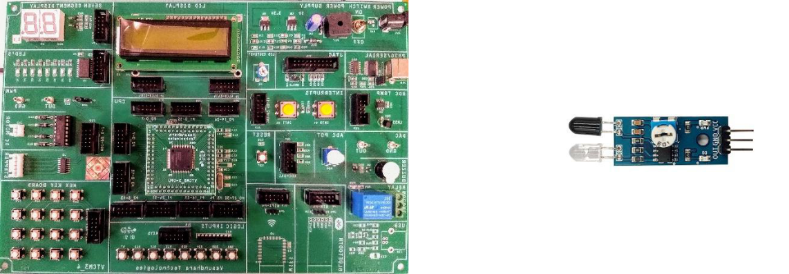

Fig 1. Lpc1768 kit and IR Sensor

Lpc1768 Microcontroller:

The LPC1768 is a microcontroller built upon the ARM Cortex-M3 architecture and manufactured by NXP Semiconductors. It belongs to the LPC1700 series, specifically engineered for embedded applications.

Processor Core:
It harnesses the power of an ARM Cortex-M3 processor core, ensuring both high performance and low power consumption, facilitating efficient execution of instructions.

Peripherals:
Equipped with on-chip peripherals such as UART, SPI, I2C, GPIO, and timers, it enables seamless communication with external devices and facilitates general-purpose input/output operations.

Memory:
Utilizes Flash memory for storing programs and SRAM for temporary data storage during program execution, ensuring efficient program handling.

Clock System:
Incorporates a sophisticated clock system, providing precise control over the processor clock frequency. This feature is vital for meeting performance demands and minimizing power consumption.

Communication Interfaces and Development Tools:
Supports multiple communication interfaces including UART, SPI, and I2C for serial communication. It is programmed and debugged using industry-standard development tools such as Keil uVision and Flash Magic, ensuring ease of development and debugging processes.

IR Sensor(Infrared Sensor):

An Infrared (IR) sensor is a device that detects infrared radiation in its surroundings. Here are some applications of the same:

Infrared Radiation Detection:
IR sensors are engineered to identify the presence of infrared radiation, which objects emit according to their temperature. This characteristic renders them highly effective in detecting the warmth emitted by living organisms or other heated objects.

Motion Detection:

A primary application of IR sensors is in motion detection. These sensors excel at identifying alterations in the infrared radiation pattern within their designated field of view, enabling them to effectively trigger alarms or activate devices upon detecting motion.

Proximity Sensing:

IR sensors are frequently employed for proximity sensing. Through the measurement of reflected infrared light, these sensors ascertain the distance between themselves and objects, facilitating applications like touchless switches or automatic faucets.
Object Detection:

- IR sensors can be employed for detecting the presence or absence of objects in their detection range. This is useful in applications like industrial automation and robotics for object recognition and handling.[2]

Energy Efficiency:

- IR sensors contribute to energy efficiency by enabling systems like automatic lighting controls. Lights can be turned on or off based on the detection of motion, reducing energy consumption in spaces when lighting is not needed.

Burglar Alarms and Security Systems:

- IR sensors play a crucial role in security systems for detecting intruders. When integrated into burglar alarm systems, they trigger alarms or activate surveillance cameras upon detecting unauthorized motion.[2]

Integration with Microcontrollers:

- IR sensors can be interfaced with microcontrollers to process and interpret the detected signals. This allows for more advanced control and automation in various applications.
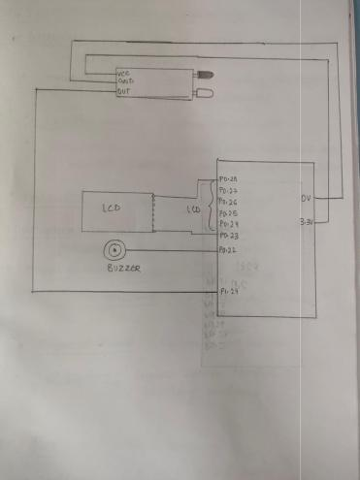

Fig 2. Circuit Diagram used for the project

- Embedded C Working Code:
- #include <lpc17xx.h>

- #include <stdio.h>

7.

- int temp1, temp2, flag1, i, x;

9.

- void delayMS(unsigned int k) {
- for (i = 0; i < k * 100; i++);

- }

13.

- void port_write(void);

- void lcd_write(void);

- void buzz_init(void);

17.

- int main() {
- int command[] = {3, 3, 3, 2, 2, 0x01, 0x06, 0x0C, 0x80};

- char message1[] = "Obstacle Present!";

- char message2[] = "No Obstacle.";

22.

- SystemInit();
- SystemCoreClockUpdate();

25.

- LPC_PINCON->PINSEL0 = 0;

27.

- LPC_PINCON->PINSEL3 = 0; // for sensor
- LPC_GPIO1->FIODIR = 0;

- LPC_PINCON->PINSEL1 |= 0;

- LPC_GPIO0->FIODIR |= 0X3F << 23;

- flag1 = 0;

- for (i = 0; i < 9; i++) {

- temp1 = command[i];

- lcd_write();
- }

- flag1 = 1;

- i = 0;

39.

- while (1) {

- if ((LPC_GPIO1->FIOPIN & (1 << 24)) == 0) {

42. | i = 0;
43. | buzz_init();
44. | while (message1[i] != '\0') {
45. | temp1 = message1[i];
46. | lcd_write();
47. | i++;
48. | }

- } else {
50. | i = 0;
51. | LPC_GPIO0->FIOCLR = 1 << 22;
52. | while (message2[i] != '\0') {
53. | temp1 = message2[i];
54. | lcd_write();
55. | i++;
56. | }

- }
- flag1 = 0;

- temp1 = 0x01;
- lcd_write();

- flag1 = 1;

62.

- delayMS(950);

- }

- }

66.

- void port_write() {

- int j;

- LPC_GPIO0->FIOPIN = temp2 << 23;

- if (flag1 == 0) {
- LPC_GPIO0->FIOCLR = 1 << 27;

- } else {

- LPC_GPIO0->FIOSET = 1 << 27;

- }

- LPC_GPIO0->FIOSET = 1 << 28;

- for (j = 0; j < 25; j++);

- LPC_GPIO0->FIOCLR = 1 << 28;

- for (j = 0; j < 30000; j++);

- }

80.

- void lcd_write() {

- temp2 = (temp1 >> 4) & 0xF;
- port_write();

- temp2 = temp1 & 0xF;

- port_write();

- }

87.

- void buzz_init() {

- LPC_PINCON->PINSEL1 |= 0;

- LPC_GPIO0->FIODIR |= 1 << 22;

91.

- LPC_GPIO0->FIOSET = 1 << 22;

- for (x = 0; x < 100000; x++);
- LPC_GPIO0->FIOCLR = 1 << 22;

- }

96.

Conclusion:

In The project effectively achieved motion detection functionality by integrating an Infrared (IR) sensor with the LPC1768 microcontroller. Upon detecting motion, the system triggers a buzzer and utilizes the Analog-to-Digital Converter (ADC) output to enhance sensitivity. This integration extends the project's scope beyond basic motion detection, offering a versatile and programmable solution. By showcasing the practical application of these technologies in security and automation contexts, the project demonstrates a comprehensive and efficient motion detection system leveraging IR sensors and the LPC1768 microcontroller.
- Future Scope:

The project involving the interfacing of an IR sensor with the LPC1768 microcontroller for motion detection opens up numerous possibilities for future enhancements and expansions:

1. Advanced Motion Detection Algorithms: Implementing more sophisticated algorithms for motion detection could improve accuracy and reduce false alarms. Techniques such as machine learning or pattern recognition could be explored for this purpose.

2. Multi-Sensor Integration: Integrating multiple IR sensors or different types of sensors (such as ultrasonic or microwave sensors) could enhance detection capabilities, especially in complex environments.

3. Wireless Connectivity: Adding wireless connectivity capabilities, such as Wi-Fi or Bluetooth, would enable remote monitoring and control of the motion detection system.

4. Energy Efficiency Optimization: Exploring methods to optimize power consumption, such as using low-power modes or optimizing sensor triggering mechanisms, could extend the system's battery life in battery-operated applications.

5. Integration with Home Automation Systems: Integrating the motion detection system with existing home automation platforms would allow for seamless integration into smart home setups, enabling automated actions based on detected motion.

6. Customizable Alerting Mechanisms: Providing options for customizable alerting mechanisms, such as SMS notifications or integration with existing security systems, could enhance the system's usability in different scenarios.

7. Cloud Integration: Incorporating cloud services for data storage, analysis, and remote access could enable advanced functionalities such as historical data analysis and predictive maintenance.

8. User Interface Improvements: Enhancing the user interface with features like a graphical display or mobile application could improve user experience and accessibility.

9. Environmental Monitoring: Expanding the capabilities to include environmental monitoring, such as temperature or humidity sensing, could provide additional context for motion detection events.

10. Scalability: Designing the system with scalability in mind would allow for easy expansion to cover larger areas or accommodate additional sensors as needed.
By exploring these future enhancements, the project can evolve into a more advanced and feature-rich motion detection system, catering to diverse applications and addressing emerging technological trends.

- References:

  - Rokhsana Titlee and Muhibul Haque Bhuyan, “Design, Implementation and Testing of Ultrasonic

High Precision Contactless Distance Measurement System Using Microcontroller”, SEU Journal of

Science and Engineering, vol. 10, no. 2, 2016

  - Li Zhengdong, Huang Shuai, Lin Zhaoyang, Luo Weifang and He Daxi, “The Ultrasonic Distance

Alarm System Based on MSP430F449”, Fifth Conference on Measuring Technology and

Mechatronics Automation, 2013

- Submitted by:
Name | Registration | Roll Number | Semester | & | Section
 | number |  | Branch
Utkarsh Shukla | 210953350 | 47 | VI (CCE) |  | C
Rounak Shankar | 210953344 | 44 | VI (CCE) |  | C
Varchasav Kumar | 210953346 | 47 | VI (CCE) |  | C
Shreyansh Sankrit | 210953352 | 48 | VI (CCE) |  | C

