**Goal Tracker**

**Project Report**

**CSD402: Monsoon 2020**

**Under the guidance of**

**Dr. Dolly Sharma**

**Group Details**

|  |  |  |  |  |
| --- | --- | --- | --- | --- |
| **Name** | **Roll Number** | **SNU ID** | **Year** | **Branch** |
| Raghav Bansal | 1710110266 | rb737 | 4th | CSE |
| Utkarsh Sharma | 1710110364 | us651 | 4th | CSE |

**Acknowledgement**

We would like to express our gratitude and deep regards to our course instructor and project guide Dr. Dolly Sharma, for her constant guidance, monitoring and encouragement throughout the course. The help and guidance given by her from time and time again made it possible for us to complete this project to the best of our abilities. Also, we would like to extend our gratitude to School of Engineering, Shiv Nadar University, for introducing this course in our curriculum that not only enhanced our knowledge but also allowed us to develop a working knowledge about these technologies.

**Problem Definition**

Goal Setting and Time Management Application

**Description: -** We wanted to develop an application that helps users in personal development on their own terms. It should help users in setting up goals as well as help them in following them. It should also help users in managing their time by using alerts, to-do lists, self-notes etc. We thought of making the process of setting up and following goals simple and easy.

**Motivation**

*”A goal properly set is halfway reached.”*, said Abraham Lincoln.

A study done by Harvard Business found that there is a direct correlation between goal setting and success. It said that 14% of the people who have goals are 10 times more successful than the people who do not have goals.

There have been numerous studies on the importance of physically writing your goals down. When you have written down your goals,It provides a sense of urgency to take action towards achieving them.

Written goals also help you remain on track and have a consistent vision.

Also people tend to have more control of their emotional responses when they have their goals written down. Also a document of your goals allows you to keep track of your progress and also allows you to break a larger target into smaller goals.

Hence we thought of providing an application that allows users to easily set up and manage these goals and therefore allow them to reap the benefits of setting up and writing down the goals.

**Technology Used**

* **React Js**(<https://reactjs.org/>)



**ReactJS** is an open-source, front end, JavaScript library maintained by Facebook for building user interfaces or UI components.

* **Firebase**(<https://firebase.google.com/>)



**Firebase** is a mobile-backend-as-a-service developed by Google that provides powerful features for building mobile apps.

* **SmtpJS**(<https://smtpjs.com/>)

**SmtpJS** is a free library used for sending emails from JavaScript.

* **Material UI-Front End library**(<https://material-ui.com/>)



**Material-UI** is an open-source project that features React components that implement Google’s Material Design.

* **React Bootstrap**(<https://react-bootstrap.github.io/>)



**React**-**Bootstrap** replaces the **Bootstrap** JavaScript. Each of the components has been built from scratch as a true **React** component, without unneeded dependencies like jQuery.

* **Vercel-Cloud Hosting and Deploying** (<https://vercel.com/>)



Vercel is a cloud platform for static sites and serverless features. It enables developers to host Jamstack websites and web services that deploy instantly scale automatically, and require no supervision, all without configuration.

**Features**

* **Adding a new goal**

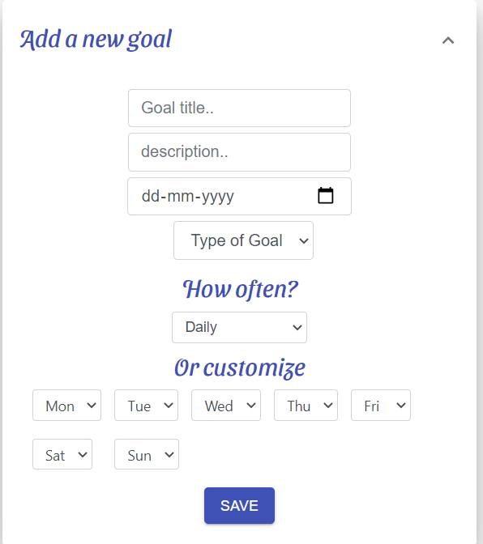

* **Editing and Closing a finished goal**

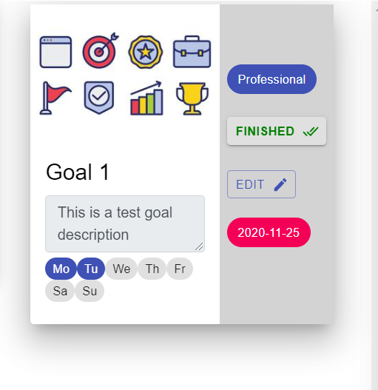

* **Track of finished and unfinished goals**

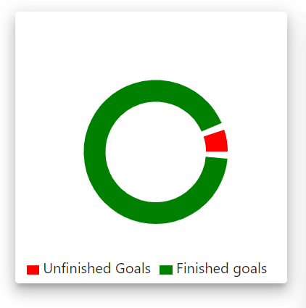

* **Upcoming Goals**

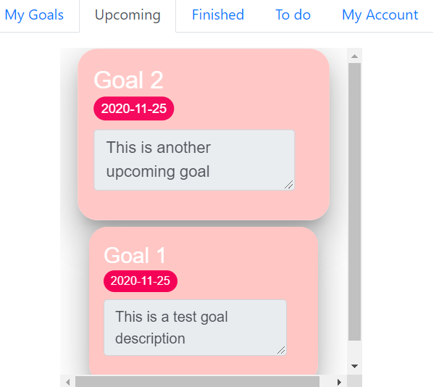

* **Finished Goals**

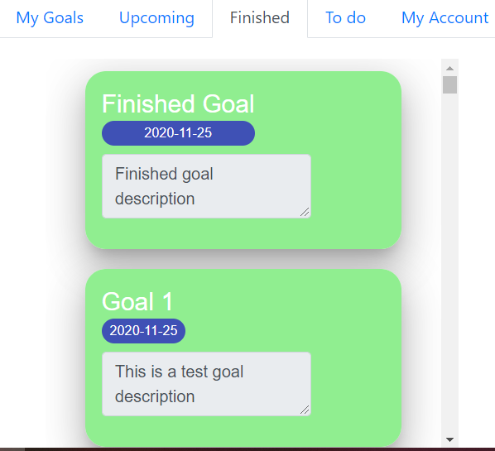

* **Email Alerts**

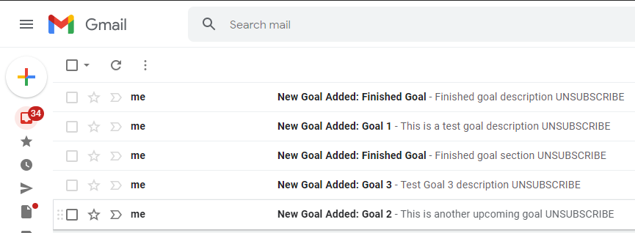

* **To-Do Lists**

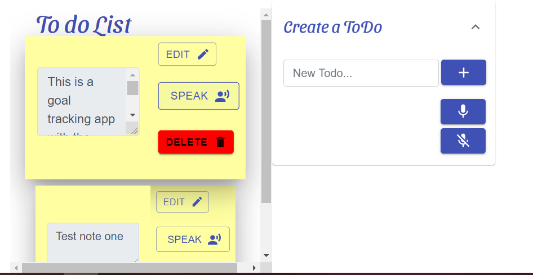

* **HomePage**

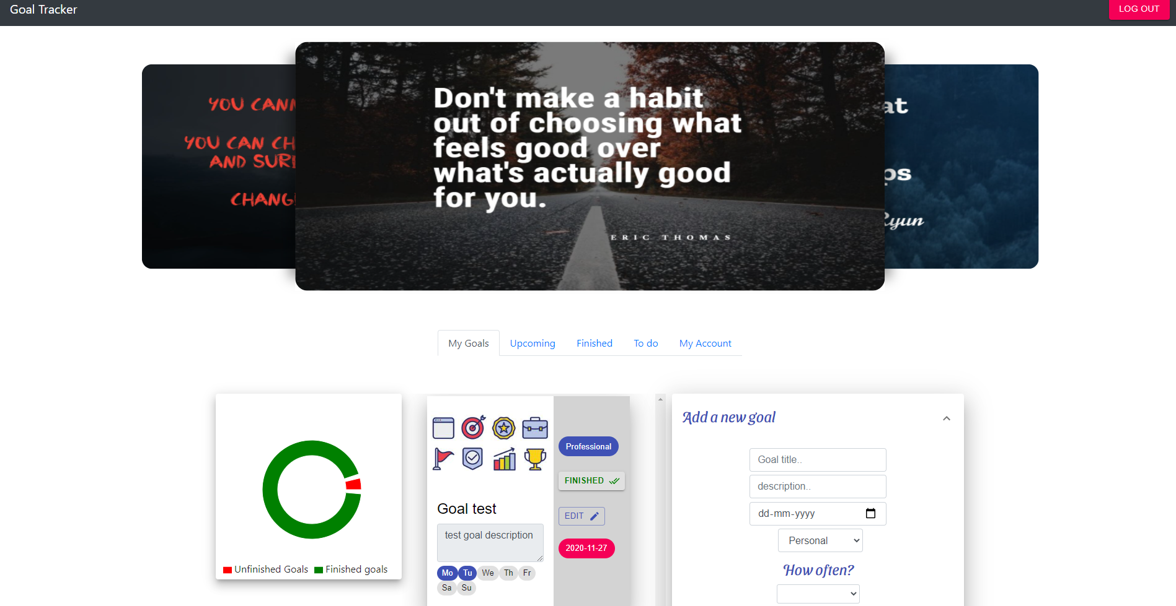

* **User Authentication**

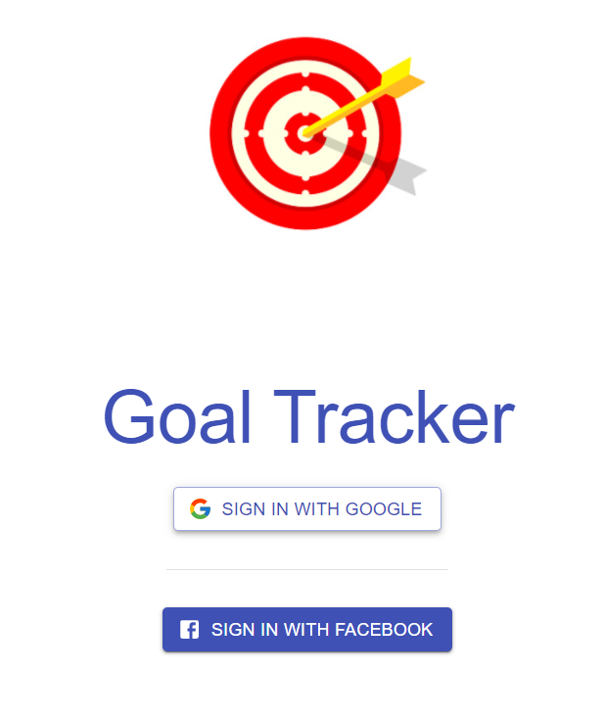

**Conclusion**

We were able to create an application which allows the users to set-up and manage their goals along with the ability to create to-do lists. We have also set up alerts and reminders which allows users to be up-to-date. Users can also keep track of completed goals to get the relevant information regarding their progress. We have tried to cover all of the possible range of situations to our knowledge that a user, who wants to set up and manage his/her goals, might get to experience.

**Analysis**

We learned about different cloud APIs which are currently being used for application development. We were able to provide solutions towards better time management using these technologies. Although there weren’t many challenges that we faced but we do think better approaches towards remote collaboration could have been used.