Proxy-URL https://corsproxy.io/?

to create a new byDefault branch: git branch -M main

package.json is for configuring npm

package-lock.json keeps the exact log of the inital viersion of all the package versions installed

A dependency that has its own dependancies is called tranisitive dependencies

In maps and loop you should always have a key ,why ? it helps the loop to uniquely identify each element or else it can fail to identify and the same loop gets repeated all the time or ELSE you can you use index, BUT React officialy doest not support or recommend this as it is a bad practice, it could change the order of your elements...if thers's like no unique id...then lastly use index

DATA STRUCTURES USED FOR REACT:

RECONCILLIATION (GIT of DOMS basically) :

Diff Aligorthm is used in manipulation of virtual DOM, it is used to find out the difference between the updated virtual DOM and previous virtual DOM,it will first calculate the difference and then simultaneously update it

all of this happens at the same time thats why the states in react gets updated so fast

This is also called as REACT FIBRE, this was introduced in react 16,this is the new way of what we discussed earlier

React fibre is the on going implementation of react's core algorithm

Its key feature is incremental rendering, incremental rendering: the ability to split the rendering work into chunks and spread it over multiple frame

super variable concept (eg const [var,setVar=useState]) is nothing but actually destructuring of array.

Monolith Architecture vs Microservice Architecture

Monolith - [API, UI, Auth, DB, SMS]

Microservice - [API] [Auth] [DB] [SMS] It has single responsibility concerns, also know as (aka) single princile concerns

React has one of the bestest and fastest rendering methods thats why you never have to bother about rendering in react

useEffect-

the useEffect gets called after the rendering of the page

also note that if there is no dependency array (i.e the array after the callback arrow function) then useEffect is called on every render

and if the useEffect contains an empty dependency array[] then it is called only on the initial render just once

fetch() is super magic provided by browser engine to javascript to fetch data from API

SHIMMER UI is the latest practice used in indrustries instead of loading a spiiner-loader

useState()-

Used to create local state variables inside a functional component

Whenever state variables are updated,react recreates a reconsiliation cycle or renders

ROUTES

-RouterProvider: this will provide actual routing configuration to our app

useRouteError() - Hook

it gives you information about your error

REACT LIFECYCLE

INITIAL PHASE

-showing in UI

- DEfault Data

Mounting Phase in react :

- Parent constructor

- Parent render

First constructor

First render

-HTML default data

- First componentDidMount

- Second componentDidMount

UPDATING Phase in react :

render (api data)

<HTML (new API data)>

componentDidUpdate

Unmounting Phase

-removing from UI

-componentWillUnmount

-usually happens when you change the component or move to a new page

\\CV

- used the latest version of react routes to follow the practice of using latest trends and also understand and improvise the judgement of what is better and what is not  
 -highly performant with page loading time (available in developer console)

-responsive with TailwindCSS with a smooth developing experience  
 -implemented caching using redux store  
 -Developed Highly Scalable React Application for Food Ordering Platform from scratch

-learned to use Reacts Custom hooks for efficient and clean coding

-fast loading with help of dynamic bundling aka lazing loading

-used the concept of controled and uncontrolled component

-highly optimized search filter

-

Code coverage (for old company)

EP-09 time: 1:21 CODE SPLITTING / CHUNKING / DYNAMIC BUNDLING / LAZY LOADING

What is higher order component?

Higher order component is function that takes a component(as an input ) and return a component(which is much more enhanced ..like adding some features to it)

//uncontrolled component does not has its own state (recieves from the parent class or controlled component)

how can a child component modify state variable of the parent component??

well its not possible directly

but a parent can pass a prop to the child (eg setShowState which will make change on click of the event)

remeber data flows in one direction i.e only from a parent to a child only

Lifting a state up in react(Very Imp)

meaning: Sometimes, you want the state of two components to always change together. To do it, remove state from both of them, move it to their closest common parent, and then pass it down to them via props. This is known as lifting state up

To coordinate these two panels, you need to “lift their state up” to a parent component in three steps:

1. Remove state from the child components.

2. Pass hardcoded data from the common parent.

3. Add state to the common parent and pass it down together with the event handlers.

Props drilling

React redux :

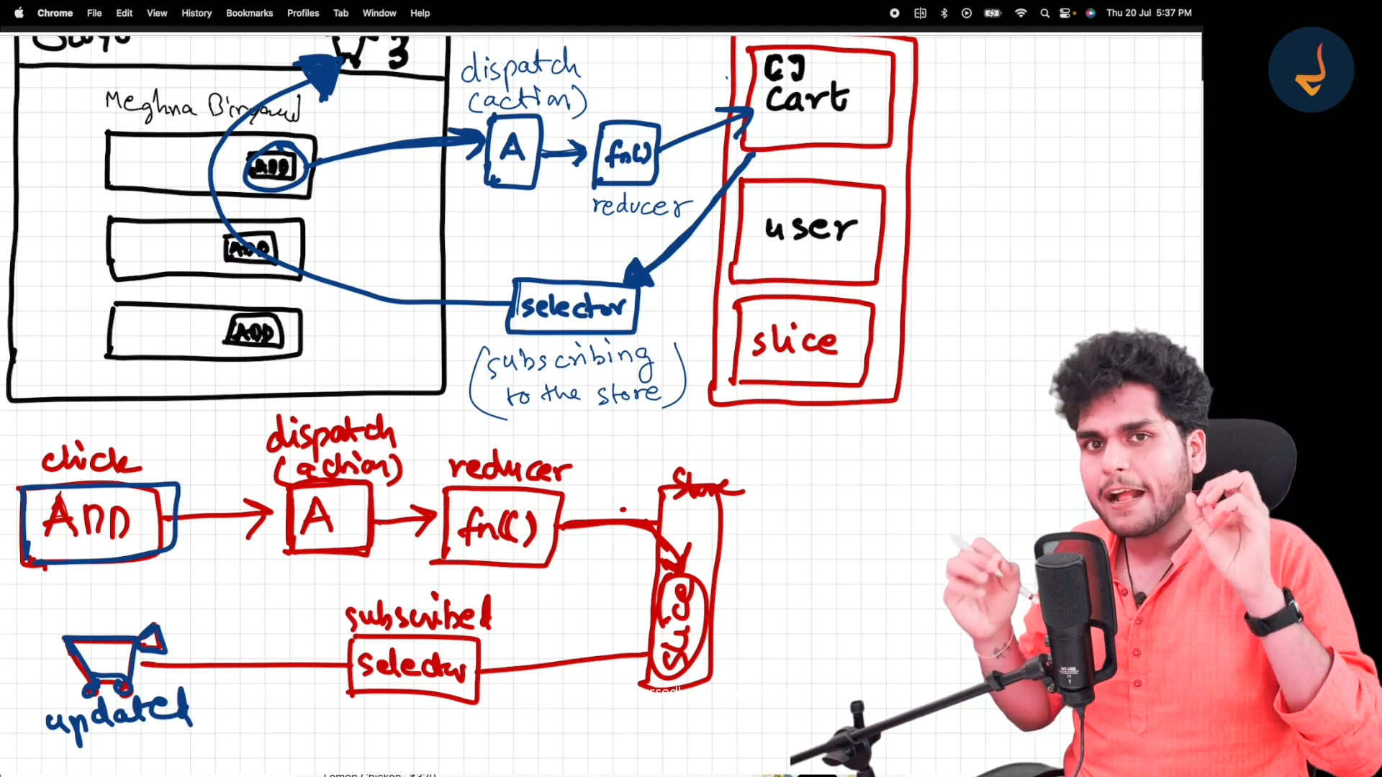

Whenever you are doing a Selector in redux make sure you are subscribing to the right specific portion only of the store(not any other) for better performance and efficiency  
(in short subscribe to the small portion of the store and not the entire store)

Older Redux

-Don’t mutate state  
 first create newState variable and then return it like this below:  
 const newState =[…state]  
 newState.items.push(action.payload);

return newState

New Redux

-can mutate state

-don’t have to return state,not mandatory  
eg:  
 name:'cart',

    initialState:{

        items:[]

    },

    reducers:{

        addItems:(state,action)=>{

            state.items.push(action.payload)

        }

React uses immer library to use that old logic behind the scenes so that developers don’t have to take the effort