Testimonials

Viplav Bhatia

1.manorama school of fine arts is a place to Know your artistic side

2.manorama school of fine arts help you to get to know the artist inside you

3.come to manorama school of fine arts and experience the joy of creating art

**Chaitanya Bhatia**

1. Manorama School of Fine Arts is not like other schools , children do drawing here as well as enjoy drawing and make fun.

2. Manorama School of Fine Arts is a place where children build their future in arts .

3. When children come here their mind distracts from tension that they have in mind .

4. In Manorama School of Fine Arts children's stress transforms in happiness.

5. Children learn many things such as oil pastel , sketching , watercolor,etc.

6. Teacher of Manorama School of Fine Arts Mr. Ganga Narayan Maharana help poor children by giving them free education about arts.

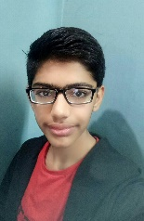

**Rajdeep Das**

Manoroma school of fine Arts headed by Mr.Ganga Narayan Maharana established in the year 2002. The way he guides us in our work with refined elegance and his mastery of his skills on arts is extraordinary and invaluable. He treats each and every student as his own child.



**Suhail Khan**

Mera naam suhail khan hai.

Or me MANORAMA SCHOOL OF FINE ARTS. mai  2 years se student hu.

MANORAMA SCHOOL OF FINE ARTS. 1993 se chalta aa raha hai.

Or is school k bare mai mujhe

GOOGLE  se pata chala.

Is school ke teacher mr. Ganga narayan maharana ji hai.

Jo hame

Sketching, painting, or Art se related jo bhi chize hai.

Wo hame sikhate hai.

Or Mrs.swarnalata maharna.

Mam hai jo hame sketching or painting me support karti hai.

Or chote chote baccho ko sikhati bhi hai.

Hamra yeh school bhot accha hai.

Sir hame full support bhi karte hai.

Hamara khayal bhi rakhte hai.

Aggr kisi ko painting and sketching pasand hai.

To MANORAMA SCHOOL OF FINE ARTS. se accha supportive school koi nahi hai.

i Love MANORAMA SCHOOL OF FINE ARTS.

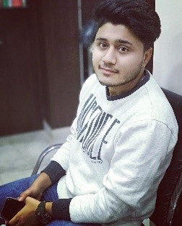

**Sushant Makheeja**

Manorama School of Fine Arts was established in the year 2000.It has the credit of holding many exhibitions at various Art Galleries. The director of the Manorama School of Fine Arts is Mr. Ganga Narayan Maharana. Manorama School of Fine Arts is in Mehrauli. There are more than 100 students which come to learn drawing and paintings and the duration of the class is 1 hour. Mr.Ganga Narayan Maharana works in Apeejay School Saket there he teaches drawing and painting to many students. I am one of the oldest student of Mr. Ganga Narayana Maharana. He is the Guru who taught me drawing and painting. I love my teacher very much.



**Sumit**

Manorma school of fine art is one of the, famous art Institute in Mehrauli , continuously since many years. I'm one of the fortunate, student, of Manorma school of fine arts, who had taken admission in that Institute. It's also a NGO, which is working for charity of the students. There are many courses in Manorma school of fine arts, like painting, sketching, art and craft, canvas painting, and all other kind of courses, you can do. Painting exhibition for junior and senior students, happens in every Two years, and that is amazing. All the poor, and rich students can participate in this exhibition. The Director of Manorma school of fine arts ,Mr. Ganga Narayan Maharana, says that, we are working for the future of  the students ,basically for poor students , who cannot afford paint and brush ,,and want to become an artist  ,we definitely help them.



Abhishek Singh

Manorama school

Is a fine institution

It encompases the many

aspects of creating n promoting creativity

It nurtures young minds

**Ardra**

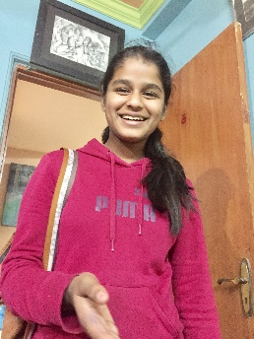

Manorama School of Fine Arts is a drawing class in Mehrauli. This school has been started since 2003 and has been the best school since then

I have joined the school in 2013 and has earned a lot from this school. This school is very different from other school and I am proud to be a part of this school.

**Prerna**

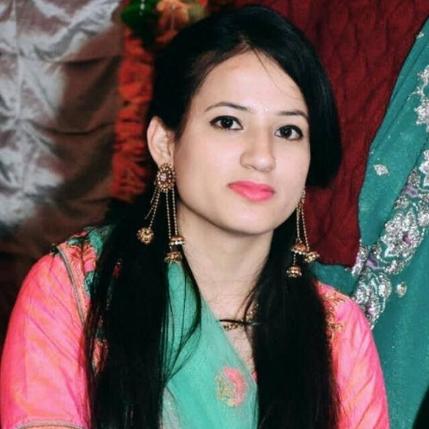

Manorama school is a very well Established. I am very fortunate that this school was started hear in Mehrauli. I love their teaching methodologies which even better than a lot of reknowned Art institutions . I am very proud to be part of this prestigious institution.

Prachi Jain

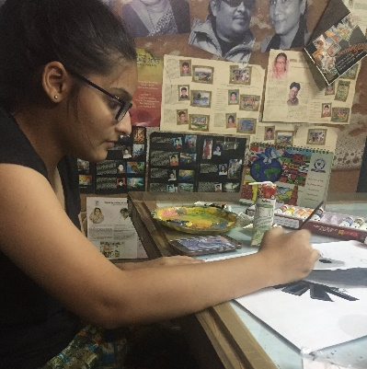

Manorma school of fine arts was established in 1993 is one of the leading school in fine arts. Through this school offers a direct easy joyful approach of learning fine arts, inspiring and encouraging his students to learn and focus about the arts and culture. Ganga narayan Maharana teaches his students various kinds of arts forms like sketching, canvas painting, fabric painting,knife painting , glass painting, steel life painting etc. As a student of this school, I've learnt a lot and provided me with knowledge and experience.