IBM Apllied Data Science

Coursera Capstone

Opening a New Shopping Mall in Bengaluru, India

By: utkal bharti

# Business Problem

* Location of the shopping mall is one of the most important decisions that will determine whether the mall will be a success or a failure
* Objective: To analyse and select the best locations in the city of Bengaluru, India to open a new shopping mall
* This project is timely as the city is currently suffering from oversupply of shopping malls
* Business question
  + In the city Bengaluru, India, if a property developer is looking to open a new shopping mall, where would you recommend that they open it?

# Data

## Data required

* + List of neighbourhoods in Bengaluru
  + Latitude and longitude coordinates of the neighbourhoods
  + Venue data, particularly data related to shopping malls

## Sources of data

* + Wikipedia page for neighbourhoods (<https://en.wikipedia.org/wiki/Category:Neighbourhoods_in_Bangalore>)
  + Geocoder package for latitude and longitude coordinates
  + Foursquare API for venue data

# Methodology

* Web scraping Wikipedia page for neighbourhoods list
* Get latitude and longitude coordinates using Geocoder
* Use Foursquare API to get venue data
* Group data by neighbourhood and taking the mean of the frequency of occurrence of each venue category
* Filter venue category by Shopping Mall
* Perform clustering on the data by using k-means clustering
* Visualize the clusters in a map using Folium

# Results

* 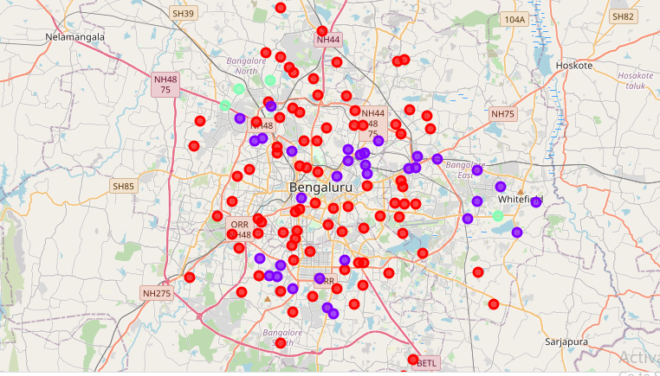­Categorized the neighbourhoods into 3 clusters :
  + Cluster 0: Neighbourhoods with moderate number of shopping malls
  + Cluster 1: Neighbourhoods with low number to no existence of shopping malls
  + Cluster 2: Neighbourhoods with high concentration of shopping malls

# Discussion

* Most of the shopping malls are concentrated in the central area of the city
* Highest number in cluster 2 and moderate number in cluster 0
* Cluster 1 has very low number to no shopping mall in the neighbourhoods
* Oversupply of shopping malls mostly happened in the central area of the city, with the suburb area still have very few shopping malls

# Recommendations

* Open new shopping malls in neighbourhoods in cluster 0 with little to no competition
* Can also open in neighbourhoods in cluster 1 with moderate competition if have unique selling propositions to stand out from the competition
* Avoid neighbourhoods in cluster 2, already high concentration of shopping malls and intense competition

# Conclusion

* Answer to business question: The neighbourhoods in cluster 1 are the most preferred locations to open a new shopping mall
* Findings of this project will help the relevant stakeholders to capitalize on the opportunities on high potential locations while avoiding overcrowded areas in their decisions to open a new shopping mall

# THANK YOU