Mini Bash Clone
A Project Based Learning Report Submitted in partial fulfilment of the requirements for the award of the degree

of

Bachelor of Technology
in The Department of Artificial Intelligence and Data Science
Operating Systems & Systems Programming (OSSP)

Submitted by
[2510080004] : [Utkalika Priyadarshinee Champati]
[2510080013] : [mandipalli akhila goud]
[2510080025] : [Bhimavarapu Venkata Naga Divya Sri]
[2510080033] : [Jinugu Kavitha Reddy]
[2510080035] : [Pamidipati ambika naidu]

Under the guidance of
[Dr. Kalpana]



[Artificial Intelligence and Data Science]
Koneru Lakshmaiah Education Foundation, Aziz Nagar
Aziz Nagar – 500075

ABSTRACT
Mini Bash Clone is an educational command-line shell project developed in the context of Operating Systems and Systems Programming. A shell accepts commands from a user, interprets the command text, and requests the operating system to run programs or perform shell-specific actions. Although users commonly interact with shells through a terminal, the internal steps—input buffering, tokenization, process creation, file-descriptor manipulation, and signal behavior—are important systems-programming concepts that can otherwise remain hidden behind a familiar interface.
The project is designed as a simplified shell written in C for Ubuntu Linux running through Windows Subsystem for Linux (WSL). GCC is used for compilation, Make provides a repeatable build entry point, and Git/GitHub provide version control. The reported baseline includes a prompt-driven command loop, dynamically managed input using malloc(), realloc(), and free(), tokenization using strtok(), argument-vector preparation, and external program execution using POSIX process APIs such as fork(), execvp(), and waitpid(). The reported built-in commands are cd, pwd, help, clear, exit, and env. Built-ins are handled by the shell itself; in particular, cd must change the working directory of the shell process rather than a short-lived child.
The project demonstrates core shell concepts including command parsing, process creation, execution, built-in commands, and selected POSIX features where implemented.
This report summarizes the design, implementation approach, experiments, results, limitations, and future improvements.
Keywords: command-line shell, C, POSIX, fork, execvp, waitpid, pipes, file descriptors, redirection, pthreads, WSL.

1. INTRODUCTION

1.3 Problem Statement
Students often use command-line shells without seeing how a command becomes a process or how the shell coordinates execution. The project addresses this learning gap by implementing a simplified shell in C. The challenge is to translate user input into a safe sequence of operations while managing dynamically allocated memory, process state, errors, and file descriptors. The project also provides a foundation for experimenting with pipes, redirection, signal behavior, and concurrent monitoring.

1.5 Project Objectives
• Develop a small interactive shell that repeatedly accepts commands until the user exits.
• Use dynamic memory allocation to support command input without relying only on a fixed-size line buffer.
• Tokenize command text and prepare an argument vector suitable for external program execution.
• Demonstrate process creation, program execution, waiting, and basic error reporting with POSIX interfaces.
• Implement and explain the reported built-in commands cd, pwd, help, clear, exit, and env.
• Study the design of signal handling, pipes, output redirection, and POSIX background monitoring where these modules are present.
• Use a repeatable build workflow and document test cases, debugging methods, and limitations accurately.

1.6 Project Scope
The core scope described in the project records is a simplified Unix-like shell in C. The reported baseline comprises an interactive prompt, dynamic input handling, tokenization, argument preparation, external command execution, and a small built-in command set. The project brief additionally reports work on signal handling, pipelines, output redirection, and a monitoring thread. Since the source tree could not be fetched or inspected during report generation, the advanced features are marked as requiring source-level verification before submission.
This project is not a replacement for Bash. Unless code and tests establish otherwise, the report does not assume support for quoted arguments, escape sequences, environment-variable expansion, input redirection (<), standard-error redirection (2>), background jobs (&), command history, tab completion, command substitution, or complete job control. A feature's inclusion in a project plan is not sufficient evidence that every edge case works.

2. METHODOLOGY
Category | Requirement / note
Operating environment | Ubuntu Linux; WSL on Windows is the reported development setup.
Compiler | GCC or another compatible C compiler.
Build tool | GNU Make or a compatible make implementation.
Language/API | C and POSIX interfaces available in the target Linux environment.
Version control | Git; repository identified as https://github.com/utkalika16/mini-bash-clone.
Validation tools | GDB, Valgrind, and/or AddressSanitizer where installed.
Optional threading | POSIX threads library; builds using pthreads generally need the compiler/linker thread option -pthread.

2.2 Technologies Used
Technology | Role in the project
C | Implements the shell loop, memory handling, parsing, built-ins, and process coordination.
Ubuntu / Linux | Provides the POSIX-like execution environment and system interfaces.
WSL | Runs a Linux user environment on the Windows development machine.
GCC | Compiles C source files and reports compiler diagnostics.
Make | Encodes build dependencies and repeatable compilation commands in a Makefile.
POSIX APIs | Interfaces such as fork(), execvp(), waitpid(), pipe(), dup2(), open(), and pthread functions, where used.
Git / GitHub | Tracks changes and stores the project repository remotely.
GDB | Allows breakpoints, stepping, stack inspection, and variable inspection.
Valgrind | Checks memory use and reports leaks or invalid memory operations for tested runs.
AddressSanitizer | Can detect classes of memory errors when enabled during compilation and execution.

2.3 Overall System Architecture
The architecture begins with user input and proceeds through input management and parsing. The resulting command representation is classified as a built-in operation or an external command. Supporting modules may configure signals, pipes, redirection, and monitoring. The figure is a schematic of the reported design, not a substitute for confirming the exact function calls and source-file boundaries.
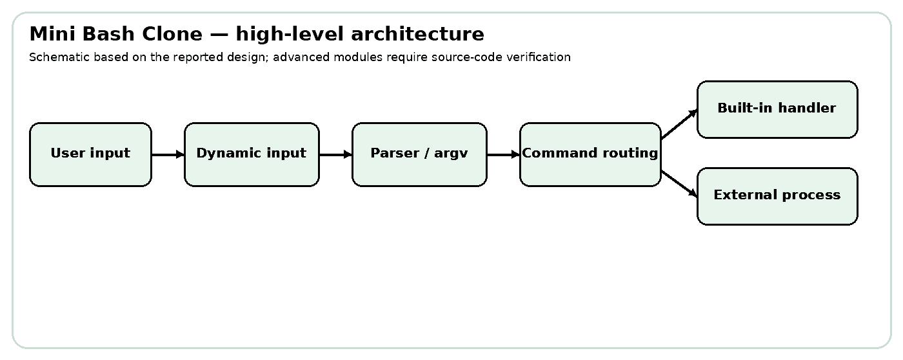
Figure 1. Overall Mini Bash Clone architecture
A robust implementation should make module responsibilities explicit. Input management should return a valid allocated line or a clear end-of-input/error indication. Parsing should define how tokens are separated and how the argument vector is terminated. Command routing should identify built-ins before creating a child when a built-in must modify the shell process. External execution should distinguish fork failure, exec failure, and child termination. Pipe and redirection code should close unused file descriptors in every process.

2.4 Project Directory Structure
The project history records a modular layout with src, include, docs, tests, and bin directories, plus a Makefile and README.md. The initial and early-week source files confirmed in project notes include src/main.c and src/input.c, with include/shell.h and include/input.h. Later modules such as parser.c, process.c, builtin.c, signals.c, pipes.c, redirect.c, and thread.c are listed in the documentation request as expected modules, but their current presence and exact names were not independently verified. The table therefore distinguishes known baseline files from planned or reported module responsibilities.
Path / module | Responsibility (status)
src/main.c | Main shell entry point and interactive loop (recorded in early project structure).
src/input.c / include/input.h | Dynamic line input and input-related declarations (recorded as Week 2 work).
include/shell.h | Shared shell declarations; earlier project notes mention correcting a header guard issue.
parser.c / parser.h | Expected location for tokenization and argv construction; verify actual file before submission.
process.c / process.h | Expected location for fork/exec/wait logic; verify actual file before submission.
builtin.c / builtin.h | Expected location for cd, pwd, help, clear, exit, and env handlers; verify actual file.
signals.c / signals.h | Expected location for signal setup; exact behavior unverified.
pipes.c / pipes.h | Expected location for pipeline handling; exact behavior unverified.
redirect.c / redirect.h | Expected location for > and >> handling; exact behavior unverified.
thread.c / thread.h | Expected location for pthread monitor; exact lifecycle unverified.
Makefile | Build entry point; inspect actual rules and compiler flags before final submission.
tests/, docs/, screenshots/, bin/ | Test artifacts, documentation, screenshots, and build output; contents vary by working copy.

2.6 Command Parsing
Parsing converts a line of text into a command name and an array of argument strings. For example, the simple line ls -l /tmp can be represented as argv[0] = "ls", argv[1] = "-l", argv[2] = "/tmp", and argv[3] = NULL. The terminating null pointer is required by execvp() and other exec-family functions.
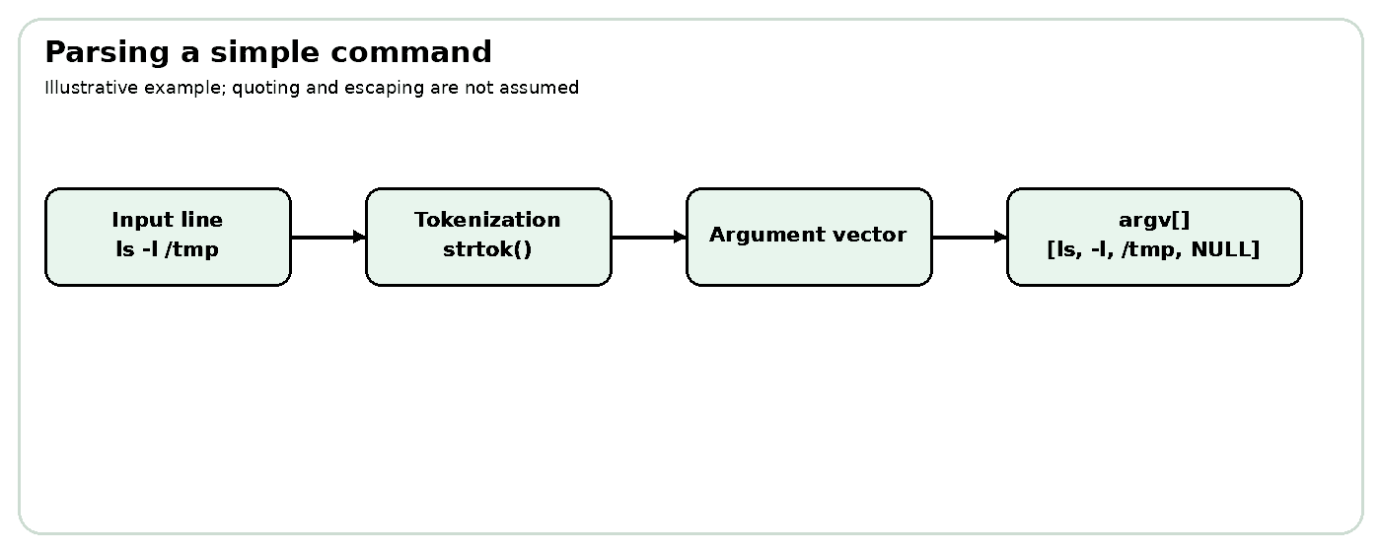
Figure 3. Command parsing and argument creation
The recorded Week 3 milestone uses strtok() and dynamic argv construction. strtok() modifies the input string by replacing delimiters with null bytes and maintains internal parsing state. It is adequate for a basic whitespace-delimited demonstration, but it is not a complete shell lexer: quoted strings, escaped spaces, nested syntax, and operators need additional logic. If strtok() is used, callers should also consider that it is not designed for concurrent tokenization of multiple strings in the same thread without using an alternative such as strtok_r().
Illustrative token vector:
Input: ls -l /tmp
argv[0] -> "ls"
argv[1] -> "-l"
argv[2] -> "/tmp"
argv[3] -> NULL
For a pipeline or redirection syntax, the parser must do more than split on spaces. It must identify operator tokens such as |, >, and >>, preserve command boundaries, and reject malformed forms. The report does not assume that these parsing edge cases are supported until they are tested against the actual implementation.

2.7 Process Creation and Execution
POSIX process management separates creating a process from loading a program into it. fork() creates a child process that initially continues from the same program state. The return value distinguishes the parent from the child: the child receives zero, while the parent receives the child's process identifier; failure is indicated by a negative return value. The child can then call execvp() to search the PATH for a program and replace its process image with that program. If execvp() succeeds, it does not return. If it returns, an error occurred.
The parent commonly calls waitpid() to wait for the child and collect its termination status. This avoids leaving an exited child as a zombie until it is reaped. A shell may use the status to decide what to display or how to continue. Error paths matter: fork() failure must not lead to use of an invalid child PID, and an execvp() failure in the child should be reported and followed by an appropriate child exit.
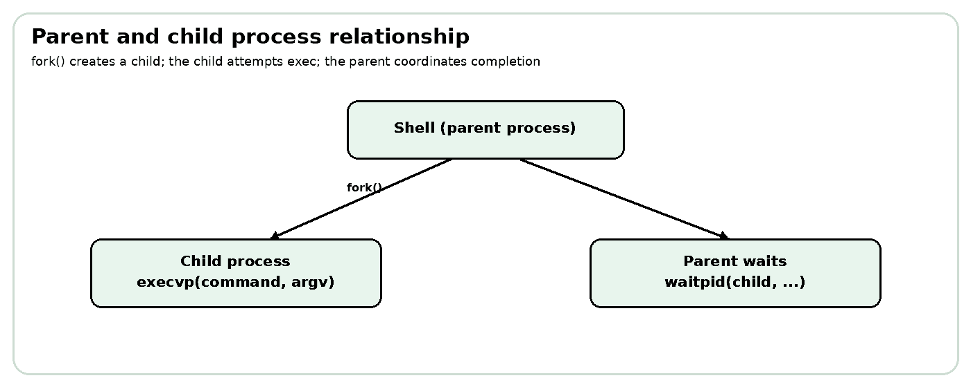
Figure 4. Parent-child process execution
/* Conceptual control flow, not project source */
pid_t pid = fork();
if (pid == 0) {
execvp(argv[0], argv);
perror("execvp");
_exit(127);
} else if (pid > 0) {
waitpid(pid, &status, 0);
} else {
perror("fork");
}
The example is illustrative and omits project-specific structures and signal policy. A final technical review should compare it with the actual process module, including how interrupted waitpid() calls and child exit status are handled.

2.8 Built-in Command Implementation
A built-in command is implemented by the shell rather than found as a separate executable. This is especially important for cd: changing the working directory in a child would change only the child's directory, and the shell would remain in its previous directory after the child exits. Therefore, cd must call chdir() in the shell process when it is intended to affect subsequent commands.
Command | Purpose | Implementation point
cd | Change the shell's current working directory. | Must execute in the shell process; report chdir() errors.
pwd | Display the current working directory. | Often uses getcwd(); check buffer/error handling.
help | Display supported commands or usage information. | Should describe only commands actually supported.
clear | Clear the terminal display. | May emit terminal control sequences; behavior depends on terminal.
exit | Terminate the shell loop/process. | Should define behavior for arguments and cleanup.
env | Display environment variables. | Typically iterates over environ or uses an equivalent mechanism.

These commands are listed in the project records as implemented by Week 5. The table explains their intended semantics; exact argument handling and error messages should be checked in the current source. For example, a production shell has detailed rules for cd with no argument, invalid paths, and environment variables such as HOME. A teaching shell may implement a smaller subset.

2.13 Compilation and Build Process
A Makefile describes targets, source dependencies, compiler options, and output paths. A typical C build invokes GCC with warning flags, include paths, source files, and an output executable. The actual Makefile should be treated as authoritative; the command below is an illustrative direct compilation pattern consistent with the recorded early source files, not a verified complete command for later modules.
gcc -Wall -Wextra -g -Iinclude src/main.c src/input.c -o bin/bashclone
The -Wall and -Wextra options enable useful warning groups, -g includes debugging information, and -Iinclude tells the compiler where to find project headers. If pthread functions are used, the compile/link command should normally include -pthread. A modular project may compile separate object files before linking; this can shorten rebuild times and make dependencies explicit. The actual target name and source list should be confirmed with make -n or by reading the Makefile.
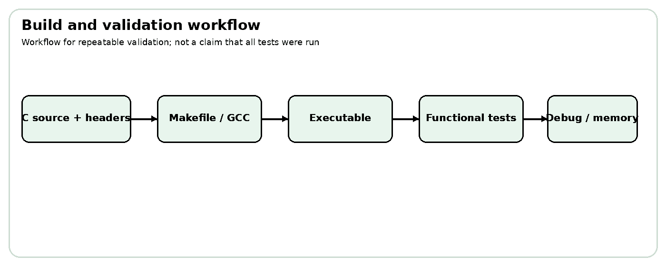
Figure 8. Build, test, and validation workflow

3. EXPERIMENTS
This chapter specifies repeatable experiments for evaluating Mini Bash Clone. Because the repository could not be fetched into the current report-generation environment and no project ZIP or source bundle was attached, expected behavior is separated from observed behavior. Where a test transcript was not provided, the observed outcome is marked “Not independently verified.” Before submission, the team should run each supported test, capture authentic terminal output, and update the evidence column.

Experiment 1: Compilation and Shell Startup
Aim: Build the shell and confirm that the executable starts and displays its prompt.
Relevant concept: Compilation, linking, Makefile targets, and the interactive read–execute loop.
Procedure:
1. Open Ubuntu/WSL and change to the project directory.
2. Review the Makefile target and source list.
3. Run make and resolve any compiler diagnostics.
4. Launch the generated executable using the documented target path.
Command / example:
cd ~/BashClone
make
./bin/bashclone
Expected behavior: The build completes without errors and the shell displays its prompt. The exact executable path may differ if the Makefile defines another target.
Observed behavior: Not independently verified in this session; no terminal transcript or build log was supplied.
Result: Procedure documented. Record the actual build output and executable path before marking as passed.

Experiment 3: Command Parsing
Aim: Verify that a command line is converted into the intended command and argument vector.
Relevant concept: Tokenization, argv[] construction, and null termination.
Procedure:
1. Launch the shell.
2. Enter a simple command with two arguments.
3. Check output or temporary debug information to confirm token boundaries.
4. Repeat with extra spaces and document how unsupported quoting is handled.
Command / example:
ls -l /tmp
Expected behavior: The simple command is represented as argv[0] = ls, argv[1] = -l, argv[2] = /tmp, argv[3] = NULL.
Observed behavior: Not independently verified; the documented Week 3 milestone reports strtok() and dynamic argv construction.
Result: The example is a parsing illustration. Verify the actual parser and argument limits.

Experiment 4: External Command Execution
Aim: Confirm that the shell launches an external executable and coordinates with the child process.
Relevant concept: fork(), execvp(), waitpid(), child exit status, and error handling.
Procedure:
1. Launch the shell.
2. Run a known external command such as ls or uname.
3. Run a nonexistent command and observe the error path.
4. Exit the shell and inspect any child-process diagnostics.
Command / example:
ls
uname -a
command_that_does_not_exist
Expected behavior: Existing commands execute through a child process; a nonexistent command produces an error rather than silently succeeding.
Observed behavior: Project notes report fork(), execvp(), and waitpid() work, but the exact run was not independently verified here.
Result: Core process-execution behavior should be validated with both success and failure cases.

Experiment 5: Built-in Commands
Aim: Test each reported built-in command and confirm its effect on the shell.
Relevant concept: Built-in dispatch, current-directory state, environment display, terminal control, and exit handling.
Procedure:
1. Run help and compare its output with the actual supported command list.
2. Run pwd, change directory with cd, then run pwd again.
3. Run env and check that environment entries are displayed.
4. Run clear and confirm terminal behavior.
5. Run exit last to leave the shell.
Command / example:
help
pwd
cd /tmp
pwd
env
clear
exit
Expected behavior: Built-ins perform their documented functions. In particular, cd changes the working directory used by subsequent commands in the shell.
Observed behavior: Project records list these six built-ins as Week 5 work; individual test observations were not supplied.
Result: Run each command individually and record any argument limitations or errors.

Experiment 7: Pipe Execution
Aim: Check whether the shell connects the output of one command to the input of another.
Relevant concept: pipe(), file descriptors, dup2(), closing unused ends, and waiting for pipeline children.
Procedure:
1. Confirm that the current parser recognizes the pipe operator.
2. Run a simple pipeline with commands available on the system.
3. Compare the output with the same pipeline run in the system shell.
4. Check for hanging behavior that may indicate an unclosed pipe descriptor.
Command / example:
ls -l | grep ".c"
Expected behavior: If pipeline parsing and execution are implemented, grep should receive the listing from ls through the pipe. This is expected behavior only.
Observed behavior: Not independently verified; the pipeline module was not available for inspection.
Result: Do not mark the example as working until it succeeds in the project shell.

Experiment 8: Output Redirection
Aim: Check whether > redirects command output to a file and overwrites existing contents.
Relevant concept: open(), dup2(), close(), standard output descriptor 1, and truncation semantics.
Procedure:
1. Choose a temporary working directory.
2. Run the command below inside the project shell if > is supported.
3. Inspect the file with a separate command or terminal.
4. Repeat after placing different content in the file to verify overwrite behavior.
Command / example:
echo Hello > test.txt
cat test.txt
Expected behavior: If implemented correctly, test.txt contains Hello followed by a newline, and prior file contents are replaced.
Observed behavior: Not independently verified; no source or output transcript was provided.
Result: Expected outcome only; confirm open() flags and actual file contents.

4. RESULTS

4.1 Functional Results
The project records establish a staged development history: initial project setup, dynamic input management, command parsing, process execution, and a set of built-in commands. These milestones provide a credible description of the baseline work. They do not, by themselves, establish that every current source file compiles or that every feature passes a fresh test. In this report, implementation history and independently observed test results are treated as different forms of evidence.
Feature area | Evidence in project records | Status for this report
Project skeleton and build workflow | Week 1 structure and Makefile-based project recorded. | Recorded; current build not independently run.
Dynamic input | Week 2 malloc/realloc/free milestone recorded. | Reported implemented; edge cases unverified.
Command parsing | Week 3 strtok()/argv milestone recorded. | Reported implemented; quoting and operators unverified.
External execution | Week 4 fork()/execvp()/waitpid() milestone recorded. | Reported implemented; current source not inspected.
Built-ins | Week 5 cd, pwd, help, clear, exit, env recorded. | Reported implemented; each command needs test evidence.
Signal handling | Listed in project brief. | Implementation details unverified.
Pipes | Listed in project brief. | Implementation details and behavior unverified.
Output redirection | Listed for > and >>. | Implementation details and behavior unverified.
POSIX monitor thread | Listed in project brief. | Implementation details and runtime output unverified.
Memory validation | Prior Valgrind summary described in project records. | Historical result only; exact test context unavailable.

4.6 Test Case Table
Test ID | Feature | Input / command | Expected result | Observed result | Status
T01 | Build | make | Build completes with no errors. | Not independently verified | Pending
T02 | Startup | ./bin/bashclone | Prompt is displayed. | Not independently verified | Pending
T03 | Input | Short and long command lines | Input accepted within supported scope. | Not independently verified | Pending
T04 | Parsing | ls -l /tmp | Arguments prepared in expected order. | Not independently verified | Pending
T05 | External execution | uname -a | External program runs and returns. | Reported milestone; no transcript | Pending re-test
T06 | Built-in cd | cd /tmp; pwd | Shell working directory changes. | Not independently verified | Pending
T07 | Signals | Ctrl+C at prompt / during sleep | Behavior matches signal policy. | Not independently verified | Pending
T08 | Pipe | ls -l | grep ".c" | Second command receives first command's output. | Not independently verified | Pending
T09 | Overwrite redirect | echo Hello > test.txt | File is created/truncated and receives output. | Not independently verified | Pending
T10 | Append redirect | echo World >> test.txt | New output is appended. | Not independently verified | Pending
T11 | Monitor thread | Launch and wait | Reported monitor message appears. | Not independently verified | Pending
T12 | Memory check | Valgrind on selected run | Diagnostics recorded with exact test context. | Historical summary only | Reproduce

4.8 Limitations
The following limitations are confirmed as evidence limitations of this report rather than definitive defects in the code: the repository source was not accessible to the generation environment, no project ZIP was attached, and no current terminal screenshots or test logs were supplied. Therefore, current module names, exact signal policy, parser edge cases, pipeline support, redirection flags, thread shutdown, and test coverage remain unverified.
At the product level, the scope is intentionally narrower than Bash. Features such as advanced quoting, expansion, input/error redirection, background jobs, history, completion, and job control should be described as unsupported only after checking the source and running tests. If they are not present, they should be listed as limitations or future work, not silently represented as implemented.

5. CONCLUSION AND FUTURE WORK

5.1 Conclusion
Mini Bash Clone is an educational shell project that applies C programming and operating-system concepts to a recognizable command-line interface. The recorded development sequence covers the initial project structure, dynamic input management, tokenization and argument preparation, process creation and external execution, and built-in commands. These components form a useful foundation for understanding how a shell bridges user commands and operating-system services.
The project also provides a context for studying signals, inter-process communication through pipes, output redirection, and POSIX threads. These advanced areas require careful implementation because they involve process relationships, descriptor ownership, asynchronous events, and concurrent output. The report has described their underlying mechanisms while clearly marking source-level details and test outcomes that were not independently verified.
Objective | Assessment from available records
Create a modular shell project | Initial structure and build setup recorded.
Read input dynamically | Week 2 memory-allocation milestone recorded.
Parse commands into argv | Week 3 strtok()/argv milestone recorded.
Execute external programs | Week 4 fork()/execvp()/waitpid() milestone recorded.
Support built-in commands | Week 5 command list recorded: cd, pwd, help, clear, exit, env.
Study signals, pipes, redirection, and threads | Included in the project brief; current implementation needs source review.
Validate memory behavior | A historical Valgrind summary is recorded, but test context should be reproduced.

5.4 Future Enhancements
• Implement input redirection with < if it is not already supported.
• Implement standard-error redirection with 2> if it is not already supported.
• Add background command execution using & and manage child processes reliably.
• Introduce job control for foreground/background jobs and terminal ownership.
• Add command history and optional tab completion.
• Improve parsing for single and double quotes, escaped characters, and malformed operators.
• Add environment-variable expansion and define how unset variables are handled.
• Improve thread synchronization and monitor lifecycle, including a clear shutdown strategy.
• Build an automated regression suite for built-ins, process failures, signals, pipes, and redirection.
• Add CI builds with compiler warnings and optional sanitizer runs.
• Document exact supported syntax and provide a feature matrix in the README.

REFERENCES
[1] The Open Group, “POSIX.1-2017: The Single UNIX Specification,” https://pubs.opengroup.org/onlinepubs/9699919799/ (accessed 14 October 2026).
[2] Linux man-pages project, “fork(2) — create a child process,” https://man7.org/linux/man-pages/man2/fork.2.html (accessed 14 October 2026).
[3] Linux man-pages project, “exec(3) — execute a file,” https://man7.org/linux/man-pages/man3/exec.3.html (accessed 14 October 2026).
[4] Linux man-pages project, “waitpid(2) — wait for process to change state,” https://man7.org/linux/man-pages/man2/waitpid.2.html (accessed 14 October 2026).
[5] Linux man-pages project, “pipe(2) — create pipe,” https://man7.org/linux/man-pages/man2/pipe.2.html (accessed 14 October 2026).
[6] Linux man-pages project, “dup(2) — duplicate a file descriptor,” https://man7.org/linux/man-pages/man2/dup.2.html (accessed 14 October 2026).
[7] Linux man-pages project, “open(2) — open and possibly create a file,” https://man7.org/linux/man-pages/man2/open.2.html (accessed 14 October 2026).
[8] Linux man-pages project, “signal(7) — overview of signals,” https://man7.org/linux/man-pages/man7/signal.7.html (accessed 14 October 2026).
[9] Linux man-pages project, “pthreads(7) — overview of POSIX threads,” https://man7.org/linux/man-pages/man7/pthreads.7.html (accessed 14 October 2026).
[10] GNU Project, “GCC Online Documentation,” https://gcc.gnu.org/onlinedocs/ (accessed 14 October 2026).
[11] GNU Project, “GNU Make Manual,” https://www.gnu.org/software/make/manual/ (accessed 14 October 2026).
[12] Valgrind Developers, “Valgrind User Manual,” https://valgrind.org/docs/manual/manual.html (accessed 14 October 2026).
[13] GNU Project, “GDB: The GNU Project Debugger,” https://www.sourceware.org/gdb/documentation/ (accessed 14 October 2026).
[14] LLVM Project, “AddressSanitizer,” https://clang.llvm.org/docs/AddressSanitizer.html (accessed 14 October 2026).
[15] Microsoft, “Windows Subsystem for Linux Documentation,” https://learn.microsoft.com/windows/wsl/ (accessed 14 October 2026).
[16] Mini Bash Clone project repository, https://github.com/utkalika16/mini-bash-clone (project URL supplied by the student; source contents were not independently accessible during this report generation).

