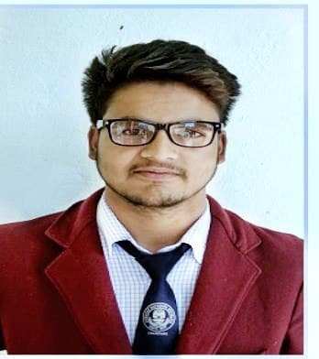­­­

+9149567259

[sheikhirshadhamidhttps://www.linkedin.com/in/irshad-hamid-sheikh-7720b0229@gmail.com](mailto:sheikhirshadhamid@gmail.com)

[2041019365.irshadhamidsheikh@gmail.com](mailto:2041019365.irshadhamidsheikh@gmail.com)

<https://www.linkedin.com/in/irshad-hamid-sheikh-7720b0229>

ITER Bhubaneswar Odisha

(751030)

As I am from jnv a residential school In my early life when I was a child I learnt how to adapt in different environments which still helps me in this stage of life, in my school days I was the school president so I often had to take hard decisions for the welfare of students. I love to spend my free time in creating new designs for websites and also use to draw some paintings. I have attended many seminars and workshops organized by the college and other private organizations .I follow the principal that if one door of opportunities closes many other opens as well just hope for the best

About Me

**IRSHAD HAMID SHEIKH**

CONTACT

9/10

Web Dev

**Web-dev Intern– [1 Month]**

Optimus Sellers Pvt ltd  
I have completed a 1 month internship at optimus sellers pvt ltd. It was a great experience working with the professional people. I also got the opportunities to work on projects and web sites. I am glad to say that the official web site of the company is designed and developed by me <https://Optimussellers.com> **Marketing & Strategy intern– [1 Month]** Mentor Box  
I have also completed a 1 month internship at Mentor Box as a Marketing & Strategy intern where I learnt about a very different thing ,how to attract the audience and I managed to do it very greatly .I also learnt to use some new tools like canvas Photoshop etc. That added a great value to my career lsjaklj

Looking forward to work with you

Experience

7/10

Python

8/10

DSA

8/10

C

8/10

C++

9/10

Java

8/10

Equipment Handling

9/10

Communication

Skills

**B.tech (CS & IT)– [2024]**

Siksha ‘o Anusandhan (deemed to be University)  
After I completed my 12 standard I choose computer science as my career subject As I already got acquainted with c++ as my additional subject in my 12th class

**12th (PCM+C++) – [2020]**

Jawahar Navodaya Vidyalaya  
I finished my 12th standard in 2020 with a percentage of 87 in (PCM) with C++ as my additional subject in Jawahar Navodaya Vidyalaya Anantnag

**10th– [2018]**

Jawahar Navodaya Vidyalaya  
I completed my 10th Standard in 2018 with a percentage of 87, taking some small steps towards a new chapter of life

Education

* English (9/10)
* Hindi(7/10)
* Urdu (8/10)
* Kashmiri(9/10)
* Coding
* Reading
* Travelling
* Gaming

LANGUAGES

INTERESTS