**Bibhudutta Dash**

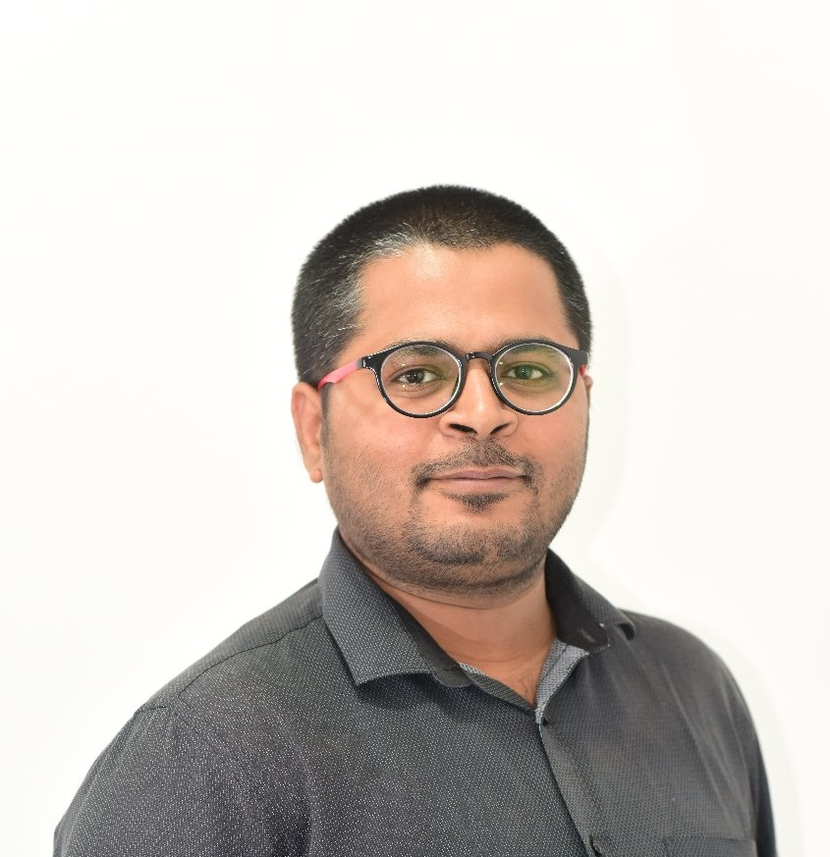

**Sr. Software Developer at Gemini Consulting Services Pvt Ltd.**

**Location : Bhubaneswar**

**Email : dbibhudutta@gmail.com**

**Mobile : +91 7809 859 382, +91 8249 689 343**

**Profile Summary**

8+ years of experience in all stages of Web and software development lifecycle, from concept and development through quality assurance (QA) and tuning. Highly versed in PHP 8 concepts with skills in creating websites and web applications using frameworks. In-depth understanding of security, SEO, and optimization to maximize site performance. Extensive knowledge and on-hands experience in information architecture, web design, project management, and testing. Good Experience in payment gateway, sms gateway or other api integration.

**Professional Experience**

**Gemini Consulting Services Pvt Ltd.** (Mar 2017 to Present)(Senior Software Developer)

* Work with team members to provide timely and accurate estimates for development solutions
* Work with leadership team to provide strategic direction for existing toolset
* Manage multiple and sometimes competing priorities and tasks within work team
* Provide feedback to the team and individuals on their performance
* Drive software solutions to completion on time while providing regular status updates
* Lead a team developing high quality software solutions
* Provide mentoring, guidance, feedback and training to team members
* Requirement gathering and client handling onsite visit etc.
* Development, testing, debugging, and maintenance of dynamic and secure websites and web-based applications, including widgets, templates, and microsites
* Oversaw third-party content integration and migration project involving architecture, design, implementation, and testing of integrated web applications on aggressive timeline. Successful project was completed on time and under budget.
* Work with technical, design, business, and editorial staff to create applications and pages.
* Research current industry trends, and assist with development and promotion of coding best practices within team and industry.

**Cupazo Consulting Services Pvt Ltd** (January 2015 to Feb 2017)(Software Developer)

* Development, testing, debugging, and maintenance of dynamic and secure websites and web-based applications, including widgets, templates, and microsites
* Oversaw third-party content integration and migration project involving architecture, design, implementation, and testing of integrated web applications on aggressive timeline. Successful project was completed on time and under budget.
* Work with technical, design, business, and editorial staff to create applications and pages.
* Research current industry trends, and assist with development and promotion of coding best practices within team and industry
* Developed international e-commerce website and Web applications, encompassing design, coding, testing, and maintenance.
* Created online exam portal.
* Create cms based websites and developed plugins for those sites.
* Integrated UI with large backend applications.

**Myneedz Services Pvt Ltd** (January 2014 to Dec 2014)(Web Developer)

* Developed international e-commerce website and Web applications, encompassing design, coding, testing, and maintenance.
* Created online exam portal.
* Create cms based websites and developed plugins for those sites.
* Integrated UI with large backend applications.

**Adventures Solutions Pvt Ltd** (June 2012 to Dec 2013)(Web developer)

* Built, tested, and implemented user interface applications.
* Assisted with product development projects.
* Wrote and edited content for company’s website and e-newsletters.
* Aided in writing technical documents for website enhancements and updates.

**Project Experience(application)**

* **Pragati Milk Collection ERP**: This application used by Pragati Milk Products Pvt Ltd. For tracking vendor milk collection and making payments to farmer. This system also includes vendor mobile app. This system also includes services which works with SAP system.
  + Technology**:** PHP, MySQL, Codeigniter.
  + Team Size: 3
  + Role: Lead Developer
* **Transport Management System**: This application is used for Odisha State Road Transport Corporation(OSRTC) for all its operations. This system includes various modules such as Bus based Fleet Monitoring System, Automatic Fare Collection System, Passenger Information System (In Bus and Bus Station), Vehicle Scheduling and Dispatch System, Incident Management System, Depot Management System.
  + Technology**:** PHP, MySQL, Laravel
  + Team Size: 5
  + Role: Lead Developer
* **Guest House Management**: The guest house management system implemented on state guest house for Govt of Odisha.
  + Technology: PHP, MySQL, Codeigniter
  + Team Size: 4
  + Role: Lead
* **MIS Application(Landesa)**: It is non-profit organization which distributes land rights among below poverty people. They maintained records in a MIS application. Generating reports PDF, Excel.
  + Technology: PHP, MySQL, CodeIgniter.
  + Team Size: 3
  + Role: Developer
* **Training Management System(WALMI):** WALMI is an institute for providing training to farmer and block level officer about using water resources and irrigation techniques. This application will help them to keep track of trainings and trainee data.
  + Technology: PHP, MySQL, CodeIgniter.
  + Team Size: 2
  + Role: Developer
* **ApexVisas (CRM)**: Apexvisas is one of the leading immigration and visa consultants in India. We are providing visa processing services for Australia, Canada, Denmark, New Zealand and more.
  + Technology: PHP, MySQL, Javascript, jQuery, Codeigniter
  + Team Size: 5
  + URL: **apexvisas.com**
  + Role: Developer
* **Seaways Group PMS**: The Seaways Group, in its successful sailing of over 28 years, has achieved the distinction of being one of the leading logistics service providers in India offering integrated and turnkey services in shipping and logistics domains. Today, Seaways has well-established NVOCCs operations in South East Asia and Middle East markets. It’s a appraisal management system.
  + Technology: PHP, MySQL, CodeIgniter.
  + Team Size: 2
  + Role: Developer
* **MN Exam**: MNExam is a FREE online exam preparation platform where the members are Students, Teachers & Institutes only. It is an online exam portal where students and both teacher share questions. Student can get free practice exams.
  + Technology: PHP, MySQL, Javascript, jQuery
  + Team Size: 5
  + URL: [www.mnexam.com](http://www.mnexam.com)
  + Role: Developer
* **Young Phoenix Public School ERP**: Its school management system having all kinds of features like attendance, payroll, online exam.
  + Technology: PHP, MySQL, Javascript, jQuery
  + Team Size: 5
  + URL: http://yppschool.com/erp/

**Educational Qualification**

* Completed **MCA** from DDCE Fakir Mohan University, Odisha.
* Completed **GNIIT** (Software Engineering) from NIIT.
* Completed **B.Sc. (IT)** from NIIT distance learning from Kuvempu University, Karnataka in the year 2011.
* Completed **+2 Sc** (PCBM) from CHSE, Orissa in the year 2007.
* Completed **HSC** from BSE, Orissa in the year 2005.

**Technical Skill**

* Programming Language- PHP
* Web Technologies: HTML, HTML5, CSS3, XML, JavaScript, Jquery, React, Angular JS.
* CMS: Wordpress, Joomla, Drupal
* PHP Framework: Codeigniter, CakePHP, Laravel, Laminas
* Javascript Framework : NodeJS, jQuery
* Ecommerce – WooCommerce, magento, Custom Ecommerce Platform.
* Office Package- MS Office, Open Office Org.
* Database- SQL Server 2005, MySQL, PgSQL

**Apart From Work and studies**

Travelling, Painting , Photography.

(District level 1st position in painting competition on year 2004).

**Declaration**

I do here by declare that all the information furnished above is true to the best of my knowledge and belief.

Date:

Place: Bhubaneswar (Bibhudutta Dash)