DEVSECOPS : Integrating Security in DevOps Practices Lab

Lab Report
Autumn 2025

Lab experiment <expt_no - 2>

Name: TANMAY RANA
Sap_ID: 500122662
Date of experiment: 25/08/2025



School of Computer Science,
University of Petroleum and Energy Studies,
Dehradun

Difference between Git reset and Git Revert :

git revert is used for undoing a commit by creating a new one, which is safe for shared repositories.

git reset is for rewriting history by moving your branch pointer, and should only be used on your local, unshared commits.

Difference between git hard , git soft , git mixed :

Git Reset --soft
This is the least destructive mode. It moves the HEAD pointer back to the specified commit but leaves both the staging area and the working directory untouched. All the changes from the undone commits remain in the staging area, ready to be committed again.

git reset --soft HEAD~1

Git Reset --mixed (Default)
This is the default mode if you don't specify an option. It moves the HEAD pointer back to the specified commit and resets the staging area to match that commit. However, it leaves the working directory untouched. The changes from the undone commits are still in your files, but they are now "unstaged," so you'd have to git add them again.

git reset --soft HEAD~1

Git Reset --hard
This is the most destructive and dangerous mode. It moves the HEAD pointer back to the specified commit and discards all changes in both the staging area and the working directory. The files in your working directory are completely overwritten to match the state of the commit you're resetting to. Any uncommitted work is permanently lost

git reset --hard HEAD~1

CHECK THE STATUS OF THE FILE :

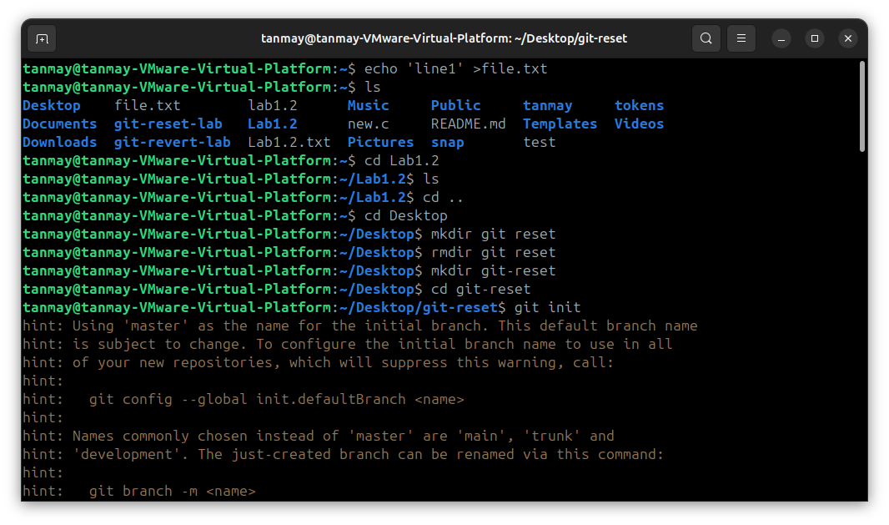

INITIALIZE THE EMPTY THE GIT REPOSITORY :

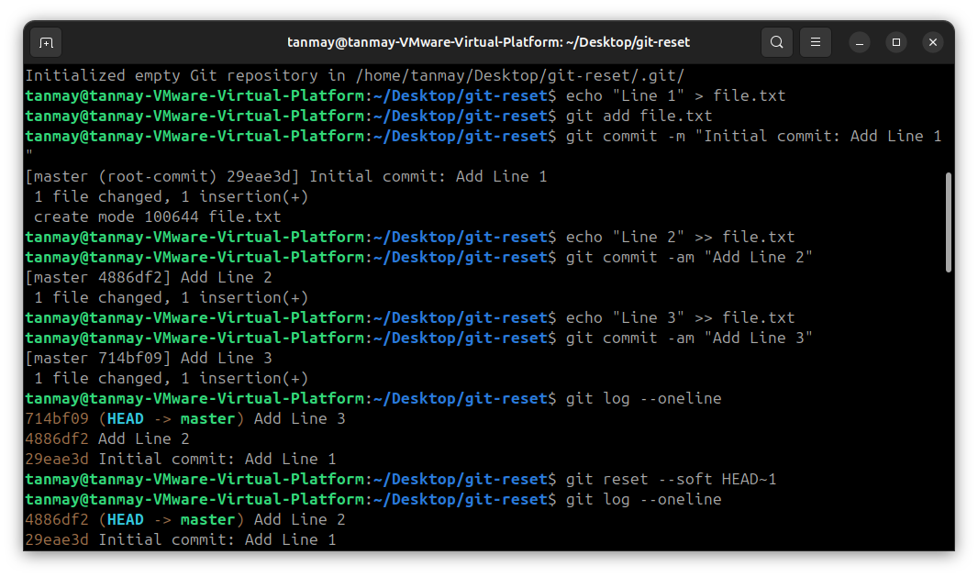

USE THE GIT LOG :

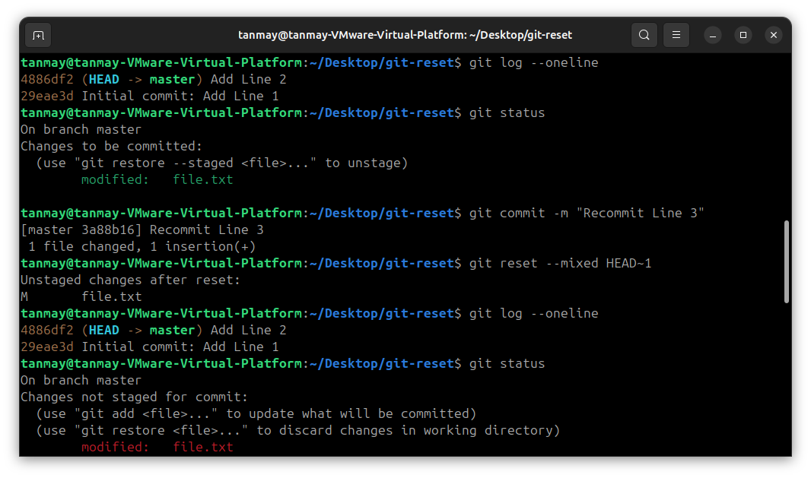

ADD THE FILE :
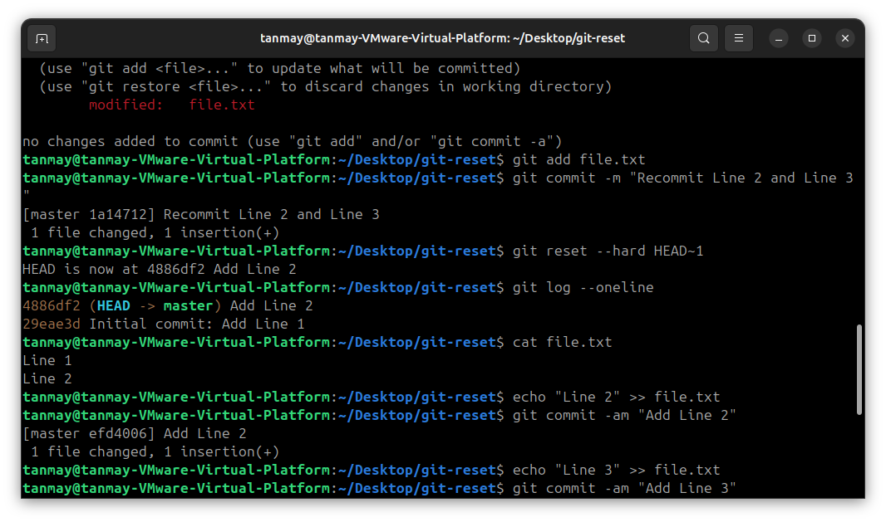
MAKE THE CHANGES

