Devsec-ops
LAB-2
Working with Git Reset
Dushyant Singh Raghav
500120590
1.Set up the Repository
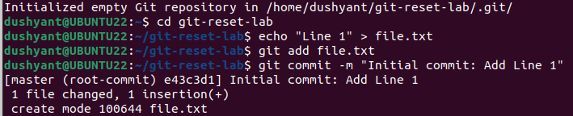
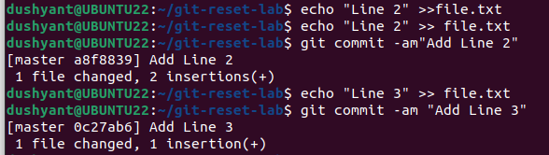


2.Use git reset –soft
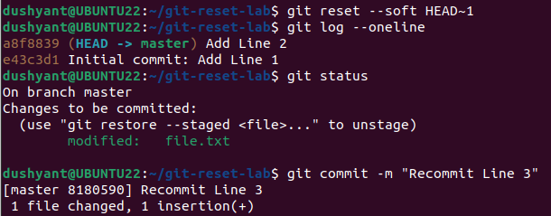
3.Use of git reset –mixed
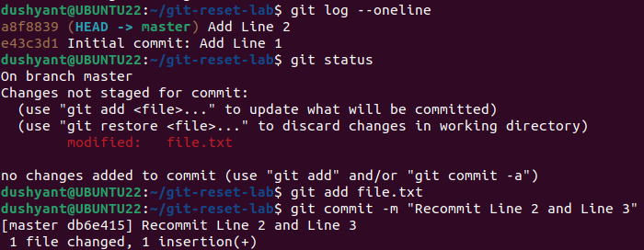

4.Use Git reset –hard
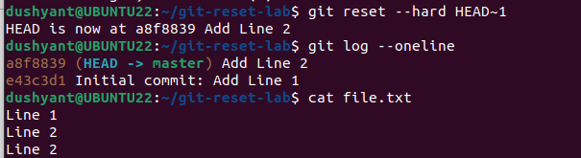
5.Use git reset with a commit hash
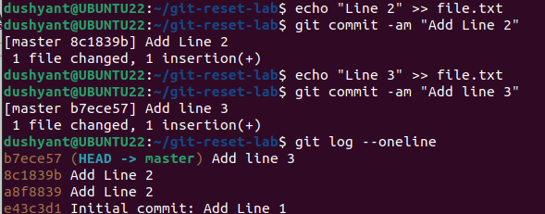
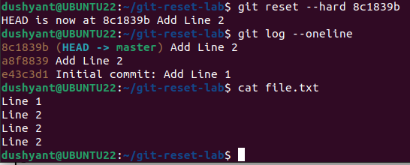

Theory
Difference between Reset : - soft,mixed,hard.
