Devsec-ops LAB
LAB – 3
Working With Git Rebase
Dushyant Singh Raghav
500120590
1.Setup the repository
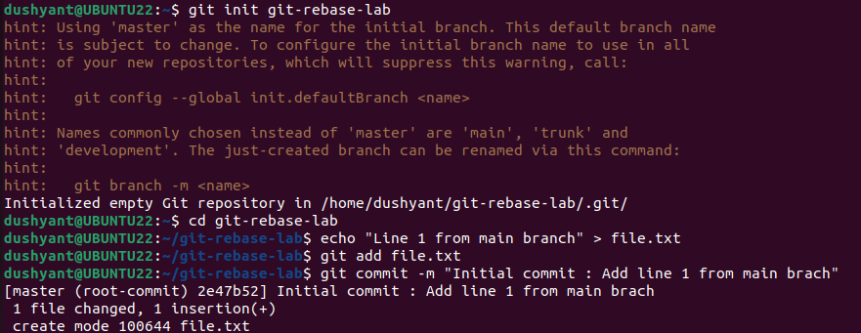
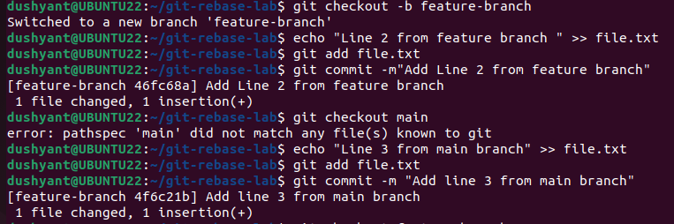

2. Rebase Feature branch-onto main
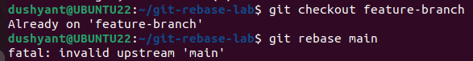
3. Verify the Rebase
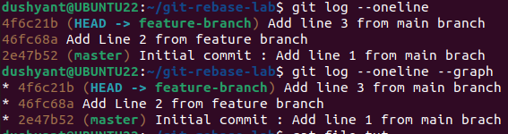
- Check the contents of the file.txt
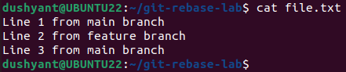
4.Push command
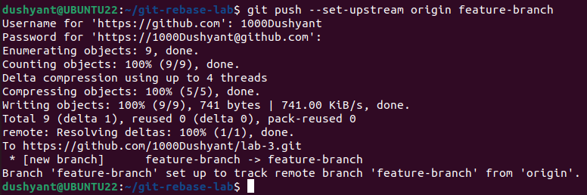

THEORY
- In Git, the rebase command is used to move or combine a sequence of commits onto a new base commit.
It’s mainly used to maintain a cleaner and more linear commit history.
- Instead of merging two branches (which creates a merge commit), rebase re-applies commits from your branch onto another branch’s tip.
- This makes it look like your work was based on the latest code all along.

