Devsec-ops LAB
Dushyant Singh Raghav
500120590
Devops-B3
Lab Exercise 5
Generate and Use SSH Key with Git and GitHub
Step 1 – Check for Existing SSH Keys
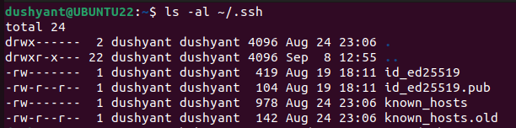
Step 2 – Generate a New SSH Key

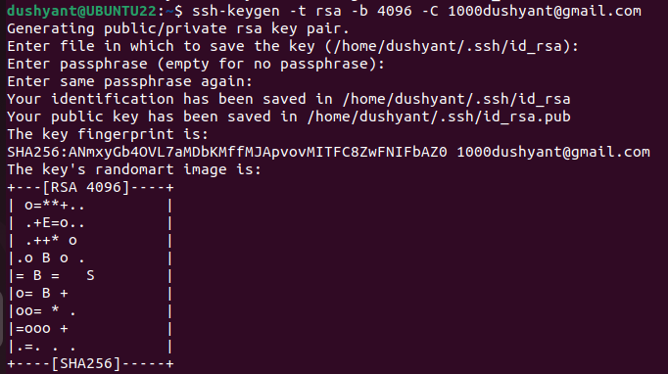
Step 3 – Start the SSH Agent
Step 4 – Add SSH Key to the Agent
Step 5 – Add SSH Key to GitHub
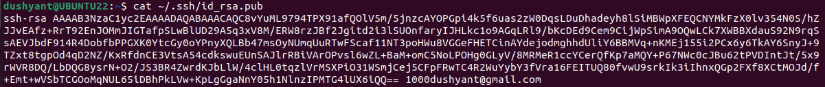
Step 6 – Test SSH Connection
Step 7 – Use SSH to Clone a Repository

