Devsec-ops LAB
Dushyant Singh Raghav
500120590
Devops B3
Lab Exercise 6.1
Managing Jenkins Freestyle Jobs
Step 1: Create a new Freestyle Job
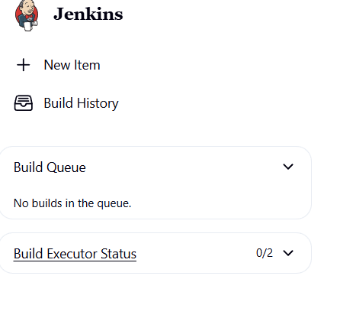
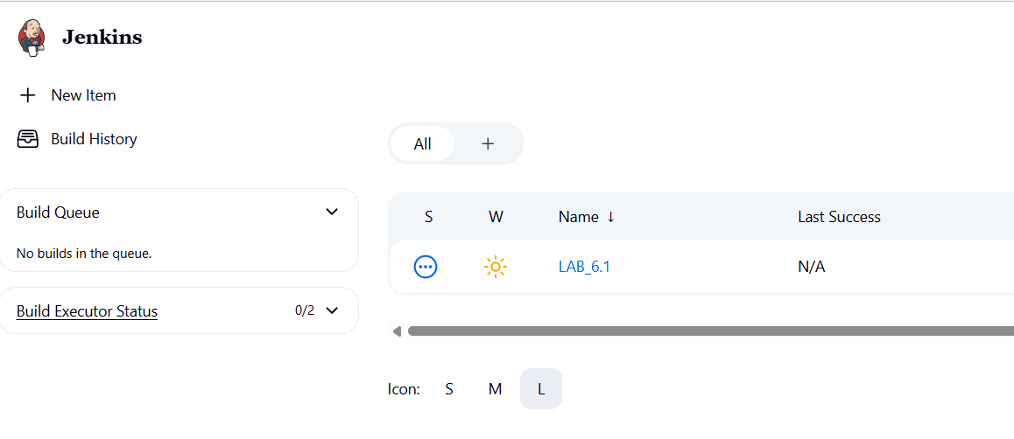
Step 2: Rename and delete the Freestyle Job
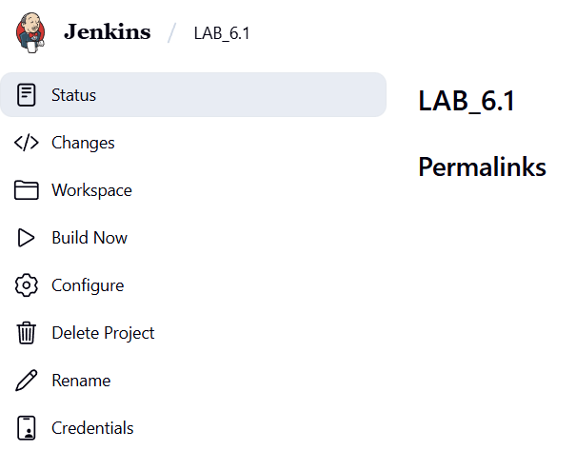
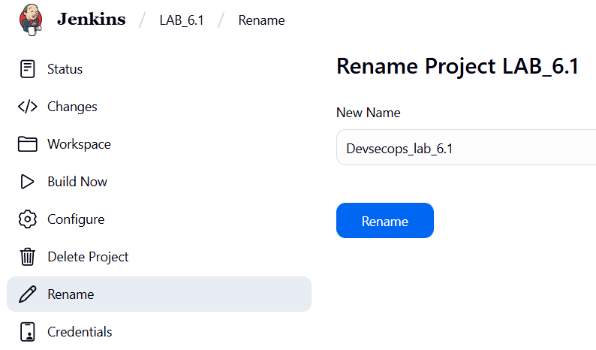
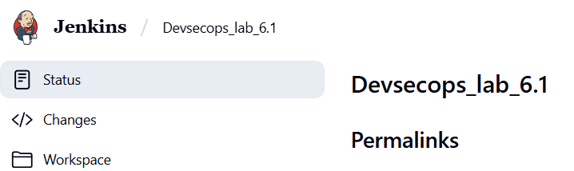

- Click on the renamed project and then click on Delete Project to delete the project

