Devsec-ops
LAB
Dushyant Singh Raghav
500120590
Devops-B3
Lab Exercise 6.2
Creating a New Jenkins Job to Checkout Source Code

Create a new Jenkins job by clicking on New Item
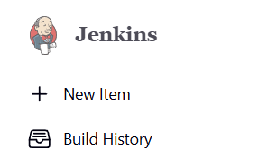

Step 2: Configure source code management
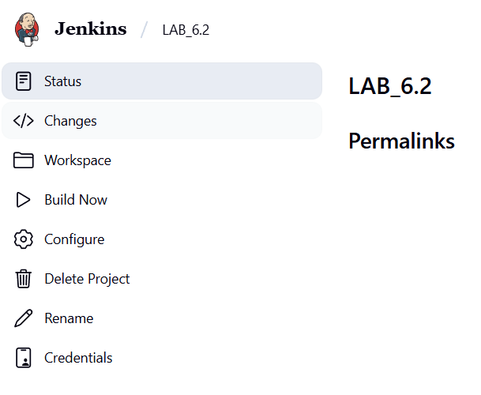
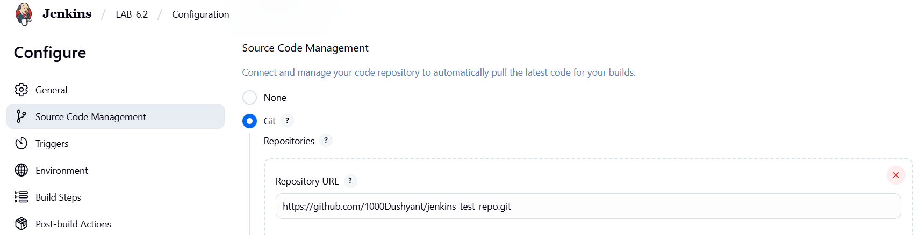
- Then, click on the Build Now option to schedule a build now.
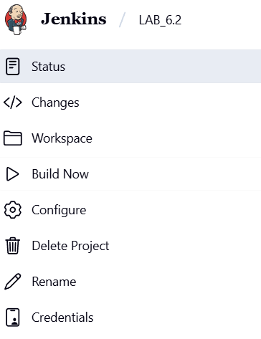
- To schedule the build, click the required link under Permalinks
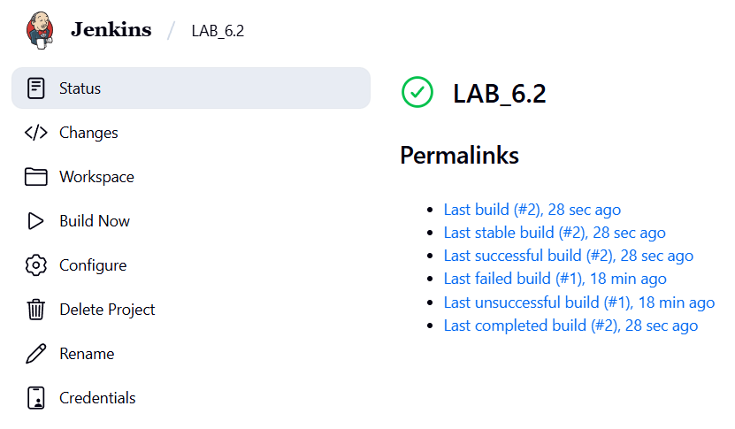
- Click on Console Output to check out the process during the build process
