Devsec-ops LAB
Dushyant Singh Raghav
500120590
Devops-B3
Lab Exercise 7
Integrating Maven with Jenkins

Step 1: Install the Maven plugin
- Click on the Manage Jenkins
- Click on the Plugins option as shown in the screenshot below:
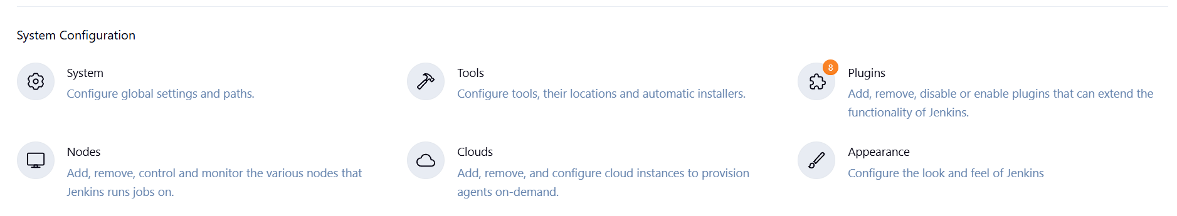

- Click on Installed plugins to verify whether the Maven Integration plugin has been installed
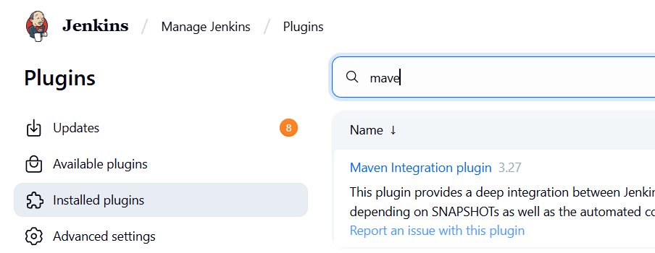
Step 2: Set up Global Tool Configuration
- Go to the Jenkins Dashboard, click on Manage Jenkins, and then select Tools from the list of options.
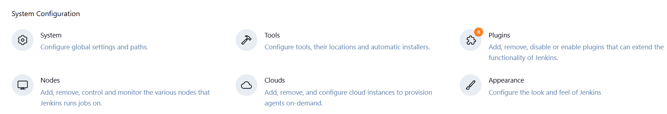

- To configure Maven, click on the Maven installations button in the Maven section and enter a Name and MAVEN_HOME path.
