Devsec-ops LAB
Dushyant Singh Raghav
500120590
Devpops-B3
Lab Exercise 8
Setting up Maven Build Job in Jenkins

In the Jenkins dashboard, click on New Item
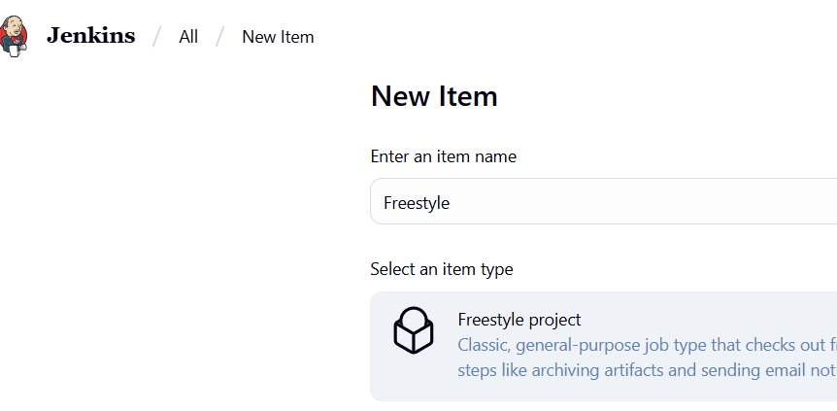

- Now, in the Configure page, navigate to Source Code Management in the left navigation bar, select Git, and then provide the Git repository URL
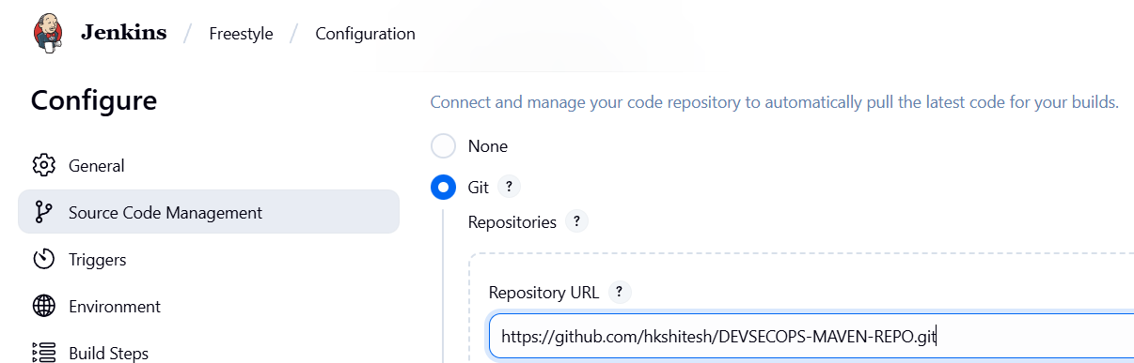
- Now, navigate to Build Steps, click on Add build step, and then select the option Invoke top-level Maven targets.
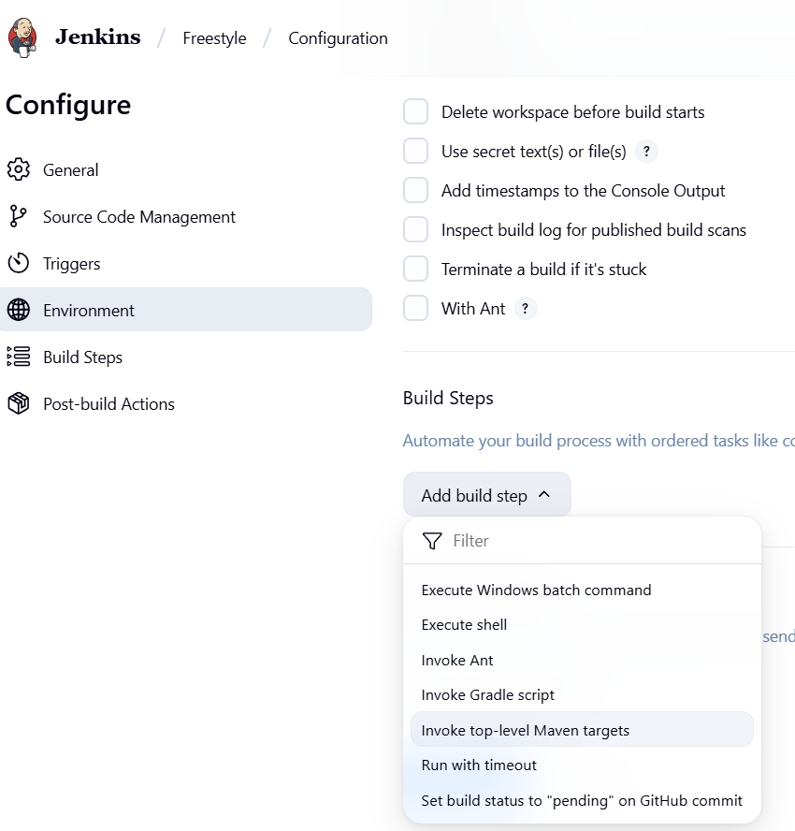

- Provide clean install under Goals section and then click on Save.
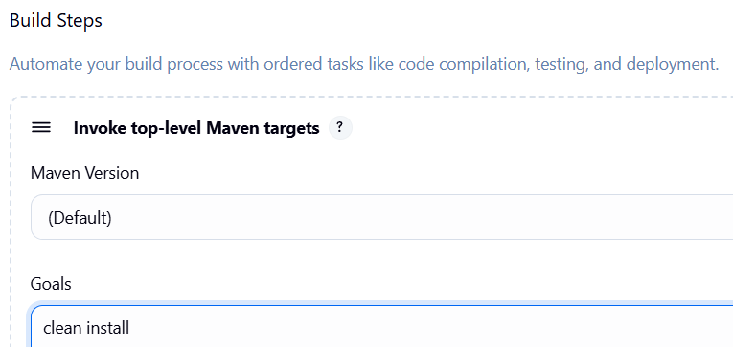
- Now, click on Build Now to initiate a new build, and the build logs will display the progress of the build process.
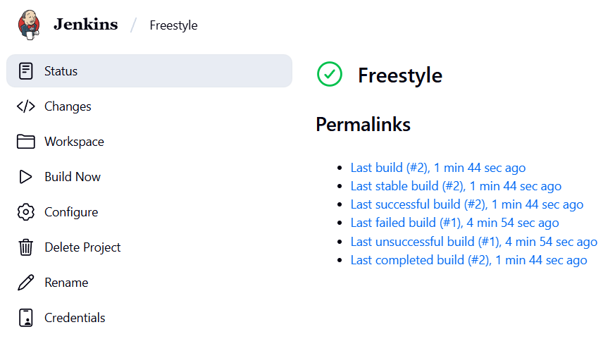
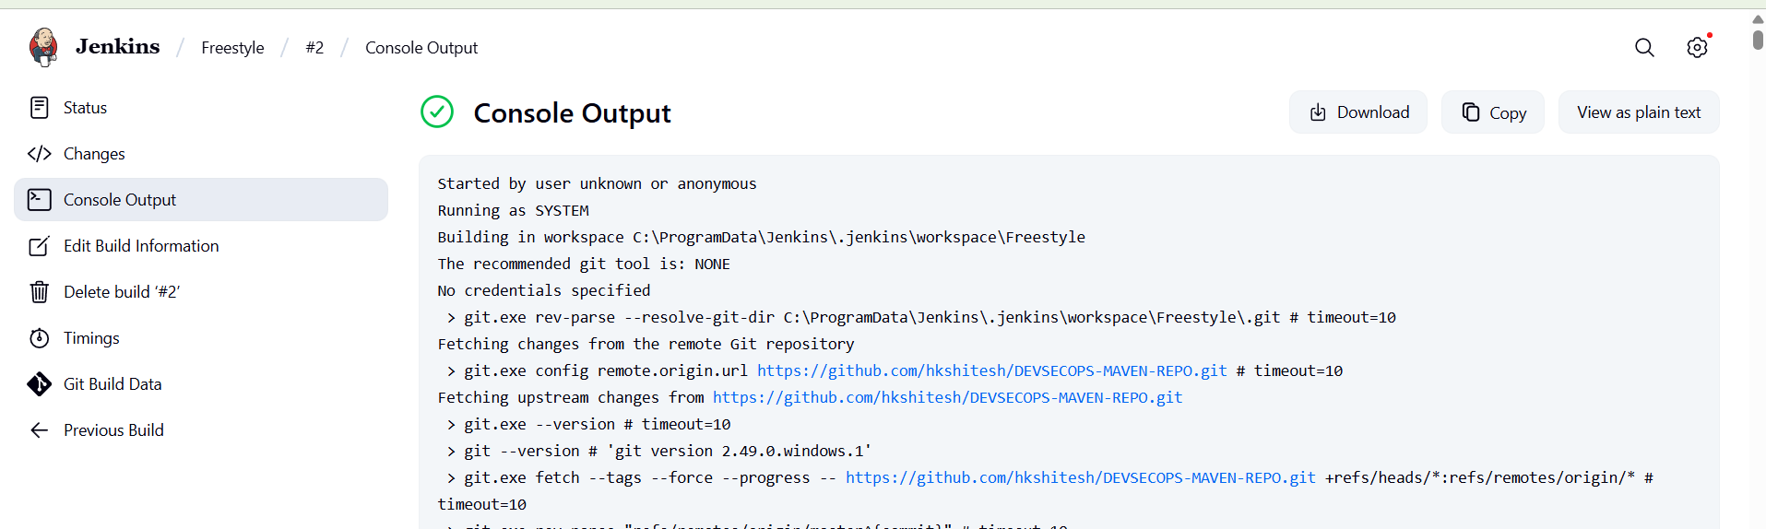
- You can see that the build is configured successfully.
