Devsec-ops LAB
Dushyant Singh Raghav
500120590
Devops-B3
Lab Exercise 9
Setting up Poll SCM Configuration in Jenkins
- In the Jenkins dashboard, click on New Item
- Select the Maven Project while creating a Jenkins job, provide a custom job name, and click on OK

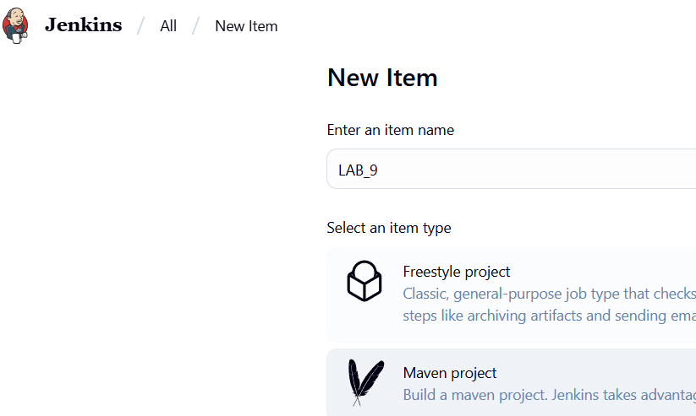

- Now, in the Configure page, navigate to Source Code Management from the left navigation bar, select Git, and then provide the Git repository URL
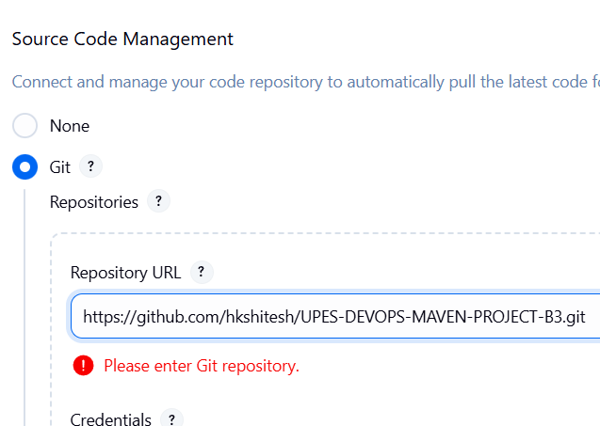
- Now, navigate to Build Environment, click on Poll SCM, provide H/2**** under the Schedule section, and then click on Save
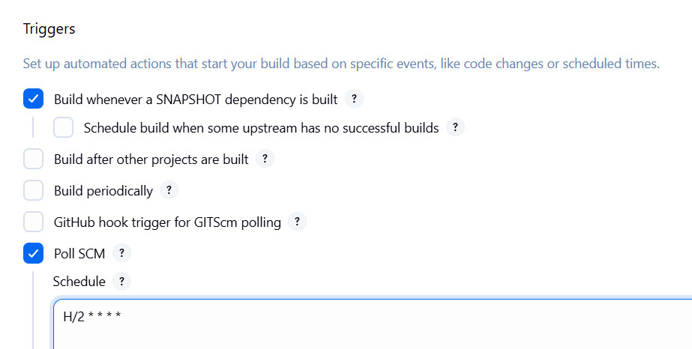
- Then, automatic build will be trigger within a minute, and you will be able to view the successful build in the Console output section.
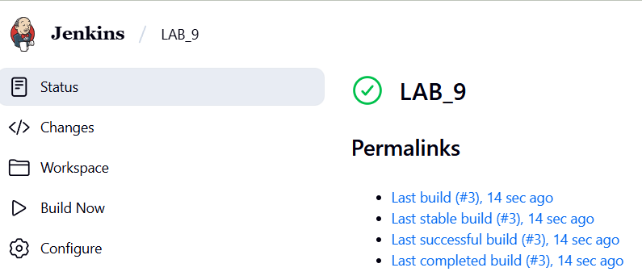
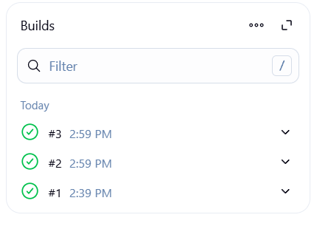
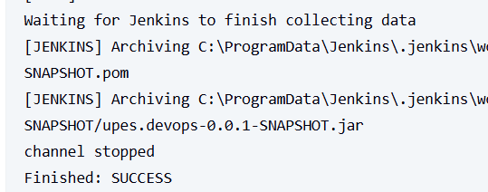
You can see that the build is configured successfully.

