Department of Computer Science and Engineering
(AI & ML)
B. Tech. CSE - 5th Semester
Aug – Dec 2026

UE23CS351A
DATABASE MANAGEMENT SYSTEMS (DBMS)

PROJECT REPORT on

DevMatch – Semantic Contributor-to-Issue Matching

PES1UG24AM310 | UTKARSH KUMAR | AIML-F (5th SEM)
PES1UG24AM320 | VIJAY SURIYA P | AIML-F (5th SEM)

Class of Prof. [Mir Junaid Rasool]
Abstract
Open-source maintainers receive more issues than they can triage, while new contributors cannot tell which issues they are able to solve. DevMatch is a full-stack web application that connects the two groups. Maintainers register projects and post issues; contributors list their skills and proficiency. Both the issue text and each contributor profile are converted into 384-dimensional embedding vectors stored in PostgreSQL with the pgvector extension, so the application ranks issues for a contributor, and applicants for an issue, by cosine similarity instead of keyword overlap.
The system uses polyglot persistence. Structured, transactional data (users, projects, issues, applications, skills, notifications) lives in a normalised PostgreSQL schema with primary, foreign, unique and check constraints, indexes, a view, two triggers, stored functions and a row-locking function that accepts one applicant atomically. Database roles with GRANT/REVOKE and row-level security enforce two roles inside the database. Semi-structured, fast-growing data lives in MongoDB: threaded issue discussions (replies embedded in each comment document, likes kept as a set) and an append-only activity log with a TTL index, queried with aggregation pipelines.
The user interface and backend are built with Next.js 15 (App Router, React 19, server components, server actions, route handlers and middleware) with JWT-cookie authentication. Complete CRUD is available for projects, issues, applications, profiles and comments, and a DB-insights page exposes the SQL, vector and aggregation queries behind the UI.
Table of Contents
Sl. No | Topic | Page No.
 | Introduction  - Problem Statement | 4
 | User Requirements Specification- Tech Stack | 5
 | E-R Model  - List of Entities [labeling Weak ones]  - List non-simple Attributes  - ER Diagram Snapshot  - ERD from tool like draw.io | 6
 | Relational Model  - List of Relations that are not Entities in ER Model  - Schema Diagram [ensure light background image] | 9
 | SQL DDL Statements | 10
 | SQL DML Statements | 15
 | NoSQL/ Vector Database Commands | 23
8. | Results  - Resulting Tables’ Screenshots | 34
9. | Next.js-Project Tree Structure | 38
10. | Few sample Screenshots of application code and demo | 40
11. | Evaluation Rubrics- Completion Status | 55

Introduction

Problem Statement

Short Description
Open-source projects publish many issues, but maintainers have little time to find the right person for each one, and new contributors struggle to find issues that fit their skills. Today this matching is manual (labels such as "good first issue") or keyword based, which misses issues that describe the same need in different words.
DevMatch is a CRUD web application that stores projects, issues, contributors and their skills in a relational database and ranks issues for a contributor (and applicants for an issue) by semantic similarity of vector embeddings. Contributors apply to issues; maintainers review applicants, ordered best fit first, and accept or reject them. Accepting one applicant is a single atomic transaction that closes the issue, rejects the other applicants and notifies everyone. Contributors and maintainers can also discuss an issue in threaded comments. The application has two roles: contributor and maintainer.

User Requirements Specification
Technology stack and justification
• Next.js 15 (React 19, TypeScript). One project provides the user interface and the backend: server components read both databases on the server, server actions perform every write, route handlers expose a JSON API and middleware protects private pages. This removes the need for a separate API server and keeps the SQL and MongoDB calls next to the pages that use them.
• PostgreSQL 16. Projects, issues, users and applications are strongly related and must stay consistent. A relational database gives foreign keys, UNIQUE and CHECK constraints, triggers and ACID transactions, which are needed for "accept one applicant, reject the rest, close the issue" to happen as one unit of work.
• pgvector (vector database). Matching needs nearest-neighbour search over embeddings. pgvector adds a vector(384) type, cosine (<=>), L2 (<->) and inner-product (<#>) operators and ivfflat indexes inside PostgreSQL, so similarity search can be combined with ordinary SQL filters and joins (for example, open issues only) without keeping a second store in sync.
• MongoDB 8. See the NoSQL justification below.
• jose and bcryptjs. Passwords are stored as bcrypt hashes; the session is a signed JWT in an HttpOnly cookie, which JavaScript in the browser cannot read.
• Docker Compose, Playwright and node:test. Docker Compose starts both databases with one command; node:test (29 tests) and Playwright (37 browser steps) verify the database behaviour and the full user flows.
Justification for choosing MongoDB as the NoSQL database
A discussion thread is a tree: a comment has replies, and each comment has a set of likes. In a relational schema this needs separate comments, replies and likes tables and joins on every page view. In MongoDB one comment is one document with an embedded replies array and a likes array, so a thread is read with a single indexed query (issueId, createdAt) and a reply or like is a single atomic update ($push, $addToSet, $pull).
The activity log is append-only, grows quickly and each event type carries different details (a login, an application and an acceptance have different fields). A schemaless document with a flexible meta sub-document fits this, and a TTL index expires events after 90 days automatically, which is a built-in feature rather than a scheduled clean-up job.
Keeping this data out of PostgreSQL leaves the relational schema small and strict, while MongoDB's aggregation pipeline ($group, $unwind, $lookup, $dateToString) gives the activity and discussion analytics shown on the DB-insights page. $jsonSchema validators keep the documents well formed despite the flexible model.

E-R Model

List of Entities (weak entity highlighted)
Entity | Store | Key attributes | Strong / weak
USER | PostgreSQL | user_id (PK), name, email (unique), password_hash, role, bio, account_status | Strong
PROJECT | PostgreSQL | project_id (PK), title, repo_url (unique), tech_stack | Strong
ISSUE | PostgreSQL | issue_id (PK), title, description, difficulty, status, embedding | Strong
SKILL | PostgreSQL | skill_id (PK), name (unique) | Strong
NOTIFICATION | PostgreSQL | notification_id (PK), message, read_status, created_at | Strong
USER_EMBEDDING | PostgreSQL + pgvector | user_id (partial key, owner's key), embedding, updated_at | WEAK (existence depends on USER; identified through the identifying relationship has_vector)
COMMENT | MongoDB | _id (PK), issueId, authorId, body, createdAt, likes, replies | Strong
ACTIVITY_EVENT | MongoDB | _id (PK), ts, type, actorId, meta | Strong
Relationships: USER maintains PROJECT (1:N); PROJECT has ISSUE (1:N); USER applies_to ISSUE (M:N, attributes status and applied_at); USER has_skill SKILL (M:N, attribute proficiency); USER receives NOTIFICATION (1:N); USER has_vector USER_EMBEDDING (1:1, identifying); ISSUE is discussed_in COMMENT (1:N); USER writes COMMENT (1:N); USER performs ACTIVITY_EVENT (1:N). The weak entity is highlighted in the table and drawn with a double border in the diagram.

List of Non-Simple Attributes
Attribute | Entity | Type | Explanation
tech_stack | PROJECT | Multivalued | A project uses several technologies; stored as one comma-separated column.
embedding | ISSUE, USER_EMBEDDING | Multivalued (384 values) | A vector of 384 numbers stored in one pgvector column.
likes | COMMENT | Multivalued | Array of user ids; $addToSet keeps it a set.
replies | COMMENT | Composite and multivalued | Embedded array of sub-documents (authorId, authorName, authorRole, body, createdAt).
meta | ACTIVITY_EVENT | Composite | Sub-document whose fields differ by event type.
match_score | applies_to / feed | Derived | Computed as 1 − cosine distance between the user and issue vectors; never stored.
proficiency, status, applied_at | relationship attributes | Descriptive | Attributes of the M:N relationships has_skill and applies_to.

ER Diagram Snapshot
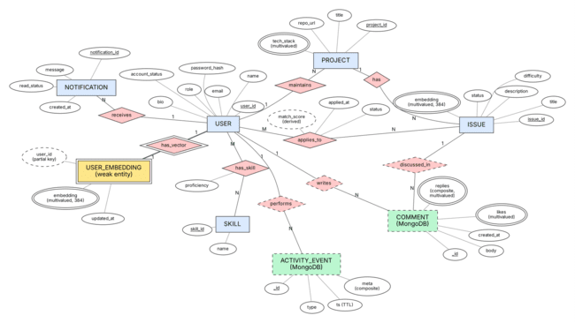
Figure 1: ER diagram in Chen notation (weak entity = double box; multivalued attributes = double ellipse; MongoDB collections = dashed green boxes).

ERD from a tool like draw.io, lucidchart
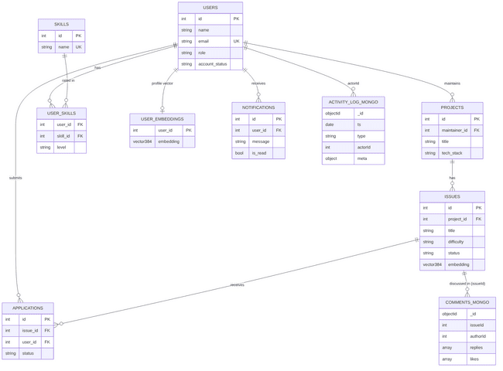
Figure 2: The same model drawn with Mermaid (crow's-foot notation; source: docs/er-diagram.mmd). Chen diagram generated with Graphviz (source: docs/diagrams/er.dot).

Relational Model
- List of Relations (relations that are not entities in the ER model are labelled)
Relation | Origin in ER model | Primary key | Foreign keys
applications | NOT an entity: from the M:N relationship USER applies_to ISSUE | id (surrogate); UNIQUE (issue_id, user_id) | issue_id → issues, user_id → users
user_skills | NOT an entity: from the M:N relationship USER has_skill SKILL | (user_id, skill_id) composite | user_id → users, skill_id → skills
users, projects, issues, skills, notifications | Entities | id | projects.maintainer_id → users; issues.project_id → projects; notifications.user_id → users
user_embeddings | Weak entity | user_id | user_id → users (ON DELETE CASCADE)
The 1:N relationships maintains, has and receives, and the 1:1 relationship has_vector, are implemented as foreign keys and need no relation of their own. The MongoDB collections comments and activity_log are referenced by issueId and actorId (application-level references).

Schema Diagram
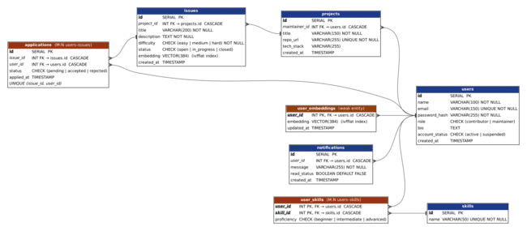
Figure 3: Relational schema (white background). Italic = foreign key, underlined = primary key; crow's foot marks the foreign-key (many) side. Orange headers are relations that are not entities; brown is the weak entity.

SQL DDL Statements
Full DDL of the database (db/schema.sql): tables with primary, foreign, unique, check and not-null constraints, indexes, a view, ALTER statements, triggers and stored functions. Constraints used: PRIMARY KEY, FOREIGN KEY … ON DELETE CASCADE, UNIQUE, CHECK, NOT NULL, DEFAULT.
-- =====================================================================
-- DevMatch — Semantic Contributor-to-Issue Matching
-- PostgreSQL 14+ with the pgvector extension
--
-- PART 1: the DDL from the project report (unchanged, apart from one
-- typo fix: "idx_issues_embeddingON" -> "idx_issues_embedding ON")
-- PART 2: server-side logic added for the application (transactional
-- accept/reject functions and integrity triggers)
-- =====================================================================
-- ---------------------------------------------------------------------
-- PART 1 — Schema from the report
-- ---------------------------------------------------------------------
CREATE EXTENSION IF NOT EXISTS vector;
CREATE TABLE users (
id SERIAL PRIMARY KEY,
name VARCHAR(100) NOT NULL,
email VARCHAR(150) UNIQUE NOT NULL,
password_hash VARCHAR(255) NOT NULL,
role VARCHAR(20) NOT NULL
CHECK (role IN ('contributor', 'maintainer')),
bio TEXT,
created_at TIMESTAMP DEFAULT CURRENT_TIMESTAMP
);
CREATE TABLE skills (
id SERIAL PRIMARY KEY,
name VARCHAR(50) UNIQUE NOT NULL
);
CREATE TABLE user_skills (
user_id INT NOT NULL
REFERENCES users(id)
ON DELETE CASCADE,
skill_id INT NOT NULL
REFERENCES skills(id)
ON DELETE CASCADE,
proficiency VARCHAR(20)
CHECK (proficiency IN ('beginner', 'intermediate', 'advanced')),
PRIMARY KEY (user_id, skill_id)
);
CREATE TABLE projects (
id SERIAL PRIMARY KEY,
maintainer_id INT NOT NULL
REFERENCES users(id)
ON DELETE CASCADE,
title VARCHAR(150) NOT NULL,
repo_url VARCHAR(255) UNIQUE NOT NULL,
tech_stack VARCHAR(255),
created_at TIMESTAMP DEFAULT CURRENT_TIMESTAMP
);
CREATE TABLE issues (
id SERIAL PRIMARY KEY,
project_id INT NOT NULL
REFERENCES projects(id)
ON DELETE CASCADE,
title VARCHAR(200) NOT NULL,
description TEXT NOT NULL,
difficulty VARCHAR(20)
CHECK (difficulty IN ('easy', 'medium', 'hard')),
status VARCHAR(20) NOT NULL DEFAULT 'open'
CHECK (status IN ('open', 'in_progress', 'closed')),
embedding VECTOR(384),
created_at TIMESTAMP DEFAULT CURRENT_TIMESTAMP
);
CREATE TABLE user_embeddings (
user_id INT PRIMARY KEY
REFERENCES users(id)
ON DELETE CASCADE,
embedding VECTOR(384),
updated_at TIMESTAMP DEFAULT CURRENT_TIMESTAMP
);
CREATE TABLE applications (
id SERIAL PRIMARY KEY,
issue_id INT NOT NULL
REFERENCES issues(id)
ON DELETE CASCADE,
user_id INT NOT NULL
REFERENCES users(id)
ON DELETE CASCADE,
status VARCHAR(20) NOT NULL DEFAULT 'pending'
CHECK (status IN ('pending', 'accepted', 'rejected')),
applied_at TIMESTAMP DEFAULT CURRENT_TIMESTAMP,
UNIQUE (issue_id, user_id)
);
CREATE TABLE notifications (
id SERIAL PRIMARY KEY,
user_id INT NOT NULL
REFERENCES users(id)
ON DELETE CASCADE,
message VARCHAR(255) NOT NULL,
read_status BOOLEAN DEFAULT FALSE,
created_at TIMESTAMP DEFAULT CURRENT_TIMESTAMP
);
CREATE INDEX idx_issues_project ON issues(project_id);
CREATE INDEX idx_issues_status ON issues(status);
CREATE INDEX idx_applications_issue ON applications(issue_id);
CREATE INDEX idx_applications_user ON applications(user_id);
CREATE INDEX idx_notifications_user ON notifications(user_id);
-- Approximate-nearest-neighbour indexes for cosine distance
CREATE INDEX idx_issues_embedding
ON issues
USING ivfflat (embedding vector_cosine_ops)
WITH (lists = 100);
CREATE INDEX idx_user_embeddings
ON user_embeddings
USING ivfflat (embedding vector_cosine_ops)
WITH (lists = 100);
CREATE VIEW open_issues_view AS
SELECT
i.id,
i.title,
i.description,
i.difficulty,
p.title AS project_title,
u.name AS maintainer,
i.created_at
FROM issues i
JOIN projects p ON i.project_id = p.id
JOIN users u ON p.maintainer_id = u.id
WHERE i.status = 'open';
-- Schema evolution statements from the report
ALTER TABLE users
ADD COLUMN account_status VARCHAR(20)
DEFAULT 'active'
CHECK (account_status IN ('active', 'suspended'));
ALTER TABLE issues
ALTER COLUMN difficulty SET NOT NULL;
DROP INDEX IF EXISTS idx_issues_status;
-- ---------------------------------------------------------------------
-- PART 2 — Server-side logic used by the web application
-- ---------------------------------------------------------------------
-- 2.1 Integrity guard on applications --------------------------------
-- * only active contributors may apply
-- * only to issues that are still 'open'
CREATE OR REPLACE FUNCTION fn_check_application() RETURNS trigger AS $$
DECLARE
v_issue_status VARCHAR(20);
v_role VARCHAR(20);
v_account VARCHAR(20);
BEGIN
SELECT status INTO v_issue_status FROM issues WHERE id = NEW.issue_id;
IF v_issue_status IS DISTINCT FROM 'open' THEN
RAISE EXCEPTION 'This issue is no longer open for applications';
END IF;
SELECT role, account_status INTO v_role, v_account
FROM users WHERE id = NEW.user_id;
IF v_role IS DISTINCT FROM 'contributor' THEN
RAISE EXCEPTION 'Only contributors can apply to issues';
END IF;
IF v_account IS DISTINCT FROM 'active' THEN
RAISE EXCEPTION 'This account is suspended';
END IF;
RETURN NEW;
END;
$$ LANGUAGE plpgsql;
CREATE TRIGGER trg_check_application
BEFORE INSERT ON applications
FOR EACH ROW EXECUTE FUNCTION fn_check_application();
-- 2.2 Notify the maintainer when someone applies ---------------------
CREATE OR REPLACE FUNCTION fn_notify_maintainer() RETURNS trigger AS $$
BEGIN
INSERT INTO notifications (user_id, message)
SELECT p.maintainer_id,
LEFT(u.name || ' applied to "' || i.title || '"', 255)
FROM issues i
JOIN projects p ON p.id = i.project_id
JOIN users u ON u.id = NEW.user_id
WHERE i.id = NEW.issue_id;
RETURN NEW;
END;
$$ LANGUAGE plpgsql;
CREATE TRIGGER trg_notify_maintainer
AFTER INSERT ON applications
FOR EACH ROW EXECUTE FUNCTION fn_notify_maintainer();
-- 2.3 Accept a candidate — ONE atomic unit of work -------------------
-- Locks the issue row (so two concurrent accepts serialise), then:
-- accepted application -> 'accepted'
-- issue -> 'closed'
-- all other pending -> 'rejected' + a notification each
-- accepted contributor -> notification
-- Any RAISE EXCEPTION rolls back the whole thing.
CREATE OR REPLACE FUNCTION accept_application(p_app_id INT, p_maintainer_id INT)
RETURNS INT AS $$
DECLARE
v_issue_id INT;
v_user_id INT;
v_title VARCHAR(200);
v_issue_status VARCHAR(20);
v_owner INT;
v_app_status VARCHAR(20);
BEGIN
SELECT issue_id, user_id INTO v_issue_id, v_user_id
FROM applications WHERE id = p_app_id;
IF NOT FOUND THEN
RAISE EXCEPTION 'Application not found';
END IF;
SELECT i.title, i.status, p.maintainer_id
INTO v_title, v_issue_status, v_owner
FROM issues i
JOIN projects p ON p.id = i.project_id
WHERE i.id = v_issue_id
FOR UPDATE OF i;
IF v_owner <> p_maintainer_id THEN
RAISE EXCEPTION 'You can only accept applicants for your own issues';
END IF;
IF v_issue_status = 'closed' THEN
RAISE EXCEPTION 'This issue is already closed';
END IF;
SELECT status INTO v_app_status FROM applications WHERE id = p_app_id;
IF v_app_status <> 'pending' THEN
RAISE EXCEPTION 'This application has already been %', v_app_status;
END IF;
UPDATE applications SET status = 'accepted' WHERE id = p_app_id;
UPDATE issues SET status = 'closed' WHERE id = v_issue_id;
-- tell everyone else, then reject them
INSERT INTO notifications (user_id, message)
SELECT a.user_id,
LEFT('Another contributor was selected for "' || v_title ||
'". The issue is now closed - keep going, new matches are waiting in your feed.', 255)
FROM applications a
WHERE a.issue_id = v_issue_id AND a.id <> p_app_id AND a.status = 'pending';
UPDATE applications
SET status = 'rejected'
WHERE issue_id = v_issue_id AND id <> p_app_id AND status = 'pending';
INSERT INTO notifications (user_id, message)
VALUES (v_user_id,
LEFT('You were accepted for "' || v_title || '". Get started!', 255));
RETURN v_issue_id;
END;
$$ LANGUAGE plpgsql;
-- 2.4 Reject a single candidate (issue stays open) -------------------
CREATE OR REPLACE FUNCTION reject_application(p_app_id INT, p_maintainer_id INT)
RETURNS VOID AS $$
DECLARE
v_issue_id INT;
v_user_id INT;
v_title VARCHAR(200);
v_owner INT;
v_app_status VARCHAR(20);
BEGIN
SELECT a.issue_id, a.user_id, a.status, i.title, p.maintainer_id
INTO v_issue_id, v_user_id, v_app_status, v_title, v_owner
FROM applications a
JOIN issues i ON i.id = a.issue_id
JOIN projects p ON p.id = i.project_id
WHERE a.id = p_app_id
FOR UPDATE OF a;
IF NOT FOUND THEN
RAISE EXCEPTION 'Application not found';
END IF;
IF v_owner <> p_maintainer_id THEN
RAISE EXCEPTION 'You can only review applicants for your own issues';
END IF;
IF v_app_status <> 'pending' THEN
RAISE EXCEPTION 'This application has already been %', v_app_status;
END IF;
UPDATE applications SET status = 'rejected' WHERE id = p_app_id;
INSERT INTO notifications (user_id, message)
VALUES (v_user_id,
LEFT('Your application for "' || v_title || '" was not selected this time.', 255));
END;
$$ LANGUAGE plpgsql;
Database roles and access control (db/rbac.sql): two roles, GRANT/REVOKE privileges and row-level security.
-- =====================================================================
-- DevMatch — Role-based access control INSIDE PostgreSQL
-- Run automatically by `npm run db:init` after db/schema.sql (idempotent).
--
-- Two database roles mirror the two application roles:
-- devmatch_contributor — can browse, apply, manage own skills, read own notifications
-- devmatch_maintainer — everything a contributor can read + manage projects/issues and review applicants
-- Row-level security limits WHICH rows a role may see (own notifications, own applications, applicants to own issues).
-- =====================================================================
DO $$
BEGIN
IF NOT EXISTS (SELECT 1 FROM pg_roles WHERE rolname = 'devmatch_contributor') THEN CREATE ROLE devmatch_contributor NOLOGIN; END IF;
IF NOT EXISTS (SELECT 1 FROM pg_roles WHERE rolname = 'devmatch_maintainer') THEN CREATE ROLE devmatch_maintainer NOLOGIN; END IF;
END $$;
REVOKE ALL ON ALL TABLES IN SCHEMA public FROM devmatch_contributor, devmatch_maintainer;
REVOKE ALL ON ALL FUNCTIONS IN SCHEMA public FROM PUBLIC, devmatch_contributor, devmatch_maintainer;
GRANT USAGE ON SCHEMA public TO devmatch_contributor, devmatch_maintainer;
-- ---- contributor -----------------------------------------------------
GRANT SELECT ON users, projects, issues, skills, user_skills, open_issues_view TO devmatch_contributor;
GRANT SELECT ON user_embeddings TO devmatch_contributor;
GRANT UPDATE (name, bio) ON users TO devmatch_contributor;
GRANT INSERT, UPDATE, DELETE ON user_skills, user_embeddings TO devmatch_contributor;
GRANT INSERT ON skills TO devmatch_contributor;
GRANT SELECT, INSERT, DELETE ON applications TO devmatch_contributor;
GRANT SELECT, UPDATE ON notifications TO devmatch_contributor;
GRANT USAGE ON ALL SEQUENCES IN SCHEMA public TO devmatch_contributor, devmatch_maintainer;
-- ---- maintainer (inherits every contributor privilege, plus) ----------
GRANT devmatch_contributor TO devmatch_maintainer;
GRANT INSERT, UPDATE, DELETE ON projects, issues TO devmatch_maintainer;
GRANT UPDATE ON applications TO devmatch_maintainer;
GRANT EXECUTE ON FUNCTION accept_application(INT, INT), reject_application(INT, INT) TO devmatch_maintainer;
-- trigger functions and the accept/reject functions write to tables the caller may not touch directly,
-- so they run with the privileges of their owner (they validate ownership themselves)
ALTER FUNCTION fn_check_application() SECURITY DEFINER SET search_path = public;
ALTER FUNCTION fn_notify_maintainer() SECURITY DEFINER SET search_path = public;
ALTER FUNCTION accept_application(INT, INT) SECURITY DEFINER SET search_path = public;
ALTER FUNCTION reject_application(INT, INT) SECURITY DEFINER SET search_path = public;
-- ---- row-level security -------------------------------------------------
-- The caller identifies itself with: SELECT set_config('app.user_id', '<id>', true);
ALTER TABLE notifications ENABLE ROW LEVEL SECURITY;
DROP POLICY IF EXISTS own_notifications ON notifications;
CREATE POLICY own_notifications ON notifications
USING (user_id = NULLIF(current_setting('app.user_id', true), '')::INT);
ALTER TABLE applications ENABLE ROW LEVEL SECURITY;
DROP POLICY IF EXISTS applicant_or_owner ON applications;
CREATE POLICY applicant_or_owner ON applications
USING (
user_id = NULLIF(current_setting('app.user_id', true), '')::INT
OR EXISTS (SELECT 1 FROM issues i JOIN projects p ON p.id = i.project_id
WHERE i.id = applications.issue_id
AND p.maintainer_id = NULLIF(current_setting('app.user_id', true), '')::INT)
)
WITH CHECK (user_id = NULLIF(current_setting('app.user_id', true), '')::INT
OR EXISTS (SELECT 1 FROM issues i JOIN projects p ON p.id = i.project_id
WHERE i.id = applications.issue_id
AND p.maintainer_id = NULLIF(current_setting('app.user_id', true), '')::INT));

SQL DML Statements
DML, joins, nested, correlated and recursive queries, view, transaction and function calls (db/queries.sql). All data-changing statements run inside a transaction that is rolled back, so the demo data is untouched. Followed by the log produced by running the file with psql.
-- =====================================================================
-- DevMatch — SQL command reference (PostgreSQL 16)
-- Runnable against the seeded database:
-- psql "$DATABASE_URL" -f db/queries.sql
-- Everything that modifies data runs inside a transaction that is ROLLED BACK at the end,
-- so the demo data is left untouched.
-- =====================================================================
\set ON_ERROR_STOP on
\pset null '∅'
-- ivfflat is an approximate index that only scans `probes` of its 100 lists; with tiny demo data the default (1) can miss rows
SET ivfflat.probes = 100;
-- ---------------------------------------------------------------------
-- 1. DDL — inspect what db/schema.sql created
-- ---------------------------------------------------------------------
\echo '== 1. Tables, constraints and indexes =='
\dt
\d issues
SELECT conname AS constraint, contype AS type, conrelid::regclass AS "table"
FROM pg_constraint
WHERE connamespace = 'public'::regnamespace AND contype IN ('c','u','f')
ORDER BY conrelid::regclass::text, conname;
-- ---------------------------------------------------------------------
-- 2. DML — INSERT / UPDATE / DELETE (rolled back)
-- ---------------------------------------------------------------------
\echo '== 2. DML inside a transaction that is rolled back =='
BEGIN;
INSERT INTO users (name, email, password_hash, role, bio)
VALUES ('Demo Maintainer', 'demo-m@devmatch.dev', 'x', 'maintainer', 'Temporary maintainer'),
('Demo Contributor', 'demo-c@devmatch.dev', 'x', 'contributor', 'Temporary contributor')
RETURNING id, name, role;
INSERT INTO projects (maintainer_id, title, repo_url, tech_stack)
SELECT id, 'Demo Project', 'https://github.com/demo/demo-project', 'SQL, PostgreSQL'
FROM users WHERE email = 'demo-m@devmatch.dev'
RETURNING id, title;
INSERT INTO issues (project_id, title, description, difficulty)
SELECT p.id, 'Demo issue', 'Add an index to speed up a slow SQL query', 'easy'
FROM projects p WHERE p.title = 'Demo Project'
RETURNING id, title, status;
-- the BEFORE INSERT trigger lets an active contributor apply, the AFTER INSERT trigger notifies the maintainer
INSERT INTO applications (issue_id, user_id)
SELECT i.id, u.id FROM issues i, users u
WHERE i.title = 'Demo issue' AND u.email = 'demo-c@devmatch.dev'
RETURNING id, status;
SELECT u.name AS notified, n.message
FROM notifications n JOIN users u ON u.id = n.user_id
WHERE u.email = 'demo-m@devmatch.dev';
UPDATE issues SET status = 'in_progress', difficulty = 'medium'
WHERE title = 'Demo issue'
RETURNING id, status, difficulty;
-- the same trigger now refuses new applications because the issue is no longer open:
SAVEPOINT late;
\set ON_ERROR_STOP off
INSERT INTO applications (issue_id, user_id)
SELECT i.id, u.id FROM issues i, users u WHERE i.title = 'Demo issue' AND u.role = 'contributor' AND u.email <> 'demo-c@devmatch.dev' LIMIT 1;
ROLLBACK TO SAVEPOINT late;
\set ON_ERROR_STOP on
DELETE FROM issues WHERE title = 'Demo issue' RETURNING id; -- cascades to applications
ROLLBACK;
-- ---------------------------------------------------------------------
-- 3. SELECT — joins, aggregation, subqueries, CTEs, window functions
-- ---------------------------------------------------------------------
\echo '== 3a. INNER JOIN across 4 tables =='
SELECT i.title AS issue, p.title AS project, u.name AS maintainer, i.difficulty
FROM issues i
JOIN projects p ON p.id = i.project_id
JOIN users u ON u.id = p.maintainer_id
WHERE i.status = 'open'
ORDER BY p.title, i.title
LIMIT 5;
\echo '== 3b. GROUP BY + HAVING =='
SELECT p.title AS project, COUNT(i.id) AS issues
FROM projects p JOIN issues i ON i.project_id = p.id
GROUP BY p.id
HAVING COUNT(i.id) >= 3
ORDER BY issues DESC, project;
\echo '== 3c. LEFT JOIN + FILTER (projects with no pending applications show 0) =='
SELECT p.title, COUNT(a.id) FILTER (WHERE a.status = 'pending') AS pending
FROM projects p
LEFT JOIN issues i ON i.project_id = p.id
LEFT JOIN applications a ON a.issue_id = i.id
GROUP BY p.id ORDER BY pending DESC, p.title;
\echo '== 3d. Subquery with IN and EXISTS =='
SELECT name FROM users
WHERE role = 'contributor'
AND id IN (SELECT user_id FROM user_skills WHERE skill_id = (SELECT id FROM skills WHERE name = 'python'))
AND NOT EXISTS (SELECT 1 FROM applications a WHERE a.user_id = users.id)
ORDER BY name;
\echo '== 3e. CTE + string_agg: skills per contributor =='
WITH skill_list AS (
SELECT us.user_id, string_agg(s.name, ', ' ORDER BY s.name) AS skills
FROM user_skills us JOIN skills s ON s.id = us.skill_id
GROUP BY us.user_id
)
SELECT u.name, sl.skills FROM users u JOIN skill_list sl ON sl.user_id = u.id ORDER BY u.name LIMIT 5;
\echo '== 3f. Window function: number the applicants of each issue in the order they applied =='
SELECT i.title AS issue, u.name AS applicant,
ROW_NUMBER() OVER (PARTITION BY a.issue_id ORDER BY a.applied_at, a.id) AS position
FROM applications a JOIN issues i ON i.id = a.issue_id JOIN users u ON u.id = a.user_id
ORDER BY i.title, position;
\echo '== 3g. Set operation: people who are either maintainers of a project or applicants =='
SELECT name FROM users WHERE id IN (SELECT maintainer_id FROM projects)
UNION
SELECT name FROM users WHERE id IN (SELECT user_id FROM applications)
ORDER BY name;
\echo '== 3h. CASE expression =='
SELECT difficulty,
COUNT(*) AS issues,
CASE WHEN COUNT(*) >= 8 THEN 'plenty' WHEN COUNT(*) >= 4 THEN 'some' ELSE 'few' END AS supply
FROM issues GROUP BY difficulty ORDER BY difficulty;
\echo '== 3i. CORRELATED subquery (re-evaluated for every issue): best-matching applicant per issue, using pgvector =='
SELECT i.title AS issue,
(SELECT u.name
FROM applications a
JOIN users u ON u.id = a.user_id
JOIN user_embeddings ue ON ue.user_id = u.id
WHERE a.issue_id = i.id
ORDER BY ue.embedding <=> i.embedding
LIMIT 1) AS best_applicant
FROM issues i
WHERE EXISTS (SELECT 1 FROM applications a WHERE a.issue_id = i.id)
ORDER BY i.title;
\echo '== 3j. Correlated subquery in WHERE: issues with more applicants than the average issue =='
SELECT i.title, (SELECT COUNT(*) FROM applications a WHERE a.issue_id = i.id) AS applicants
FROM issues i
WHERE (SELECT COUNT(*) FROM applications a WHERE a.issue_id = i.id)
> (SELECT AVG(c) FROM (SELECT COUNT(*) AS c FROM applications GROUP BY issue_id) per_issue)
ORDER BY applicants DESC, i.title;
\echo '== 3k. RECURSIVE CTE: a 14-day calendar (generated recursively) joined with applications per day =='
WITH RECURSIVE days(d) AS (
SELECT (CURRENT_DATE - 13)
UNION ALL
SELECT d + 1 FROM days WHERE d < CURRENT_DATE
)
SELECT days.d AS day, COUNT(a.id) AS applications
FROM days
LEFT JOIN applications a ON a.applied_at::date = days.d
GROUP BY days.d
ORDER BY days.d;
\echo '== 3l. RECURSIVE CTE: running total of applications over the calendar (recursion + window) =='
WITH RECURSIVE days(d) AS (
SELECT MIN(applied_at)::date FROM applications
UNION ALL
SELECT d + 1 FROM days WHERE d < (SELECT MAX(applied_at)::date FROM applications)
), per_day AS (
SELECT days.d, COUNT(a.id) AS n FROM days LEFT JOIN applications a ON a.applied_at::date = days.d GROUP BY days.d
)
SELECT d AS day, n, SUM(n) OVER (ORDER BY d) AS running_total FROM per_day ORDER BY d;
-- ---------------------------------------------------------------------
-- 4. VIEW
-- ---------------------------------------------------------------------
\echo '== 4. The open_issues_view view =='
SELECT id, title, difficulty, project_title, maintainer FROM open_issues_view ORDER BY id LIMIT 4;
-- ---------------------------------------------------------------------
-- 5. Transactions and stored functions
-- ---------------------------------------------------------------------
\echo '== 5. accept_application(): one atomic unit of work (rolled back) =='
BEGIN;
SELECT a.id AS application_id, a.issue_id, u.name AS applicant, m.id AS maintainer_id
FROM applications a
JOIN users u ON u.id = a.user_id
JOIN issues i ON i.id = a.issue_id
JOIN projects p ON p.id = i.project_id
JOIN users m ON m.id = p.maintainer_id
WHERE a.status = 'pending'
ORDER BY a.id LIMIT 1 \gset
SELECT accept_application(:application_id, :maintainer_id) AS closed_issue_id;
SELECT status, COUNT(*) FROM applications WHERE issue_id = :issue_id GROUP BY status ORDER BY status;
SELECT status FROM issues WHERE id = :issue_id;
-- a different maintainer is refused and nothing changes (the function raises, the statement aborts)
SAVEPOINT try_wrong_owner;
\set ON_ERROR_STOP off
SELECT accept_application(:application_id, (SELECT id FROM users WHERE role = 'maintainer' AND id <> :maintainer_id LIMIT 1));
ROLLBACK TO SAVEPOINT try_wrong_owner;
\set ON_ERROR_STOP on
ROLLBACK;
-- ---------------------------------------------------------------------
-- 6. Indexes and query plans
-- ---------------------------------------------------------------------
\echo '== 6. EXPLAIN: foreign-key index on applications(issue_id) =='
SET enable_seqscan = off;
EXPLAIN (COSTS OFF) SELECT * FROM applications WHERE issue_id = 1;
RESET enable_seqscan;
-- ---------------------------------------------------------------------
-- 7. Schema evolution statements from the project report
-- ---------------------------------------------------------------------
\echo '== 7. account_status column added with ALTER TABLE =='
SELECT column_name, data_type, column_default
FROM information_schema.columns
WHERE table_name = 'users' AND column_name = 'account_status';
SELECT column_name, is_nullable FROM information_schema.columns
WHERE table_name = 'issues' AND column_name = 'difficulty';
Output log (psql -f db/queries.sql):
== 1. Tables, constraints and indexes ==
List of relations
Schema | Name | Type | Owner
--------+-----------------+-------+----------
public | applications | table | postgres
public | issues | table | postgres
public | notifications | table | postgres
public | projects | table | postgres
public | skills | table | postgres
public | user_embeddings | table | postgres
public | user_skills | table | postgres
public | users | table | postgres
(8 rows)
Table "public.issues"
Column | Type | Collation | Nullable | Default
-------------+-----------------------------+-----------+----------+------------------------------------
id | integer | | not null | nextval('issues_id_seq'::regclass)
project_id | integer | | not null |
title | character varying(200) | | not null |
description | text | | not null |
difficulty | character varying(20) | | not null |
status | character varying(20) | | not null | 'open'::character varying
embedding | vector(384) | | |
created_at | timestamp without time zone | | | CURRENT_TIMESTAMP
Indexes:
"issues_pkey" PRIMARY KEY, btree (id)
"idx_issues_embedding" ivfflat (embedding vector_cosine_ops) WITH (lists='100')
"idx_issues_project" btree (project_id)
Check constraints:
"issues_difficulty_check" CHECK (difficulty::text = ANY (ARRAY['easy'::character varying, 'medium'::character varying, 'hard'::character varying]::text[]))
"issues_status_check" CHECK (status::text = ANY (ARRAY['open'::character varying, 'in_progress'::character varying, 'closed'::character varying]::text[]))
Foreign-key constraints:
"issues_project_id_fkey" FOREIGN KEY (project_id) REFERENCES projects(id) ON DELETE CASCADE
Referenced by:
TABLE "applications" CONSTRAINT "applications_issue_id_fkey" FOREIGN KEY (issue_id) REFERENCES issues(id) ON DELETE CASCADE
constraint | type | table
-----------------------------------+------+-----------------
applications_issue_id_fkey | f | applications
applications_issue_id_user_id_key | u | applications
applications_status_check | c | applications
applications_user_id_fkey | f | applications
issues_difficulty_check | c | issues
issues_project_id_fkey | f | issues
issues_status_check | c | issues
notifications_user_id_fkey | f | notifications
projects_maintainer_id_fkey | f | projects
projects_repo_url_key | u | projects
skills_name_key | u | skills
user_embeddings_user_id_fkey | f | user_embeddings
user_skills_proficiency_check | c | user_skills
user_skills_skill_id_fkey | f | user_skills
user_skills_user_id_fkey | f | user_skills
users_account_status_check | c | users
users_email_key | u | users
users_role_check | c | users
(18 rows)
== 2. DML inside a transaction that is rolled back ==
id | name | role
----+------------------+-------------
38 | Demo Maintainer | maintainer
39 | Demo Contributor | contributor
(2 rows)
id | title
----+--------------
36 | Demo Project
(1 row)
id | title | status
----+------------+--------
36 | Demo issue | open
(1 row)
id | status
----+---------
38 | pending
(1 row)
notified | message
-----------------+------------------------------------------
Demo Maintainer | Demo Contributor applied to "Demo issue"
(1 row)
id | status | difficulty
----+-------------+------------
36 | in_progress | medium
(1 row)
psql:db/queries.sql:63: ERROR: This issue is no longer open for applications
CONTEXT: PL/pgSQL function fn_check_application() line 9 at RAISE
id
----
36
(1 row)
== 3a. INNER JOIN across 4 tables ==
issue | project | maintainer | difficulty
-------------------------------------------------------------+------------+------------+------------
Add a dark theme to the React components | BytePlot | Marcus Lee | easy
Make the chart legend keyboard accessible | BytePlot | Marcus Lee | medium
Migrate the tooltip component from JavaScript to TypeScript | BytePlot | Marcus Lee | easy
Translate the API reference into Spanish | DocuBridge | Priya Nair | medium
Write a getting-started tutorial for new contributors | DocuBridge | Priya Nair | easy
(5 rows)
== 3b. GROUP BY + HAVING ==
project | issues
-------------+--------
PipelineKit | 4
BytePlot | 3
NeuroLite | 3
QuickAPI | 3
RustCache | 3
(5 rows)
== 3c. LEFT JOIN + FILTER (projects with no pending applications show 0) ==
title | pending
--------------+---------
QuickAPI | 4
BytePlot | 3
RustCache | 1
DocuBridge | 0
NeuroLite | 0
PipelineKit | 0
PixelForge | 0
PocketGarden | 0
(8 rows)
== 3d. Subquery with IN and EXISTS ==
name
-------------
Ananya Iyer
(1 row)
== 3e. CTE + string_agg: skills per contributor ==
name | skills
---------------+-----------------------------------------------------
Ananya Iyer | nlp, pandas, python, pytorch
Diego Alvarez | c++, game development, glsl, opengl
Ishaan Verma | css, django, html, javascript
Karthik S | bash, docker, github actions, kubernetes, terraform
Liam O'Brien | go, grpc, microservices, redis
(5 rows)
== 3f. Window function: number the applicants of each issue in the order they applied ==
issue | applicant | position
------------------------------------------------------+--------------+----------
Add a dark theme to the React components | Ishaan Verma | 1
Add a dark theme to the React components | Neha Kapoor | 2
Add pagination to the /items REST endpoint | Vijay Kumar | 1
Fix typos and outdated steps in the quickstart guide | Meera Joshi | 1
Fix typos and outdated steps in the quickstart guide | Ishaan Verma | 2
Make the chart legend keyboard accessible | Neha Kapoor | 1
Rate-limit login attempts to prevent brute force | Zoe Chen | 1
Reduce memory fragmentation in the slab allocator | Rohan Mehta | 1
Speed up the slow search query with a database index | Vijay Kumar | 1
Speed up the slow search query with a database index | Liam O'Brien | 2
(10 rows)
== 3g. Set operation: people who are either maintainers of a project or applicants ==
name
--------------
Asha Rao
Ishaan Verma
Liam O'Brien
Marcus Lee
Meera Joshi
Neha Kapoor
Priya Nair
Rohan Mehta
Tomas Silva
Vijay Kumar
Zoe Chen
(11 rows)
== 3h. CASE expression ==
difficulty | issues | supply
------------+--------+--------
easy | 7 | some
hard | 7 | some
medium | 8 | plenty
(3 rows)
== 3i. CORRELATED subquery (re-evaluated for every issue): best-matching applicant per issue, using pgvector ==
issue | best_applicant
------------------------------------------------------+----------------
Add a dark theme to the React components | Neha Kapoor
Add pagination to the /items REST endpoint | Vijay Kumar
Fix typos and outdated steps in the quickstart guide | Meera Joshi
Make the chart legend keyboard accessible | Neha Kapoor
Rate-limit login attempts to prevent brute force | Zoe Chen
Reduce memory fragmentation in the slab allocator | Rohan Mehta
Speed up the slow search query with a database index | Vijay Kumar
(7 rows)
== 3j. Correlated subquery in WHERE: issues with more applicants than the average issue ==
title | applicants
------------------------------------------------------+------------
Add a dark theme to the React components | 2
Fix typos and outdated steps in the quickstart guide | 2
Speed up the slow search query with a database index | 2
(3 rows)
== 3k. RECURSIVE CTE: a 14-day calendar (generated recursively) joined with applications per day ==
day | applications
------------+--------------
2026-10-29 | 0
2026-10-30 | 0
2026-10-31 | 0
2026-11-01 | 0
2026-11-02 | 0
2026-11-03 | 0
2026-11-04 | 0
2026-11-05 | 0
2026-11-06 | 0
2026-11-07 | 0
2026-11-08 | 10
2026-11-09 | 0
2026-11-10 | 0
2026-11-11 | 0
(14 rows)
== 3l. RECURSIVE CTE: running total of applications over the calendar (recursion + window) ==
day | n | running_total
------------+----+---------------
2026-11-08 | 10 | 10
(1 row)
== 4. The open_issues_view view ==
id | title | difficulty | project_title | maintainer
----+--------------------------------------------------+------------+---------------+------------
1 | Cache dependency layers in the Docker build step | medium | PipelineKit | Asha Rao
2 | Add a Kubernetes manifest generator command | hard | PipelineKit | Asha Rao
4 | Colourise CLI output and add a --no-color flag | easy | PipelineKit | Asha Rao
5 | Add pagination to the /items REST endpoint | medium | QuickAPI | Asha Rao
(4 rows)
== 5. accept_application(): one atomic unit of work (rolled back) ==
closed_issue_id
-----------------
5
(1 row)
status | count
----------+-------
accepted | 1
(1 row)
status
--------
closed
(1 row)
psql:db/queries.sql:198: ERROR: You can only accept applicants for your own issues
CONTEXT: PL/pgSQL function accept_application(integer,integer) line 24 at RAISE
== 6. EXPLAIN: foreign-key index on applications(issue_id) ==
QUERY PLAN
---------------------------------------------------
Bitmap Heap Scan on applications
Recheck Cond: (issue_id = 1)
-> Bitmap Index Scan on idx_applications_issue
Index Cond: (issue_id = 1)
(4 rows)
== 7. account_status column added with ALTER TABLE ==
column_name | data_type | column_default
----------------+-------------------+-----------------------------
account_status | character varying | 'active'::character varying
(1 row)
column_name | is_nullable
-------------+-------------
difficulty | NO
(1 row)
Role-based access control in the database (db/rbac-demo.sql) and its log:
-- =====================================================================
-- DevMatch — demonstration of database-level access control
-- psql "$DATABASE_URL" -f db/rbac-demo.sql (everything is rolled back)
-- =====================================================================
\set ON_ERROR_STOP on
\pset null '∅'
\echo '== 1. The two roles and their table privileges =='
SELECT grantee, table_name, string_agg(privilege_type, ', ' ORDER BY privilege_type) AS privileges
FROM information_schema.role_table_grants
WHERE grantee IN ('devmatch_contributor', 'devmatch_maintainer') AND table_schema = 'public'
AND table_name IN ('projects', 'issues', 'applications', 'notifications')
GROUP BY grantee, table_name ORDER BY table_name, grantee;
SELECT rolname AS role, ARRAY(SELECT b.rolname FROM pg_auth_members m JOIN pg_roles b ON b.oid = m.roleid WHERE m.member = r.oid) AS inherits_from
FROM pg_roles r WHERE rolname LIKE 'devmatch_%' ORDER BY rolname;
SELECT u.id AS contributor_id FROM users u WHERE email = 'vijay@devmatch.dev' \gset
SELECT u.id AS maintainer_id FROM users u WHERE email = 'asha@devmatch.dev' \gset
SELECT a.id AS app_id FROM applications a JOIN issues i ON i.id = a.issue_id JOIN projects p ON p.id = i.project_id
WHERE p.maintainer_id = :maintainer_id AND a.status = 'pending' ORDER BY a.id LIMIT 1 \gset
BEGIN;
\echo '== 2. Acting as a CONTRIBUTOR (Vijay) =='
SET LOCAL ROLE devmatch_contributor;
SELECT set_config('app.user_id', :'contributor_id', true);
SELECT COUNT(*) AS own_applications_visible FROM applications; -- row-level security: only his own
SELECT COUNT(*) AS own_notifications_visible FROM notifications; -- only his own
SAVEPOINT s1; \set ON_ERROR_STOP off
\echo '-- contributor tries to create a project:'
INSERT INTO projects (maintainer_id, title, repo_url) VALUES (1, 'x', 'https://x.example/x');
ROLLBACK TO SAVEPOINT s1;
\echo '-- contributor tries to accept an application:'
SELECT accept_application(:app_id, :contributor_id);
ROLLBACK TO SAVEPOINT s1;
\echo '-- contributor tries to promote himself to maintainer:'
UPDATE users SET role = 'maintainer' WHERE id = :contributor_id;
ROLLBACK TO SAVEPOINT s1;
\set ON_ERROR_STOP on
RESET ROLE;
\echo '== 3. Acting as a MAINTAINER (Asha) =='
SET LOCAL ROLE devmatch_maintainer;
SELECT set_config('app.user_id', :'maintainer_id', true);
SELECT COUNT(*) AS applicants_to_own_issues_visible FROM applications; -- only applicants of her own issues
SELECT accept_application(:app_id, :maintainer_id) AS closed_issue_id; -- allowed
RESET ROLE;
ROLLBACK;
== 1. The two roles and their table privileges ==
grantee | table_name | privileges
----------------------+---------------+------------------------
devmatch_contributor | applications | DELETE, INSERT, SELECT
devmatch_maintainer | applications | UPDATE
devmatch_contributor | issues | SELECT
devmatch_maintainer | issues | DELETE, INSERT, UPDATE
devmatch_contributor | notifications | SELECT, UPDATE
devmatch_contributor | projects | SELECT
devmatch_maintainer | projects | DELETE, INSERT, UPDATE
(7 rows)
role | inherits_from
----------------------+------------------------
devmatch_contributor | {}
devmatch_maintainer | {devmatch_contributor}
(2 rows)
== 2. Acting as a CONTRIBUTOR (Vijay) ==
set_config
------------
5
(1 row)
own_applications_visible
--------------------------
2
(1 row)
own_notifications_visible
---------------------------
0
(1 row)
-- contributor tries to create a project:
psql:db/rbac-demo.sql:32: ERROR: permission denied for table projects
-- contributor tries to accept an application:
psql:db/rbac-demo.sql:35: ERROR: permission denied for function accept_application
-- contributor tries to promote himself to maintainer:
psql:db/rbac-demo.sql:38: ERROR: permission denied for table users
== 3. Acting as a MAINTAINER (Asha) ==
set_config
------------
1
(1 row)
applicants_to_own_issues_visible
----------------------------------
6
(1 row)
closed_issue_id
-----------------
5
(1 row)

NoSQL / Vector Database Commands
A. MongoDB collections, validators and indexes (db/mongo-init.js).
// =====================================================================
// DevMatch — MongoDB setup (mongosh). Same effect as setupMongo() in src/lib/mongo.ts.
//
// mongosh "mongodb://localhost:27017/devmatch" --file db/mongo-init.js
//
// Idempotent: safe to run more than once.
//
// Collections
// comments discussion threads on issues; replies are EMBEDDED in each comment document
// activity_log append-only event stream; `meta` differs per event type; TTL index expires old events
// =====================================================================
const commentValidator = {
$jsonSchema: {
bsonType: 'object',
required: ['issueId', 'authorId', 'authorName', 'authorRole', 'body', 'createdAt', 'likes', 'replies'],
properties: {
issueId: { bsonType: ['int', 'long', 'double'], minimum: 1 },
authorId: { bsonType: ['int', 'long', 'double'], minimum: 1 },
authorName: { bsonType: 'string' },
authorRole: { enum: ['contributor', 'maintainer'] },
body: { bsonType: 'string', minLength: 1, maxLength: 2000 },
createdAt: { bsonType: 'date' },
likes: { bsonType: 'array', items: { bsonType: ['int', 'long', 'double'] } },
replies: {
bsonType: 'array',
items: {
bsonType: 'object',
required: ['_id', 'authorId', 'authorName', 'body', 'createdAt'],
properties: {
body: { bsonType: 'string', minLength: 1, maxLength: 2000 },
createdAt: { bsonType: 'date' },
},
},
},
},
},
};
const activityValidator = {
$jsonSchema: {
bsonType: 'object',
required: ['ts', 'type', 'actorId', 'actorName'],
properties: {
ts: { bsonType: 'date' },
type: { bsonType: 'string' },
actorId: { bsonType: ['int', 'long', 'double'] },
actorName: { bsonType: 'string' },
meta: { bsonType: 'object' },
},
},
};
function ensureCollection(name, validator) {
const exists = db.getCollectionInfos({ name }).length > 0;
if (!exists) {
db.createCollection(name, { validator, validationLevel: 'strict', validationAction: 'error' });
print(`created collection ${name}`);
} else {
db.runCommand({ collMod: name, validator, validationLevel: 'strict', validationAction: 'error' });
print(`updated validator of ${name}`);
}
}
ensureCollection('comments', commentValidator);
ensureCollection('activity_log', activityValidator);
// --- comments: thread lookup, author lookup, multikey index on the embedded array, full-text search
db.comments.createIndex({ issueId: 1, createdAt: -1 }, { name: 'issue_thread' });
db.comments.createIndex({ authorId: 1 }, { name: 'by_author' });
db.comments.createIndex({ 'replies.authorId': 1 }, { name: 'by_reply_author' });
db.comments.createIndex({ body: 'text', 'replies.body': 'text' }, { name: 'comment_text' });
// --- activity_log: newest first, by type, by actor, and a TTL index (events vanish after 90 days)
db.activity_log.createIndex({ ts: -1 }, { name: 'recent_first' });
db.activity_log.createIndex({ type: 1, ts: -1 }, { name: 'by_type' });
db.activity_log.createIndex({ actorId: 1, ts: -1 }, { name: 'by_actor' });
db.activity_log.createIndex({ ts: 1 }, { name: 'ttl_90_days', expireAfterSeconds: 60 * 60 * 24 * 90 });
print('\nIndexes on comments: ' + db.comments.getIndexes().map((i) => i.name).join(', '));
print('Indexes on activity_log: ' + db.activity_log.getIndexes().map((i) => i.name).join(', '));
B. MongoDB create, read, update, delete, aggregation, text search, explain and validation (db/mongo-commands.js).
// =====================================================================
// DevMatch — MongoDB command reference (mongosh)
//
// mongosh "mongodb://localhost:27017/devmatch" --file db/mongo-commands.js
//
// Runs against the seeded database. Documents it creates use issueId 999999 and are deleted at the end.
// =====================================================================
const show = (title, value) => {
print('\n== ' + title + ' ==');
printjson(value);
};
// ---------------------------------------------------------------- 0. inspect
show('0. collections and sizes', {
database: db.getName(),
collections: db.getCollectionNames(),
comments: db.comments.countDocuments(),
activity_log: db.activity_log.countDocuments(),
});
show('0. one comment document (replies are embedded)', db.comments.findOne({}, { body: 1, authorName: 1, likes: 1, replies: 1 }));
// ---------------------------------------------------------------- 1. CREATE
const t0 = new Date();
const r1 = db.comments.insertOne({
issueId: 999999, authorId: 1, authorName: 'Demo Author', authorRole: 'contributor',
body: 'Is a cursor-based approach acceptable for the first version?', createdAt: t0, likes: [], replies: [],
});
const r2 = db.comments.insertMany([
{ issueId: 999999, authorId: 2, authorName: 'Demo Maintainer', authorRole: 'maintainer',
body: 'Please add a benchmark with the trigram index', createdAt: new Date(t0.getTime() + 1000), likes: [1, 3], replies: [] },
{ issueId: 999999, authorId: 3, authorName: 'Demo Reviewer', authorRole: 'contributor',
body: 'I can pick this up next week', createdAt: new Date(t0.getTime() + 2000), likes: [], replies: [] },
]);
show('1. insertOne / insertMany', { insertedOne: r1.acknowledged, insertedMany: Object.keys(r2.insertedIds).length });
db.activity_log.insertOne({ ts: new Date(), type: 'demo_event', actorId: 1, actorName: 'Demo Author', actorRole: 'contributor',
issueId: 999999, meta: { note: 'meta can hold any shape', tags: ['a', 'b'], nested: { ok: true } } });
// ---------------------------------------------------------------- 2. READ
show('2a. find + filter + projection + sort + limit',
db.comments.find({ issueId: 999999 }, { _id: 0, authorName: 1, body: 1 }).sort({ createdAt: -1 }).limit(2).toArray());
show('2b. comparison and logical operators ($gte, $and, $or)',
db.comments.find({ $and: [{ issueId: { $gte: 1 } }, { $or: [{ authorRole: 'maintainer' }, { likes: { $size: 2 } }] }] },
{ _id: 0, issueId: 1, authorName: 1, authorRole: 1 }).limit(4).toArray());
show('2c. array operators: likes contains 1, $size, $elemMatch on embedded replies',
{
likedByUser1: db.comments.countDocuments({ issueId: 999999, likes: 1 }),
withTwoLikes: db.comments.countDocuments({ issueId: 999999, likes: { $size: 2 } }),
withMaintainerReply: db.comments.countDocuments({ replies: { $elemMatch: { authorRole: 'maintainer' } } }),
});
show('2d. regular expression + dot notation into an embedded document',
db.comments.find({ body: /index/i }, { _id: 0, authorName: 1, body: 1 }).limit(3).toArray());
show('2e. distinct and count', {
eventTypes: db.activity_log.distinct('type'),
issuesWithThreads: db.comments.distinct('issueId').length,
});
// ---------------------------------------------------------------- 3. UPDATE
const first = db.comments.findOne({ issueId: 999999, authorId: 1 });
db.comments.updateOne({ _id: first._id }, { $set: { body: first.body + ' (edited)' } });
db.comments.updateOne({ _id: first._id }, {
$push: { replies: { _id: new ObjectId(), authorId: 2, authorName: 'Demo Maintainer', authorRole: 'maintainer', body: 'Yes, cursor-based please', createdAt: new Date() } },
});
db.comments.updateOne({ _id: first._id }, { $addToSet: { likes: 2 } });
db.comments.updateOne({ _id: first._id }, { $addToSet: { likes: 2 } }); // duplicate -> ignored: likes behaves as a set
show('3a. $set, $push (embedded reply) and $addToSet', db.comments.findOne({ _id: first._id }, { _id: 0, body: 1, likes: 1, 'replies.body': 1 }));
db.comments.updateOne({ _id: first._id }, { $pull: { likes: 2 } });
db.comments.updateOne({ _id: first._id, 'replies.authorId': 2 }, { $set: { 'replies.$.body': 'Yes, cursor-based please (edited)' } }); // positional operator
show('3b. $pull and the positional $ operator', db.comments.findOne({ _id: first._id }, { _id: 0, likes: 1, 'replies.body': 1 }));
db.comments.updateMany({ issueId: 999999, authorId: 1 }, { $set: { authorName: '[deleted user]' } });
db.comments.updateMany({ issueId: 999999 }, { $set: { 'replies.$[r].authorName': '[deleted user]' } }, { arrayFilters: [{ 'r.authorId': 2 }] });
show('3c. updateMany + arrayFilters (anonymise an author everywhere)',
db.comments.find({ issueId: 999999 }, { _id: 0, authorName: 1, 'replies.authorName': 1 }).sort({ createdAt: 1 }).toArray());
const up = db.activity_log.updateOne({ type: 'demo_upsert' }, { $setOnInsert: { ts: new Date(), actorId: 1, actorName: 'Demo' }, $inc: { 'meta.count': 1 } }, { upsert: true });
db.activity_log.updateOne({ type: 'demo_upsert' }, { $inc: { 'meta.count': 1 } });
show('3d. upsert + $inc', { upsertedCount: up.upsertedCount, counter: db.activity_log.findOne({ type: 'demo_upsert' }).meta.count });
// ---------------------------------------------------------------- 4. AGGREGATION
show('4a. events by type ($group, $sort)', db.activity_log.aggregate([
{ $group: { _id: '$type', events: { $sum: 1 } } },
{ $sort: { events: -1, _id: 1 } },
{ $limit: 6 },
]).toArray());
show('4b. events per day ($match, $dateToString)', db.activity_log.aggregate([
{ $match: { ts: { $gte: new Date(Date.now() - 14 * 86400000) } } },
{ $group: { _id: { $dateToString: { format: '%Y-%m-%d', date: '$ts' } }, events: { $sum: 1 } } },
{ $sort: { _id: 1 } },
]).toArray().slice(-5));
show('4c. most active users ($group + $addToSet + $project + $size)', db.activity_log.aggregate([
{ $group: { _id: { actor: '$actorName', role: '$actorRole' }, events: { $sum: 1 }, kinds: { $addToSet: '$type' }, lastSeen: { $max: '$ts' } } },
{ $project: { _id: 0, actor: '$_id.actor', role: '$_id.role', events: 1, distinctKinds: { $size: '$kinds' } } },
{ $sort: { events: -1, actor: 1 } },
{ $limit: 3 },
]).toArray());
show('4d. most discussed issues ($project with $size, $group, $addFields)', db.comments.aggregate([
{ $match: { issueId: { $lt: 999999 } } },
{ $project: { issueId: 1, replyCount: { $size: '$replies' }, likeCount: { $size: '$likes' } } },
{ $group: { _id: '$issueId', comments: { $sum: 1 }, replies: { $sum: '$replyCount' }, likes: { $sum: '$likeCount' } } },
{ $addFields: { messages: { $add: ['$comments', '$replies'] } } },
{ $sort: { messages: -1, _id: 1 } },
{ $limit: 3 },
]).toArray());
show('4e. who replies most ($unwind on an embedded array)', db.comments.aggregate([
{ $match: { issueId: { $lt: 999999 } } },
{ $unwind: '$replies' },
{ $group: { _id: '$replies.authorName', replies: { $sum: 1 } } },
{ $sort: { replies: -1, _id: 1 } },
{ $limit: 3 },
]).toArray());
show('4f. collection-to-collection join ($lookup)', db.comments.aggregate([
{ $match: { issueId: { $lt: 999999 } } },
{ $group: { _id: '$issueId', comments: { $sum: 1 } } },
{ $lookup: { from: 'activity_log', localField: '_id', foreignField: 'issueId', as: 'events' } },
{ $project: { _id: 1, comments: 1, relatedEvents: { $size: '$events' } } },
{ $sort: { _id: 1 } },
{ $limit: 3 },
]).toArray());
// ---------------------------------------------------------------- 5. TEXT SEARCH
show('5. full-text search with relevance score ($text, $meta: textScore)', db.comments.find(
{ $text: { $search: 'trigram index benchmark' } }, { _id: 0, authorName: 1, body: 1, score: { $meta: 'textScore' } },
).sort({ score: { $meta: 'textScore' } }).limit(3).toArray());
// ---------------------------------------------------------------- 6. INDEXES AND PLANS
const plan = db.comments.find({ issueId: 999999 }).sort({ createdAt: -1 }).explain('executionStats');
const winning = plan.queryPlanner.winningPlan.queryPlan ?? plan.queryPlanner.winningPlan;
const chain = (p) => [p.stage].concat(p.inputStage ? chain(p.inputStage) : []);
show('6a. explain(): the thread query uses the issue_thread index', {
stages: chain(winning),
index: JSON.stringify(plan.queryPlanner.winningPlan).match(/"indexName":"([^"]+)"/)?.[1],
docsExamined: plan.executionStats.totalDocsExamined,
returned: plan.executionStats.nReturned,
});
show('6b. all indexes', {
comments: db.comments.getIndexes().map((i) => i.name),
activity_log: db.activity_log.getIndexes().map((i) => ({ name: i.name, ttlSeconds: i.expireAfterSeconds })),
});
// ---------------------------------------------------------------- 7. SCHEMA VALIDATION
const attempts = {};
for (const [label, doc] of [
['missing required fields', { issueId: 1 }],
['empty body', { issueId: 1, authorId: 1, authorName: 'x', authorRole: 'contributor', body: '', createdAt: new Date(), likes: [], replies: [] }],
['invalid role', { issueId: 1, authorId: 1, authorName: 'x', authorRole: 'admin', body: 'hi', createdAt: new Date(), likes: [], replies: [] }],
]) {
try { db.comments.insertOne(doc); attempts[label] = 'ACCEPTED (unexpected)'; } catch (e) { attempts[label] = 'rejected, code ' + e.code; }
}
show('7. $jsonSchema validator rejects bad documents', attempts);
// ---------------------------------------------------------------- 8. DELETE (cleanup)
const d1 = db.comments.deleteOne({ issueId: 999999, authorId: 3 });
const d2 = db.comments.deleteMany({ issueId: 999999 });
const d3 = db.activity_log.deleteMany({ type: { $in: ['demo_event', 'demo_upsert'] } });
show('8. deleteOne / deleteMany', { deleteOne: d1.deletedCount, deleteMany: d2.deletedCount, activityCleaned: d3.deletedCount });
Output log (mongosh --file db/mongo-commands.js):
== 0. collections and sizes ==
{
database: 'devmatch_next',
collections: [
'comments',
'activity_log'
],
comments: 6,
activity_log: 71
}
== 0. one comment document (replies are embedded) ==
{
_id: ObjectId('6af08539d5c1c4b5944ac091'),
authorName: 'Vijay Kumar',
body: 'Is cursor-based pagination required, or would limit/offset be acceptable for a first version?',
likes: [
1
],
replies: [
{
_id: ObjectId('6af08539d5c1c4b5944ac092'),
authorId: 1,
authorName: 'Asha Rao',
authorRole: 'maintainer',
body: 'Cursor-based please — offset gets slow on the large items table. Keep the old response shape behind a `legacy` flag.',
createdAt: ISODate('2026-11-06T16:07:41.526Z')
},
{
_id: ObjectId('6af08539d5c1c4b5944ac093'),
authorId: 5,
authorName: 'Vijay Kumar',
authorRole: 'contributor',
body: 'Makes sense. I will base the cursor on the (created_at, id) pair so ordering stays stable.',
createdAt: ISODate('2026-11-06T16:54:41.526Z')
}
]
}
== 1. insertOne / insertMany ==
{
insertedOne: true,
insertedMany: 2
}
== 2a. find + filter + projection + sort + limit ==
[
{
authorName: 'Demo Reviewer',
body: 'I can pick this up next week'
},
{
authorName: 'Demo Maintainer',
body: 'Please add a benchmark with the trigram index'
}
]
== 2b. comparison and logical operators ($gte, $in, $and, $or) ==
[
{
issueId: 6,
authorName: "Liam O'Brien",
authorRole: 'contributor'
},
{
issueId: 999999,
authorName: 'Demo Maintainer',
authorRole: 'maintainer'
}
]
== 2c. array operators: likes contains 1, $size, $elemMatch on embedded replies ==
{
likedByUser1: 1,
withTwoLikes: 1,
withMaintainerReply: 4
}
== 2d. regular expression + dot notation into an embedded document ==
[
{
authorName: "Liam O'Brien",
body: 'Do we have an EXPLAIN ANALYZE from production? A trigram GIN index might beat a plain B-tree for this search.'
},
{
authorName: 'Demo Maintainer',
body: 'Please add a benchmark with the trigram index'
}
]
== 2e. distinct and count ==
{
eventTypes: [
'accepted',
'applied',
'comment',
'demo_event',
'issue_created',
'login',
'project_created',
'register',
'reply'
],
issuesWithThreads: 7
}
== 3a. $set, $push (embedded reply) and $addToSet ==
{
body: 'Is a cursor-based approach acceptable for the first version? (edited)',
likes: [
2
],
replies: [
{
body: 'Yes, cursor-based please'
}
]
}
== 3b. $pull and the positional $ operator ==
{
likes: [],
replies: [
{
body: 'Yes, cursor-based please (edited)'
}
]
}
== 3c. updateMany + arrayFilters (anonymise an author everywhere) ==
[
{
authorName: '[deleted user]',
replies: [
{
authorName: '[deleted user]'
}
]
},
{
authorName: 'Demo Maintainer',
replies: []
},
{
authorName: 'Demo Reviewer',
replies: []
}
]
== 3d. upsert + $inc ==
{
upserted: false,
counter: 2
}
== 4a. events by type ($group, $sort) ==
[
{
_id: 'issue_created',
events: 22
},
{
_id: 'register',
events: 15
},
{
_id: 'applied',
events: 10
},
{
_id: 'project_created',
events: 8
},
{
_id: 'comment',
events: 6
},
{
_id: 'reply',
events: 5
}
]
== 4b. events per day ($match, $dateToString) ==
[
{
_id: '2026-11-04',
events: 2
},
{
_id: '2026-11-05',
events: 7
},
{
_id: '2026-11-06',
events: 7
},
{
_id: '2026-11-07',
events: 5
},
{
_id: '2026-11-08',
events: 3
}
]
== 4c. most active users ($group + $addToSet + $project + $size) ==
[
{
events: 14,
actor: 'Asha Rao',
role: 'maintainer',
distinctKinds: 6
},
{
events: 12,
actor: 'Marcus Lee',
role: 'maintainer',
distinctKinds: 5
},
{
events: 8,
actor: 'Priya Nair',
role: 'maintainer',
distinctKinds: 3
}
]
== 4d. most discussed issues ($project with $size, $group, $addFields) ==
[
{
_id: 5,
comments: 1,
replies: 2,
likes: 1,
messages: 3
},
{
_id: 6,
comments: 1,
replies: 1,
likes: 2,
messages: 2
},
{
_id: 11,
comments: 1,
replies: 1,
likes: 0,
messages: 2
}
]
== 4e. who replies most ($unwind on an embedded array) ==
[
{
_id: 'Asha Rao',
replies: 2
},
{
_id: 'Marcus Lee',
replies: 2
},
{
_id: 'Vijay Kumar',
replies: 1
}
]
== 4f. collection-to-collection join ($lookup) ==
[
{
_id: 3,
comments: 1,
relatedEvents: 5
},
{
_id: 5,
comments: 1,
relatedEvents: 5
},
{
_id: 6,
comments: 1,
relatedEvents: 5
}
]
== 5. full-text search with relevance score ($text, $meta: textScore) ==
[
{
authorName: 'Demo Maintainer',
body: 'Please add a benchmark with the trigram index',
score: 1.7999999999999998
},
{
authorName: "Liam O'Brien",
body: 'Do we have an EXPLAIN ANALYZE from production? A trigram GIN index might beat a plain B-tree for this search.',
score: 1.0833333333333333
},
{
authorName: 'Rohan Mehta',
body: 'Do you have a benchmark that reproduces the growth? I would like to start from a failing test.',
score: 0.5714285714285714
}
]
== 6a. explain(): the thread query uses the issue_thread index ==
{
stages: [
'FETCH',
'IXSCAN'
],
index: 'issue_thread',
docsExamined: 3,
returned: 3
}
== 6b. all indexes ==
{
comments: [
'_id_',
'issue_thread',
'by_author',
'by_reply_author',
'comment_text'
],
activity_log: [
{
name: '_id_',
ttlSeconds: undefined
},
{
name: 'recent_first',
ttlSeconds: undefined
},
{
name: 'by_type',
ttlSeconds: undefined
},
{
name: 'by_actor',
ttlSeconds: undefined
},
{
name: 'ttl_90_days',
ttlSeconds: 7776000
}
]
}
== 7. $jsonSchema validator rejects bad documents ==
{
'missing required fields': 'rejected, code 121',
'empty body': 'rejected, code 121',
'invalid role': 'rejected, code 121'
}
== 8. deleteOne / deleteMany ==
{
deleteOne: 1,
deleteMany: 2,
activityCleaned: 2
}
C. Vector database commands: pgvector (db/vector-commands.sql).
-- =====================================================================
-- DevMatch — pgvector command reference (vector database features inside PostgreSQL)
-- psql "$DATABASE_URL" -f db/vector-commands.sql
-- =====================================================================
\set ON_ERROR_STOP on
\pset null '∅'
SET ivfflat.probes = 100; -- see section 8: more probes = better recall
\echo '== 1. Extension and vector columns =='
SELECT extname, extversion FROM pg_extension WHERE extname = 'vector';
SELECT table_name, column_name, udt_name
FROM information_schema.columns WHERE udt_name = 'vector' ORDER BY table_name;
SELECT 'issues' AS "table", COUNT(*) AS vectors, MIN(vector_dims(embedding)) AS dims FROM issues WHERE embedding IS NOT NULL
UNION ALL
SELECT 'user_embeddings', COUNT(*), MIN(vector_dims(embedding)) FROM user_embeddings;
\echo '== 2. Literal vectors and the three distance operators =='
SELECT '[1,0,0]'::vector <=> '[1,1,0]'::vector AS cosine_distance,
'[1,0,0]'::vector <-> '[1,1,0]'::vector AS l2_distance,
'[1,2,3]'::vector <#> '[4,5,6]'::vector AS negative_inner_product;
\echo '== 3. Vector arithmetic and norms =='
SELECT vector_norm('[3,4]'::vector) AS norm,
'[1,2,3]'::vector + '[4,5,6]'::vector AS sum,
vector_dims('[1,2,3]'::vector) AS dims;
\echo '== 4. k-nearest-neighbour: top issues for one contributor (cosine similarity) =='
SELECT u.name AS contributor, i.title AS issue,
ROUND((1 - (i.embedding <=> ue.embedding))::numeric, 3) AS similarity
FROM user_embeddings ue
JOIN users u ON u.id = ue.user_id
JOIN issues i ON i.status = 'open'
WHERE u.email = 'vijay@devmatch.dev'
ORDER BY i.embedding <=> ue.embedding
LIMIT 5;
\echo '== 5. Reverse search: best contributors for one issue =='
SELECT u.name AS contributor,
ROUND((1 - (ue.embedding <=> i.embedding))::numeric, 3) AS similarity
FROM issues i
JOIN user_embeddings ue ON TRUE
JOIN users u ON u.id = ue.user_id
WHERE i.title = 'Speed up the slow search query with a database index'
ORDER BY ue.embedding <=> i.embedding
LIMIT 5;
\echo '== 6. Issue <-> issue: nearest neighbours (the "similar issues" panel) =='
SELECT j.title AS similar_issue,
ROUND((1 - (j.embedding <=> i.embedding))::numeric, 3) AS similarity
FROM issues i JOIN issues j ON j.id <> i.id
WHERE i.title = 'Add pagination to the /items REST endpoint'
ORDER BY j.embedding <=> i.embedding
LIMIT 4;
\echo '== 7. Aggregates over vectors: the centroid of all contributor profiles =='
SELECT vector_dims(avg(embedding)) AS centroid_dims FROM user_embeddings;
SELECT i.title, ROUND((1 - (i.embedding <=> (SELECT avg(embedding) FROM user_embeddings)))::numeric, 3) AS closeness_to_community
FROM issues i ORDER BY i.embedding <=> (SELECT avg(embedding) FROM user_embeddings) LIMIT 3;
\echo '== 8. Approximate-nearest-neighbour index (ivfflat) =='
SELECT indexname, indexdef FROM pg_indexes WHERE indexname IN ('idx_issues_embedding', 'idx_user_embeddings');
SHOW ivfflat.probes;
-- how the index would be created / tuned:
-- CREATE INDEX idx_issues_embedding ON issues USING ivfflat (embedding vector_cosine_ops) WITH (lists = 100);
-- SET ivfflat.probes = 10; -- more probes = better recall, slower
-- (an HNSW index is the alternative: USING hnsw (embedding vector_cosine_ops))
\echo '== 9. Query plan for a nearest-neighbour search (index forced on) =='
SET enable_seqscan = off;
EXPLAIN (COSTS OFF)
SELECT id FROM issues ORDER BY embedding <=> (SELECT embedding FROM issues WHERE id = 1) LIMIT 3;
RESET enable_seqscan;
\echo '== 10. Dimension safety: a wrong-sized vector is rejected =='
BEGIN;
SAVEPOINT s;
\set ON_ERROR_STOP off
INSERT INTO issues (project_id, title, description, difficulty, embedding) VALUES (1, 't', 'd', 'easy', '[1,2,3]');
ROLLBACK TO SAVEPOINT s;
\set ON_ERROR_STOP on
ROLLBACK;
Output log (psql -f db/vector-commands.sql):
== 1. Extension and vector columns ==
extname | extversion
---------+------------
vector | 0.6.0
(1 row)
table_name | column_name | udt_name
-----------------+-------------+----------
issues | embedding | vector
user_embeddings | embedding | vector
(2 rows)
table | vectors | dims
-----------------+---------+------
issues | 22 | 384
user_embeddings | 11 | 384
(2 rows)
== 2. Literal vectors and the three distance operators ==
cosine_distance | l2_distance | negative_inner_product
---------------------+-------------+------------------------
0.29289321881345254 | 1 | -32
(1 row)
== 3. Vector arithmetic and norms ==
norm | sum | dims
------+---------+------
5 | [5,7,9] | 3
(1 row)
== 4. k-nearest-neighbour: top issues for one contributor (cosine similarity) ==
contributor | issue | similarity
-------------+------------------------------------------------------+------------
Vijay Kumar | Speed up the slow search query with a database index | 0.784
Vijay Kumar | Add pagination to the /items REST endpoint | 0.777
Vijay Kumar | Rate-limit login attempts to prevent brute force | 0.528
Vijay Kumar | Make the app work offline with local SQLite sync | 0.431
Vijay Kumar | Translate the API reference into Spanish | 0.328
(5 rows)
== 5. Reverse search: best contributors for one issue ==
contributor | similarity
--------------+------------
Vijay Kumar | 0.784
Liam O'Brien | 0.456
Meera Joshi | 0.104
Rohan Mehta | 0.104
Zoe Chen | 0.100
(5 rows)
== 6. Issue <-> issue: nearest neighbours (the "similar issues" panel) ==
similar_issue | similarity
------------------------------------------------------+------------
Speed up the slow search query with a database index | 0.651
Rate-limit login attempts to prevent brute force | 0.629
Translate the API reference into Spanish | 0.433
Make the app work offline with local SQLite sync | 0.431
(4 rows)
== 7. Aggregates over vectors: the centroid of all contributor profiles ==
centroid_dims
---------------
384
(1 row)
title | closeness_to_community
--------------------------------------------------+------------------------
Add pagination to the /items REST endpoint | 0.519
Rate-limit login attempts to prevent brute force | 0.488
Translate the API reference into Spanish | 0.408
(3 rows)
== 8. Approximate-nearest-neighbour index (ivfflat) ==
indexname | indexdef
----------------------+---------------------------------------------------------------------------------------------------------------------------
idx_issues_embedding | CREATE INDEX idx_issues_embedding ON public.issues USING ivfflat (embedding vector_cosine_ops) WITH (lists='100')
idx_user_embeddings | CREATE INDEX idx_user_embeddings ON public.user_embeddings USING ivfflat (embedding vector_cosine_ops) WITH (lists='100')
(2 rows)
ivfflat.probes
----------------
100
(1 row)
== 9. Query plan for a nearest-neighbour search (index forced on) ==
QUERY PLAN
---------------------------------------------------------
Limit
InitPlan 1 (returns $0)
-> Index Scan using issues_pkey on issues issues_1
Index Cond: (id = 1)
-> Index Scan using idx_issues_embedding on issues
Order By: (embedding <=> $0)
(6 rows)
== 10. Dimension safety: a wrong-sized vector is rejected ==
psql:db/vector-commands.sql:78: ERROR: expected 384 dimensions, not 3

Results

Resulting Tables' Screenshots
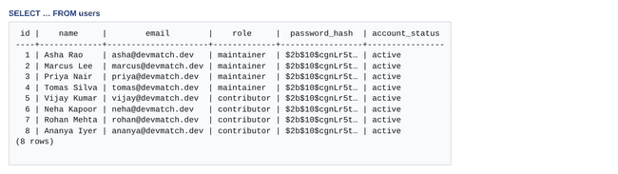
Result: users
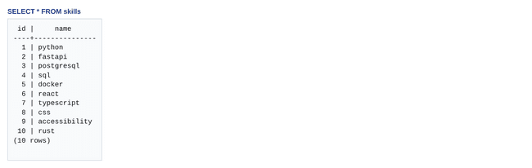
Result: skills
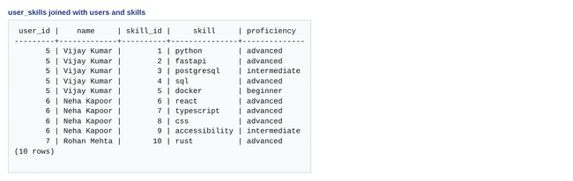
Result: user_skills
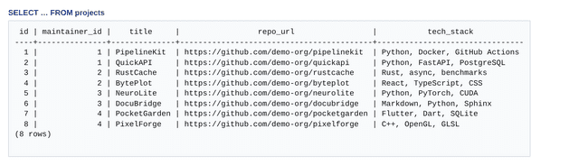
Result: projects
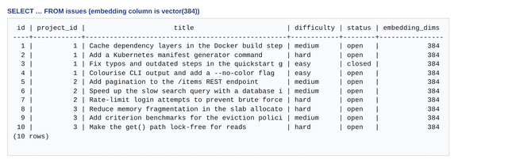
Result: issues
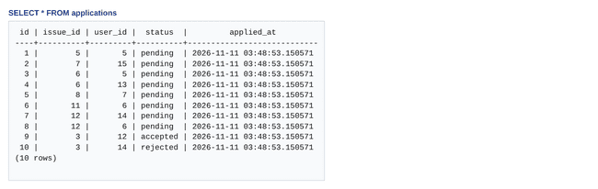
Result: applications
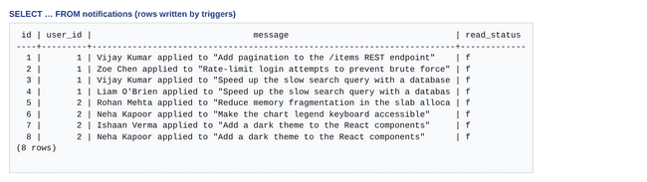
Result: notifications
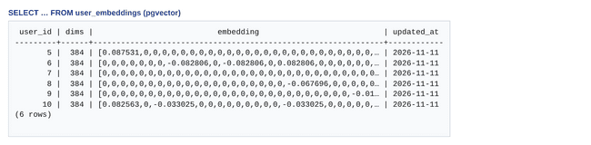
Result: user_embeddings (pgvector)
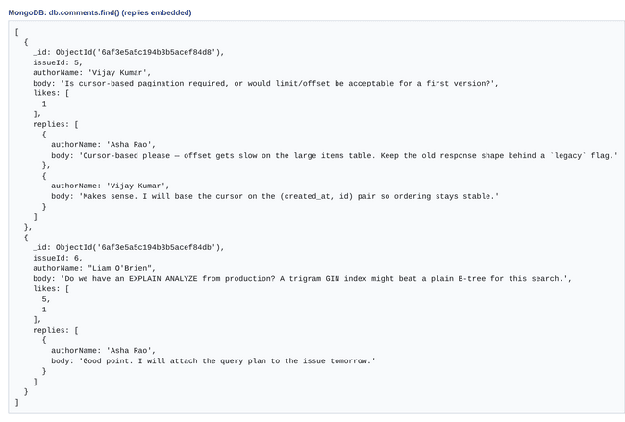
Result: MongoDB collection comments
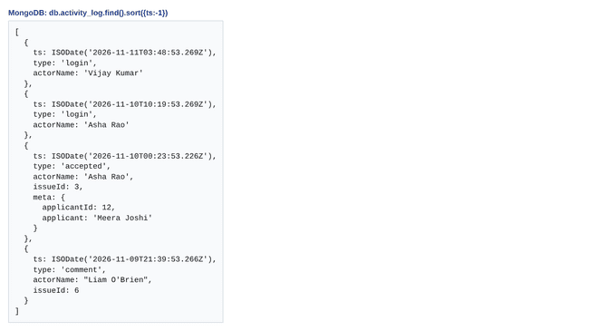
Result: MongoDB collection activity_log
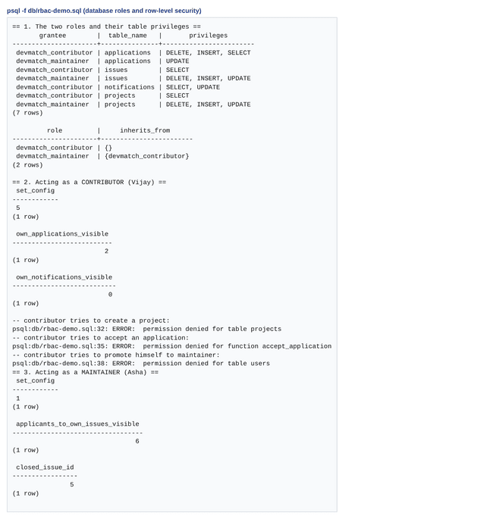
Result: Database roles and row-level security demo

Next.js – Project Tree Structure
The project uses the Next.js App Router. Folders in src/app are routes; [id] folders are dynamic routes; src/app/actions holds the server actions that perform all writes; src/app/api holds route handlers; src/middleware.ts protects private pages; src/lib holds the PostgreSQL, MongoDB, embedding and authentication code.
devmatch/
├── db/
│ ├── mongo-commands.js
│ ├── mongo-init.js
│ ├── queries.sql
│ ├── rbac-demo.sql
│ ├── rbac.sql
│ ├── schema.sql
│ └── vector-commands.sql
├── docs/
│ ├── diagrams/
│ ├── results/
│ ├── screenshots/
│ ├── er-diagram.mmd
│ └── project-tree.txt
├── public/
├── scripts/
│ ├── env.ts
│ ├── init-db.ts
│ ├── reindex.ts
│ ├── seed-data.json
│ └── seed.ts
├── src/
│ ├── app/
│ │ ├── actions/
│ │ │ ├── applications.ts
│ │ │ ├── auth.ts
│ │ │ ├── comments.ts
│ │ │ ├── issues.ts
│ │ │ ├── notifications.ts
│ │ │ ├── profile.ts
│ │ │ └── projects.ts
│ │ ├── activity/
│ │ │ └── page.tsx
│ │ ├── api/
│ │ │ ├── feed/
│ │ │ │ └── route.ts
│ │ │ ├── health/
│ │ │ │ └── route.ts
│ │ │ ├── issues/
│ │ │ │ ├── [id]/
│ │ │ │ │ ├── matches/
│ │ │ │ │ │ └── route.ts
│ │ │ │ │ └── similar/
│ │ │ │ │ └── route.ts
│ │ │ │ └── route.ts
│ │ │ └── me/
│ │ │ └── route.ts
│ │ ├── applications/
│ │ │ └── page.tsx
│ │ ├── dashboard/
│ │ │ └── page.tsx
│ │ ├── feed/
│ │ │ └── page.tsx
│ │ ├── insights/
│ │ │ └── page.tsx
│ │ ├── issues/
│ │ │ ├── [id]/
│ │ │ │ ├── edit/
│ │ │ │ │ └── page.tsx
│ │ │ │ └── page.tsx
│ │ │ └── page.tsx
│ │ ├── login/
│ │ │ └── page.tsx
│ │ ├── notifications/
│ │ │ └── page.tsx
│ │ ├── profile/
│ │ │ └── page.tsx
│ │ ├── projects/
│ │ │ ├── [id]/
│ │ │ │ ├── edit/
│ │ │ │ │ └── page.tsx
│ │ │ │ ├── issues/
│ │ │ │ │ └── new/
│ │ │ │ │ └── page.tsx
│ │ │ │ └── page.tsx
│ │ │ └── new/
│ │ │ └── page.tsx
│ │ ├── register/
│ │ │ └── page.tsx
│ │ ├── error.tsx
│ │ ├── globals.css
│ │ ├── layout.tsx
│ │ ├── not-found.tsx
│ │ └── page.tsx
│ ├── components/
│ │ ├── forms/
│ │ │ ├── AuthForms.tsx
│ │ │ ├── ProfileForm.tsx
│ │ │ └── ProjectIssueForms.tsx
│ │ ├── ConfirmForm.tsx
│ │ ├── Flash.tsx
│ │ ├── Header.tsx
│ │ ├── NavLink.tsx
│ │ ├── SkillEditor.tsx
│ │ ├── SubmitButton.tsx
│ │ ├── Thread.tsx
│ │ ├── ui.tsx
│ │ └── useActionForm.ts
│ ├── lib/
│ │ ├── activity.ts
│ │ ├── analytics.ts
│ │ ├── auth.ts
│ │ ├── db.ts
│ │ ├── discussion.ts
│ │ ├── embedder.ts
│ │ ├── flash.ts
│ │ ├── format.ts
│ │ ├── insights.ts
│ │ ├── mongo.ts
│ │ ├── params.ts
│ │ ├── queries.ts
│ │ ├── types.ts
│ │ └── writes.ts
│ └── middleware.ts
├── tests/
│ ├── db.test.ts
│ ├── e2e.cjs
│ └── embedder.test.ts
├── .env.example
├── .gitignore
├── DevMatch_Report.docx
├── README.md
├── REPORT.md
├── docker-compose.yml
├── next-env.d.ts
├── next.config.mjs
├── package-lock.json
├── package.json
└── tsconfig.json

Few Sample Screenshots of Application Code and Demo
Demo logins (password password123): maintainer asha@devmatch.dev; contributors vijay@, neha@ and ishaan@devmatch.dev.
Demo
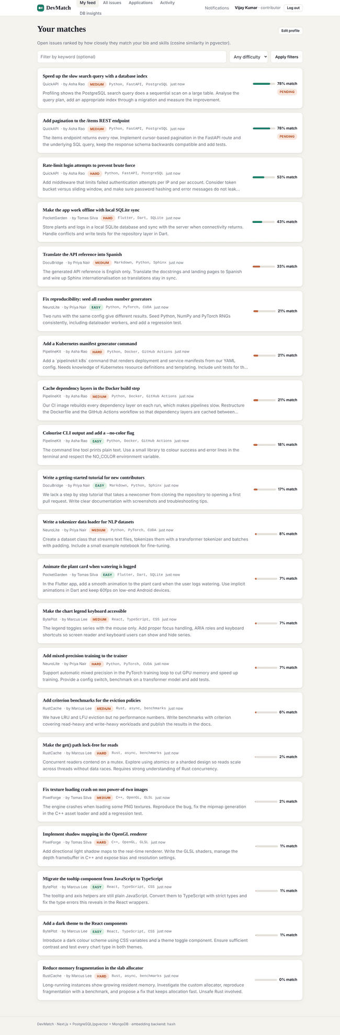
Contributor feed: issues ranked by pgvector cosine similarity
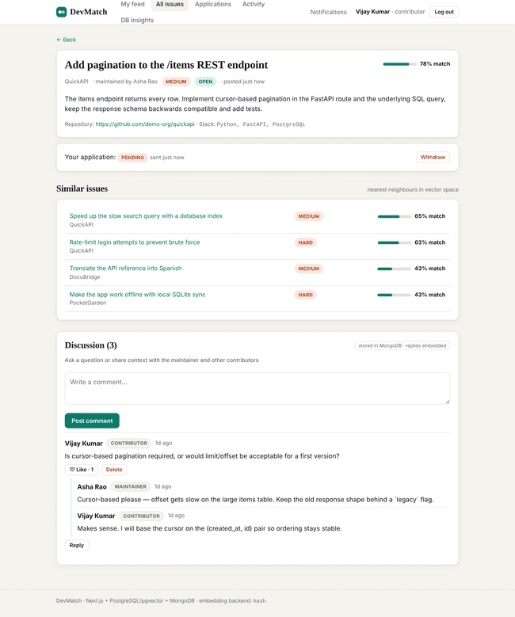
Issue page: match score, similar issues (pgvector) and discussion thread (MongoDB)
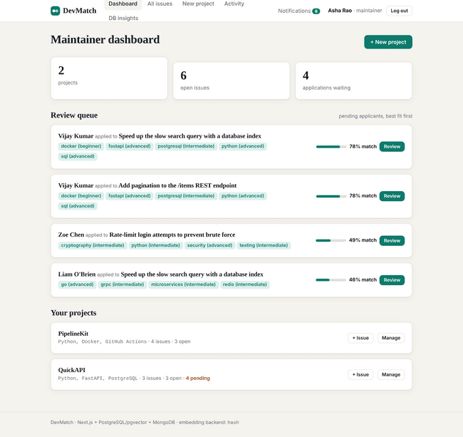
Maintainer dashboard and review queue (best fit first)
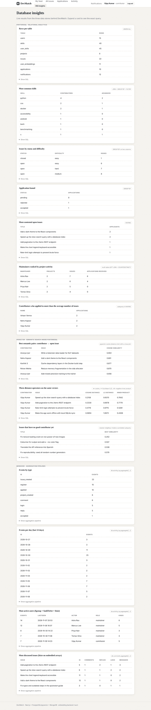
DB-insights page: SQL, pgvector and MongoDB queries behind the UI
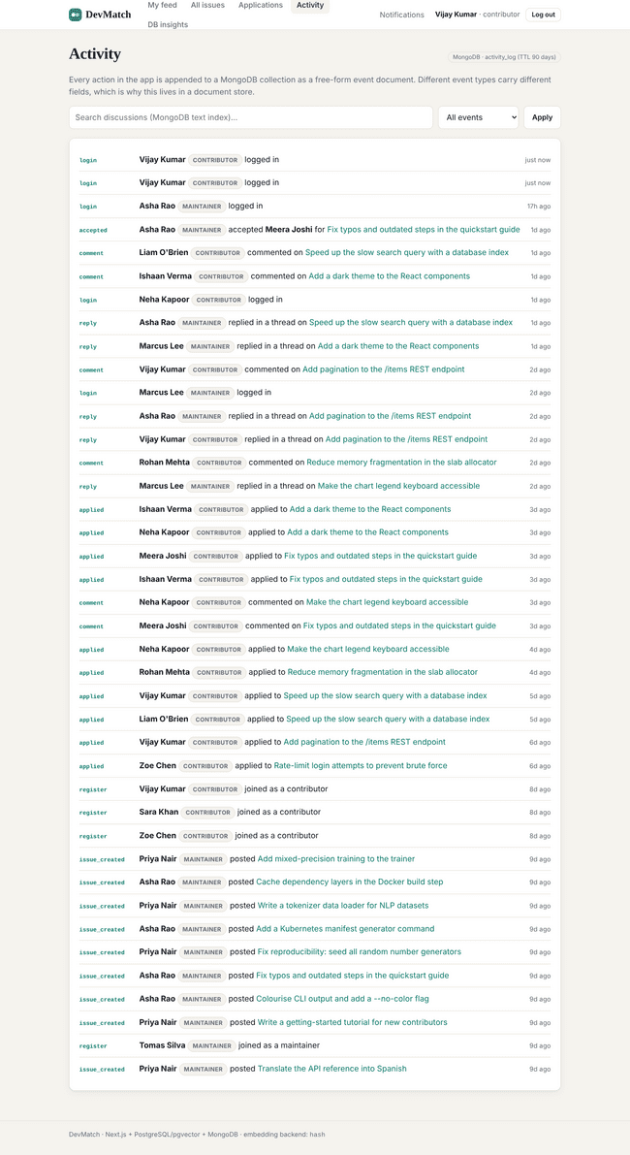
Activity feed read from MongoDB
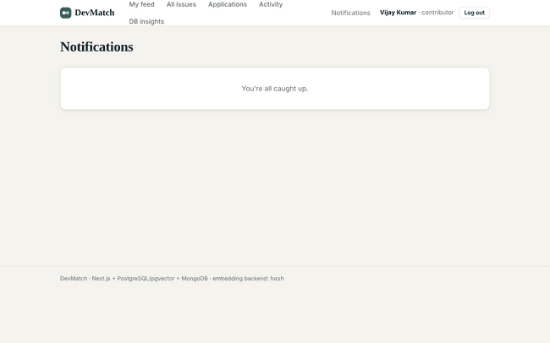
Notifications written by a PostgreSQL trigger
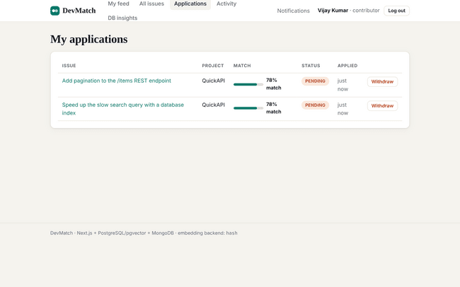
Contributor: my applications
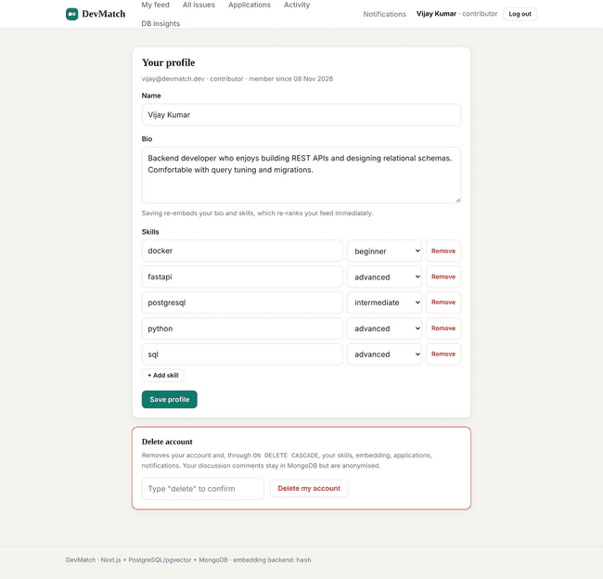
Profile and skills (re-embeds the profile vector on save)
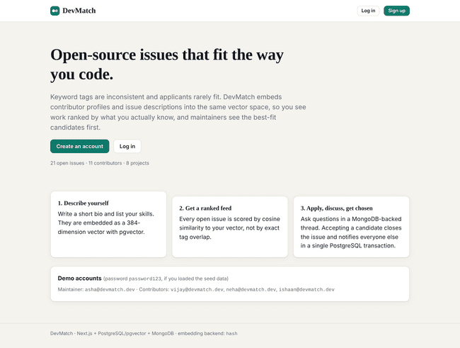
Landing page
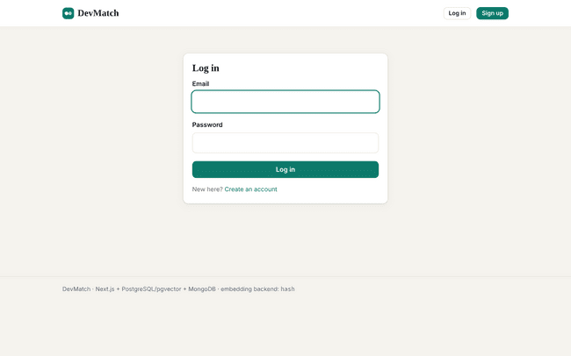
Login
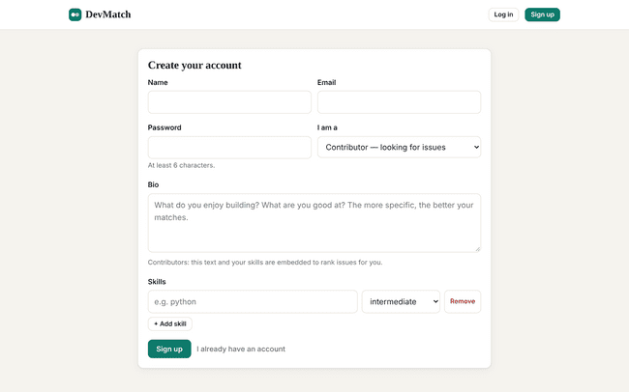
Registration with role selection
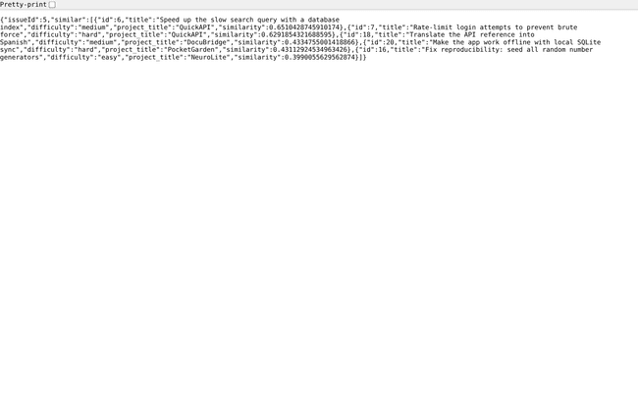
Route handler: /api/issues/[id]/similar
Application code
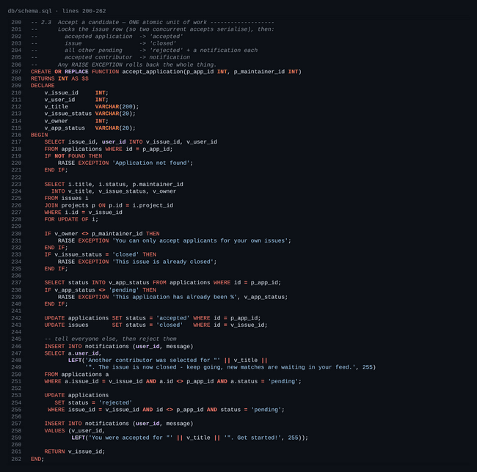
SQL: transactional accept_application() function (row lock, atomic update)
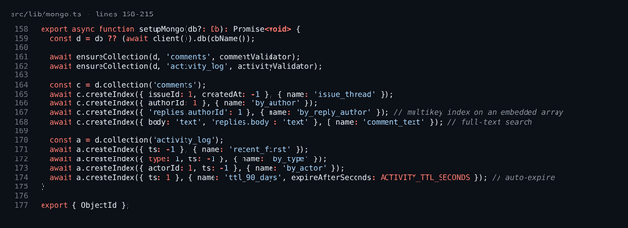
MongoDB: collection validators and indexes
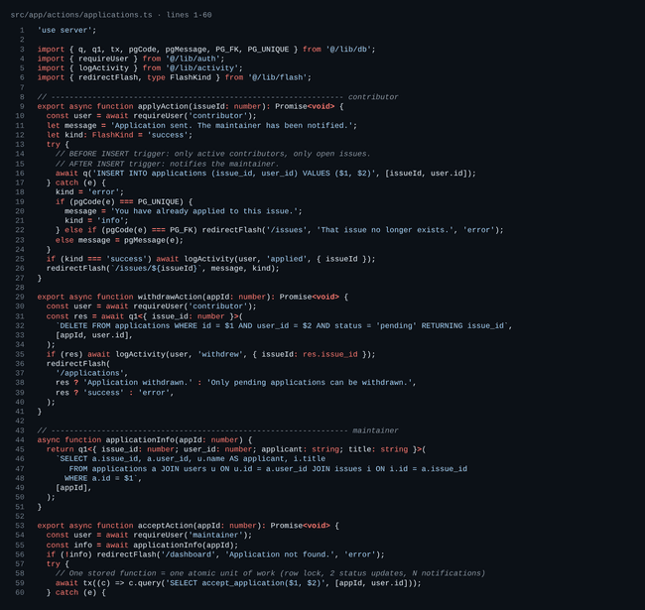
Next.js: server actions for applications
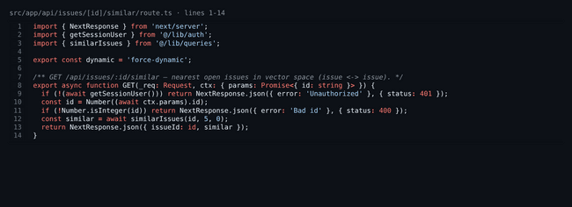
Next.js: route handler (JSON API)
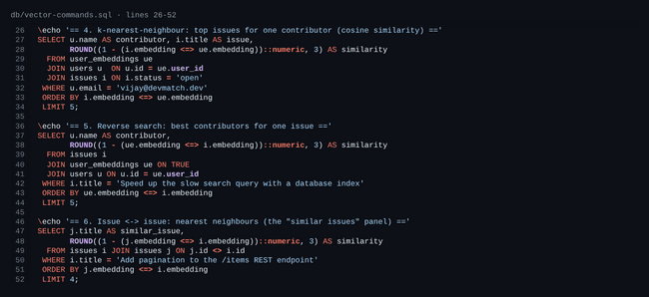
pgvector: k-nearest-neighbour queries
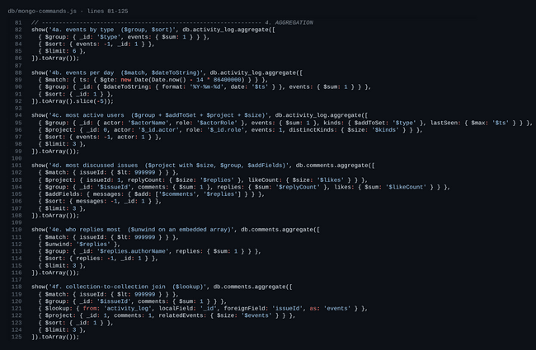
MongoDB: aggregation pipelines
Evaluation Rubrics
# | Criteria | Distribution | Status
1 | Database Design | ER diagram , relational schema with keys, relationships, and constraints | Completed. ER diagram in Chen notation with a weak entity and multivalued, composite and derived attributes, plus a Mermaid version (Section 3). Relational schema with primary and foreign keys, cardinalities, CASCADE rules and CHECK/UNIQUE constraints (Section 4).
2 | Database Creation | SQL database implementation - DDL with constraints , NoSQL/Vector database creation , Technology justification | Completed. SQL DDL with constraints, indexes, view, triggers and functions (Section 5). NoSQL/vector creation: MongoDB collections with $jsonSchema validators and compound, multikey, text and TTL indexes; pgvector vector(384) columns with ivfflat indexes (Section 7). Technology justification in Section 2.
3 | SQL Operations and Queries | DML operations , Nested/correlated/Recursive SQL queries, Join SQL queries | Completed. INSERT/UPDATE/DELETE with RETURNING; joins across four tables; GROUP BY/HAVING; nested IN/EXISTS subqueries; correlated subqueries; recursive CTEs; UNION; CASE; window functions (Section 6, with output log).
4 | Advanced Database Concepts | Advanced database concepts (Procedure/function, trigger, CTE) , NoSQL/Vector feature RUD | Completed. Functions accept_application() and reject_application() (row locking, one transaction); triggers fn_check_application and fn_notify_maintainer; view open_issues_view; CTE and recursive CTE (Sections 5 and 6). MongoDB read, update and delete operations with aggregation and text search; pgvector read (KNN), update (re-embed) and cascade delete (Sections 7 and 8).
5 | Web Application and Database Integration | Next.js interface , Backend/API and database integration | Completed. Next.js 15 App Router: server components, server actions, route handlers and middleware; backend and API integrated with PostgreSQL, pgvector and MongoDB (Sections 9 and 10).
6 | Authentication and Authorization | Authentication implementation (front end and backend) and minimum two roles and role-based access control in database | Completed. Login and registration pages (front end); bcrypt password hashing, JWT HttpOnly cookie and middleware (back end); two roles, contributor and maintainer, enforced in the application and in the database through roles, GRANT/REVOKE and row-level security (db/rbac.sql, db/rbac-demo.sql).
7 | Documentation, Git/GitHub, Demonstration, Testing, and Originality | Documentation, Git/GitHub , Originality and individual contribution | Documentation completed (this report, README, command files, 29 database tests and 37 browser tests). PENDING for the team: GitHub repository link and the individual-contribution entries (below).
Marks-wise status
# | Evaluation component | Max | Status | Where it is implemented
1 | ER diagram | 2 | Completed | Section 3; docs/diagrams/er.dot, docs/er-diagram.mmd
2 | Relational schema with keys, relationships and constraints | 3 | Completed | Section 4; db/schema.sql
3 | SQL database implementation – DDL with constraints | 4 | Completed | Section 5; db/schema.sql, db/rbac.sql
4 | NoSQL / Vector database creation | 4 | Completed | Section 7; db/mongo-init.js, pgvector columns and ivfflat indexes
5 | Technology justification | 1 | Completed | Section 2
6 | DML operations | 4 | Completed | Section 6; db/queries.sql (section 2 of the file)
7 | Nested / correlated / recursive queries, joins | 4 | Completed | db/queries.sql: 3a–3c joins, 3d nested, 3i–3j correlated, 3k–3l recursive
8 | Advanced SQL: procedure / function, trigger, CTE | 6 | Completed | Functions accept/reject_application; triggers; CTE 3e, 3k, 3l
9 | NoSQL / Vector feature, RUD | 7 | Completed | db/mongo-commands.js (read, update, delete), db/vector-commands.sql; in app: comments, likes, replies, delete
10 | Next.js interface | 3 | Completed | src/app (pages, server actions, middleware)
11 | Backend / API and database integration | 2 | Completed | src/app/api, src/lib/db.ts, src/lib/mongo.ts
12 | Authentication (front end and back end), two roles, RBAC in database | 4 | Completed | Login/register pages, src/lib/auth.ts, src/middleware.ts; db/rbac.sql roles, GRANT and row-level security; db/rbac-demo.sql
13 | Documentation, Git/GitHub | 2 | Completed | This report, README.md. GitHub link: [added in the submission gform]
14 | Originality, individual contribution, modification / viva | 4 | COMPLETED | MENTIONED BELOW
Originality
DevMatch combines three data models in one application: relational (PostgreSQL), vector (pgvector) and document (MongoDB). Matching is semantic rather than keyword based, applicants are ranked by profile similarity, accepting an applicant is one locked transaction, and two stores are kept consistent by the application (project deletion removes Mongo threads; account deletion anonymises Mongo comments). The database enforces two roles itself with GRANT and row-level security.
Individual contribution
Student | SRN | Contribution
VIJAY SURIYA P | PES1UG24AM320 | Designed and implemented the PostgreSQL database schema, triggers, stored functions, constraints, and indexes; developed the pgvector-based embedding and matching engine, database queries, relational server actions, and database initialization, seeding, reindexing, and testing scripts.
UTKARSH KUMAR | PES1UG24AM310 | Implemented MongoDB collections, validators, indexes, aggregation pipelines, and discussion/comment functionality; developed authentication and security mechanisms, notifications, application pages, UI components, JSON APIs, Docker infrastructure, and MongoDB and end-to-end tests.

