**MARTIFY**

**(ONLINE MART)**



Everything That You Want

Don't stop living in the rest.. Discover something new.. Experience the lifestyle

**Project Team Member:**

1. **Avika Sharma**
2. **Gurden Singh**
3. **Manya Gupta**
4. **Uthkarsh Pathak**
5. **Vyom Aggarwal**

**1.0 Introduction:**

**1.1 Overview**

This SRS specifies the requirements of the Martify using which users can buy the products. This website provide will support all popular web browser. Martify is a special library where you find house hold goods , self care products , electronic products , glooming products. So, here we basically build a portal where user can simply login and find its need.

**1.2 Purpose**

This document detail the software requirements for the Martify .It provide an easy way for the customers who have to go to different shops to buy different products. Here the customer find what he wants under one roof.

The purpose of this SRS is to verify that all the specifications are correct and verified. This document also ensure that the software is traceable throughout its software development cycle .

**1.3** **Scope**

E-commerce is a term for any type of business, or commercial transaction that involves the transfer of information across the Internet. It covers a range of different types of businesses, from consumer based retail sites, through auction or music sites, to business exchanges trading goods and services between corporations. It is currently one of the most important aspects of the Internet to emerge.

**1.4 Outline of SRS**

This document describes the project's target audience and its user interface, hardware and software requirements. It defines how our client, team and audience see the product and its functionality. Nonetheless, it helps any designer and developer to assist in software delivery lifecycle (SDLC) processes.

**1.5 Abbreviations**

SRS System Requirements Specification UI User Interface FAQ Frequently Asked Questions CRM Customer Relationship Management DFD Data Flow Diagram .

**2.0 Module use case**

**->FOR CUSTOMER**

**2.1 User log in and singup**

In User Login and Signup module, user login is to access the website. If user hasn't registered, he/she will go to signup page to create a new account by providing the required details like,

-Name

-LogintypeID

-Email

-Password

-Phone number

-Address

-City

-Pincode

After creating the account , the user will login to the website.

**2.2 Product List**

This module helps the general user to search for the product and get the details to purchase it. It shows the following:

-Category Name

-Product Name

-About Product

-Avalaible Stock

-Product Price

-Product Image

It should also contain a cart option by which user directly add any product into its cart.

**2.3 Cart**

This module contains the details of the product that the user will add into his cart and also contain a option of delete so that he can compare different product**.**

**2.4 Your Order**

This module contains the details of the orders that user have placed.

**2.5 Sign Out**

This module ends the session, if the current user wishes to end the login session. After that , it navigates to the login page**.**

**->FOR VENDOR**

**2.1 Product:**

This module can be use only by the vendor. Here vendor can add different products with following details:

-Customer ID

-Product Name

-About Product

-Product Quantity

-Category ID

-Product Price

-Product Image

**2.2 Sign Out**

This module ends the session, if the current user wishes to end the login session. After that , it navigates to the login page**.**

**-> FOR ADMIN**

**2.1 Category**

This module have variety of product's category which is added only by the admin like

-Electronics

-Fitness

-Grocery

-Medicine

-Fashion

-Men's clothes

-Women's clothes

-Toys

**2.2 Role**

This module contains the details of the login type and the rights is to admin so that he can edit , delete or find the details of the user.

**2.3 Payment Mode**

This module contains different kinds of payment mode which ensure the customer ease to pay .

**2.4 Sign Out**

This module ends the session, if the current user wishes to end the login session. After that , it navigates to the login page**.**

**3.0 Design and Implementation Constraints**

**3.1 Database:** The system shall use the MS SQL Server Database, which is open source and free**.**

**3.2 Operating System:** The Development environment shall be Window 10.

**3.3 Web Based:** The system shall be MVC**.**

**4.0 Defines module & Functionality**

**Login:** When the Email id and password is match edit allows the user to dashboard where they can see their ID description or else it denies the user to enter into the website.

**Product:** When a common user visit the website and login , they can see the products and its description **.**

**Login Type:** When the user visit the website, he can get a option while he want to login via vendor or customer.

* 1. **Schema Diagram** 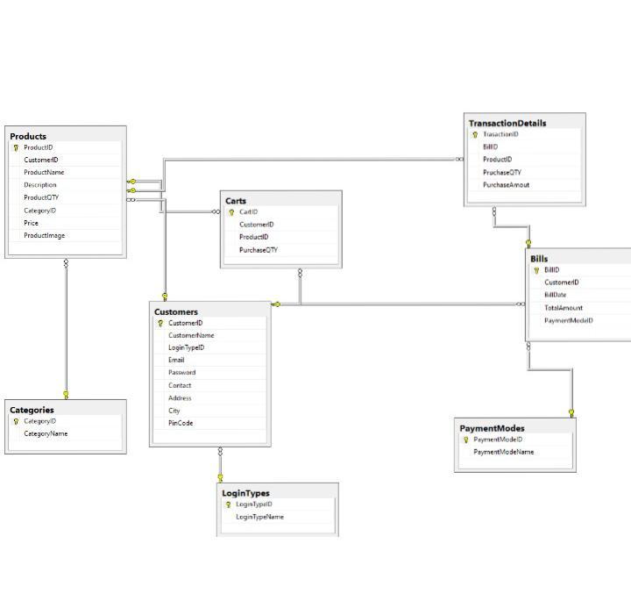

Primary keys are:

* Products – ProductID
* Categories – CategoryID
* Carts. – CartID
* Customers CustomerID
* LoginTypes – LoginTypesID
* TransactionDetails – TransactionID
* Bills – BillID
* PaymentModes – PaymentModeID

**6.0 Technical**

HTML 5

CSS

BOOTSTRAP v4

JQUERY

SQL

MVC

VALIDATION