Online Appointment Management System
Project Planning Document
Microservices Architecture — Plan Before Implementation
Prepared as part of Capgemini Prompt Engineering & Agentic AI Training
To be implemented using AI-assisted, prompt-engineered development with GitHub Copilot
July 2026

1. Project Overview
The Online Appointment Management System (OAMS) will be a microservices-based platform allowing patients to search for doctors, view real-time availability, and book appointments online, while doctors manage their schedules and approve or reject incoming requests. This document plans the system before implementation begins: it defines what will be built, how the pieces fit together, and in what order, so that reading it gives a complete picture of the finished system before a single line of code is written.
The project is deliberately scoped as a realistic, production-shaped architecture rather than a simple monolithic CRUD app: independent Spring Boot microservices, service discovery via Eureka, centralized routing and security through an API Gateway, stateless authentication via JWT, resilient inter-service communication via OpenFeign, a small AI-assisted feature built with Spring AI, and a CI/CD pipeline with automated quality gates via Jenkins and SonarQube. The entire implementation will be generated through structured, iterative prompts given to an AI coding agent (GitHub Copilot) as part of a Prompt Engineering and Agentic AI training program.

1.1 Objectives
- Build a realistic microservices architecture with proper separation of concerns and database-per-service isolation
- Implement stateless, JWT-based security validated centrally at the API Gateway
- Use resilient service-to-service communication via OpenFeign and Resilience4j
- Deliver a usable, styled frontend using server-side rendering (Thymeleaf) rather than a separate SPA
- Introduce a small, well-scoped Spring AI feature as a final enhancement once the core system works
- Establish a CI/CD pipeline with automated build, test, static analysis, and containerized deployment
- Demonstrate effective prompt engineering throughout — scoping each AI generation to a reviewable unit

1.2 Technology Stack
Layer | Technology
Language | Java 25
Application Framework | Spring Boot 4.1.0
Microservices Framework | Spring Cloud 2025.1.2
Service Discovery | Netflix Eureka
API Gateway | Spring Cloud Gateway
Security | Spring Security + JWT (io.jsonwebtoken / jjwt 0.13.0)
Inter-service Communication | OpenFeign + Resilience4j (circuit breaker)
Object Mapping | ModelMapper — Entity-to-DTO and DTO-to-Entity conversion, one shared bean per service
AI Integration | Spring AI 2.0 (GA, Spring Boot 4-compatible) — a single, small AI-assisted feature, added last
Database | PostgreSQL 15 — one database per service
Frontend | Thymeleaf (server-rendered) + Tailwind CSS
Build Tool | Maven, using the Maven Wrapper (./mvnw) — no global Maven required
Testing | JUnit 5 + Mockito (unit), Testcontainers PostgreSQL (integration)
CI/CD | Jenkins (declarative pipeline)
Code Quality | SonarQube + JaCoCo coverage
Containerization | Docker + Docker Compose
AI Development Tooling | GitHub Copilot, driven by structured iterative prompts

2. Problem Statement

2.1 Current Approach and Its Limitations
Appointment scheduling in many small clinics and individual practices is still handled manually — over the phone, via walk-ins, or through a paper/whiteboard register kept at the front desk. This has several recurring problems:
- Patients have no visibility into a doctor's real-time availability and must call or visit in person to check open slots.
- Double-booking and scheduling conflicts are common when multiple front-desk staff or channels update the same register.
- There is no self-service way for a patient to cancel or reschedule without another phone call.
- Doctors have no consolidated, structured view of upcoming appointments.
- A patient unsure which specialist they need has no easy way to figure that out before calling.

2.2 Planned Solution
OAMS will address these gaps with a self-service web platform where patients search doctors by specialization, view real, live slot availability, and book directly — with the system itself preventing double-booking at the data layer rather than relying on manual coordination. Doctors will get a structured dashboard to manage availability and respond to requests. As a final enhancement, a small Spring AI-powered feature will help a patient who isn't sure which specialization they need, based on a short free-text description of their symptoms (see Section 10).

3. User Roles
Role | Description | Key Capabilities
Patient | An end user seeking to book appointments with doctors. | Register/login, optionally describe symptoms to get an AI-suggested specialization, search doctors, view available slots, book an appointment, view and cancel their own appointments.
Doctor | A healthcare provider offering consultations. | Register/login, maintain their profile, define available time slots, view incoming appointment requests, approve or reject bookings.
Admin | System administrator overseeing the platform. | View all registered doctors, monitor appointment statistics across the system (read-only in this scope).

4. Core Features

4.1 Patient Features
- Account registration and secure login (JWT-based session)
- Search and filter doctors by specialization
- Optional: describe symptoms in plain text and receive an AI-suggested specialization to search for
- View a doctor's real-time available time slots
- Book an appointment with a reason/note, with conflict prevention (no double-booking a slot)
- View appointment history and current status
- Cancel a pending or approved appointment

4.2 Doctor Features
- Account registration and secure login
- Maintain profile details: specialization, qualification, experience, consultation fee
- Define and manage available appointment slots
- View, approve, or reject incoming appointment requests

4.3 Admin Features
- View a directory of all registered doctors
- View platform-wide appointment statistics

4.4 Platform & Security Features
- Centralized JWT validation at the API Gateway, with identity propagated to downstream services via headers
- Service discovery and dynamic routing via Eureka — no hardcoded service URLs
- Resilient inter-service calls via OpenFeign with Resilience4j circuit breakers and fallbacks
- Database-per-service isolation (PostgreSQL)
- Input validation on all API requests via Jakarta Bean Validation
- Automated build, test, static code analysis, and containerized deployment

5. Non-Functional Requirements
Category | Requirement
Security | All state-changing requests must carry a valid, unexpired JWT verified at the API Gateway; passwords hashed with BCrypt; role-based access enforced per endpoint.
Scalability | Each microservice can be scaled independently behind Eureka-based load balancing.
Availability / Resilience | A failure in one downstream service must not cascade — Feign calls are protected by Resilience4j circuit breakers with defined fallbacks.
Data Isolation | Each service owns an independent PostgreSQL database; no service queries another service's tables directly.
Maintainability | Consistent package structure, DTO-based API contracts, and centralized configuration conventions across all services.
Usability | The Thymeleaf frontend follows one consistent design system so the experience feels like a single product.
AI Feature Scope | The Spring AI integration is intentionally minimal and non-critical-path — if it fails or is unavailable, the core booking flow (manual specialization search) must continue to work unaffected.

6. Microservices Architecture Plan
The system will be composed of seven core modules plus one small AI module added at the end: a service registry, an API gateway, four business microservices, a server-rendered frontend, and finally a lightweight AI service. Each business microservice will own its own PostgreSQL database, with no shared tables or cross-service foreign keys — cross-service references will be plain identifier fields resolved at call time via OpenFeign.
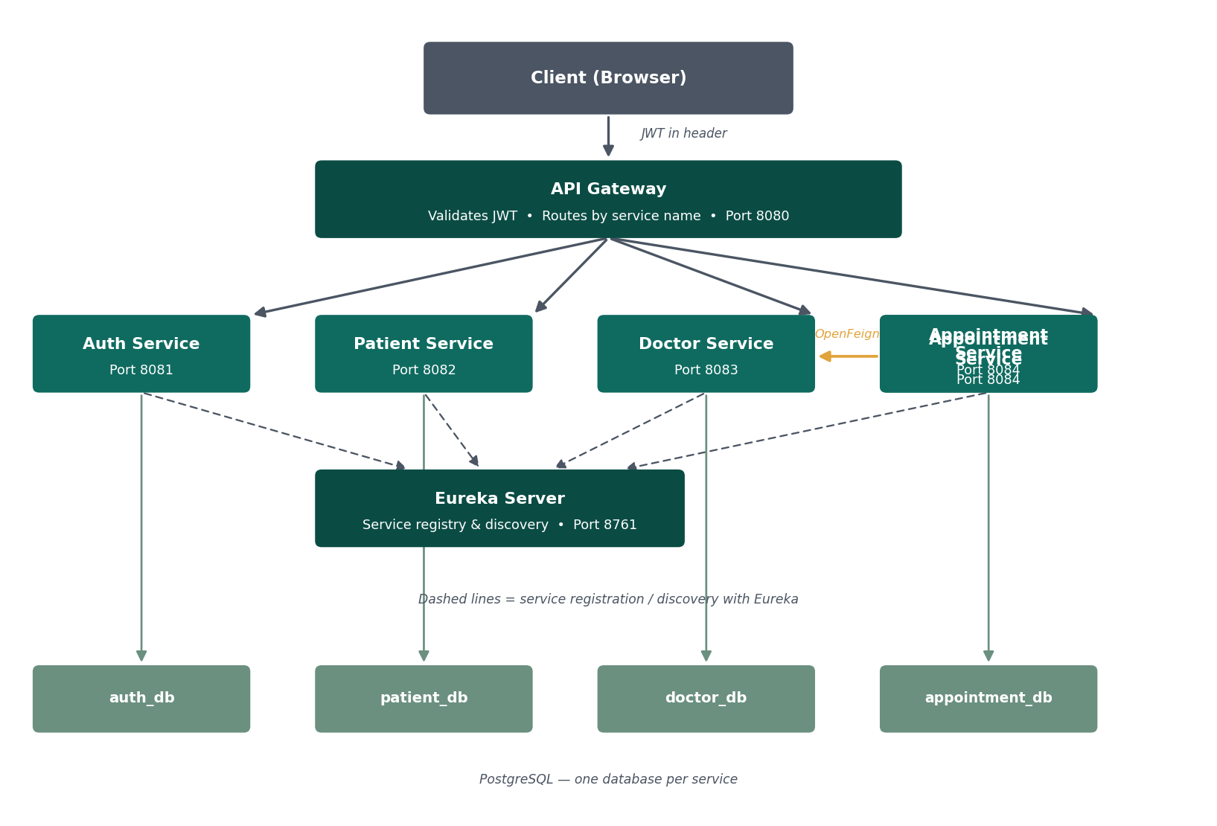
(The AI Service described in Section 10 is not shown in the diagram above since it is added in the final implementation phase — it will sit alongside the four business services, registering with Eureka and routed through the same Gateway, with no database of its own.)

6.1 Service Directory
Service | Port | Responsibility | Database
Eureka Server | 8761 | Service registry — every other service registers here and discovers peers by name. | None
API Gateway | 8080 | Single entry point for all client traffic. Validates JWTs and routes requests by service name via Eureka. | None
Auth Service | 8081 | Owns user identity: registration, login, password hashing, and JWT issuing. | auth_db
Patient Service | 8082 | Owns patient profile data. | patient_db
Doctor Service | 8083 | Owns doctor profile data and slot availability. | doctor_db
Appointment Service | 8084 | Owns appointment booking data; calls Doctor Service via OpenFeign. | appointment_db
web-client | 8085 | Thymeleaf frontend; calls only the API Gateway, holds no data of its own. | None
AI Service (final phase) | 8086 | Small Spring AI-powered symptom-to-specialization suggestion endpoint. No persistence. | None

6.2 Security Flow (JWT)
- Auth Service will authenticate credentials and issue a signed JWT (HS256) containing the user's ID, email, and role, expiring in 1 hour.
- The API Gateway will intercept every request (except login/register), validate the JWT, and reject invalid requests with HTTP 401.
- On success, the Gateway will forward the authenticated user's ID and role as headers (X-User-Id, X-User-Role) to the downstream service.

6.3 Inter-Service Communication
- All service-to-service calls will use OpenFeign, with clients resolved dynamically by Eureka service name.
- Feign calls will be wrapped with Resilience4j circuit breakers and fallbacks.
- Example: when booking an appointment, Appointment Service will call Doctor Service to confirm and reserve the slot before persisting the new appointment.

7. Database Design Plan
Each microservice will own its own PostgreSQL database. Real JPA relationships will exist only between entities within the same service; references to entities owned by another service will be plain identifier fields, resolved via OpenFeign rather than a database join.

7.1 auth_db — Auth Service
Entity | Field | Notes
User | id (PK), name, email (unique), password, role, createdAt | role is an enum: PATIENT, DOCTOR, ADMIN. Password is BCrypt-hashed.

7.2 patient_db — Patient Service
Entity | Field | Notes
Patient | id (PK), userId, dob, address, medicalHistory, emergencyContact, createdAt | userId references auth_db's User.id logically, not via JPA.

7.3 doctor_db — Doctor Service
Entity | Field | Notes
Doctor | id (PK), userId, specialization, qualification, experienceYears, consultationFee | Real @OneToMany relationship to Slot (same database).
Slot | id (PK), doctorId (FK), date, startTime, endTime, isBooked | Real @ManyToOne relationship back to Doctor.

7.4 appointment_db — Appointment Service
Entity | Field | Notes
Appointment | id (PK), patientId, doctorId, slotId, status, reason, createdAt | All three reference fields are plain Longs, no JPA relation. status: PENDING, APPROVED, REJECTED, CANCELLED, COMPLETED.

8. Appointment Booking Workflow
The diagram below traces the planned core user journey — from a patient logging in through to a confirmed appointment — showing which service is responsible at each step.
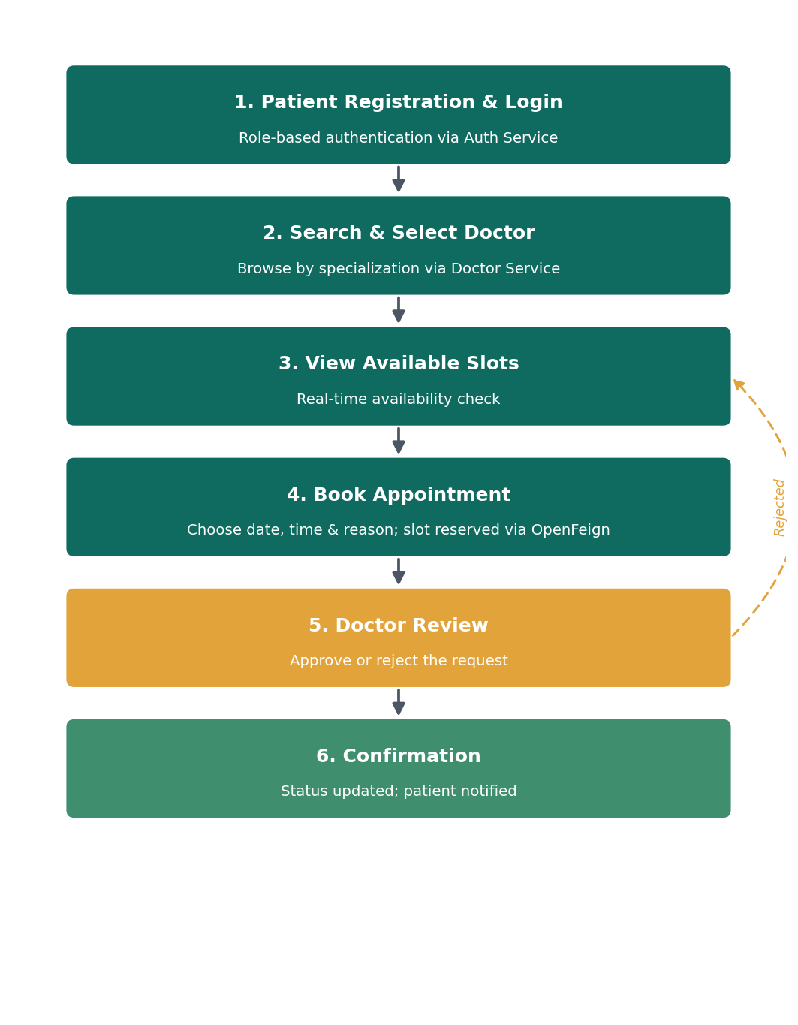
- Patient registration & login — Auth Service authenticates and issues a JWT.
- (Optional) Patient describes symptoms — AI Service suggests a specialization to search for.
- Search & select doctor — the patient queries Doctor Service by specialization.
- View available slots — Doctor Service returns only currently unbooked slots.
- Book appointment — Appointment Service calls Doctor Service via OpenFeign to verify and reserve the slot, then persists a new Appointment as PENDING.
- Doctor review — the doctor approves or rejects the request; a rejection returns the patient to slot selection.
- Confirmation — the appointment's status updates and is reflected in the patient's dashboard.

9. REST API Planning (Grouped by Service)
All external traffic will enter through the API Gateway (http://localhost:8080). Every endpoint below except /auth/register and /auth/login will require a valid Bearer JWT.

9.1 Auth Service — /auth/**
Method | Endpoint | Auth | Description
POST | /auth/register | Public | Registers a new user; password hashed with BCrypt.
POST | /auth/login | Public | Verifies credentials, returns a signed JWT.

9.2 Patient Service — /patients/**
Method | Endpoint | Auth | Description
POST | /patients | PATIENT / ADMIN | Creates a patient profile.
GET | /patients/{userId} | Owner / ADMIN | Fetches a patient's profile.
PUT | /patients/{userId} | Owner / ADMIN | Updates a patient's profile.

9.3 Doctor Service — /doctors/**
Method | Endpoint | Auth | Description
POST | /doctors | DOCTOR / ADMIN | Creates a doctor profile.
GET | /doctors?specialization= | Any authenticated | Searches doctors by specialization.
GET | /doctors/{id} | Any authenticated + internal | Fetches one doctor's profile.
POST | /doctors/{id}/slots | DOCTOR owner / ADMIN | Adds a new availability slot.
GET | /doctors/{id}/slots | Any authenticated | Lists available slots.
GET | /doctors/slots/{slotId} | Internal (Feign) | Fetches a single slot.
PUT | /doctors/slots/{slotId}/book | Internal (Feign) | Marks a slot booked.

9.4 Appointment Service — /appointments/**
Method | Endpoint | Auth | Description
POST | /appointments | PATIENT | Books an appointment via a Feign call to Doctor Service.
PUT | /appointments/{id}/status | DOCTOR / owning PATIENT | Updates status.
GET | /appointments/patient/{patientId} | Owner / ADMIN | Lists a patient's appointments.
GET | /appointments/doctor/{doctorId} | Owner / ADMIN | Lists a doctor's appointments.

9.5 AI Service — /ai/** (added in the final phase, see Section 10)
Method | Endpoint | Auth | Description
POST | /ai/suggest-specialization | PATIENT | Accepts free-text symptoms, returns a suggested specialization and a short explanation.

10. Spring AI Integration Plan
A single, small AI-assisted feature will be added once the entire core system (all four business services, the frontend, and tests) is working end-to-end. The scope is intentionally minimal: this is a demonstration of Spring AI integration, not a second major subsystem, and it is not on the critical path of booking an appointment.

10.1 The Feature
On the patient's "search doctors" page, an optional text box will let a patient describe their symptoms in plain language (e.g. "I've had a persistent skin rash for a week"). A "Suggest a specialist" button will call the AI Service, which returns a suggested specialization (e.g. "Dermatology") and a one-line explanation. The suggestion pre-fills the existing specialization search — it does not replace or bypass the normal doctor search, and a patient can always ignore it and search manually.

10.2 Technical Approach
- A new, lightweight AI Service (port 8086) will be added — no database, registers with Eureka like every other service, routed through the existing API Gateway at /ai/**.
- It will use Spring AI 2.0 (GA, released June 2026, built for Spring Boot 4.0/4.1 and Spring Framework 7 — matching this project's existing stack) with the ChatClient abstraction.
- Model provider: spring-ai-starter-model-anthropic (Claude) — chosen for a simple, single-call use case with no need for RAG, vector stores, or tool calling; an OpenAI-compatible starter is a drop-in alternative if preferred.
- The endpoint will take a short prompt template, insert the patient's symptom text, and constrain the model to respond with one specialization from a fixed list matching the specializations already used in Doctor Service (e.g. Cardiology, Dermatology, Orthopedics, General Physician), plus a one-sentence explanation — avoiding open-ended, unbounded model output.
- If the AI Service is unreachable or the call fails, the web-client will simply hide the suggestion box and fall back to normal manual search — consistent with the non-functional requirement in Section 5 that this feature must never block the core booking flow.

10.3 Why This Is Deliberately Small
This integration is scoped to one endpoint, one model call, and one UI element by design. It is added last, after the rest of the system is proven, specifically so that learning and demonstrating Spring AI does not put the project's core deliverable (the working booking system) at risk. If time permits after this is working, a natural next step — not part of the current scope — would be giving the AI feature light context about a doctor's actual availability, but that is intentionally deferred rather than attempted here.

11. Testing Strategy Plan
Testing will follow a two-layer pyramid across all four core business microservices: fast, isolated unit tests for business logic, and integration tests against a real, ephemeral PostgreSQL instance via Testcontainers.

11.1 Unit Testing
JUnit 5 with Mockito will mock all external dependencies (repositories, Feign clients) to isolate and verify business logic. Each service's *Service class is the primary target — validation, conflict-checking, and orchestration logic lives there.

11.2 Integration Testing
@SpringBootTest with Testcontainers' PostgreSQL module will validate real JPA mappings and query behavior. Controller-level tests will use MockMvc (WebTestClient for the reactive Gateway) to exercise full HTTP cycles, including validation errors and role-based header checks. Appointment Service's tests will mock the DoctorClient Feign interface with @MockBean so booking-conflict and downstream-failure scenarios are deterministic.

11.3 Coverage Target
Each core service will target a minimum of ~70% line coverage, measured via JaCoCo, feeding into the SonarQube quality gate in Section 12. The AI Service, being a thin single-endpoint wrapper, will be tested with a mocked ChatClient response rather than live model calls, to keep tests fast and deterministic.

12. CI/CD Pipeline Plan
Each service will be built and validated through a declarative Jenkins pipeline, with SonarQube providing static analysis and coverage gating before any Docker image is built. All Maven commands will use each service's checked-in Maven Wrapper (./mvnw) rather than assuming a global Maven install.
# | Stage | Description
1 | Checkout | Pulls the latest source from version control.
2 | Build | Runs ./mvnw clean package -DskipTests for each module.
3 | Unit Test | Runs ./mvnw test per module; publishes JUnit results.
4 | SonarQube Analysis | Runs ./mvnw sonar:sonar per module.
5 | Quality Gate | Aborts the pipeline if SonarQube's quality gate fails.
6 | Docker Build | Builds a tagged Docker image per service.
7 | Deploy | Runs docker-compose up -d --build to redeploy locally.

13. Prompt Engineering Approach
Since the implementation will be generated by an AI coding agent (GitHub Copilot), the prompting approach itself is planned here, not left to improvisation:
- A single context-setting overview prompt will be reused at the start of every session, fixing shared decisions (versions, architecture, database-per-service rule, security model) so every later prompt stays consistent.
- Each service will be generated through one comprehensive, self-contained prompt covering entities, validation, JPA relationship rules, and layered structure — scoped to review before moving on.
- The Thymeleaf frontend will be split into focused sub-prompts (setup/layout, auth pages, patient pages, doctor pages, admin pages, polish) rather than one large prompt.
- Tests will be generated per service immediately after that service is manually verified, and always before CI/CD configuration.
- The Spring AI feature will be prompted last, as its own small, isolated addition, after the rest of the system is confirmed working — keeping it from becoming a dependency risk for the core deliverable.
- CI/CD configuration will be generated only after every service (including the AI Service) is confirmed working locally by hand.

14. Implementation Roadmap
The system will be built in the following order. Each phase should be functionally complete and manually verified before moving to the next.
Phase | Deliverable | Notes
1 | Eureka Server + API Gateway | Backbone infrastructure; routes will 404 until business services exist, which is expected.
2 | Auth Service | Registration, login, JWT issuing — needed before any other service can be meaningfully tested.
3 | Patient Service + Doctor Service | Independent of each other, can be built in either order.
4 | Appointment Service | Depends on Doctor Service via Feign; build last among the business services.
5 | web-client (Thymeleaf frontend) | Wires the full user journey together across all four business services.
6 | Unit + integration tests | Per service, immediately after each is manually verified.
7 | Spring AI integration (final feature) | New AI Service + one small web-client addition — added only after everything above works.
8 | CI/CD (Jenkins + SonarQube + Docker) | Wired last, once every service including the AI Service builds, tests, and runs correctly on its own.

15. Future Enhancements
- Notification Service — asynchronous email/SMS confirmations via a message broker (Kafka/RabbitMQ).
- Distributed tracing and centralized logging across services.
- Stronger cross-service identity verification — validating patientId against Patient Service at booking time.
- RSA-based JWT signing instead of a shared HMAC secret.
- Full admin capabilities — doctor onboarding/deactivation and user management.
- Kubernetes orchestration instead of Docker Compose.
- Extending the AI feature with awareness of real-time doctor availability, once the current minimal version is proven — explicitly out of scope for the initial build.

