**OUTPUT**

**Case 1:**

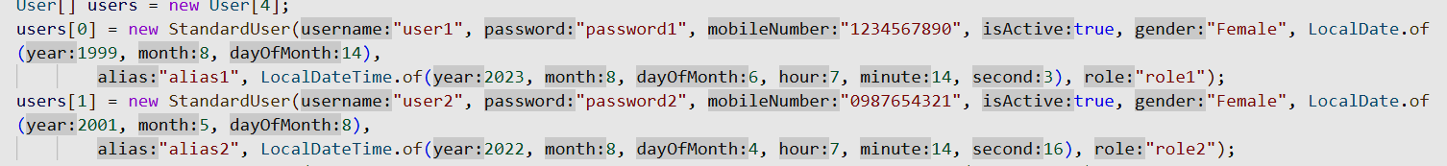

**Case 2:**

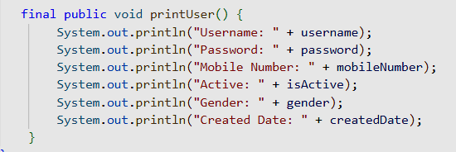

**Case 3:**



**Case 4:**

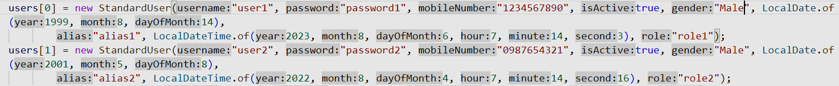

**Case 5:**



