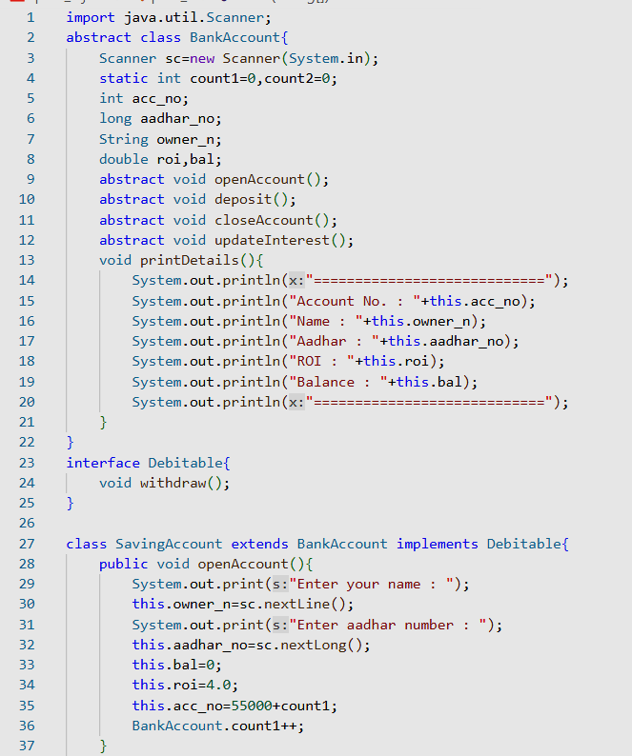

**OUTPUT:**

