Name : Utkarsh pratap singh.

KSPL_1232

Section-A

1. 4
2. 1,3,4,5
3. 2
4. 3
5. 1
6. 2
7. 1,3,4
8. 4
9. 4
10. 4
11. 4
12. 2,3,4
13. 2
14. 2
15. 2
16. 4
17. 1
18. 2
19. 1
20. 4

Section B:

Validation Rules (15 Marks)

1. While closing the opportunity ( 'Closed Won') , an Opportunity Line Item should be present. If  opportunity line item is not present under a opportunity ,

it should give the error message "Opportunity Line Item should be present while closing the opportunity." **(10 Marks)**

Solution:- 1) First we select validation on opportunity and made new validation

With the label validation on opportunity.

And wrote a respective Validation formula to satisfy given condition on

Question.

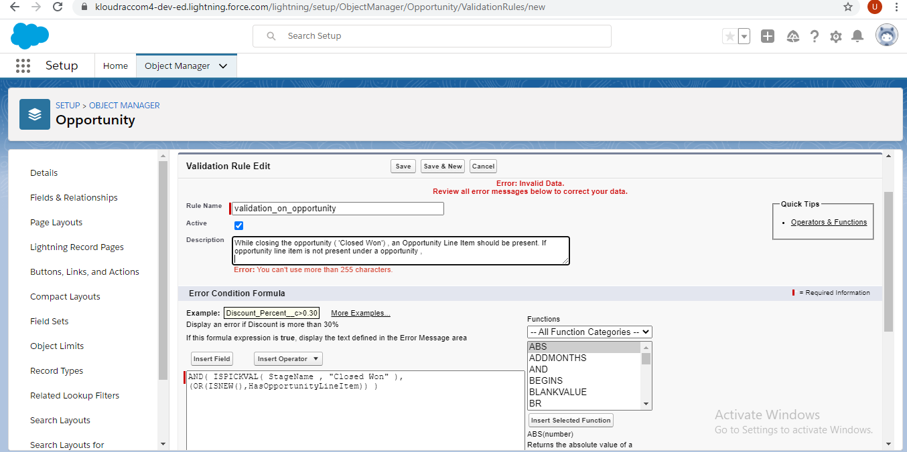

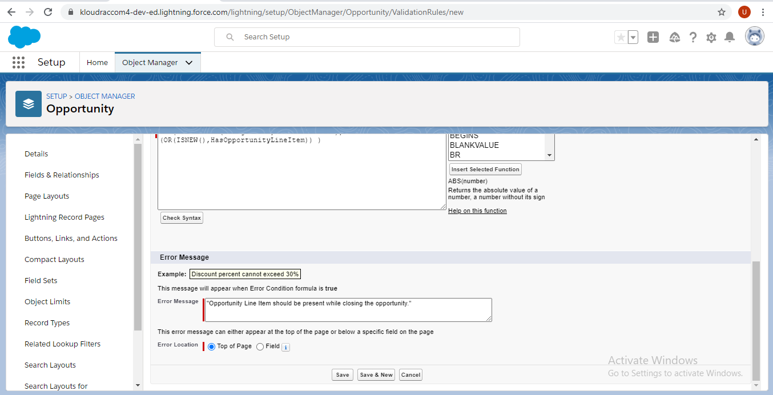

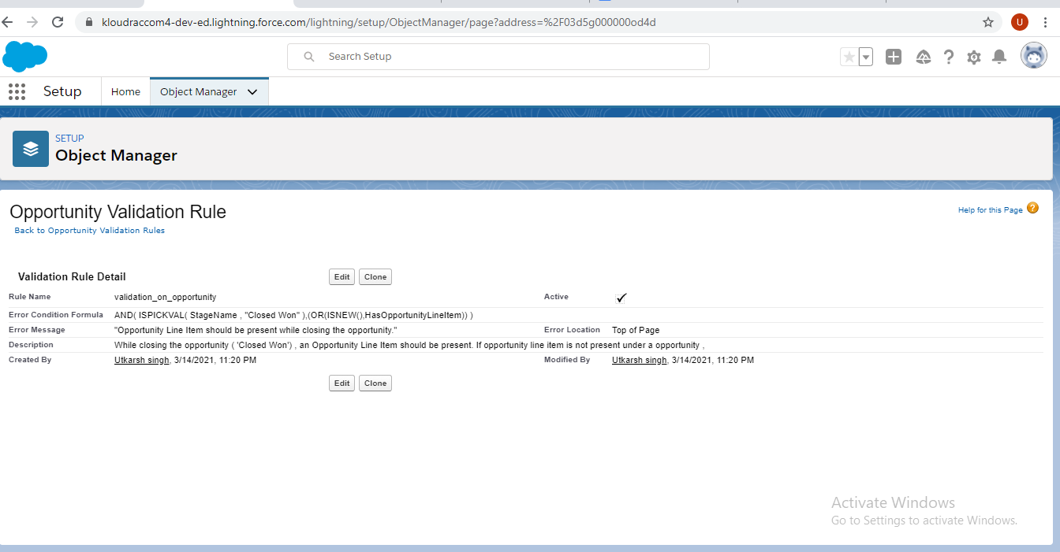

2) Then, tried to make a opportunity record to ensure if validation works correctly. And got a following error message.

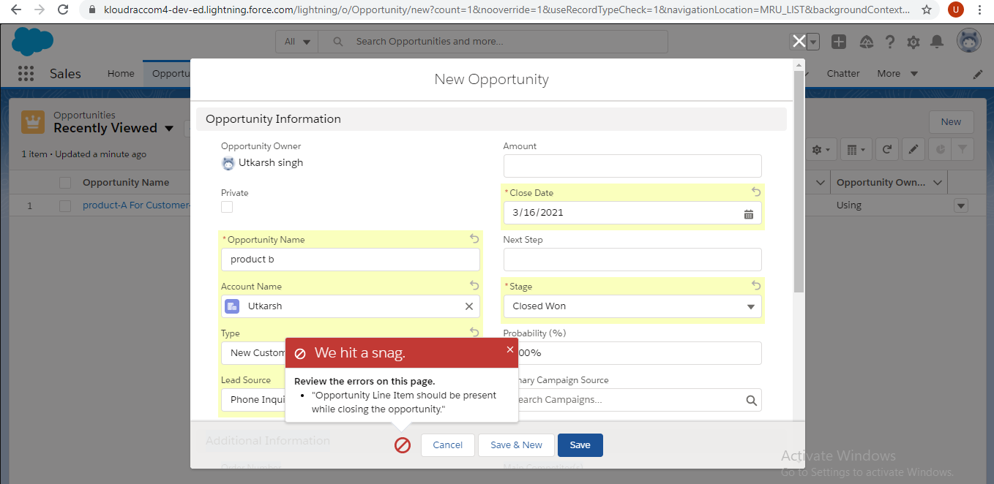

**Workflow Rule (5 Marks)**

If Amount > $10,000 send an email alert on opportunity **closed won (Stage field value)** to pgoyal@kloudrac.com and msharma@kloudrac.com

Email Template .

Subject : Deal closed Alert - $Amount - Opportunity Name

Opportunity Name :

Account Name :

Account Owner :

Amount :

Close Date :

Best Regards

Salesforce Team - Kloudrac

Solution:- 1) Firstly, we go through the Workflow rules from a home.

2) Then, put the label of the rule and make the rule according to mentioned criteria.

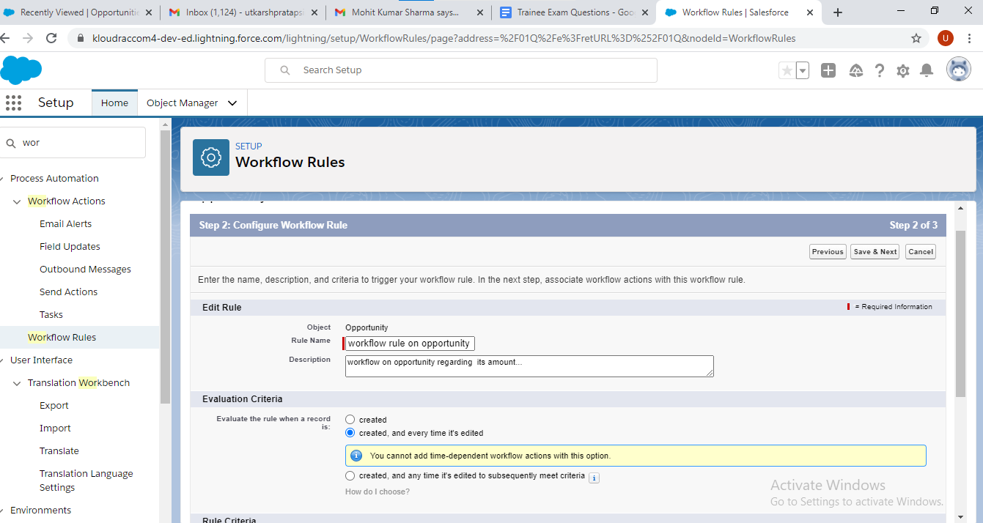

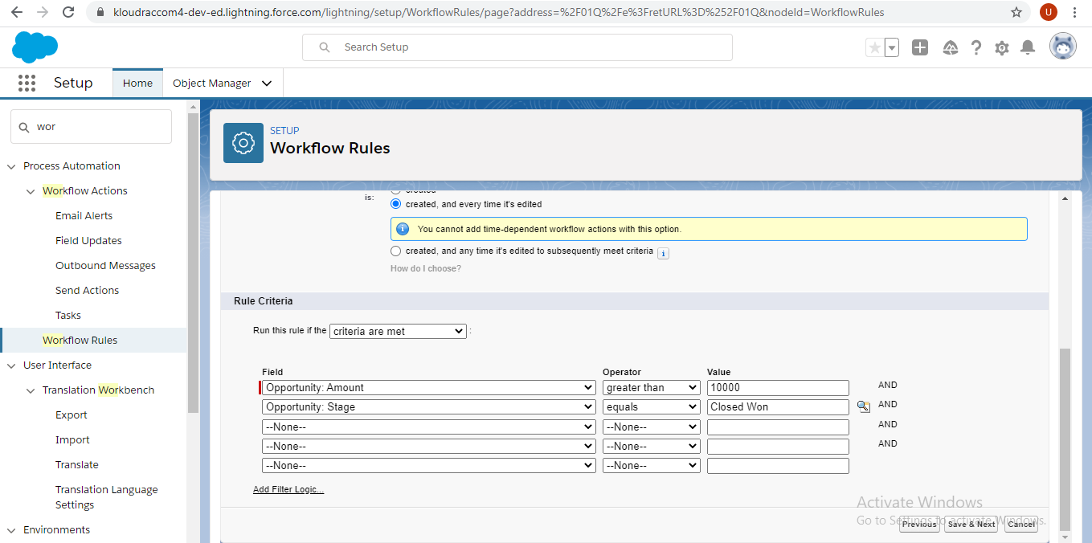

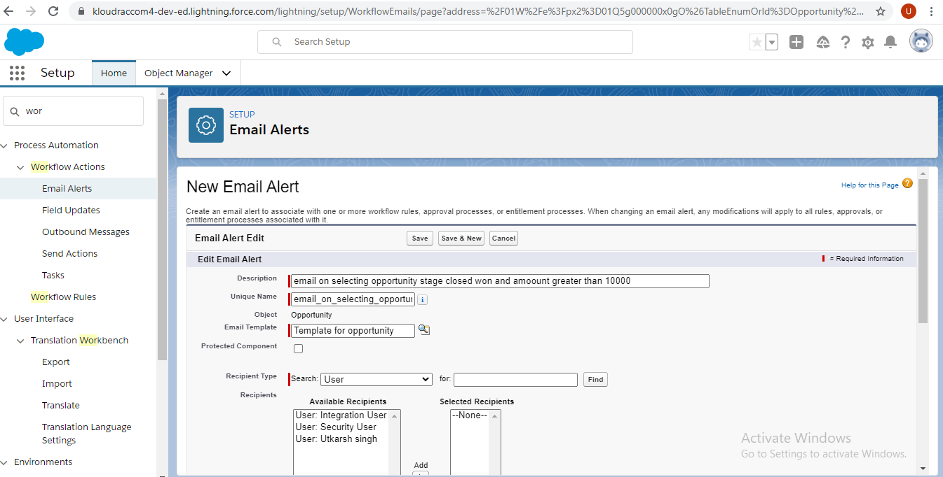

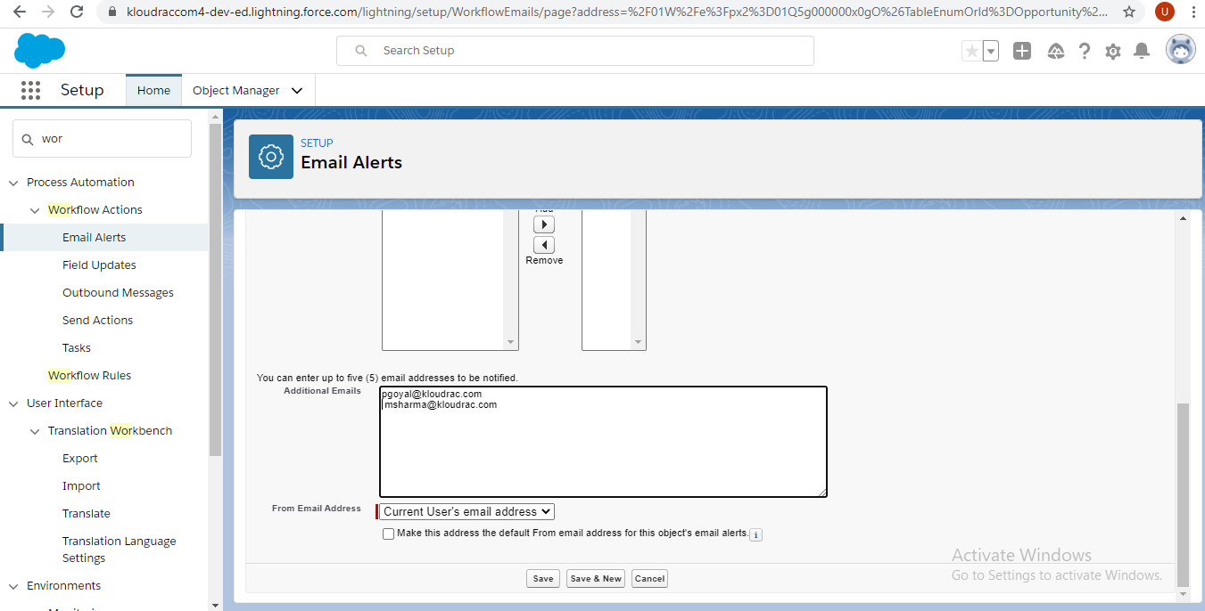

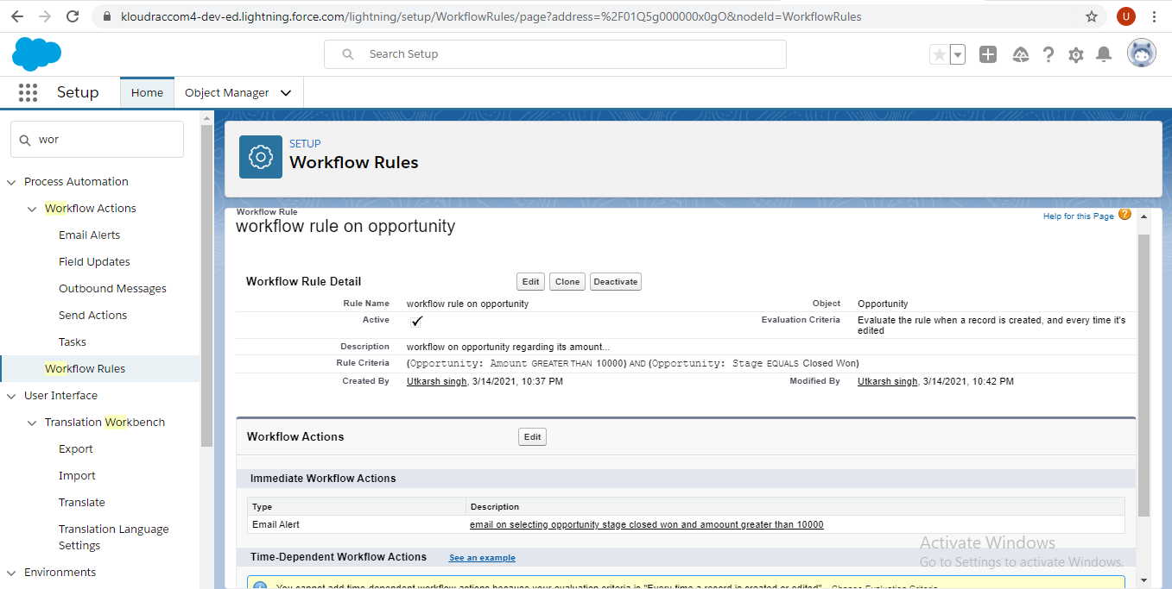

**section B - Triggers (Attempt at least 2) (30 Marks)**

1. Quote and Quote Line Item should get auto created while Opportunity revenue is greater than 100000. **(15 Marks).**

**Solution:**

trigger trg_quoteandquotelineitemonopp on Opportunity (after insert) {

List<QuoteLineItem> lstquotelineitem = new List<QuoteLineItem>();

//List<PricebookEntry> lstPBE = new List<PricebookEntry>();

product2 objProduct2 = [select Name,ProductCode from Product2 limit 1 ] ;

Pricebook2 objPricebook2 = [select Name ,(select id from PricebookEntries) from Pricebook2 limit 1];

PricebookEntry lstPBE = [select id from PricebookEntry where Pricebook2Id = :objPricebook2.Id limit 1];

if(Trigger.new!=null && Trigger.new.size()>0){

for(Opportunity opp : Trigger.new){

if(opp.ExpectedRevenue>100000){

Quote objQuote = new Quote(Name='Quote 1' ,OpportunityId=opp.Id);

insert objQuote;

QuoteLineItem objQuoteLineItem = new QuoteLineItem();

objQuoteLineItem.Product2Id=objProduct2.id;

objQuoteLineItem.QuoteId=objQuote.id;

objQuoteLineItem.UnitPrice=56767;

objQuoteLineItem.Quantity= 3;

objQuoteLineItem.PricebookEntryId=lstPBE.id;

lstquotelineitem.add(objQuoteLineItem);

}

}

}

insert lstquotelineitem;

}