NORTHBRIDGE ENGINEERING PENSION SCHEME
Quarterly Investment Report
Quarter to 30 September 2026
Prepared for: Trustees
Generated by Ledgerline from reconciled source data. Every figure is traceable to its source.

At a glance
TOTAL ASSETS  £1.54bn | RETURN (QUARTER)  4.06%  -0.25% vs benchmark | RETURN (1 YEAR)  11.76%  -0.68% vs benchmark | FUNDING RATIO  93.40%  £108.6m deficit | INTEREST-RATE HEDGE  81.96%

Investment commentary
Over the quarter the Scheme's assets returned 4.06%, behind the benchmark return of 4.32% by 0.25%. Over one year the fund returned 11.76% against a benchmark of 12.44%, underperforming by 0.68%. Relative to benchmark, UK Property was the strongest mandate this quarter, ahead by 0.43%, while Diversified Growth lagged by 1.45%. Attribution over one year shows asset allocation added 0.21% and manager selection detracted 0.79%. The funding ratio stands at 93.40%, a deficit of £108.6m, and the interest-rate hedge covers 81.96% of the liabilities' sensitivity to rates. In our stress tests, a fall of one percentage point in interest rates would reduce the funding ratio by 3.18 percentage points, while a fall of a fifth in growth asset values would reduce it by 10.91 percentage points.
✓ Commentary generated from the computed figures and verified.

Performance by mandate
Mandate | Value | Quarter | vs bmk | 1 year | vs bmk | 3 years p.a. | vs bmk
Global Equity | £429.0m | 10.26% | +0.41% | 26.16% | -2.08% | 19.59% | +0.18%
Emerging Markets Equity | £155.2m | -3.11% | -0.74% | 15.08% | -5.84% | 13.29% | -3.82%
Diversified Growth | £156.3m | 3.49% | -1.45% | 10.35% | -2.10% | 12.91% | +0.77%
UK Property | £156.6m | 1.41% | +0.43% | 14.41% | +1.91% | 18.95% | +1.59%
Buy & Maintain Credit | £216.7m | 2.79% | +0.16% | 4.66% | +1.72% | 6.93% | +1.37%
Liability Driven Investment | £422.9m | 3.36% | +0.17% | 1.25% | -0.06% | -3.38% | +0.21%
Total fund | £1.54bn | 4.06% | -0.25% | 11.76% | -0.68% | 9.80% | +0.46%
Returns are time-weighted (Modified Dietz monthly, chain-linked); periods over one year are annualised. 'vs bmk' = fund return minus benchmark return.

Benchmark returns
Benchmark | Quarter | 1 year | 3 years p.a.
Global equity index (GBP) | 9.86% | 28.23% | 19.41%
EM equity index (GBP) | -2.37% | 20.92% | 17.11%
SONIA + 4% p.a. | 4.94% | 12.45% | 12.14%
UK property index | 0.98% | 12.50% | 17.36%
Sterling corporate bond index | 2.64% | 2.95% | 5.57%
Scheme liability benchmark | 3.18% | 1.31% | -3.59%
Total benchmark | 4.32% | 12.44% | 9.34%

Cumulative performance since inception
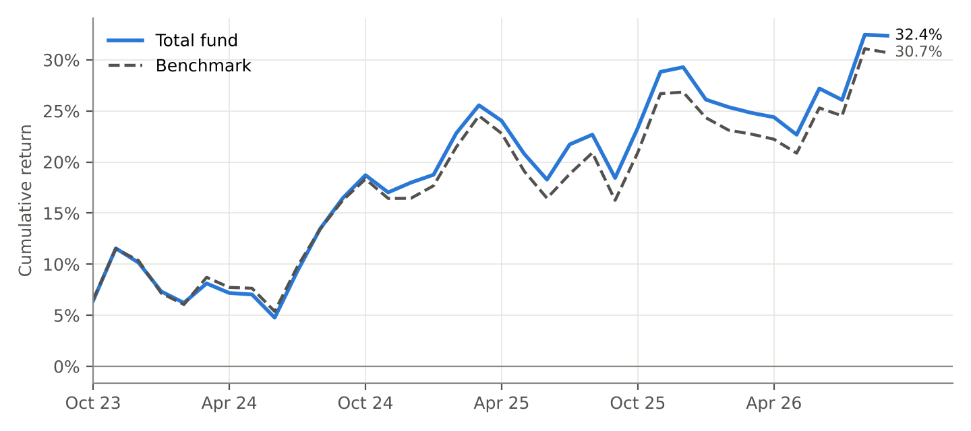
Growth of the total fund vs its strategic benchmark, cumulative since start of data.

What drove relative performance?
Over 1 year, the fund underperformed its benchmark by 0.68%. Allocation measures the effect of holding more or less than the strategic weight in each asset class; selection measures each manager against its own benchmark.

Attribution by mandate (1 year)
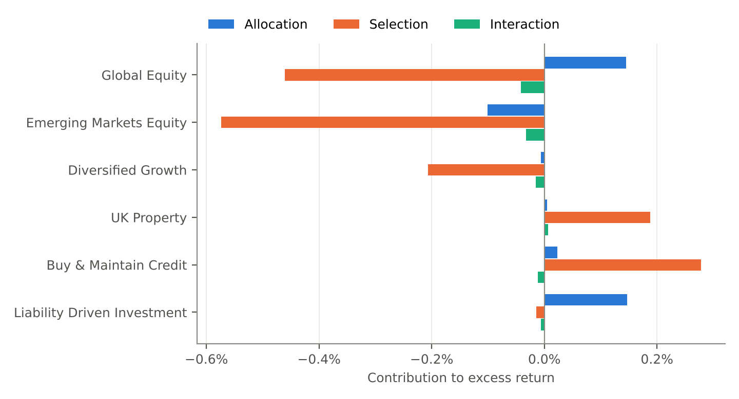
Mandate | Allocation | Selection | Interaction | Total
Global Equity | +0.15% | -0.46% | -0.04% | -0.36%
Emerging Markets Equity | -0.10% | -0.57% | -0.03% | -0.71%
Diversified Growth | -0.01% | -0.21% | -0.02% | -0.23%
UK Property | +0.00% | +0.19% | +0.01% | +0.20%
Buy & Maintain Credit | +0.02% | +0.28% | -0.01% | +0.29%
Liability Driven Investment | +0.15% | -0.01% | -0.01% | +0.13%
Total | +0.21% | -0.79% | -0.10% | -0.68%
Brinson-Fachler attribution, monthly effects Carino-linked so they sum exactly to the compounded excess return (-0.68%).

Asset allocation vs strategy

Actual vs strategic allocation
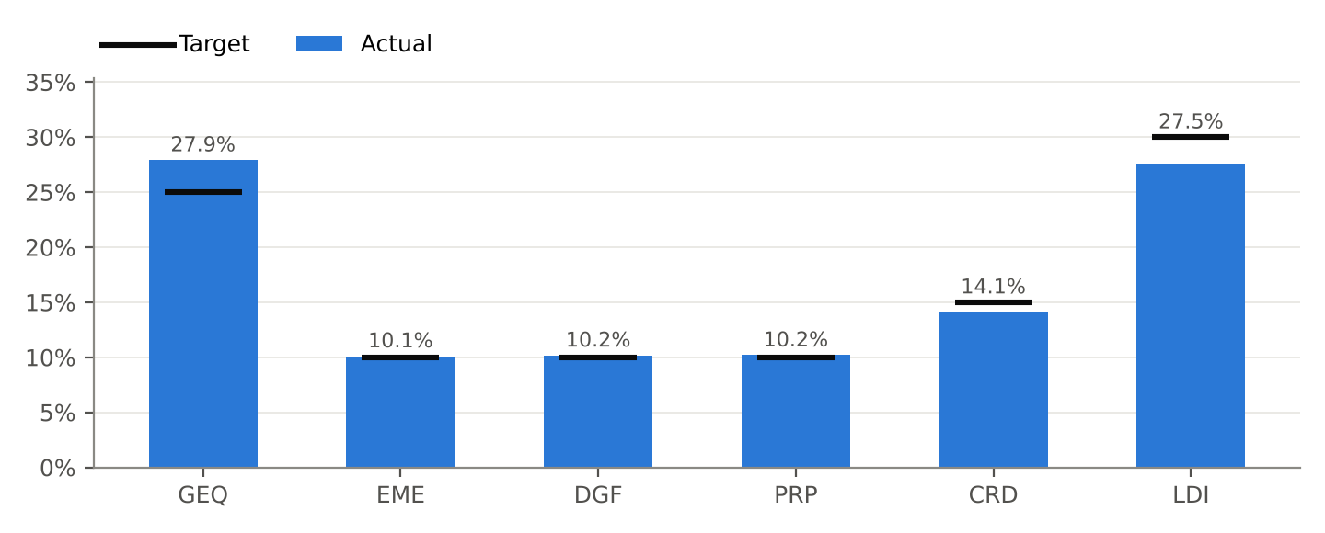
Mandate | Value | Actual | Target | Deviation
Global Equity | £429.0m | 27.92% | 25.00% | +2.92%
Emerging Markets Equity | £155.2m | 10.10% | 10.00% | +0.10%
Diversified Growth | £156.3m | 10.17% | 10.00% | +0.17%
UK Property | £156.6m | 10.19% | 10.00% | +0.19%
Buy & Maintain Credit | £216.7m | 14.10% | 15.00% | -0.90%
Liability Driven Investment | £422.9m | 27.52% | 30.00% | -2.48%
Total fund | £1.54bn | 100.00% | 100.00%

Risk (3 years, annualised)
Mandate | Volatility | Tracking error | Information ratio | Sharpe ratio | Max drawdown
Global Equity | 14.53% | 3.80% | 0.05 | 1.07 | -9.70%
Emerging Markets Equity | 17.89% | 4.22% | -0.90 | 0.52 | -8.86%
Diversified Growth | 7.91% | 2.82% | 0.27 | 1.13 | -4.05%
UK Property | 7.85% | 1.79% | 0.89 | 1.90 | -2.35%
Buy & Maintain Credit | 6.91% | 0.82% | 1.68 | 0.42 | -5.99%
Liability Driven Investment | 15.08% | 0.38% | 0.55 | -0.49 | -27.21%
Total fund | 9.10% | 1.28% | 0.36 | 0.64 | -6.09%
Volatility and tracking error are annualised standard deviations of monthly returns / excess returns.

Funding position and interest-rate hedging
FUNDING RATIO  93.40% | LIABILITIES  £1.65bn | SURPLUS / (DEFICIT)  -£108.6m | HEDGE RATIO  81.96% | LIABILITY DURATION  15.6 yrs

Stress tests: change in funding ratio
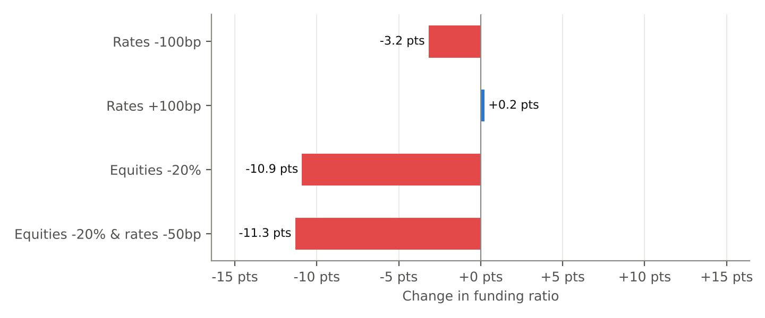
Scenario | Funding ratio after | Change
Rates -100bp | 90.22% | -3.18%
Rates +100bp | 93.64% | +0.24%
Equities -20% | 82.49% | -10.91%
Equities -20% & rates -50bp | 82.08% | -11.32%
Liabilities are revalued on a shifted zero curve bootstrapped from government par yields; rate-sensitive assets move by -duration x shift; growth assets take the equity shock.

The median projected funding ratio in ten years is 97.29%, with a 47% probability of being fully funded, assuming the deficit is paid off by the sponsor over ten years. This illustrates the range of outcomes and is not an actuarial valuation.

Projected funding ratio (10 years)
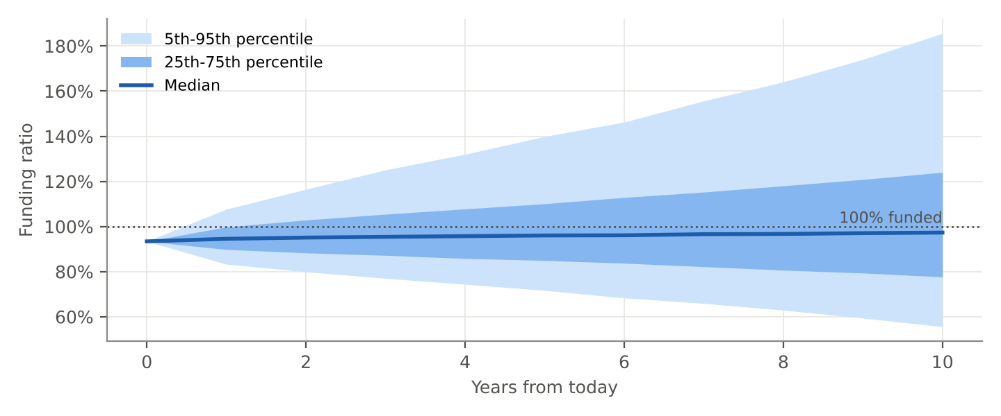
10,000 simulated paths of interest rates and growth-asset returns.

Data quality and reconciliation
Every monthly return was checked against the fund manager's own figures. 4 difference(s) above tolerance were found in the reporting history; 0 material item(s) remain open.
Mandate | Month | Issue | Custodian | Manager | Outcome | Reason
Global Equity | 2026-05 | value mismatch | -1.37% | -1.06% | custodian accepted | Manager quoted gross of fees; the custodian's net-of-fee figure is correct
Buy & Maintain Credit | 2026-06 | value mismatch | 0.33% | 0.42% | custodian accepted | Pricing-source timing difference within expected range
Emerging Markets Equity | 2026-08 | value mismatch | 11.85% | -11.85% | custodian accepted | Sign error in the manager pack, confirmed by the manager
Diversified Growth | 2026-09 | missing manager | -2.33% | – | custodian accepted | Manager figure not yet published; custodian valuation used

Appendix: where the headline numbers come from
Every figure in this report is traceable: it is computed by a documented formula from other figures, down to individual cells in the custodian, manager, benchmark and actuarial files. The interactive (HTML) version lets you click any number to see its full derivation.
Figure | Value | How it is calculated | Built from
Total market value at 2026-09-30 | £1.54bn | Sum of mandate closing values | 6 input figures
Total fund return, 3 months | 4.06% | Chain-linked over 3 months: prod(1 + r_t) - 1 | 3 input figures
Total fund excess return, 3 months | -0.25% | Fund return - benchmark return (arithmetic difference) | 2 input figures
Total fund return, 1 year | 11.76% | Chain-linked over 12 months: prod(1 + r_t) - 1 | 12 input figures
Total active return explained, 1 year | -0.68% | Allocation + selection + interaction; equals compounded fund return - compounded benchmark return | 3 input figures
Value of liabilities (PV of projected benefits) | £1.65bn | Sum of cashflow_t x discount factor_t, zero curve bootstrapped from government par yields | liability_cashflows_actuary_2026.csv (70 annual cashflows, dataset v4); gilt_par_curve_2026-09-30.csv (as of 2026-09-30, dataset v5)
Funding ratio | 93.40% | Assets / liabilities | 2 input figures
Interest-rate hedge ratio | 81.96% | Asset PV01 / liability PV01 | 2 input figures

