NORTHBRIDGE ENGINEERING PENSION SCHEME
Investment Summary
Quarter to 30 September 2026
Prepared for: Trustees (summary)
Generated by Ledgerline from reconciled source data. Every figure is traceable to its source.

Headlines
QUARTER RETURN  4.06%  -0.25% vs benchmark | FUNDING RATIO  93.40% | HEDGE RATIO  81.96%

Summary
Over the quarter the Scheme's assets returned 4.06%, behind the benchmark return of 4.32% by 0.25%. Over one year the fund returned 11.76% against a benchmark of 12.44%, underperforming by 0.68%. Relative to benchmark, UK Property was the strongest mandate this quarter, ahead by 0.43%, while Diversified Growth lagged by 1.45%. Attribution over one year shows asset allocation added 0.21% and manager selection detracted 0.79%. The funding ratio stands at 93.40%, a deficit of £108.6m, and the interest-rate hedge covers 81.96% of the liabilities' sensitivity to rates. In our stress tests, a fall of one percentage point in interest rates would reduce the funding ratio by 3.18 percentage points, while a fall of a fifth in growth asset values would reduce it by 10.91 percentage points.
✓ Commentary generated from the computed figures and verified.

Performance
Mandate | Value | Quarter | vs bmk | 1 year | vs bmk
Global Equity | £429.0m | 10.26% | +0.41% | 26.16% | -2.08%
Emerging Markets Equity | £155.2m | -3.11% | -0.74% | 15.08% | -5.84%
Diversified Growth | £156.3m | 3.49% | -1.45% | 10.35% | -2.10%
UK Property | £156.6m | 1.41% | +0.43% | 14.41% | +1.91%
Buy & Maintain Credit | £216.7m | 2.79% | +0.16% | 4.66% | +1.72%
Liability Driven Investment | £422.9m | 3.36% | +0.17% | 1.25% | -0.06%
Total fund | £1.54bn | 4.06% | -0.25% | 11.76% | -0.68%
Returns are time-weighted (Modified Dietz monthly, chain-linked); periods over one year are annualised. 'vs bmk' = fund return minus benchmark return.

Benchmark returns
Benchmark | Quarter | 1 year
Global equity index (GBP) | 9.86% | 28.23%
EM equity index (GBP) | -2.37% | 20.92%
SONIA + 4% p.a. | 4.94% | 12.45%
UK property index | 0.98% | 12.50%
Sterling corporate bond index | 2.64% | 2.95%
Scheme liability benchmark | 3.18% | 1.31%
Total benchmark | 4.32% | 12.44%

Funding
FUNDING RATIO  93.40% | LIABILITIES  £1.65bn | SURPLUS / (DEFICIT)  -£108.6m | HEDGE RATIO  81.96% | LIABILITY DURATION  15.6 yrs

Stress tests: change in funding ratio
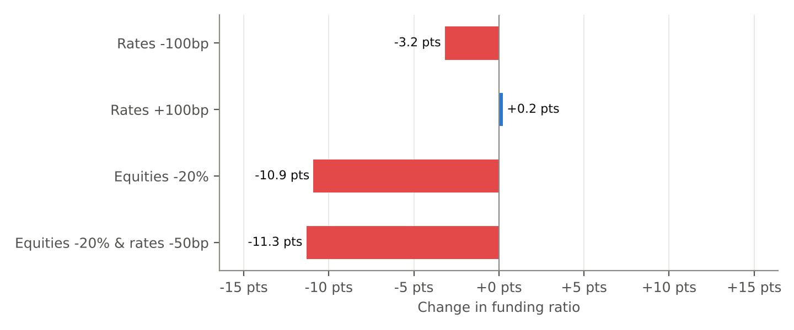
Scenario | Funding ratio after | Change
Rates -100bp | 90.22% | -3.18%
Rates +100bp | 93.64% | +0.24%
Equities -20% | 82.49% | -10.91%
Equities -20% & rates -50bp | 82.08% | -11.32%
Liabilities are revalued on a shifted zero curve bootstrapped from government par yields; rate-sensitive assets move by -duration x shift; growth assets take the equity shock.

