OLYMPUSS AI
UPSRTC — Uttar Pradesh State Road Transport Corporation
Branch Evaluation
integration/main
What was built · whether it works · what it would take to detect and
resolve bus bunching across a fleet of 14,000 buses
An independent read of all 98 commits on the branch, verified by running the test suites, typecheck and lint in both packages.
98 commits · 738 files · +140,217 / −18,494 lines against main
Prepared 14 August 2026
Every quantity in this document is either measured in the repository and cited to the file that measured it, or a stated arithmetic projection labelled as such. No secret values are printed.

Contents
In Microsoft Word, right-click the field below and choose “Update Field” (or select it and press F9) to populate the entries and page numbers.
Right-click and Update Field to build the table of contents.

1. Executive Summary
main is a UI prototype. integration/main is the actual system: two independently deployed applications, a real GPS ingestion and state-estimation pipeline, a headway controller, a human-authorised command path that reaches a driver's phone, and a role-based operations console on top of all of it.
VERDICT The engineering quality is high and the honesty discipline is exceptional. Everything builds, typechecks, lints and passes 2,410 tests. It is a working, end-to-end system at pilot scale on a handful of corridors. It is not yet a 14,000-bus system, for two independent reasons — throughput and coverage — plus one architectural gap that changes what the product is at fleet scale.

Scorecard
Dimension | Verdict | Basis
Does it build and pass its tests | YES — fully green | 2,410 tests pass; typecheck and lint clean in both packages (§3)
Is the bunching loop closed end to end | YES — detect → propose → approve → deliver → acknowledge | Verified by reading every stage plus two E2E specs (§2)
Is it honest about what it measures | YES — unusually so; a genuine strength | Calibration refuses to invent H*; consoles refuse to print unobserved numbers (§4)
Can it see the fleet | NO — 7.2% of vehicles report live GPS | 664 of 9,262 records, harvest.ts (§5.1)
Can it detect across the network | NO — 25.7% of route-directions have a target headway | 171 of 666, odTimetable.ts (§5.2)
Does it propose actions network-wide | NO — the solver is pull-only, one corridor at a time | solve() has exactly one caller, POST /v1/mpc/solve (§5.3)
Will ingestion sustain 14,000 buses | NO — sequential loop, ~84–210 s per 30 s cycle | Projection from the query count in pipeline.ts / service.ts (§6.1)
Will the map render 14,000 buses | YES — already benchmarked past it | 9,170 vehicles at 4.3 ms/frame, fleetCanvasLayer.ts (§6.5)

The three things to fix first
1. Batch the ingestion writes. The single highest-value change in the repository. It converts a projected 84–210 second ingestion cycle into single-digit seconds and is the difference between a controller that acts and one that silently stops acting (§6.1).
2. Add a scheduled network-wide solve and a ranked recommendation queue. Today an operator must select each corridor to discover it has a problem. This is the difference between a tool that works and a tool that gets used (§5.3).
3. Raise GPS reporting above 7.2%. Not a code change — a procurement and operations conversation with UPSRTC. Nothing built downstream matters more than this (§5.1).

2. What Landed on the Branch

2.1 The size of the change
Grouped from `git diff --numstat main..integration/main`. Totals: 738 files, +140,217 / −18,494.
Area | Files | Added | Removed | What it is
control-service/src | 111 | +20,315 | 0 | The new backend service — did not exist on main
control-service/test(s) | 79 | +23,121 | 0 | Its unit and integration suites
src/components | 137 | +16,300 | −3,176 | Operator consoles and the driver surface, rebuilt
src/tests | 113 | +29,171 | −656 | Web-app suites
src/lib | 102 | +14,371 | −2,298 | Auth/RBAC, control-service clients, ops models, copilot
src/app | 84 | +8,173 | −385 | Routes, pages and API handlers
db/migrations + control-service/db | 19 | +2,619 | 0 | Two separate datastores, by design
tests/e2e | 9 | +1,608 | −59 | Playwright specs incl. live command delivery

2.2 The six workstreams
Workstream | What landed
A second deployed service | control-service/ — Express + Postgres/PostGIS with its own migrations, deployed separately from the Next.js app. Ingestion, state estimation, headway, MPC, commands, pilot rollout, rehearsal, arrival prediction.
Sensing | In-process GPS poller → map-matching (Kalman filter + a 0.05° spatial grid prefilter) → vehicle_states. A network-geometry cache with single-flight loading and stale-while-revalidate refresh removes what its own header calls “the wall that has to come down before ingestion can run at fleet scale”.
Detection | Time-domain headway, EWT and CV per route-direction; a reactive rule that opens a bunching_incident only after k consecutive samples below a configured fraction of H*, and closes it on recovery.
Decision and delivery | Terminal-dispatch regulation, two-way holding, self-equalizing fallback, a hard safety filter, and an occupancy-weighted advisory — then dispatcher approval, commands, webhook delivery, and a driver PWA that acknowledges.
Identity and consoles | Supabase-backed RBAC across seven roles with depot scoping, invites, an append-only audit log, kill switches and rollout stages; driver, dispatcher, depot, control-room, planner and admin consoles rebuilt on shadcn/ui + Tailwind.
Calibration and provenance | Target headway derived from two published UPSRTC sources with a precedence rule, never fabricated. Every screen distinguishes measured data from model output (docs/LIVE_VS_PREDICTED.md is authoritative).

2.3 Not committed
- `docs/technical-architecture/` — a generated architecture .docx plus 13 diagrams, and the two Python generators `scripts/gen-arch-diagrams.py` and `scripts/gen-arch-docx.py`. These are untracked in the working tree. They are build outputs and tooling, not product code, but the generators are worth committing so the document can be rebuilt by anyone.

3. Verification — Does It Actually Work?
Not taken on trust. Both packages were installed and everything below was run.
2,410 tests pass in total. Executed locally against the branch as checked out.
Check | Command | Result
control-service tests | pnpm test in control-service/ | 731 passed, 63 files, 3.3 s
Web-app tests | pnpm test at the repo root | 1,679 passed, 46 skipped, 102 files
Typecheck — web | pnpm typecheck | Clean
Typecheck — control-service | pnpm typecheck | Clean
Lint — web | pnpm lint | No warnings or errors
Lint — control-service | pnpm lint | Clean

On the 46 skipped tests
Five test files skip locally and are designed to. They are the ones that prove guarantees living in SQL rather than in TypeScript — keyset pagination that must not lose safety records, `ON CONFLICT` dedupe — so they need a real `OPS_DATABASE_URL`. They skip when it is unset and hard-FAIL when `CI=true`. The CI workflow provisions an `ops-db` service and runs `pnpm migrate:ops` against it, so nothing skips in CI. That guard exists because those files skipped on every CI run the repository had ever done — a green suite that said nothing about the SQL it was supposed to protect.

One environment issue found, and it was not a code defect
Two test files initially failed to load: `@radix-ui/react-slot` could not be resolved from `src/components/ui/button.tsx`. The package is declared in `package.json` and present in `pnpm-lock.yaml`; the local `node_modules` was simply stale, predating the commit that introduced shadcn/ui. Running `pnpm install --frozen-lockfile` installed it — and pruned five other `@radix-ui/*` packages that nothing in `src` imports — after which the full suite passed. Worth noting only because a newcomer cloning the branch will hit the same thing if they skip the install step in either package.

What was not verified, and why
- The Playwright E2E specs were not run. They require a live control-service, a running web app, a seeded Postgres and seven seeded operator accounts. CI provisions all of it and runs them; that is the right place for them.
- Behaviour against the live UPSRTC feed was not exercised. No credentials were used and no upstream endpoint was contacted.
- The throughput numbers in §6 are projections, not benchmarks. They are computed from the query count the ingestion path demonstrably issues. The absence of any load test in the repository is itself one of the findings.

4. What Is Genuinely Good
Three things stand out, and they are the reason the gaps in §5 and §6 are worth fixing rather than working around.

4.1 It refuses to invent numbers, at a measured cost
The clearest example is the OD calibration seeder. Two estimators were run over the same 53,898-row corpus and compared on the 906 line-directions both could answer for:
Measured over the full sweep of all 210 ordered city pairs, 2026-08-11 (`odTimetable.ts`).
Estimator | Median derived H* | Line-directions answered
Pooled per route | 1,635 s | 1,441
Bucketed per boarding stop | 2,582 s | 940

Pooling reports a 37% shorter headway on 44% of the pairs. Because every threshold in the detection path is a ratio of H*, a too-small denominator makes a bunched route look healthy — the silent false negative. Against the seeded database, pooling would have calibrated 111 route-directions and bucketing calibrates 97. Fourteen route-directions of coverage were deliberately given up to keep the other 97 honest, and the trade is documented numerically rather than asserted.

4.2 The failure modes are the right ones
- The rollout gate fails closed. It previously returned early and ALLOWED a command when an approval carried no route-direction — a fail-open hole with the blast radius of the entire gate. Both paths now return 422.
- Arrival prediction declines rather than extrapolating. Its ten-minute cutoff is derived, not chosen: at the measured 38.5 km/h median running speed a bus covers 6.4 km in ten minutes, against a measured 7.9 km median inter-stop gap.
- The copilot returns 503 rather than a guess. There is deliberately no fallback path that produces text without a successful model call.
- The map shows an outage as an outage. Upstream failure yields zero rows and an `UPSTREAM UNAVAILABLE` badge — never substituted demo buses in the same table as real ones.

4.3 The comments encode incidents, not intentions
This is rarer than it sounds and it is what will let a new engineer work safely in this code.
- `headwayCompute.ts` explains why computing headway on the ingestion path is catastrophic rather than merely expensive: it would collapse three samples taken three minutes apart into 45 milliseconds, turning every GPS wobble into an incident. “The cadence IS the semantics.”
- `store.ts#upsertHeadwayStates` records the bug it exists to fix — the solver read a permanently empty headway map and returned zero candidates on a genuinely bunched route. “Persisting is not publishing.”
- The command-lifecycle notes record a delivery path that told an operator an approval had not been consumed while the driver already had the instruction on screen, and why one webhook dispatch is deliberately not awaited as a result.

5. Effectiveness Gaps
These are not defects. Everything here works as designed; the question is how much of the bunching problem the design can currently reach.
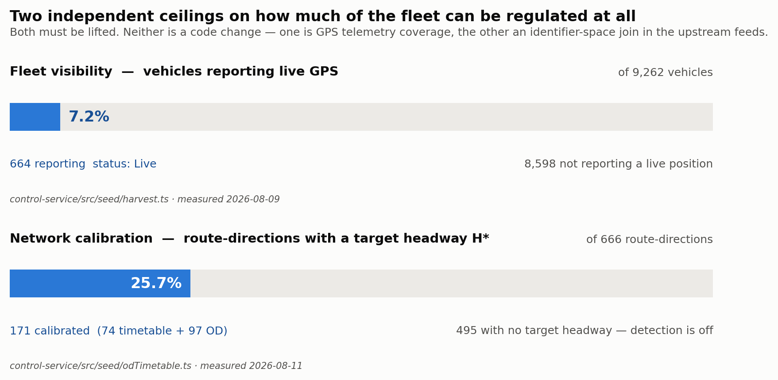
Figure 1 — The two coverage ceilings. Both are upstream of anything the control logic does, and neither is fixed by writing code.

5.1 Only 7.2% of the fleet is visible
Measured from the upstream feed on 2026-08-09 (`harvest.ts`): 9,262 vehicle records, of which 664 carry `status === 'Live'`. Only 1,602 carry a route name at all. Among the live subset there are 517 distinct route names.
CONSEQUENCE Nothing downstream can compensate for this. Headway is a property of a pair of buses; a bus that does not report a position cannot be half of one.

5.2 Only 25.7% of the network can detect at all
171 of 666 active route-directions have a target headway — 74 from the corridor timetable and 97 from the statewide OD schedule. The remaining 495 have none, so detection is structurally off for them. Correctly and visibly off, but off.
The seeder names its own ceiling precisely: `line_name` matches `routes.id` for only about 170 of the 666 seeded route-directions, because `routes.id` came from one feed's `line_id` while this feed's `line_name` is frequently a description rather than an identifier. The limit is the join, not the estimator — which means it is fixable without touching any control logic.
Compounding it: with 664 live buses spread across 517 route names, most route-directions carry zero or one vehicle and cannot form a leader/follower pair at all. The sweep's own header puts the number that can at “a few dozen”.

5.3 Nothing proposes an action unless a human goes looking
This is the most consequential architectural gap in the branch.
`solve()` has exactly one caller in the entire repository: `POST /v1/mpc/solve`, which the web app invokes when an operator opens the control room on one selected corridor. The service runs five scheduled jobs — command delivery sweep, TTL sweep, GPS poll, headway compute and geometry refresh. None of them is the solver.
Stage | Runs automatically, network-wide? | Mechanism
Detection | Yes | headwayCompute sweep every 60 s
Resolution | No | Operator opens a corridor → one POST /v1/mpc/solve

The human-approval requirement is correct and should stay — it is named an explicit permanent design constraint. The gap is not the approval. It is that nothing proposes across the network and ranks by severity, so an operator responsible for 666 route-directions has to guess which one to look at.

5.4 The control authority does not match the network
Easy to miss, and it undercuts the whole control layer. The seeded network averages 215 km and 19 stops per route-direction, with a measured 7.9 km median gap between stops and a median OD-derived target headway of 2,582 seconds — roughly 43 minutes. `max_hold_seconds` defaults to 90.
THE MISMATCH Classic bunching control is an urban high-frequency problem: 5–15 minute headways, where a 60-second hold is meaningful authority. Against a 43-minute headway a 90-second hold corrects 3.5% of the target gap. The control laws are correctly implemented; they are simply under-powered for this operating regime.

5.5 It is not actually model-predictive control
`prediction_horizon_control_points` is used, in the code's own words, “to label/scale the occupancy-weighted MPC advisory, not to run a true multi-step solve yet”. The three control laws are reactive proportional controllers over the current headway snapshot. There is no receding-horizon optimisation and no forward prediction of where a bunch travels. The code is honest about this; the naming is not.

5.6 The data the model needs does not exist yet
From the rehearsal simulator's provenance manifest: `route_links` is empty, `trips` and `trip_stop_times` are empty, and `vehicle_states.occupancy_count` is null fleet-wide.
Missing input | What it disables
Occupancy counts | The occupancy-weighted advisory always runs on an estimated mid-load — the weighting is inert
trips / trip_stop_times | resolveCurrentTrip always returns null; schedule adherence is unmeasurable
route_links | No segment-level running-time model

The rehearsal simulator is scrupulous about this: its control laws are the deployed ones, and its demand, dwell, capacity and disturbance model is openly invented. That line — real control, guessed traffic — is stated field by field in every rehearsal's provenance manifest.

5.7 Three levers, all of them holds
The solver emits `terminal_dispatch_hold`, `two_way_hold` and `self_equalizing_hold`. The schema already models `stop_skip`, `short_turn`, `deadhead`, `boarding_limit` and `standby_injection`; none is generated. On 215 km routes, short-turn and standby injection are the levers with real authority. Holding is the weakest one available, and it is the only one implemented.

6. Scaling to 14,000 Buses
At today's 664 live buses every component fits comfortably. What follows is what breaks at roughly twenty-one times that, in the order it breaks.

6.1 Wall 1 — ingestion is sequential (hard blocker)
`ingestPositionEvents` is a `for` loop with `await` inside it. Each event triggers three database round-trips: `loadActiveHold`, `resolveCurrentTrip` and `saveVehicleState`. The batch therefore costs fleet × 3 × round-trip, strictly serially.
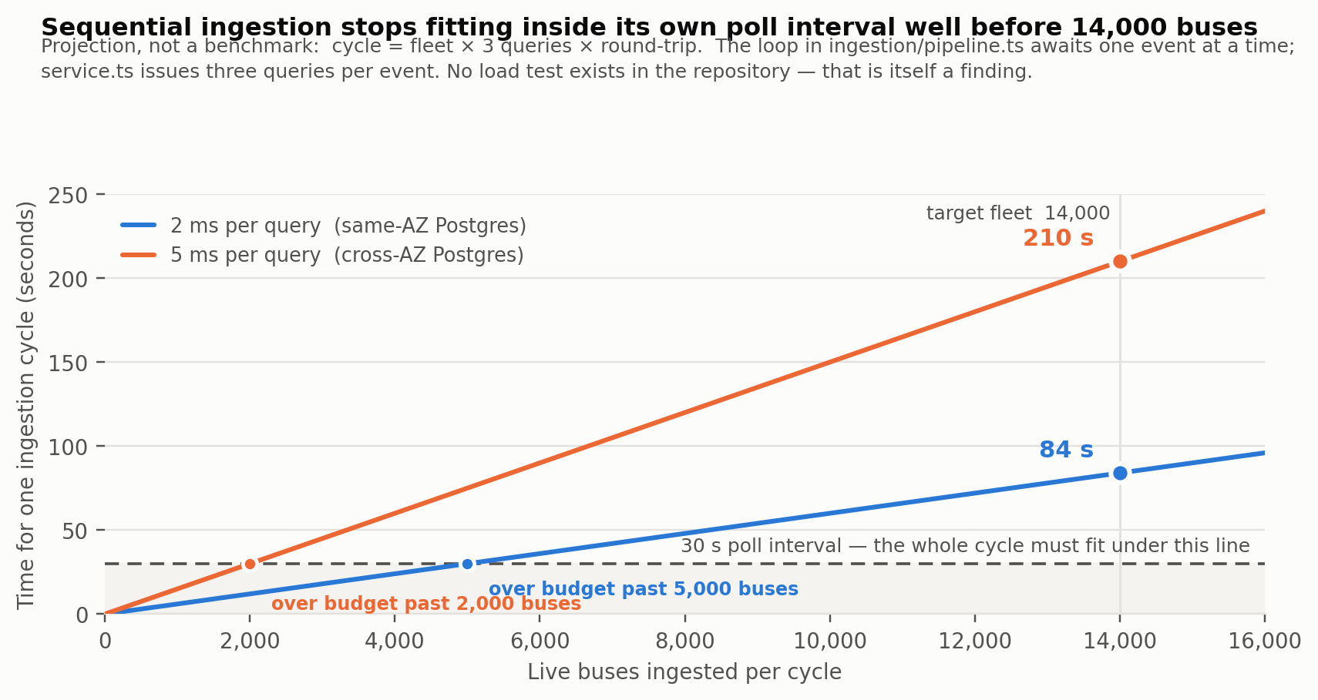
Figure 2 — One ingestion cycle against the 30-second poll interval it must fit inside. Today's 664 live buses sit near the origin, comfortably within budget.
THE FAILURE IS QUIET, WHICH IS WHAT MAKES IT DANGEROUS Overlap suppression means slow cycles are skipped rather than stacked, so position age drifts to 1.5–3.5 minutes. The hard safety filter then rejects every candidate as stale against its 90-second bound. The system fails safe and stops acting — while the logs still show healthy polls. Nothing looks broken.

The fix
- Batch the writes. A multi-row `INSERT … ON CONFLICT` carrying the same `observed_at` out-of-order guard, driven by `unnest`.
- Prefetch the holds. One query for the whole batch instead of one per vehicle.
- Drop `resolveCurrentTrip` until `trips` is populated. It always returns null today (§5.6), so it is a round-trip per bus per cycle for a guaranteed null.

6.2 Wall 2 — detection latency multiplies
The sweep visits a route-direction once every ⌈eligible ÷ batch⌉ cycles, so latency does not degrade smoothly — it jumps by a whole three-minute sample window at a time.
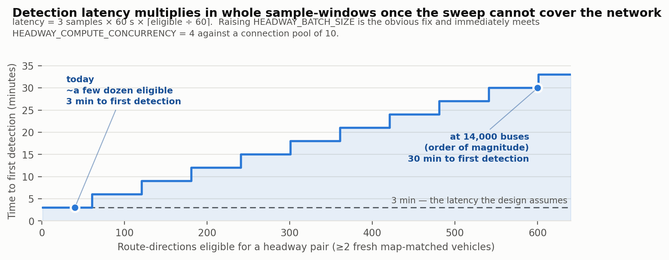
Figure 3 — Time to first detection as the eligible set outgrows one sweep. The code already logs a warning when this starts happening; it does not mitigate it.
Raising `HEADWAY_BATCH_SIZE` is the obvious fix and immediately runs into `HEADWAY_COMPUTE_CONCURRENCY = 4` against a connection pool capped at 10. All three have to move together, and the pool has to move first.

6.3 Wall 3 — single process by construction
Component | Why it cannot scale horizontally today
stateStore | A module-level in-memory Map, rehydrated from Postgres at boot
Network geometry cache | Per-process, TTL'd and self-refreshing
GPS poller | GPS_POLL_ENABLED must be true on exactly one instance, or replicas duplicate ingestion and race the out-of-order guard
listVehicleStates(routeDirectionId) | Full O(N) scan of every vehicle, per solve

The whole ingest-to-detect path is therefore single-node. Moving the state store behind Redis is already named in the production roadmap as Phase 4 work; at 14,000 buses it stops being hardening and becomes a prerequisite.

6.4 Wall 4 — the copilot spawns a CLI per request
The copilot authenticates with an operator's personal Claude subscription OAuth token and invokes the `claude` CLI as a child process per call. The reasoning is sound for the current setup and the module is careful — it strips `ANTHROPIC_API_KEY` from the child environment so a stray key cannot silently move calls onto metered billing. But a control room with concurrent users will hit subscription rate limits, pay a process spawn per request, and require the CLI installed on every server instance.

6.5 What already scales
The fleet map. Measured at 9,170 vehicles and 4.3 ms per frame — 120 fps sustained, down from 53.7 ms per frame and 18.5 fps before the rewrite. It will render 14,000 buses without modification.

7. What Remains, Prioritised

7.1 Blocking for 14,000 buses
# | Work | Why it is first
1 | Batch ingestion writes and the hold lookup | Converts a projected 84–210 s cycle into single digits. Highest value-per-line change in the repository.
2 | Raise the pg pool; re-tune HEADWAY_BATCH_SIZE and HEADWAY_COMPUTE_CONCURRENCY together; add a 14,000-fixture load test | There is no throughput budget stated anywhere in the repository and no load test. Both are gaps in their own right.
3 | Move stateStore behind Redis so ingestion can shard by route-direction | The only route to more than one ingesting instance.

7.2 Blocking for effectiveness
# | Work | Why
4 | A scheduled network-wide solve feeding a severity-ranked recommendation queue | So the control room opens on “here are the twelve corridors that need you”, not a corridor picker. The difference between a tool that works and one that gets used.
5 | Fix the calibration join to lift H* coverage past 26% | The blocker is identifier-space mismatch between two upstream feeds, not the estimator — so the fix is cheap relative to its effect.
6 | Raise GPS reporting above 7.2% with UPSRTC | Not a code change. Nothing built downstream matters more.

7.3 Effectiveness, next tier
# | Work | Why
7 | Per-corridor max_hold_seconds matched to a 43-minute H*, or implement short_turn / standby_injection | Holding is the weakest lever and currently the only one. The schema already models the others.
8 | Populate trips and trip_stop_times | Unlocks schedule adherence and makes resolveCurrentTrip meaningful instead of a guaranteed null.
9 | Real receding-horizon MPC over prediction_horizon_control_points | Replaces one-step reactive control and makes the module's name true.
10 | Ingest occupancy from ticketing or APC | Until then the occupancy-weighted advisory is decorative.

7.4 Hardening
# | Work | Why
11 | Replace the copilot CLI spawn with a proper API integration | Before multi-user load, not after.
12 | SSE or WebSocket push instead of polling | Already on the roadmap; matters more as corridor count grows.
13 | Refresh docs/PRODUCTION_ROADMAP.md | It still lists “No authentication” as a known gap. This branch closed it; the doc is partly stale and will mislead a reader who trusts it.

Appendix A — Measured Figures and Their Sources
Every quantity used in this document, with the file that measured it. Nothing here is estimated unless the row says so.
Quantity | Value | Source
Vehicle records in the live feed | 9,262 | control-service/src/seed/harvest.ts (2026-08-09)
Records with status == 'Live' | 664 | harvest.ts
Records carrying a route name | 1,602 | harvest.ts
Distinct route names among the live subset | 517 | harvest.ts
Live payload size | ~11.7 MB | scheduler/gpsPoll.ts
Active route-directions seeded | 666 | control-service/src/seed/odTimetable.ts (2026-08-11)
Route-directions with a target headway | 171 (74 timetable + 97 OD) | odTimetable.ts
Route-directions with none | 495 | odTimetable.ts
OD corpus swept | 53,898 rows, 210 city pairs | odTimetable.ts
Median H*, bucketed estimator | 2,582 s (~43 min) | odTimetable.ts
Median H*, pooled estimator (rejected) | 1,635 s | odTimetable.ts
Average route-direction length | 215 km, 19 stops | control-service/src/rehearsal/run.ts
Median inter-stop gap | 7.9 km | control-service/src/arrival-prediction/predict.ts
Median running speed, moving fleet | 38.5 km/h (512 live rows, 2026-08-14) | predict.ts
Default max hold | 90 s | control-service/db/migrations/…__core_data_model.sql
Default bunched / warning thresholds | 0.25 × H* / 0.5 × H* | same migration
Hard staleness bound on a candidate | 90 s | control-service/src/mpc/safety.ts
GPS poll interval / headway sweep interval | 30 s / 60 s | control-service/src/config/env.ts
Headway batch size / concurrency / pool max | 60 / 4 / 10 | config/env.ts, db/pool.ts
Fleet map render cost | 9,170 vehicles at 4.3 ms/frame | src/components/map/fleetCanvasLayer.ts
Fleet map cost before the rewrite | 53.7 ms/frame, 18.5 fps | fleetCanvasLayer.ts
Tests passing | 2,410 (731 + 1,679) | Run for this evaluation

Projections, clearly separated
Projection | Basis | Result
Ingestion cycle cost at 14,000 buses | fleet × 3 queries × round-trip, from the sequential loop in ingestion/pipeline.ts and the three queries in state-estimation/service.ts | ≈84 s at 2 ms RTT; ≈210 s at 5 ms
Fleet size at which the cycle exceeds 30 s | same model | 5,000 buses at 2 ms; 2,000 at 5 ms
Detection latency at fleet scale | 3 samples × 60 s × ⌈eligible ÷ 60⌉, with eligible route-directions estimated at 400–600 | 20–30 minutes

Appendix B — How This Evaluation Was Made
- Scope. All 98 commits between `main` and `integration/main`, read as a diff and as a final state.
- Verification. Both packages installed from the lockfile; test suites, typecheck and lint run in each. Results in §3 are from those runs.
- Sources. Quantities were taken from the repository's own measurement comments, which record the date and method of each measurement, and cross-checked against the code they describe.
- Limits. No live UPSRTC endpoint was contacted and no credentials were used. The E2E suite was not run — it needs services CI provisions. Throughput figures are arithmetic, not benchmarked; producing a real benchmark is recommendation #2.

