OLYMPUSS AI
UPSRTC — Uttar Pradesh State Road Transport Corporation
Technical Architecture &
Code Walkthrough
Real-time bus operations · GPS state estimation · bunching detection,
prediction & intervention · dashboards · APIs · maps · authentication
Complete reverse-engineering of the repository — evidence-based, implementation-level, prepared for a Principal Software Engineer review.
Repository branch: integration/full-system
Every architectural claim cites the source file it is drawn from. No secret values are printed.

Table of Contents
In Microsoft Word, right-click the table below and choose “Update Field” (or select it and press F9) to populate page numbers.
Right-click and Update Field to build the table of contents.

1. Executive Technical Summary
This document is a complete, evidence-based reverse-engineering of the Olympuss AI / UPSRTC repository. It is written for a Principal Software Engineer who will ask implementation-level questions; every architectural claim is anchored to a source file.

What the repository actually contains
The repository is not a single application. It is two independently deployed systems plus shared external dependencies, living in one monorepo:
- A Next.js 15 web application (repo root, src/) — the operator-facing surface: a public Olympuss landing site, a live UPSRTC fleet dashboard, a role-based operations (“ops”) console, a client-side bus-bunching simulator, and the server-side proxy that fetches the real UPSRTC GPS feed.
- A persistent “control-service” (control-service/) — an always-on Node/Express backend with its own Postgres/PostGIS datastore that does the real transport intelligence: GPS ingestion, Kalman-smoothed state estimation, leader/follower ordering, headway/EWT/CV computation, reactive bunching detection, and a Model-Predictive-Control (MPC) decision engine that recommends holds and dispatch adjustments.

The single most important architectural distinction
KEY FINDING There are TWO separate “bunching” implementations, and conflating them is the most likely way to mislead a reviewer. (1) src/lib/bunching/* is a deterministic, hard-coded 4-bus CLIENT-SIDE SIMULATION for the demo page — no live data flows through it. (2) control-service/src/{state-estimation,headway,mpc}/* is the real, tested, server-side pipeline that operates on live GPS. This document keeps them rigorously separate and labels every claim PRODUCTION / PROTOTYPE / SIMULATION / PLANNED.

Maturity at a glance
Table 1 — Capability maturity, derived from repository evidence.
Capability | Status | Evidence
Live UPSRTC GPS proxy + normalization | PRODUCTION (web) | src/app/api/upsrtc/live/route.ts, src/lib/upsrtc/normalizer.ts
Google Maps live fleet visualization | PRODUCTION (web) | src/components/map/FleetMap.tsx, fleetCanvasLayer.ts
Enterprise + ops RBAC authentication | PRODUCTION (web) | src/middleware.ts, src/lib/auth/rbac/*
State estimation (map-match + Kalman) | PRODUCTION (control-service, tested, NOT yet wired to live ingest by default) | control-service/src/state-estimation/*
Headway/EWT/CV + reactive bunching | PRODUCTION (control-service, tested) | control-service/src/headway/*
MPC hold/dispatch decision engine | PRODUCTION (control-service, tested) | control-service/src/mpc/*
Occupancy-weighted predictive MPC | PROTOTYPE (advisory only, single-step) | control-service/src/mpc/occupancyMpc.ts
Client-side bunching demo | SIMULATION (hard-coded 4 buses) | src/lib/bunching/*, src/components/bunching/*
LLM control-room copilot | PRODUCTION (web, grounded, advisory) | src/lib/copilot/*, Anthropic API
Trained neural net / ML model in control loop | NOT PRESENT | No model files; all control laws are closed-form
Automated (no-human) command execution | PLANNED / gated | Commands require human approval + driver ack

Headline engineering concerns (expanded in §26–27)
- Live GPS ingestion into the control-service is gated OFF by default (GPS_POLL_ENABLED=false), and the README states the estimator is “not called yet” by the runtime by default — so the sophisticated pipeline can be dormant in a given deploy.
- The web app and control-service each maintain their own auth, cache, and rate-limit state per warm process unless Redis is configured — correct-looking limits silently reset on serverless cold starts.
- The UPSRTC upstream is an undocumented PHP endpoint with schema quirks (IST timestamps labelled Z, HTML content-type on JSON, double-encoded arrays) handled defensively but fragile to upstream change.
- No automated command execution — every intervention needs a human dispatcher and a driver acknowledgement, which is a safety strength but a throughput ceiling.

2. System Purpose
The system exists to keep UPSRTC bus services evenly spaced. On a high-frequency route, passengers do not read a timetable; they rely on consistent headway (the time gap between consecutive buses). When one bus is delayed, it picks up the passengers that would have boarded the next bus, dwells longer, and falls further behind — while the bus behind it finds fewer passengers, speeds up, and closes the gap. Left alone this feedback loop collapses two or more buses into a “bunch,” halving effective frequency and leaving a large gap behind them.
The product’s job is to (a) observe the fleet from live GPS, (b) detect and predict bunching, (c) recommend the least-disruptive intervention (usually holding a bus a few seconds at a terminal or stop), and (d) route that recommendation to a human dispatcher and then to the driver, closing the loop by re-measuring headway.
Primary operational surfaces: the live UPSRTC dashboard (/project/upsrtc), the role-based ops console (/ops/* — driver, pilot-driver, dispatcher, depot, control-room, planner, admin), and the bunching explainer/simulator (/project/bunching).

3. Technology Stack
Derived from the two package.json files, the lockfile (pnpm), and the config files.
Table 2 — Technology stack with source evidence.
Layer | Technology | Where / why
Language | TypeScript 5 (strict) | tsconfig.json; both packages
Package manager | pnpm 10.29.3 | package.json packageManager, pnpm-lock.yaml
Web framework | Next.js 15.5 (App Router) | next.config.ts; src/app/*
UI runtime | React 19 | package.json
Web state | Zustand 5 | src/stores/copilotStore.ts
Styling | Tailwind 3.4 + Radix UI + framer-motion + GSAP | tailwind.config.ts, components
3D / landing | three.js 0.185 + @react-three/fiber + drei | src/three/*, landing globe
Maps | Google Maps JS SDK (@googlemaps/js-api-loader) | src/lib/maps/loader.ts, FleetMap.tsx
Charts | Recharts 2 | impact/observability dashboards
Validation | Zod 3 (shared contracts) | src/models/*, control-service schemas
Enterprise auth | Supabase (@supabase/ssr, supabase-js) | src/lib/supabase/*
Ops auth | Custom HS256 JWT via jose + bcryptjs | src/lib/auth/rbac/*
Web DB access | pg (Postgres) + Supabase | src/lib/db/pool.ts
LLM | Anthropic Messages API (raw fetch) | src/lib/copilot/anthropic.ts
Shared limiter/breaker store | Upstash Redis (optional) | src/lib/redis/client.ts
Email | Resend | src/lib/email/resend.ts
Control-service | Node ≥20, Express 4, pino, Zod, pg (PostGIS) | control-service/package.json
Error tracking | @sentry/node (control-service) | control-service/src/telemetry/sentry.ts
Testing | Vitest (unit) + Playwright (e2e) | vitest.config.ts, playwright.config.ts
Web hosting | Vercel (serverless) | next.config.ts outputFileTracingRoot, CSP
Control-service hosting | Render (Docker, always-on) | control-service/README.md, render.yaml

4. Repository Architecture
Directory tree (build artifacts, node_modules, and .next excluded). Annotations describe each directory’s architectural responsibility.
repo root | Next.js app + config; the control-service is a nested, separately-built package
├─ src/app/ | App Router. Route groups: (public) landing/login, (protected) UPSRTC dashboard, (ops) RBAC console, api/ route handlers
│ ├─ (public)/ | Marketing landing page + enterprise login
│ ├─ (protected)/project/ | UPSRTC live dashboard (upsrtc/) and bunching simulator (bunching/)
│ ├─ (ops)/ops/ | 7-role operations console (driver…admin), each with its own layout+guard
│ └─ api/ | Server routes: auth/, upsrtc/ (live+schedule proxy), ops/ (RBAC APIs), control-service/webhook
├─ src/components/ | Feature UI: map/, live-fleet/, bunching/, ops/, command-center/, ai-core/, landing/, scenarios/
├─ src/lib/ | Non-UI logic: upsrtc/ (proxy), auth/ (+rbac/), bunching/ (sim math), controlService/ (client), copilot/ (LLM), redis/, supabase/, webhooks/
├─ src/hooks/ | React hooks: useLiveFleet (polling), useSchedule, useAlertStream, …
├─ src/stores/ | Zustand store (copilotStore) — the dashboard’s client state
├─ src/models/ | Zod contracts: canonical.ts (bus/feed), control.ts (control-service API), copilot.ts
├─ src/three/ | three.js landing globe + scene
├─ src/fixtures/ | Bundled UPSRTC sample payloads (offline demo only)
├─ src/tests/ | Vitest unit tests (bunching, normalizer, rbac, control, copilot, …)
├─ src/middleware.ts | Edge middleware — first-line auth gate for protected/ops/api surfaces
├─ control-service/ | Independently deployed backend (own package.json, tsconfig, Dockerfile, DB)
│ ├─ src/ingestion/ | UPSRTC upstream client + normalizer + position pipeline
│ ├─ src/state-estimation/ | map matching, Kalman filter, confidence, stop-state, leader/follower ordering
│ ├─ src/headway/ | pair headways, EWT/CV aggregate, reactive bunching rule, service orchestration
│ ├─ src/mpc/ | terminal dispatch, two-way hold, self-equalizing, safety filter, occupancy MPC, solver
│ ├─ src/scheduler/ | cron-like jobs: gpsPoll, headwayCompute, geometryRefresh, commandTtlSweep
│ ├─ src/routes/ | Express routers: commands, headway, mpc, positions, pilot, vehicleStates, health
│ ├─ src/simulation/ | regression/replay simulator (demandBurst, gpsDropout, missedTrip, nonCompliance)
│ ├─ src/seed/ | network geometry + timetable seeding/harvest/recalibration
│ └─ src/webhooks/ | outbound signed webhook dispatch to the web app
├─ db/ & control-service/db/ | SQL migrations for the two isolated datastores
├─ docs/ | Blueprint (.md/.docx), integration + deployment contracts, API_DISCOVERY, roadmap
├─ scripts/ | Admin/ops scripts: create-project-user, seed/migrate ops, inspect-upsrtc-api
└─ public/ | Static brand assets + pilot-driver PWA assets

5. High-Level System Architecture
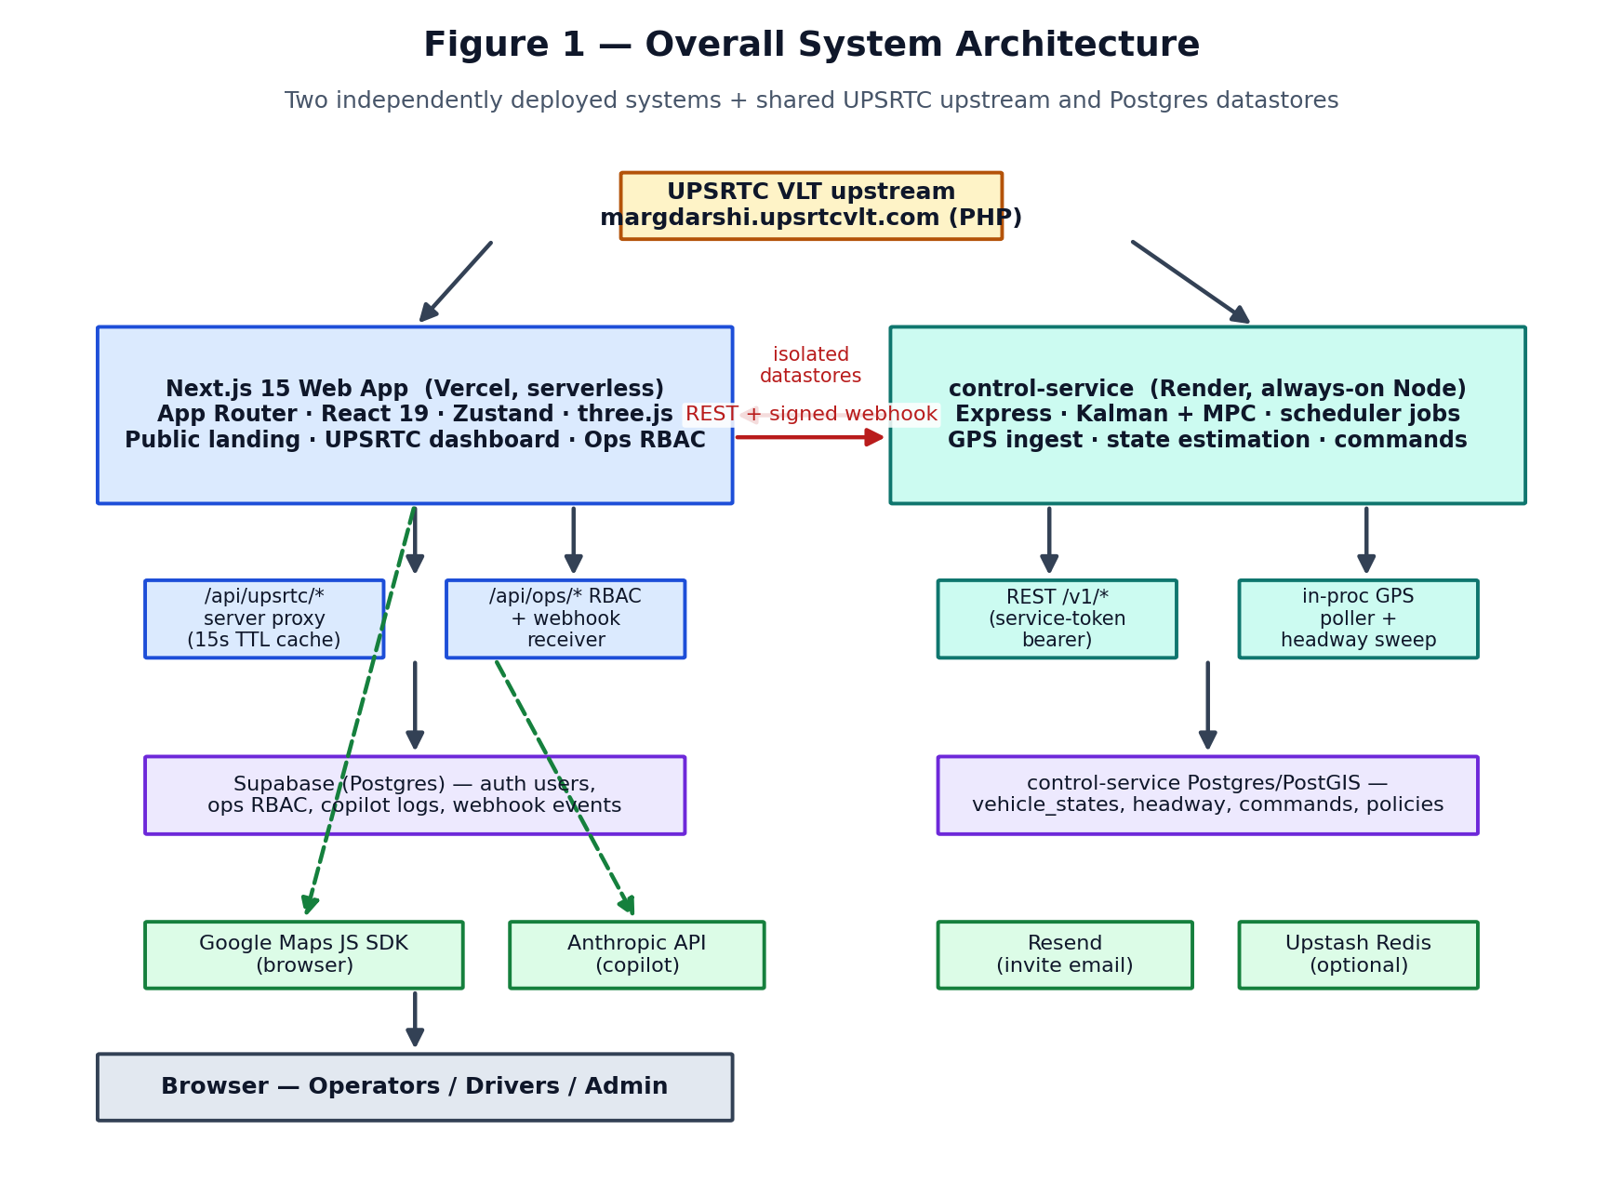
Figure 1 — Overall system architecture.
The load-bearing decision is the boundary between the two systems. Per control-service/README.md and docs/CONTROL_SERVICE_INTEGRATION.md, the web app never connects to the control-service database and never holds write credentials to it. The two communicate only over REST (web → control-service, Bearer service token) and signed webhooks (control-service → web, HMAC-SHA256). A shared database was explicitly considered and rejected.
Both systems independently consume the same undocumented UPSRTC upstream: the web app proxies it for display (src/lib/upsrtc/client.ts), and the control-service polls it for ingestion (control-service/src/scheduler/gpsPoll.ts). They deliberately do NOT share the normalizer, but they DO mirror the same IST timestamp correction — a documented “sibling implementation” pair that must be changed together.

6. Application Startup Flow
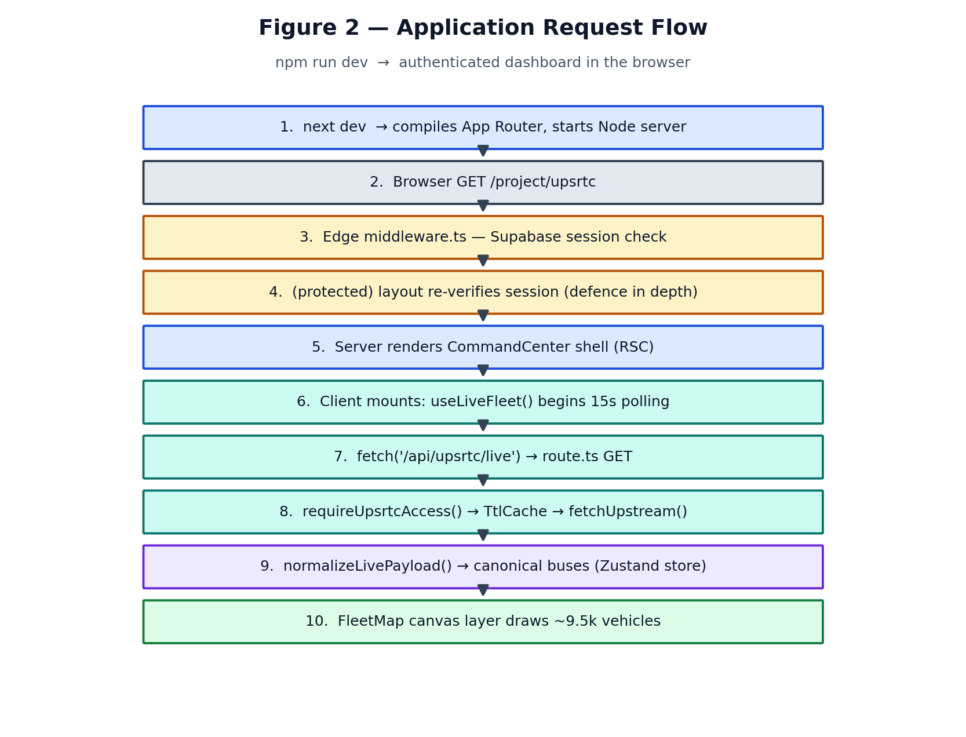
Figure 2 — From npm run dev to a rendered, authenticated dashboard.

Web app: `pnpm dev` → browser
- `next dev` (package.json scripts) compiles the App Router and starts the Node dev server.
- A request to a protected path (e.g. /project/upsrtc) hits src/middleware.ts first. The matcher is a deliberate allowlist — /project/*, /api/upsrtc/*, /ops/*, /api/ops/* — never a broad /api/*, so the machine webhook stays exempt.
- For the Supabase surface, middleware calls getMiddlewareUser(); no user → redirect to /login?next=… (pages) or 401 JSON (APIs).
- The (protected) layout re-verifies the session independently — defence in depth; middleware is never the only check.
- The server renders the CommandCenter shell (React Server Component boundary), then the client mounts and useLiveFleet() starts a 15s poll of /api/upsrtc/live.
- The route handler authorizes, serves from a 15s TtlCache or fetches upstream, normalizes to canonical buses, and returns them; the store updates and FleetMap draws ~9.5k vehicles on one canvas.

Control-service: `pnpm start` / dev
Entry point control-service/src/index.ts boots the process; app.ts assembles the Express app (health routes unauthenticated, then requireServiceToken on everything else), rehydrates in-memory state from Postgres, registers scheduler jobs (scheduler/index.ts), and exposes /healthz + /readyz. /readyz returns 503 until at least one active route-direction has a seeded shape (REQUIRE_SEEDED_NETWORK).

7. Frontend Architecture
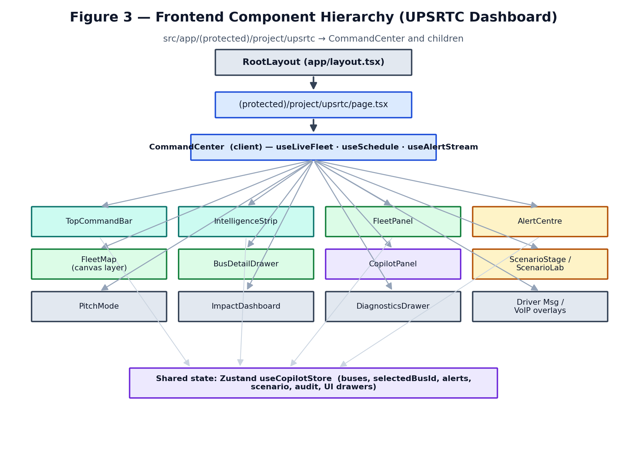
Figure 3 — UPSRTC dashboard component hierarchy.
The UPSRTC dashboard page is a one-line server component (src/app/(protected)/project/upsrtc/page.tsx) that renders <CommandCenter/>. CommandCenter (src/components/command-center/CommandCenter.tsx) is the client root: it wires the three data hooks (useLiveFleet, useSchedule, useAlertStream) and composes the map, fleet panel, alert centre, copilot panel, bus drawer, scenario stage, and the presentation/diagnostics overlays.

State management
A single Zustand store — src/stores/copilotStore.ts — is the dashboard’s source of truth for view state: buses, feedMeta, selectedBusId, schedule, filters, alerts, activeScenario, and every UI-drawer boolean. Selectors like useSelectedBus() derive the selected bus from buses + selectedBusId, so a position update never goes stale against a cached copy.
Hooks encapsulate side effects and keep components declarative:
Table 3 — Key frontend hooks.
Hook | File | Responsibility
useLiveFleet | src/hooks/useLiveFleet.ts | 15s poll of /api/upsrtc/live; AbortController per tick; writes store
useSchedule | src/hooks/useSchedule.ts | Loads a selected bus’s schedule via /api/upsrtc/schedule
useAlertStream | src/hooks/useAlertStream.ts | Derives predictive alerts anchored to real vehicles
useFleetDistribution | src/hooks/useFleetDistribution.ts | Aggregates fleet by depot/route/quality for panels
useSimulationPlayer | src/components/bunching/useSimulationPlayer.ts | Drives the client-side bunching simulation playback

Rendering model
- Server components render the shells and layouts (auth checks run server-side).
- Client components ('use client') own anything interactive or stateful: the map, panels, store, three.js.
- The public landing page (src/app/(public)/page.tsx + src/three/*) is a heavier three.js/@react-three/fiber experience, isolated in its own route group with its own fonts.

8. Backend / API Architecture
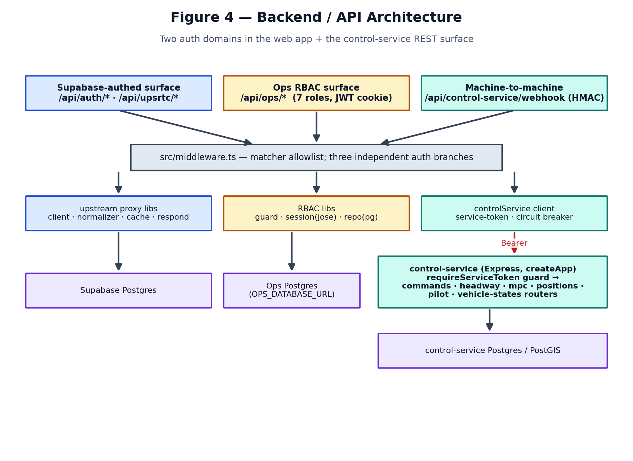
Figure 4 — Backend and API architecture across three auth domains.
The web app’s API is split into three authentication domains, enforced in src/middleware.ts and again in each handler:
- Supabase-authed: /api/auth/*, /api/upsrtc/* — enterprise session cookie.
- Ops RBAC: /api/ops/* — custom HS256 JWT cookie, role derived from the URL segment.
- Machine-to-machine: /api/control-service/webhook — HMAC signature is the entire authentication; deliberately exempt from both session gates.
The control-service is a classic Express app: health routes are public for Render’s checker, and every /v1/* route sits behind requireServiceToken (control-service/src/app.ts). A full API inventory is in §29.

9. Data Sources
Table 4 — Operational data sources.
Source | Type | Consumed by | Notes
UPSRTC getGpsLiveData.php | Live GPS (undocumented PHP) | web proxy + control-service poller | ~9,261 rows / ~11.7 MB; ~665 status='Live'
UPSRTC getScheduledBusInfo.php | Per-vehicle schedule | web /api/upsrtc/schedule | Returns bare string when unassigned; multi-trip quirks
Supabase Postgres | Auth users + ops RBAC + logs | web | No self-service signup
control-service Postgres/PostGIS | vehicle_states, headway, commands, policies, incidents | control-service | Isolated; web reads only via REST
Bundled fixtures | Sample payloads | web (offline demo only) | src/fixtures/upsrtc-*-sample.json; opt-in
Anthropic API | LLM completions | web copilot | Grounded, advisory only

SIMULATION Traffic overlays, scenario stages, and the client-side bunching page are generated locally (src/lib/demo-scenarios/*, src/lib/simulation/*, src/lib/bunching/*). FleetMap.tsx explicitly does NOT enable Google’s TrafficLayer — “all traffic here is simulated.” These are presentation constructs, not live feeds.

10. UPSRTC Live GPS Data Flow
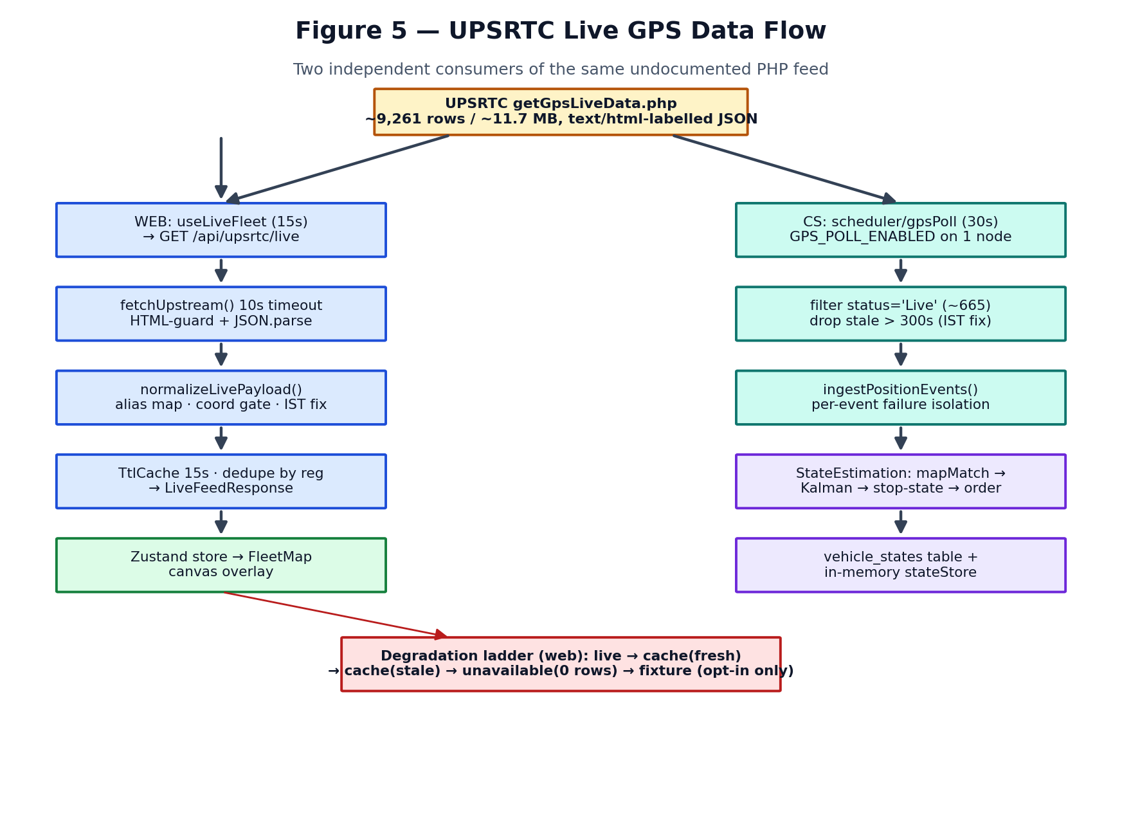
Figure 5 — Two independent consumers of the same PHP feed.

Web proxy path (for display)
Browser → useLiveFleet (src/hooks/useLiveFleet.ts, 15s) → GET /api/upsrtc/live (src/app/api/upsrtc/live/route.ts) → fetchUpstream() (src/lib/upsrtc/client.ts, 10s timeout, HTML-guard, tolerant JSON parse) → normalizeLivePayload() (src/lib/upsrtc/normalizer.ts) → TtlCache (15s) → Zustand → FleetMap canvas.
Critically, the browser NEVER touches the UPSRTC endpoint directly — the upstream URL and any headers live server-side only. The upstream URL defaults are in client.ts and can be overridden by UPSRTC_LIVE_URL / UPSRTC_SCHEDULE_URL env vars.

The degradation ladder (a deliberate design)
On a failed refresh, the route returns the honest state — never demo buses — in this order (src/app/api/upsrtc/live/route.ts):
- `source: 'live'` — fresh upstream success (or a genuine empty “no vehicles on road”).
- `source: 'cache'` (fresh) — within the 15s TTL window.
- `source: 'cache'` (stale) — last-known-good real data after a failed refresh.
- `source: 'unavailable'` — ZERO rows, explicitly flagged, when no cache is held.
- `source: 'fixture'` — bundled sample data, ONLY when `ALLOW_FIXTURE_FALLBACK` or `NEXT_PUBLIC_DEMO_MODE` is set (off in real deploys).
ARCHITECTURAL DECISION Recent commit “Stop substituting demo data for live data on upstream failure” makes the honest-empty state the default. Rationale (from the code comments): filling a dispatcher’s fleet table with demo buses that do not exist during an outage is worse than showing zero. This is a mature, safety-first choice worth calling out to the reviewer.

Upstream schema quirks the normalizer survives
- IST-as-Z timestamps: the feed stamps IST wall-clock time and labels it Z, putting every fix ~5.5h in the future. parseUpstreamInstant() detects a future value and shifts it back one IST offset; a value still in the future is a broken unit clock and is dropped (null), failing safe to stale.
- Alias tolerance: ~12 aliases for registration, 6 for latitude, 8 for longitude, etc., so an upstream rename does not black out the control room.
- Coordinate gate: isValidCoordinate() rejects out-of-range and null-island (0,0) “no-fix” sentinels.
- Duplicate merge: records are de-duplicated by registration, keeping the most recent VALID timestamp (a broken-clock record sorts to −∞ and can never win).
- Content-type lie: the endpoint advertises text/html while returning JSON, and sometimes double-encodes the array as a JSON string; extractArray() unwraps all observed shapes.

Control-service ingestion path (for computation)
Independently, control-service/src/scheduler/gpsPoll.ts polls every 30s (gated by GPS_POLL_ENABLED, default false so exactly one instance polls), filters to status='Live' (~665 of ~9,261 — ingesting parked buses would 9× the cost and corrupt map-matching to off_route), drops stale fixes (>300s), and calls the shared ingestPositionEvents() pipeline with per-event failure isolation.

11. Google Maps Architecture
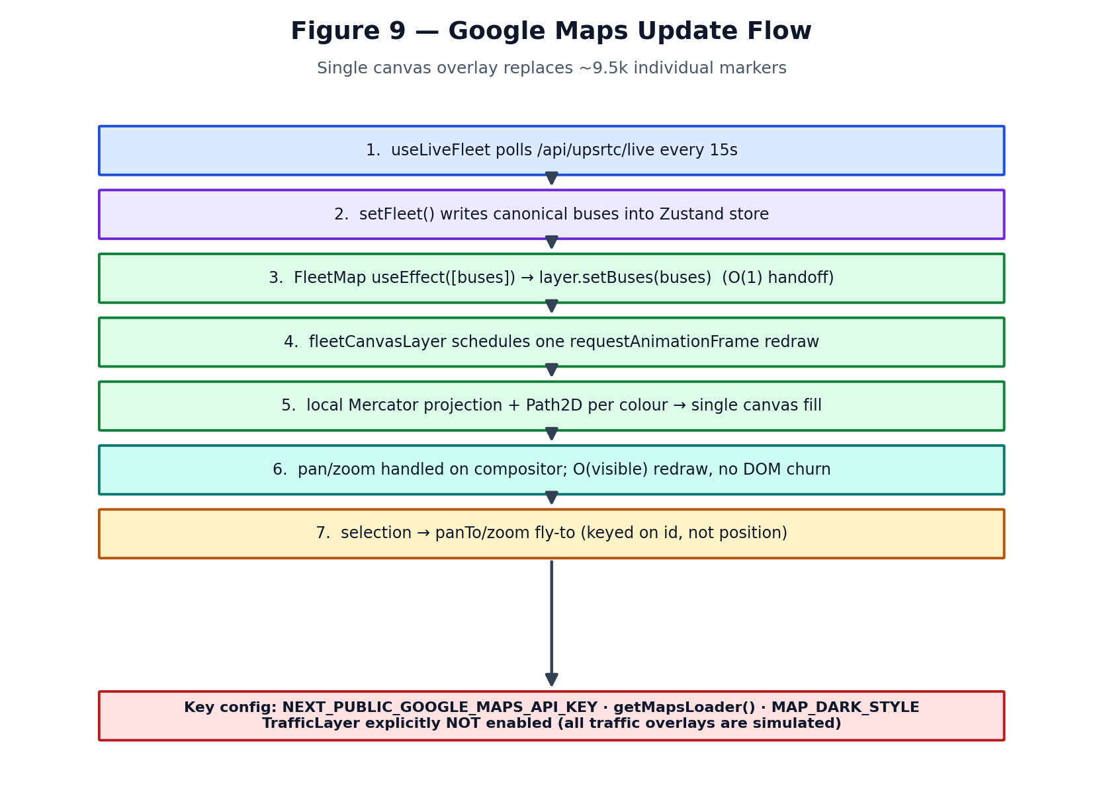
Figure 9 — Map update flow.
The map is owned by src/components/map/FleetMap.tsx. The SDK loads via getMapsLoader() (src/lib/maps/loader.ts) using NEXT_PUBLIC_GOOGLE_MAPS_API_KEY. The map builds once (empty dependency array) centred on Uttar Pradesh (DEFAULT_MAP_CENTER = {lat:26.85, lng:80.95}, zoom 7).

Why a canvas overlay, not markers
The single most important performance decision on the frontend: the feed carries ~9,500 vehicles. One google.maps.Marker per bus (plus MarkerClusterer) was measured at 5.1 seconds of main-thread blocking across a few zoom steps. Instead, src/components/map/fleetCanvasLayer.ts draws every vehicle into ONE canvas overlay: chevrons accumulate into one Path2D per colour and fill in a single call, and positions use local Mercator maths rather than ~9.5k round-trips through the Maps projection API. Redraw is O(visible) on a requestAnimationFrame, so pan/zoom stays on the compositor.

Marker → data lifecycle
- Data → layer: useEffect([buses]) calls layer.setBuses(buses) — an O(1) array handoff; the redraw it schedules is O(visible).
- Colour = data quality: green (good), amber (degraded), red (stale) from classifyDataQuality() age buckets (≤5 min / ≤30 min / older).
- Selection: clicking a chevron sets selectedBusId; the camera fly-to is keyed on id alone so the 15s poll never yanks the camera back.
- Invalid coordinates are already filtered out upstream in the normalizer, so the layer never renders a bus at null-island.

Failure handling
If NEXT_PUBLIC_GOOGLE_MAPS_API_KEY is missing or the SDK fails to load, FleetMap renders MapFallback with a retry, rather than crashing the dashboard. A Maps auth failure is also caught via src/lib/maps/authFailure.ts.

12. Bus Bunching System
READ THIS FIRST The repository contains TWO bunching implementations. Section 12.1 is the real server-side pipeline (control-service). Section 12.2 is the client-side demo simulation (web). They share terminology (headway, hold) but no code and no data.

12.1 Production pipeline — control-service (live data)
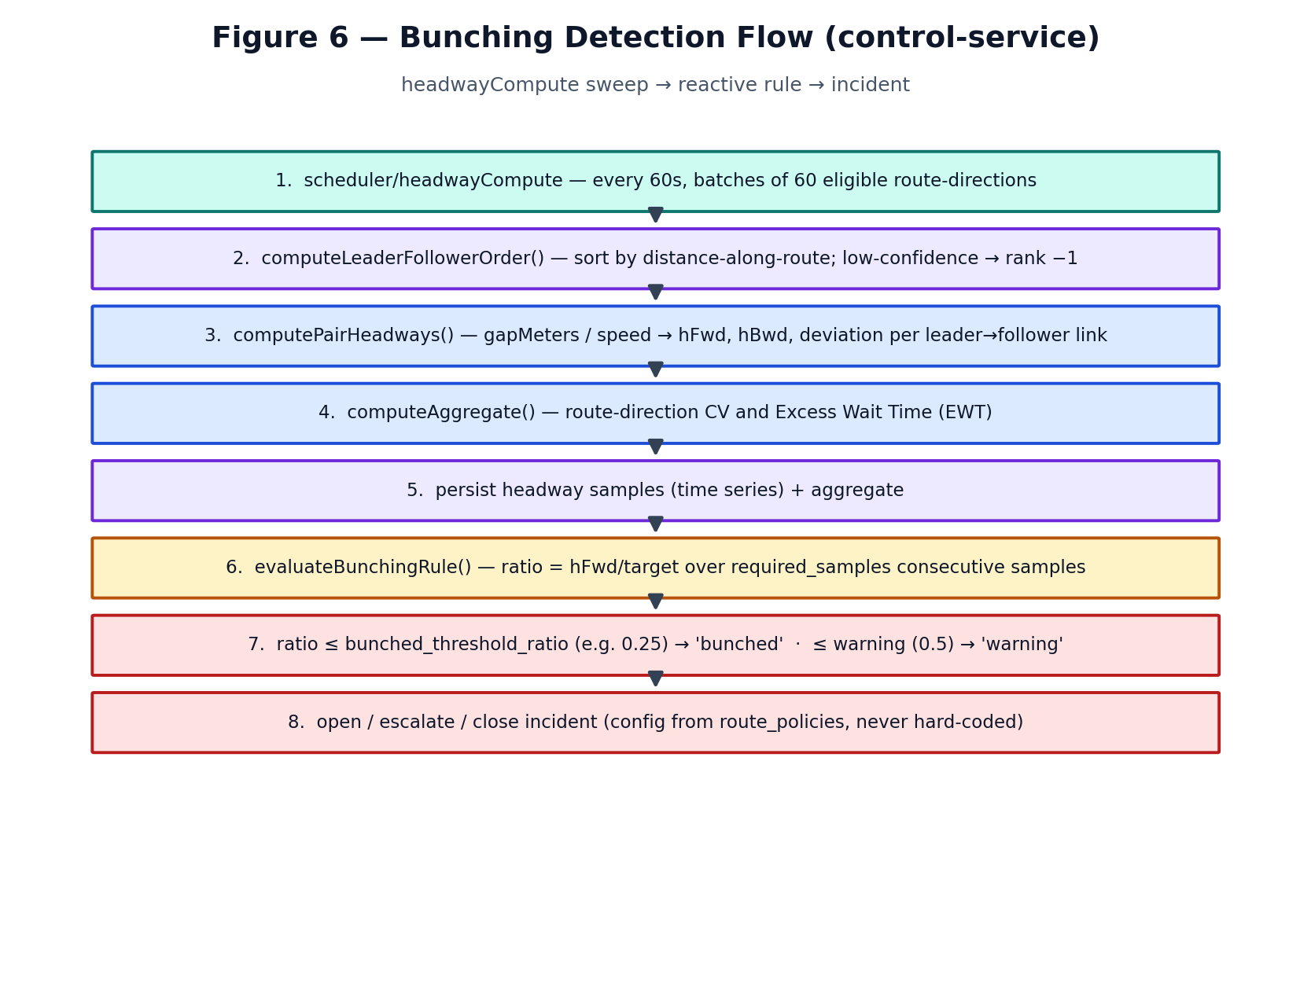
Figure 6 — Reactive bunching detection flow.

How buses are represented
A live GPS fix becomes a PositionEvent (vehicleId, lat, lon, speed, heading, observedAt). The registration number IS the vehicle id. The estimator turns it into a VehicleStateEstimate with a route-relative distanceAlongRouteMeters, smoothed speed, confidence, and stop-state (control-service/src/state-estimation/estimator.ts).

How positions are obtained and cleaned
- Map matching (mapMatching.ts): the raw lat/lon is projected onto candidate route-direction shapes.
- Direction confidence (confidence.ts): a candidate is chosen and scored; low-confidence or off-route fixes are flagged, not silently trusted.
- Kalman smoothing (kalmanFilter.ts): a constant-velocity filter over [distance, speed] denoises the track and estimates speed even when the fix omits it.
- Stop-state classification (stopStateClassifier.ts): dwelling_at_stop / in_transit / off_route / held.

Ordering: who leads whom
computeLeaderFollowerOrder() (state-estimation/ordering.ts) sorts eligible vehicles by distanceAlongRouteMeters descending — rank 0 is the leader-most bus — and links each to its follower. Loop routes wrap (the furthest-along bus is “led” by the one nearest the start). Low-confidence vehicles get rank −1 and carry no links, so a bad fix can never anchor a neighbour’s headway.

Headway: time vs spatial
computePairHeadways() (headway/metrics.ts) computes a spatial gap first, then converts to TIME headway:

gapMeters = distanceAlong(leader) − distanceAlong(follower) (wraps at totalDistance for loops)
hFwd = gapMeters / followerSpeed hBwd = gapMeters / leaderSpeed
So it is time headway derived from spatial gap and current speed — the “closing” headway a reactive rule watches. Speed is floored at 1 km/h (MIN_SPEED_KMPH) to avoid divide-by-zero, and every headway is capped at 24h so a stalled bus reports a large-but-finite, JSON-safe number instead of Infinity.

Detection: the reactive rule
evaluateBunchingRule() (headway/bunching.ts) flags an incident when a pair’s ratio hFwd / targetHeadway stays at or below a threshold for required_samples consecutive samples. Thresholds are config, not code — read from the route-direction’s route_policies row:
Table 5 — Reactive bunching classification (config-driven).
Condition (all over required_samples consecutive samples) | Result
ratio ≤ bunched_threshold_ratio (e.g. 0.25 → ≤25% of target) | severity = 'bunched'
ratio ≤ warning_threshold_ratio (e.g. 0.5 → ≤50% of target) | severity = 'warning'
ratio > warning for the whole window while an incident is open | recovered = true

PREDICTION — honest labelling The SHIPPED detection is REACTIVE (it fires after the gap has been short for N samples). The blueprint describes a predictive tier, and the occupancy-weighted MPC (§12.1 below, occupancyMpc.ts) projects one step forward, but there is no multi-step forecast or trained predictive model in the control loop today. Do not present the reactive rule as prediction.

Intervention: the MPC decision engine
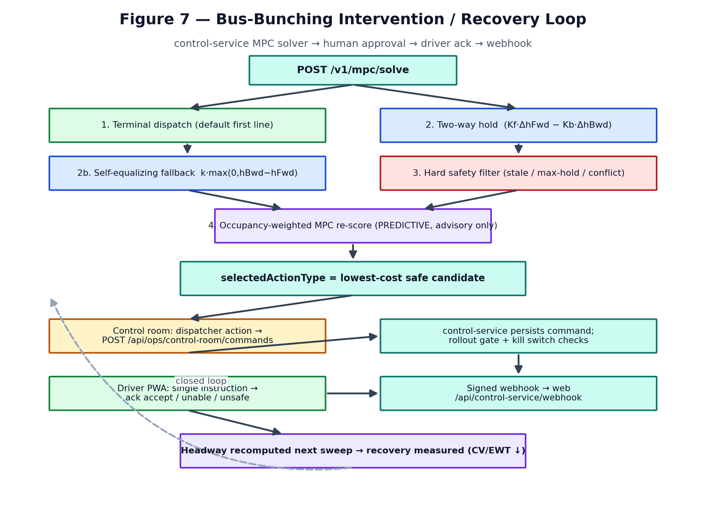
Figure 7 — Intervention / recovery loop.
solve() (control-service/src/mpc/solver.ts) runs one decision cycle for a route-direction, trying control levers in priority order and applying a hard safety filter:
- Terminal dispatch (terminalDispatch.ts) — the default first line: hold a bus dwelling at the origin until it has the target gap to the bus that already left. Least disruptive.
- Two-way holding (twoWayHold.ts) — mid-route hold using both the gap ahead and behind, so the controller doesn’t export the problem downstream.
- Self-equalizing fallback (selfEqualizing.ts) — used only where two-way’s inputs (Kf/Kb or hBwd) are unavailable.
- Hard safety filter (safety.ts) — rejects candidates on stale state, max-hold breach, or a conflicting active command; rejections are logged AND returned for explainability.
- Occupancy-weighted MPC re-score (occupancyMpc.ts) — advisory only, always labelled PREDICTIVE, never the source of the automatic selection.
The selected action is the lowest-cost safe candidate (terminal dispatch wins ties). It is NOT executed automatically — it becomes a recommendation a human dispatcher issues as a command, which a driver then acknowledges (accept / unable / unsafe).

Command vocabulary & lifecycle
From src/models/control.ts, the 9 action types are: terminal_dispatch_hold, two_way_hold, self_equalizing_hold, speed_guidance, stop_skip, short_turn, deadhead, boarding_limit, standby_injection. Command status flows through: proposed → awaiting_approval → authorized → delivered → acknowledged → executing → completed (or expired / cancelled / failed).

12.2 Client-side simulator — web demo (NOT live)
SIMULATION / HARD-CODED src/lib/bunching/* and src/components/bunching/* are a self-contained demonstration with exactly 4 buses (A, B, C, D) and hard-coded parameters in config.ts. No GPS, no control-service, no network. It exists to explain the concept on /project/bunching.

The engine is src/lib/bunching/math.ts. Its comment is explicit: “Every number the page displays comes from a function in this module.” Key demo constants (config.ts): TARGET_HEADWAY_MINUTES = 10, HEADWAY_FEEDBACK_GAIN = 0.35, CONTROL_GAIN = 0.55, MAX_HOLD_MINUTES = 5. These are demonstration parameters, explicitly “not UPSRTC operating standards.”
It faithfully models the mechanism (dwell-time feedback → self-amplifying bunch, a no-overtaking physical floor, and a coordinated controller that recovers headway progressively) — useful pedagogy, but a reviewer must not mistake it for the production control system.

13. Mathematical / Algorithmic Logic
Every formula below is implemented in the repository; the source file is cited. Production formulas (control-service) and simulation formulas (web) are separated.

13.1 Production formulas (control-service)
Table 6 — Production control/measurement formulas.
Quantity | Formula | File | Units
Spatial gap | gap = s_leader − s_follower (wraps at total for loops) | headway/metrics.ts | m
Forward headway | hFwd = gap / max(v_follower, 1 km/h) | headway/metrics.ts | s
Backward headway | hBwd = gap / max(v_leader, 1 km/h) | headway/metrics.ts | s
Deviation | dev = hFwd − targetHeadway | headway/metrics.ts | s
Headway CV | CV = stddev(hFwd) / mean(hFwd) | headway/metrics.ts | —
Excess Wait Time | EWT = max(0, (var+mean²)/(2·mean) − target/2) | headway/metrics.ts | s
Bunching ratio | ratio = hFwd / targetHeadway | headway/bunching.ts | —
Two-way hold | hold = clamp(Kf·(H*−hFwd) − Kb·(H*−hBwd), 0, hold_max) | mpc/twoWayHold.ts | s
Self-equalizing | hold = clamp(k·max(0, hBwd−hFwd), 0, hold_max) | mpc/selfEqualizing.ts | s
Terminal dispatch | hold = clamp(H* − hFwd, 0, hold_max) | mpc/terminalDispatch.ts | s
MPC wait cost | waitCost = (1/H*)·predictedHFwd²/2·w_wait | mpc/occupancyMpc.ts | —
MPC onboard cost | onboardCost = loadFraction·hold·w_onboard | mpc/occupancyMpc.ts | —

Kalman filter (state estimation)
kalmanFilter.ts is a constant-velocity (white-noise-acceleration) filter on state [s, v]. Predict: s' = s + v·dt, P' = F·P·Fᵀ + Q with F = [[1, dt],[0,1]]. Update assimilates the map-matched distance with Kalman gain K = P₀₀/(P₀₀+R), default measurement variance R = 225 m² (~15 m GPS stddev), accel variance 0.015 (m/s²)². The full covariance is serialized so a restart resumes from the persisted state instead of a cold prior.

Interpretation notes
- EWT follows the standard TfL Excess Wait Time methodology (actual mean wait for a Poisson-arriving passenger minus scheduled wait). It is a real transport KPI.
- The two-way law is the blueprint’s Algorithm B; the backward term prevents the controller from creating a new bunch behind the one it is fixing.
- Occupancy MPC currently uses a single deterministic projection (not a true expectation) and fixed weights w_wait = w_onboard = 1 — a documented prototype.

13.2 Simulation formulas (web demo — SIMULATION)
Table 7 — Client-side SIMULATION formulas (demo only).
Quantity | Formula | File
Headway coupling | H'_AB = H_AB + u_B − u_A (per pair) | bunching/math.ts applyDeltas
Dwell feedback | δ_i = clamp(gain·(H_ahead − target), ±0.8) | bunching/math.ts feedbackDeltas
Mean abs error | MAE = mean(|H_i − target|) | bunching/math.ts
Regularity (demo) | 100·(1 − MAE/target), floored at 0 | bunching/math.ts (not a UPSRTC KPI)
Variance | population variance of headways | bunching/math.ts
Passenger wait proxy | Σh² / (2·Σh) | bunching/math.ts passengerWaitProxy
Recovery progress | 100·(MAE₀ − MAE)/MAE₀ | bunching/math.ts recoveryProgress

These drive the /project/bunching explainer. They are internally consistent and pedagogically sound, but the constants are demo values and the four buses are fictitious.

14. AI / ML Architecture
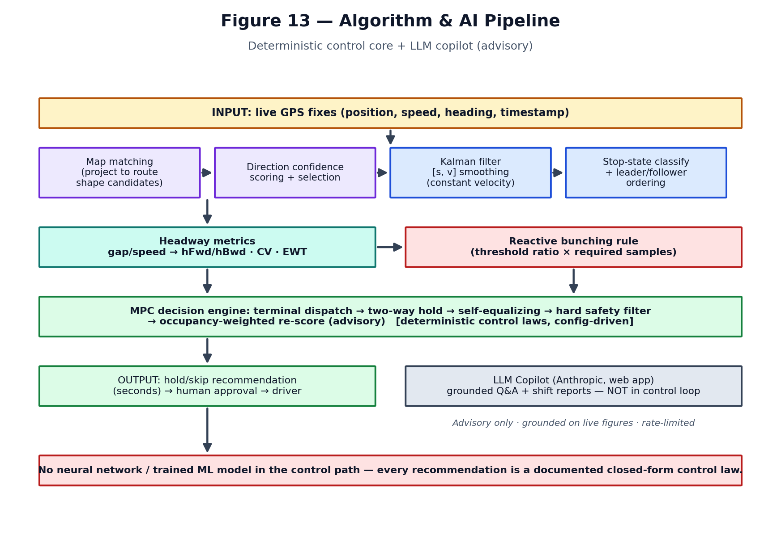
Figure 13 — Algorithm & AI pipeline.
HONEST CLASSIFICATION There is NO trained neural network or machine-learning model in the control loop. Every control decision is a documented closed-form control law with config-driven gains. The only LLM is an Anthropic-powered control-room copilot that is advisory and grounded — it never issues commands. The UI naming (‘Intelligence Core’, ‘AI Decision Panel’) is product language, not evidence of ML.

Table 8 — AI/algorithm inventory: what is really there.
Capability | Current implementation | Location | Status
State estimation | Kalman filter (constant-velocity) + map matching | control-service/src/state-estimation/* | Production
Bunching detection | Rule-based threshold over consecutive samples | control-service/src/headway/bunching.ts | Production
Intervention | Deterministic control laws (terminal/two-way/self-eq) | control-service/src/mpc/* | Production
Predictive MPC | Occupancy-weighted single-step re-score | control-service/src/mpc/occupancyMpc.ts | Prototype (advisory)
Control-room copilot | Anthropic Messages API, grounded prompts | src/lib/copilot/* | Production (advisory)
Client bunching demo | Deterministic feedback simulation | src/lib/bunching/* | Simulation
Neural net / trained ML | None | — | Not present
Multi-step forecasting | None in control loop | — | Planned (blueprint)

The LLM copilot in detail
src/lib/copilot/anthropic.ts is the only LLM adapter (raw fetch, no SDK). The service (src/lib/copilot/service.ts) builds a grounded prompt (prompts.ts + grounding.ts) from live figures, enforces a citation contract in the system prompt, rate-limits calls (rateLimit.ts), and logs every interaction to ops_copilot_interactions. It powers control-room Q&A, incident explanations, and shift-report drafting — all reviewed by a human. Default model: claude-sonnet-4-5 (overridable via ANTHROPIC_MODEL).
Failure handling is defensive: missing key, timeout (20s), non-2xx, or empty response all return {ok:false, error} — the copilot never throws a 500 into a route handler, and the API key and incident-sensitive bodies are never logged to stdout.

15. State Management & Data Lifecycle
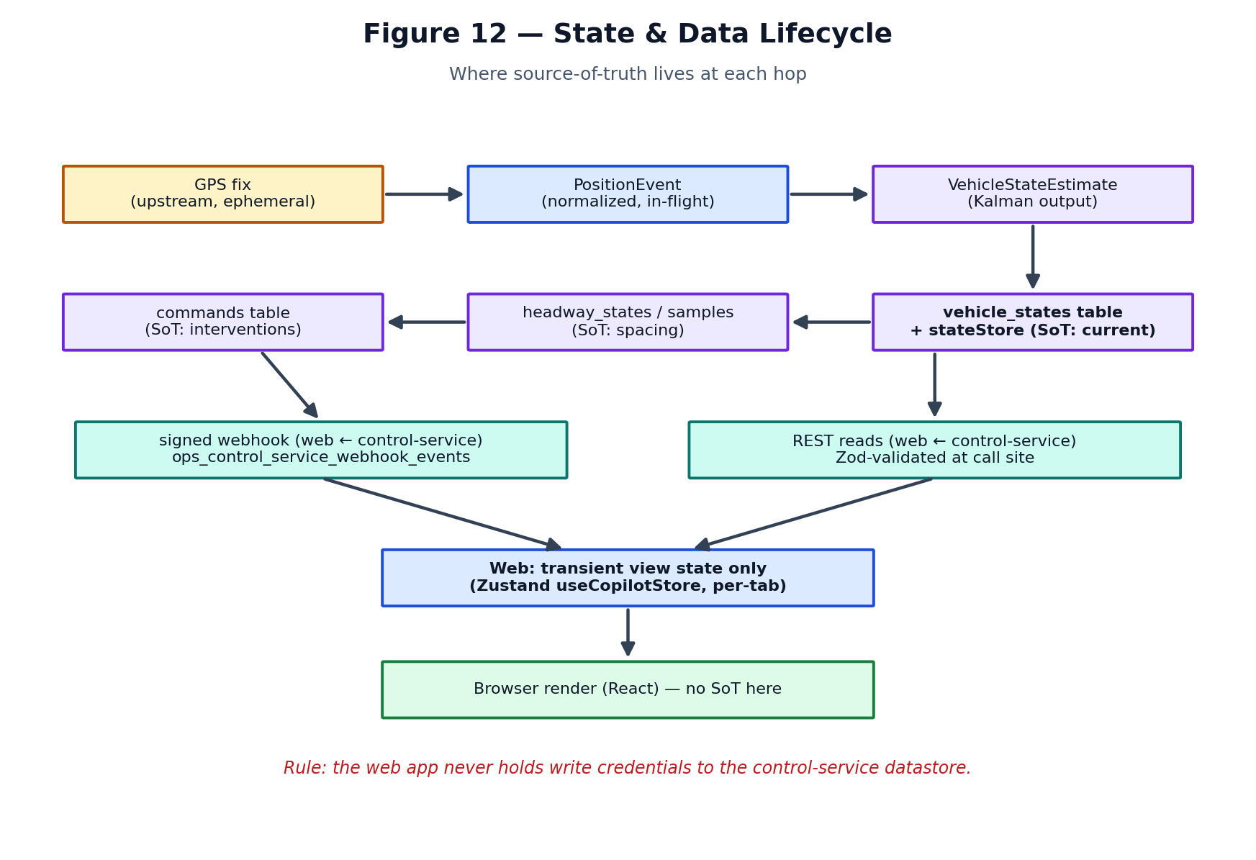
Figure 12 — Where source-of-truth lives at each hop.
Table 9 — State ownership.
Layer | State store | Source of truth for | Lifetime
Web client | Zustand copilotStore | View state (selection, filters, UI, alerts) | Per browser tab
Web server | Module-scoped TtlCache | Last live UPSRTC payload (15s) | Per warm process
Web server | In-memory counters or Redis | Rate-limit + circuit-breaker state | Per process / shared
Supabase | Postgres | Auth users, ops RBAC, copilot/webhook logs | Durable
control-service | stateStore (in-memory) + Postgres | vehicle_states, headway, commands, policies | Durable + rehydrated

SCALABILITY WATCH-OUT The web server’s TtlCache and default in-memory rate-limit/breaker counters are PER WARM PROCESS. On Vercel’s serverless model, each instance has its own copy, and a cold start resets them. Redis (REDIS_URL) is the single switch that makes these shared across instances — see §22.

16. Authentication
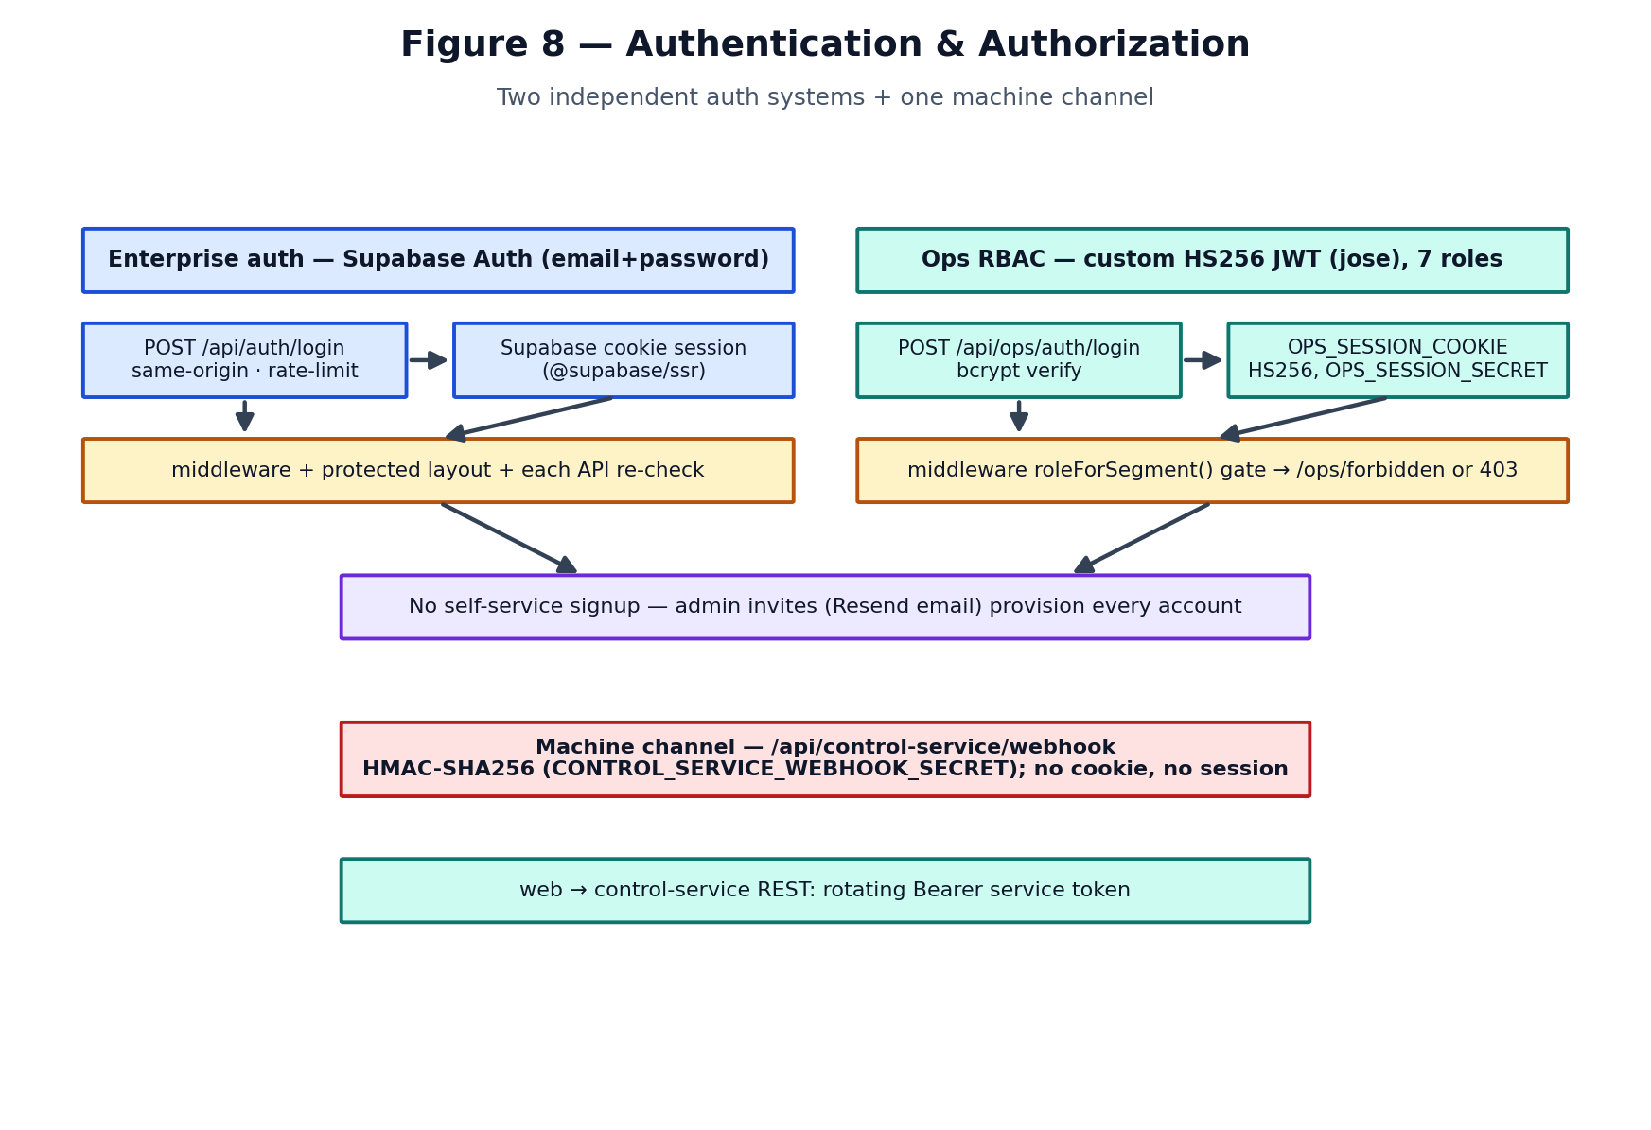
Figure 8 — Two independent auth systems + one machine channel.

Enterprise auth (Supabase)
POST /api/auth/login (src/app/api/auth/login/route.ts) requires same-origin + JSON, validates with Zod, rate-limits by IP+email, and calls Supabase signInWithPassword. It returns a generic “Invalid email or password” for every failure (no user enumeration) and never returns a token in the body — the session is a Supabase cookie (@supabase/ssr). There is no self-service signup; accounts are provisioned out-of-band via pnpm run create-project-user.

Ops RBAC (custom JWT)
A completely separate system: POST /api/ops/auth/login verifies a bcrypt password and issues an HS256 JWT (jose) stored in OPS_SESSION_COOKIE, signed with OPS_SESSION_SECRET. Seven roles (driver, pilot_driver, dispatcher, depot, control_room, planner, admin). Middleware derives the required role from the URL segment (roleForSegment()) and returns 403/redirect-to-forbidden for a wrong role (never “not signed in”).

Route protection — defence in depth
- Edge middleware is the first gate (src/middleware.ts).
- Layouts re-check the session server-side (protected + each ops layout).
- Every API handler re-authorizes independently — e.g. requireUpsrtcAccess() in the live route, requireOpsRole() in ops routes. “Never rely on middleware alone.”

Machine channel
POST /api/control-service/webhook authenticates purely by HMAC-SHA256 over the exact raw bytes (no cookie). It is exempt from both session gates by design — a redirect there would make an unauthenticated POST look like HTTP 200, silently dropping every command lifecycle event.

17. Security Architecture & Lightweight Review

Strengths (evidence-based)
- Server-side proxy: the browser never contacts the UPSRTC upstream; the URL/headers stay server-side.
- Strong headers/CSP in next.config.ts: production CSP, HSTS (2y, preload), frame-ancestors 'none', X-Content-Type-Options, restrictive Permissions-Policy.
- HMAC + timing-safe compare on webhooks; body size capped BEFORE hashing (bytes, not string length); bad signature returns non-retryable 400.
- Login hardening: same-origin check, Zod validation, rate limiting, generic error, no token in body.
- Fail-safe rate limiter: if Redis is down, callers fall back to in-process counters — never to “allowed” (can’t DoS the limiter off) and never to “denied” (can’t lock out a control room).
- Secret hygiene: .env* is gitignored; no secrets are committed to git (verified). Service-role key is server-only; the Supabase anon key is public by design.

Risks & findings
Table 10 — Security findings (no secret values printed).
Finding | Severity | Detail / file | Recommendation
NEXT_PUBLIC_GOOGLE_MAPS_API_KEY is browser-exposed | Medium | By design (NEXT_PUBLIC). A local .env.local key is real. | Restrict by HTTP referrer + API in Google Cloud; rotate; set quotas
Stale legacy secrets in local .env.local | Low/Med | PROJECT_PIN_HASH / SESSION_SECRET remain locally though the PIN system was removed | Purge unused secrets from all local/deploy envs
CSP allows 'unsafe-inline'/'unsafe-eval' on scripts | Medium | next.config.ts (documented trade-off) | Move to per-request nonces
No app-layer rate limit on the live proxy | Low | Auth-gated but any signed-in user can poll | Add per-user quota; the 15s cache absorbs most load
SSRF surface via UPSRTC_LIVE_URL/env | Low | URL is env-controlled, not user-controlled | Keep env-only; validate host allowlist
Two independent secrets must match (webhook HMAC) | Ops risk | Mismatch drops every event silently as 400 | Rotate both ends together; alert on 400 rate

SECRETS No secret values appear in this document. The local .env.local was inspected only to confirm hygiene; it is correctly gitignored and was never committed to git.

18. Deployment Architecture
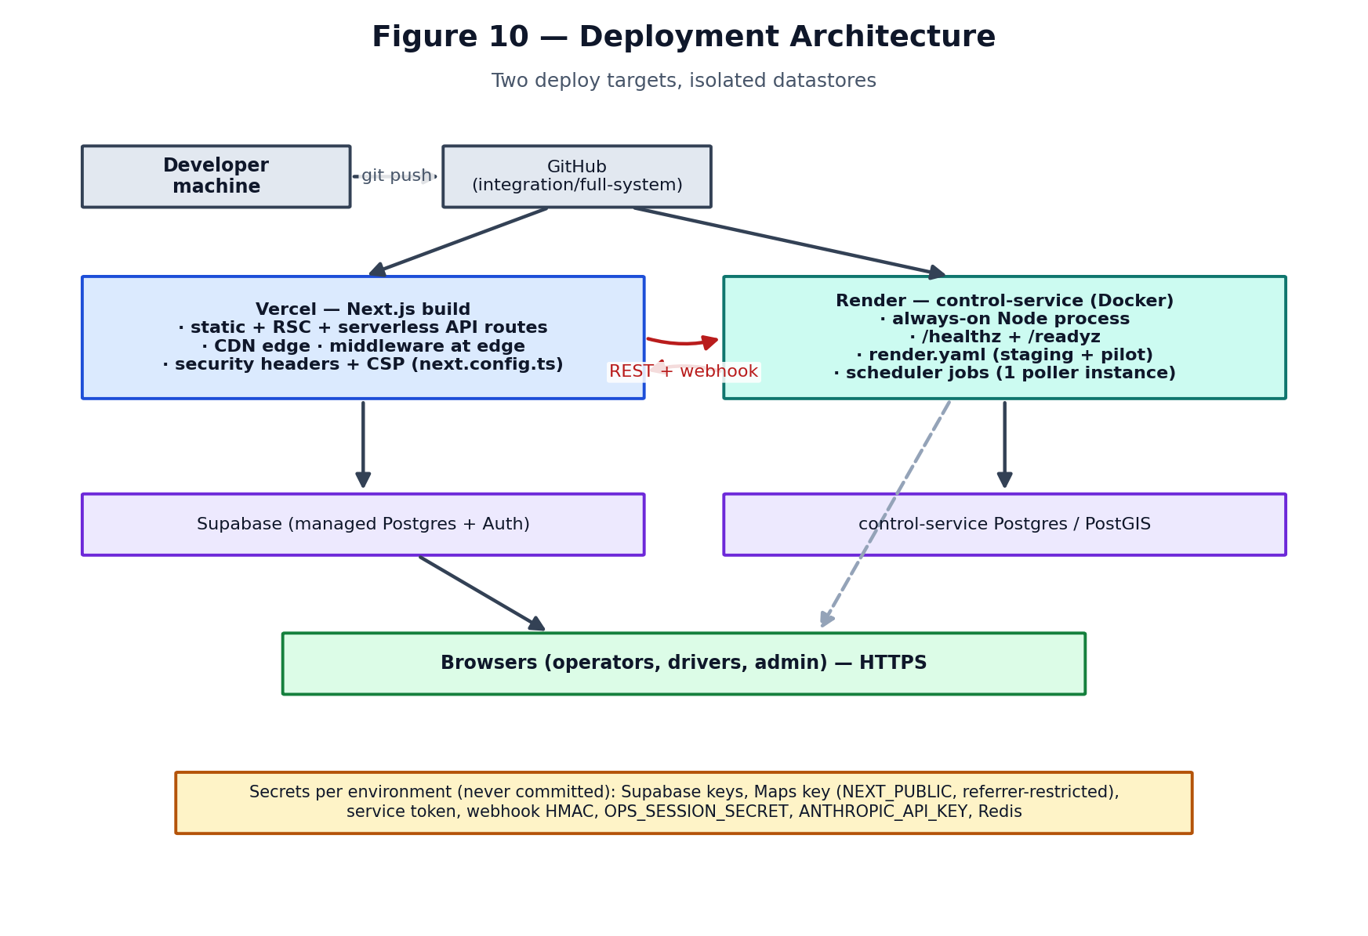
Figure 10 — Two deploy targets, isolated datastores.
- Web app → Vercel: Next.js build produces static assets + RSC + serverless API routes; middleware runs at the edge; security headers/CSP from next.config.ts; compress: true (the ~3.8 MB live payload compresses to a few hundred KB).
- control-service → Render (Docker, always-on): needed because state estimation, the scheduler jobs, and in-memory stateStore require a persistent process — a serverless model cannot host the 30s poller or keep rehydrated state warm.
- Datastores: Supabase (web) and control-service Postgres/PostGIS are deliberately isolated.
- Env config: .env.example documents every variable with security notes; secrets are set per-environment, never committed. render.yaml defines staging + pilot services.
Static vs dynamic: the API routes are force-dynamic + nodejs runtime (they need Node crypto/pg and must not be cached). The dashboard shell is server-rendered; live data is client-polled.

19. Error Handling & Observability

Web app
- Upstream failures are structured, not thrown: fetchUpstream() returns {ok,status,error}; the route degrades down the ladder (§10).
- liveDiagnostics (in the live route) tracks lastAttempt/lastSuccess/lastError/consecutiveFailures, surfaced in the developer DiagnosticsDrawer.
- Client resilience: useLiveFleet aborts in-flight polls, ignores AbortError, and re-applies the error on an ‘unavailable’ payload; FleetMap shows MapFallback on SDK failure; FleetErrorBanner surfaces feed errors.

control-service
- pino / pino-http structured logs; @sentry/node spans (e.g. the mpc.solve span the dashboards are built on).
- Per-event ingest classification: one bad fix among 665 is rejected individually with a SQLSTATE-mapped code; an unrecognized error fails the batch (a bug must not hide as a data problem).
- /healthz + /readyz for Render; readiness gates on a seeded network.
Gaps: no end-to-end tracing across the web↔control-service boundary; no product-level uptime/SLO dashboard evidenced in-repo beyond Sentry; the web app has no Sentry/RUM.

20. Scalability Analysis
Analysed from the actual loops and data volumes. N = number of live vehicles.
Table 11 — Core operation complexity.
Concern | Complexity / behaviour | Where
Leader/follower ordering | O(N log N) sort per route-direction | ordering.ts
Pair headways | O(N) over links per route-direction | headway/metrics.ts
Bunching rule | O(required_samples) per pair | headway/bunching.ts
MPC solve | O(pairs) per route-direction cycle | mpc/solver.ts
Map render | O(visible) redraw, single canvas | fleetCanvasLayer.ts
Live payload transfer | ~3.8 MB JSON / 15s (compressed) | next.config.ts
Upstream download (ingest) | ~11.7 MB / 30s, one instance | gpsPoll.ts

Table 12 — Behaviour at scale.
Fleet size | Expected behaviour on current architecture
10 | Trivial. Everything real-time; map & compute negligible.
100 | Comfortable. Canvas map fine; headway sweep sub-second per route.
1,000 | Fine on control-service; web payload grows but canvas + compression hold. Batch sweep (size 60) fans out.
10,000 | ≈ current UPSRTC scale. Canvas layer was purpose-built for ~9.5k. Bottlenecks: 11.7 MB single-download poll, per-process web cache, and headway sweep latency = required_samples × interval × ceil(eligible/batch). Needs streaming ingest + horizontal control-service + shared cache.

- Race conditions: mitigated by the vehicle_states out-of-order guard (a newer persisted fix wins) and single-instance polling; the web per-process cache can serve slightly different snapshots across instances.
- Serverless multiplicity: each Vercel instance holds its own cache/limiter — Redis is the fix (§22).

21. Failure Modes
Table 13 — Failure modes and handling.
Failure | Current behaviour | Operational impact | Recommended handling
UPSRTC upstream down | Degradation ladder → cache(stale) → unavailable (0 rows) | Map empties honestly; flagged | Add alerting on consecutiveFailures; status banner (exists)
Malformed / HTML upstream body | Guarded + rejected; error recorded | No crash; feed flagged | Already handled; add metric on reject rate
IST-mislabelled timestamp | Corrected; broken-clock fix dropped → stale | Correct age/quality badges | Already handled (parseUpstreamInstant)
Invalid coordinates / null-island | Rejected in normalizer | Bus omitted, counted as rejected | Already handled
Duplicate vehicle | Merged by reg, newest valid ts wins | Single marker | Already handled
One bus stops sending | Ages to degraded→stale (colour changes) | Visible staleness | Add explicit ‘dark vehicle’ alert
Google Maps fails | MapFallback with retry | Dashboard usable minus map | Already handled
Auth session expires | 401/redirect to login | Re-login | Already handled
control-service unreachable (web) | Circuit breaker opens after 3 fails, 30s cooldown | Ops panels show notice, don’t hang | Already handled (controlService/client.ts)
Webhook secret mismatch | 400 (non-retryable) → events dropped silently | Command outcomes never arrive | Alert on 400 rate; rotate both ends together
Multi-instance GPS poll | Prevented by GPS_POLL_ENABLED on one node | Avoids N× writes/races | Already handled; document the operational rule
Vercel cold start | Per-process cache/limiter reset | Weaker rate limits; extra upstream fetch | Enable Redis
Conflicting interventions | Hard safety filter rejects on active command | No double-hold | Already handled (mpc/safety.ts)

22. A note on shared state (Redis)
REDIS_URL is the single activation switch (src/lib/redis/client.ts). Unset (default for local/CI): the failed-login limiter, the copilot limiter, and the control-service circuit breaker use per-process in-memory counters. Set: all instances share one budget. If Redis is configured but unreachable, every caller falls back to its in-process counter — never to “allowed” or “denied”. This should be ON for any multi-instance or serverless production deploy.

23. Testing
Both packages use Vitest; the web app adds Playwright e2e. The web app has a substantial unit suite (src/tests/unit/*): normalizer, bunching math, rbac, control contracts, copilot (anthropic/prompts/rate-limit/boundary), control-service client/webhook/freshness, ops dashboards, fleet data/view, geo, alerts, audit, invite email. control-service ships tested state-estimation, headway, and MPC libraries plus a regression/replay simulator (demandBurst, gpsDropout, missedTrip, nonCompliance).

Assessment
- Strong: pure algorithm modules are well isolated and unit-tested (estimator, headway, MPC, normalizer).
- Gaps: no evidence of contract tests spanning the web↔control-service HTTP boundary end-to-end; limited e2e; the live-ingest wiring (estimator → runtime) is the least-covered seam.

Recommended test pyramid
- Unit (broad base): keep the pure-function coverage; add boundary tests.
- Contract (middle): Zod-schema contract tests on every /v1/* + webhook shape, run against both sides.
- Integration: ingest→estimate→headway→bunching→command with a seeded PostGIS fixture.
- E2E (thin top): login → dashboard → select bus → issue command → driver ack → control-room sees outcome.

Deterministic bunching tests to add
- Normal headway (no incident fires)
- Two buses bunching (ratio crosses bunched threshold for required_samples)
- Multi-bus chain reaction (bunch propagates down the chain)
- GPS dropout (one vehicle goes low-confidence → excluded, rank −1)
- Delayed telemetry (stale fix rejected by safety filter)
- Intervention recovery (hold → ratio recovers → incident closes)
- Threshold boundary (ratio exactly at bunched/warning ratio)

24. Production vs Prototype vs Mock vs Planned
Table 14 — Maturity classification from repository evidence.
Feature | Production | Prototype | Mock/Hard-coded | Planned
Live GPS proxy (web) | ✔
Live fleet map | ✔
Schedule lookup | ✔
Enterprise + ops auth | ✔
State estimation (Kalman/map-match) | ✔ (tested) |  |  | wired to live ingest = further work
Headway/EWT/CV + reactive bunching | ✔ (tested)
MPC hold/dispatch engine | ✔ (tested)
Occupancy-weighted predictive MPC |  | ✔ (advisory, 1-step) |  | multi-step QP
Bunching PREDICTION (forecast) |  |  |  | ✔ (blueprint)
Client bunching page |  |  | ✔ (4 buses)
Traffic / scenario overlays |  |  | ✔ (simulated)
LLM copilot | ✔ (advisory)
Driver PWA command ack | ✔
Automated command execution |  |  |  | ✔ (gated by human+ack)
Depot/central-control integration |  |  |  | ✔

25. Technical Debt
- Duplicated upstream normalization + IST correction across web and control-service (documented “sibling implementations” with no shared package) — must be changed in lockstep; a real drift risk.
- Estimator not wired to live ingestion by default: the powerful state-estimation library exists and is tested but GPS_POLL_ENABLED=false by default and the README notes the runtime “does not call it yet”. The gap between capability and activation is the biggest debt.
- MPC objective weights hard-coded (W_WAIT=W_ONBOARD=1) with no route_policies column yet.
- Two large narrative docs (README.md 92 KB, DEV_VS_MAIN_ANALYSIS.md 88 KB) risk drifting from code.
- Per-process web state without Redis is a correctness-looking-but-not control on serverless.
- CSP unsafe-inline/eval pending nonces.

26. Engineering Recommendations

Critical before production

Wire live ingestion to the estimator, deliberately
Problem: The control loop’s value depends on the estimator running on live GPS, but it is off by default.
Files: control-service/src/scheduler/gpsPoll.ts, ingestion/pipeline.ts, state-estimation/singleton.ts
Risk: Shipping a pilot where the ‘AI’ pipeline is dormant.
Suggested design: Enable GPS_POLL_ENABLED on exactly one instance; add readiness/ingest-lag alerts; document the single-poller rule.
Priority: CRITICAL

Alerting on silent-drop failure modes
Problem: Webhook 400s and upstream outages drop data without paging anyone.
Files: src/app/api/control-service/webhook/route.ts, live/route.ts liveDiagnostics
Risk: Command outcomes or live feed silently missing during an incident.
Suggested design: Emit metrics on webhook 400 rate and consecutiveFailures; alert; dashboard.
Priority: CRITICAL

Important for pilot

Enable Redis for shared limits/cache
Problem: Per-process counters reset on cold start and diverge across instances.
Files: src/lib/redis/client.ts, auth/rate-limit.ts, copilot/rateLimit.ts, controlService/client.ts
Risk: Rate limits weaker than they appear; inconsistent snapshots.
Suggested design: Provision Upstash; set REDIS_URL/REDIS_TOKEN in production.
Priority: HIGH

De-duplicate the upstream normalizer
Problem: Two hand-kept copies of tricky parsing/IST logic.
Files: src/lib/upsrtc/normalizer.ts, control-service/src/ingestion/upsrtc/normalize.ts
Risk: Silent divergence on an upstream change.
Suggested design: Extract a tiny shared package or generate one from the other; add a cross-test asserting identical parsing.
Priority: HIGH

Scalability / reliability / architecture

Move from polling to streaming ingest
Problem: 11.7 MB every 30s downloaded whole by one node.
Files: control-service/src/scheduler/gpsPoll.ts
Risk: Download latency and single-node bottleneck at scale.
Suggested design: If UPSRTC offers deltas/streaming use it; else shard by depot/region across instances with a coordinator.
Priority: MEDIUM

Introduce a queue between ingest and estimation
Problem: Ingest and estimation run inline in the poll cycle.
Files: control-service/src/ingestion/pipeline.ts
Risk: A slow estimate backs up the poll; no backpressure.
Suggested design: Insert a durable queue (e.g. Postgres LISTEN/NOTIFY or a broker) so ingestion and compute scale independently.
Priority: MEDIUM

Security / code quality / AI-ML

CSP nonces + Maps key restriction
Problem: unsafe-inline/eval scripts; browser-exposed Maps key.
Files: next.config.ts
Risk: XSS blast radius; key abuse.
Suggested design: Per-request nonces; referrer+API restrictions and quotas on the Maps key in Google Cloud.
Priority: MEDIUM

Promote predictive MPC from advisory to real forecasting
Problem: Detection is reactive; predictive MPC is single-step with fixed weights.
Files: control-service/src/mpc/occupancyMpc.ts
Risk: Interventions fire after bunching starts.
Suggested design: Add a short-horizon headway forecast (even a Kalman-projected multi-step) and per-route tunable weights; validate on the replay simulator before enabling.
Priority: MEDIUM

27. Important Functions

GET (live feed)
File | src/app/api/upsrtc/live/route.ts
Responsibility | Server proxy for live UPSRTC GPS; authorizes, caches, normalizes, degrades.
Inputs | NextRequest (auth cookie, accept-encoding)
Processing | requireUpsrtcAccess → demo/cache check → fetchUpstream → normalizeLivePayload → cache set → degradation ladder
Outputs | LiveFeedResponse (buses, source, stale, counts)
Called by | useLiveFleet poll
Calls | fetchUpstream, normalizeLivePayload, TtlCache
Side effects | Updates module cache + liveDiagnostics
Failure cases | Upstream down → cache/unavailable; unauthorized → 401
Why it matters | The only bridge between the browser and the real UPSRTC feed.

normalizeLivePayload
File | src/lib/upsrtc/normalizer.ts
Responsibility | Turn messy upstream rows into canonical buses.
Inputs | unknown payload, now(ms)
Processing | extractArray → alias pick → coord gate → IST timestamp fix → dedupe by reg (newest valid)
Outputs | {buses, recordCount, rejectedRecordCount}
Called by | live route, fixture responses
Calls | extractArray, parseUpstreamInstant, isValidCoordinate
Side effects | None (pure)
Failure cases | Bad rows counted as rejected; unusable ts → dropped/stale
Why it matters | Every downstream badge/table/marker reads its output; the app’s data-quality contract.

estimateVehicleState
File | control-service/src/state-estimation/estimator.ts
Responsibility | One position-event → smoothed route-relative state.
Inputs | EstimationContext (event, candidate shapes, prior state, held flag)
Processing | matchCandidates → selectChosenCandidate → confidence → Kalman update (loop unwrap) → stop-state
Outputs | VehicleStateEstimate
Called by | StateEstimationService / pipeline
Calls | map matching, confidence, DistanceKalmanFilter, stop classifier
Side effects | None (pure)
Failure cases | No candidates/off-route → off_route estimate; low confidence flagged
Why it matters | The core sensor-fusion step everything downstream depends on.

computePairHeadways
File | control-service/src/headway/metrics.ts
Responsibility | Per leader→follower link, compute spatial gap and time headways.
Inputs | ordered vehicles, speed/confidence lookups, route geometry, target
Processing | gapMeters (loop-aware) → hFwd/hBwd (speed floored) → deviation → min-confidence
Outputs | HeadwayPairMetric[]
Called by | headway service / sweep
Calls | computeGapMeters
Side effects | None (pure)
Failure cases | Missing speed → null headway; capped at 24h
Why it matters | The measurement layer the bunching rule and MPC both consume.

evaluateBunchingRule
File | control-service/src/headway/bunching.ts
Responsibility | Classify a pair as bunched/warning/recovered from recent ratios.
Inputs | ratios (newest first), required_samples, thresholds, hasOpenIncident
Processing | window of N samples; all ≤ bunched / all ≤ warning / all recovered
Outputs | {severity, recovered, ratio}
Called by | headway service
Calls | —
Side effects | None (pure)
Failure cases | Too few samples → severity null (avoids noise)
Why it matters | The actual detection decision; config-driven so ops can tune per route.

solve (MPC)
File | control-service/src/mpc/solver.ts
Responsibility | Pick the least-disruptive safe intervention for a route-direction.
Inputs | routeDirectionId (reads state store + policy + active commands)
Processing | terminal → two-way → self-eq candidates → hard safety filter → occupancy re-score → select lowest cost
Outputs | MpcSolveResult (selected action, cost, rejected, predictive advisory)
Called by | POST /v1/mpc/solve
Calls | the four control modules + applyHardSafetyFilter, listActiveVehicleIds
Side effects | Sentry span; warn logs on rejection
Failure cases | No policy → 404; stale/conflict → rejected
Why it matters | The decision engine that produces every recommended command.

computeTwoWayCandidates
File | control-service/src/mpc/twoWayHold.ts
Responsibility | Blueprint Algorithm B mid-route hold.
Inputs | headway states, terminal vehicle set, policy (Kf,Kb,hold_max)
Processing | hold = clamp(Kf·(H*−hFwd) − Kb·(H*−hBwd), 0, hold_max); skip ≤0
Outputs | CandidateAction[] sorted by cost
Called by | solver
Calls | clamp
Side effects | None (pure)
Failure cases | Missing Kf/Kb/hBwd → empty (self-eq covers)
Why it matters | The primary mid-route control law; backward term prevents exporting the bunch.

useLiveFleet
File | src/hooks/useLiveFleet.ts
Responsibility | Client polling loop for live data.
Inputs | — (reads store actions)
Processing | 15s interval; AbortController per tick; setFleet / re-apply error on 'unavailable'
Outputs | void (writes Zustand store)
Called by | CommandCenter
Calls | fetch('/api/upsrtc/live'), store setters
Side effects | Network + store writes; interval
Failure cases | Abort ignored; non-OK → setFleetError
Why it matters | Drives the entire live experience; the client heartbeat.

POST (webhook)
File | src/app/api/control-service/webhook/route.ts
Responsibility | Receive signed control-service events.
Inputs | raw body + signature/timestamp/idempotency headers
Processing | size cap → HMAC verify → parse → envelope → store (idempotent) → side effects → mark processed
Outputs | 200/400/413/500/503 tuned to sender retry policy
Called by | control-service webhook dispatch
Calls | verifyControlServiceWebhook, applyWebhookSideEffects
Side effects | Writes ops_control_service_webhook_events
Failure cases | Bad sig → 400 (no retry); secret unset/db down → 503 (retry)
Why it matters | The only inbound channel for command outcomes; correctness is safety-critical.

computeLeaderFollowerOrder
File | control-service/src/state-estimation/ordering.ts
Responsibility | Rank vehicles along a route-direction.
Inputs | vehicles, {isLoop, totalDistance}
Processing | filter low-confidence → sort by distance desc → link leader/follower → loop wrap
Outputs | OrderedVehicle[] (rank, leader/follower ids)
Called by | headway service
Calls | —
Side effects | None (pure)
Failure cases | Low-confidence → rank −1, no links
Why it matters | Establishes who is whose leader — the basis of every headway.

28. Call Graphs (critical paths)

Live fleet render
CommandCenter
→ useLiveFleet()
→ fetch('/api/upsrtc/live')
→ route GET → requireUpsrtcAccess()
→ TtlCache.get / fetchUpstream(UPSRTC_LIVE_URL)
→ normalizeLivePayload()
→ LiveFeedResponse
→ copilotStore.setFleet()
→ FleetMap useEffect([buses]) → fleetCanvasLayer.setBuses()
→ canvas redraw

Bunching detection → recommendation (control-service)
scheduler headwayCompute
→ StateEstimation ordering (computeLeaderFollowerOrder)
→ computePairHeadways → computeAggregate (CV/EWT)
→ persist samples
→ evaluateBunchingRule() → open/close incident
… then, on demand:
POST /v1/mpc/solve → solve()
→ terminal/two-way/self-eq candidates
→ applyHardSafetyFilter → computePredictiveAdvisory
→ selected CandidateAction

Command issue → outcome
Control room UI
→ POST /api/ops/control-room/commands (RBAC + kill-switch)
→ createControlServiceCommand() (Bearer)
→ control-service persists (rollout gate)
→ driver PWA GET /v1/pilot-driver/commands
→ POST ack (accept|unable|unsafe)
→ signed webhook → POST /api/control-service/webhook
→ applyWebhookSideEffects → control room sees outcome

29. API Reference
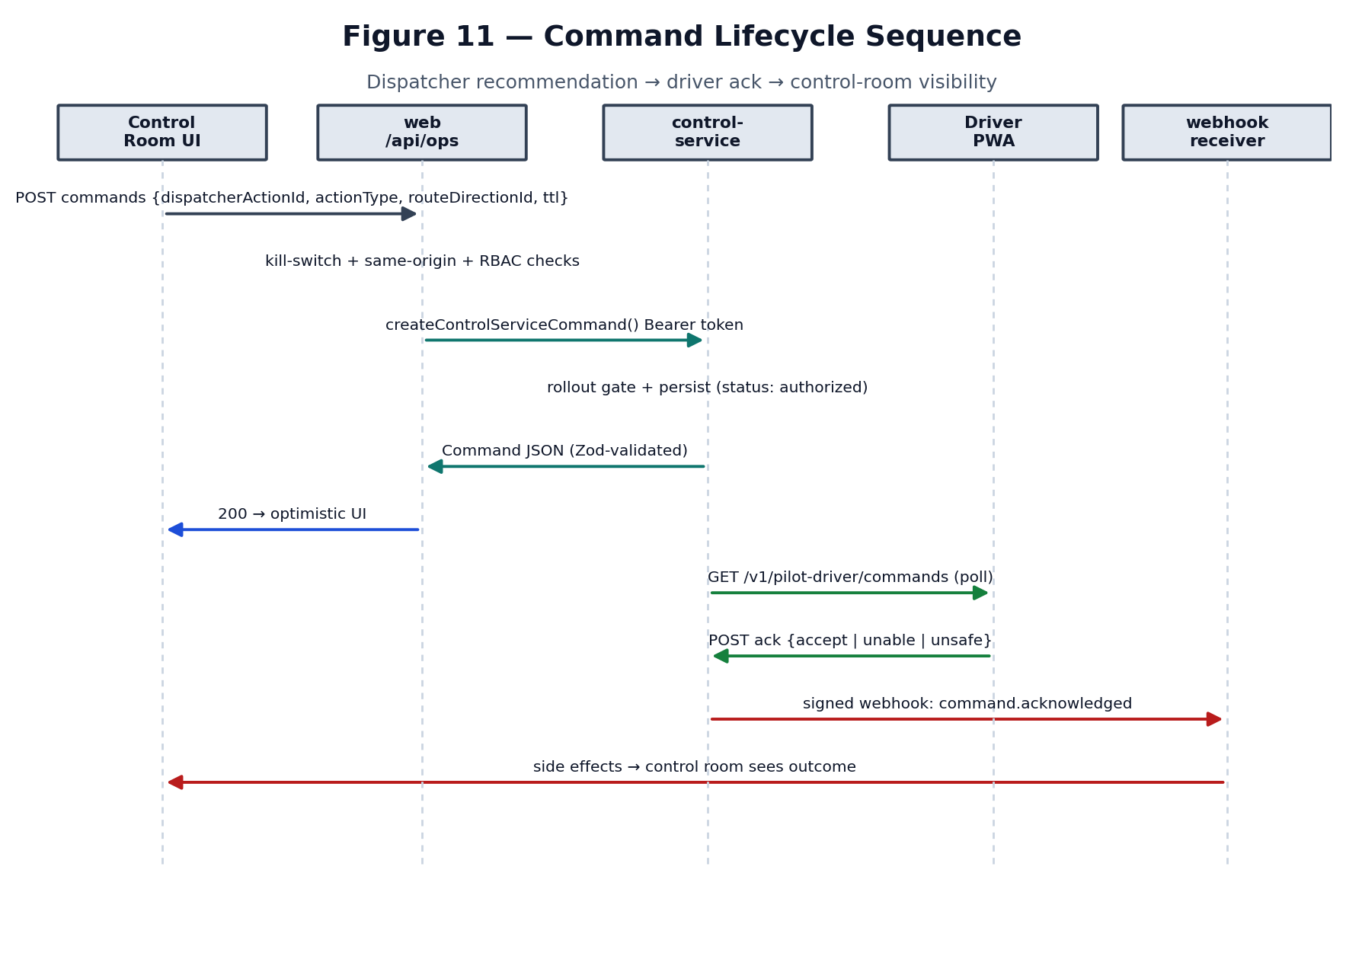
Figure 11 — Command lifecycle sequence.

29.1 Web app API routes (src/app/api)
Table 15 — Web app API surface (37 route files).
Method | Path | Auth | Purpose
POST | /api/auth/login | same-origin | Supabase sign-in; generic errors; rate-limited
POST | /api/auth/logout | session | End Supabase session
GET | /api/auth/session | session | Current session probe
GET | /api/upsrtc/live | Supabase | Live GPS proxy (cache + degradation ladder)
GET | /api/upsrtc/schedule | Supabase | Per-vehicle schedule lookup
POST | /api/control-service/webhook | HMAC | Inbound command lifecycle events
POST/GET | /api/ops/auth/login·logout·session | ops JWT | Ops RBAC auth
POST | /api/ops/auth/accept-invite | invite token | Set password from invite
POST | /api/ops/control-room/commands | control_room | Bridge dispatcher action → control-service command
GET | /api/ops/control-room/commands/[id] | control_room | Command detail
POST | /api/ops/control-room/overrides | control_room | Manual override (distinct from 9 command types)
GET/POST | /api/ops/control-room/kill-switches[/…] | control_room | Engage/disengage route kill switches
POST | /api/ops/control-room/approvals/[id]/reject | control_room | Reject a pending approval
POST | /api/ops/control-room/copilot/query·explain | control_room | Grounded LLM Q&A / incident explanation
POST/GET | /api/ops/control-room/copilot/shift-reports[/…] | control_room | Draft/finalize shift reports
GET | /api/ops/control-room/pilot/kpi·war-room·guardrail-breaches | control_room | Pilot KPIs & war-room
POST/GET | /api/ops/dispatcher/approvals | dispatcher | Dispatcher approval queue
POST | /api/ops/driver/breakdown-reports | driver | Driver breakdown report
GET | /api/ops/pilot-driver/commands | pilot_driver | Driver’s current command (poll)
POST | /api/ops/pilot-driver/commands/[id]/ack | pilot_driver | Acknowledge (accept/unable/unsafe)
POST/GET | /api/ops/admin/invites·users·rollout-stages[/…] | admin | Provision accounts, manage rollout stages
GET | /api/ops/fleet/schedule | ops | Fleet schedule lookup

29.2 control-service REST (/v1, Bearer service token)
Table 16 — control-service REST surface.
Method | Path | Purpose
GET | /healthz · /readyz | Liveness / readiness (unauthenticated)
POST | /v1/positions | Ingest a batch of GPS fixes
POST | /v1/admin/geometry/refresh | Invalidate network-geometry cache
GET | /v1/vehicle-states | Current per-vehicle estimated states
GET | /v1/route-directions[/…] | Route-direction list + geometry
GET | /v1/route-directions/:id/headway | Latest headway snapshot
POST | /v1/route-directions/:id/headway/compute | Force a headway compute
GET | /v1/incidents · /v1/incidents/:id | Open/closed bunching incidents
POST | /v1/mpc/solve | Run the MPC decision engine for a route-direction
POST | /v1/commands | Create a command
GET | /v1/commands/active · /:id · /:id/audit · /by-dispatcher-action/:id | Command reads
POST | /v1/commands/:id/deliver · /ack · /supersede | Command lifecycle transitions
GET/PUT | /v1/rollout-stages · /v1/route-directions/:id/rollout-stage[/audit] | Pilot rollout gating
GET | /v1/guardrail-breaches · /v1/kpi/daily | Pilot guardrails & KPIs
GET/PUT | /v1/war-room/incidents[/:id/review] | War-room incident review

All /v1/* require the Bearer service token (control-service/src/app.ts). Web calls go through src/lib/controlService/client.ts, which adds an 8s timeout and a 3-failure / 30s circuit breaker so one bad control-service instance cannot hang an ops dashboard.

30. Environment Variables
From .env.example (web) and control-service/.env.example. NEXT_PUBLIC_* are exposed to the browser bundle. No values are printed.

Web app
Table 17 — Web environment variables.
Variable | Client/Server | Purpose | Security note
NEXT_PUBLIC_SUPABASE_URL / _ANON_KEY | Client | Supabase Auth | Public by design; access enforced by Auth
SUPABASE_SERVICE_ROLE_KEY | Server | Provision accounts (scripts only) | Never NEXT_PUBLIC; high privilege
NEXT_PUBLIC_GOOGLE_MAPS_API_KEY | Client | Maps SDK | Browser-exposed → restrict by referrer + quotas
UPSRTC_LIVE_URL / UPSRTC_SCHEDULE_URL | Server | Upstream feed URLs | Server-only; keeps upstream off the browser
ALLOW_FIXTURE_FALLBACK / NEXT_PUBLIC_DEMO_MODE | Server/Client | Opt-in demo data | Leave OFF in real deploys
CONTROL_SERVICE_BASE_URL / _SERVICE_TOKEN | Server | Web→control-service REST | Rotating bearer
CONTROL_SERVICE_WEBHOOK_SECRET | Server | Verify inbound webhooks | Must equal control-service WEBHOOK_HMAC_SECRET
OPS_DATABASE_URL | Server | Ops RBAC datastore | Separate from Supabase
OPS_SESSION_SECRET | Server | HS256 ops JWT signing | ≥32 chars; distinct auth system
RESEND_API_KEY / RESEND_FROM_EMAIL | Server | Invite email | —
ANTHROPIC_API_KEY / ANTHROPIC_MODEL | Server | Copilot LLM | Never logged
REDIS_URL / REDIS_TOKEN | Server | Shared limiter/breaker/cache | Recommended in production
SITE_URL | Server | Canonical URL / metadata | —

control-service
Table 18 — control-service environment variables.
Variable | Purpose
CONTROL_SERVICE_DATABASE_URL | Own Postgres/PostGIS (never the web’s Supabase URL)
SERVICE_TOKEN_SECRET | Verify web→control-service bearer
WEBHOOK_HMAC_SECRET / WEB_APP_WEBHOOK_URL | Sign + deliver outbound webhooks
GPS_POLL_ENABLED / _INTERVAL_MS / _URL / GPS_MAX_AGE_SECONDS | In-process poller (enable on ONE instance)
HEADWAY_COMPUTE_INTERVAL_MS / _BATCH_SIZE / _CONCURRENCY | Headway sweep tuning (drives detection latency)
SHAPE_CACHE_TTL_MS / REQUIRE_SEEDED_NETWORK | Geometry cache + readiness gate
SENTRY_DSN / SENTRY_ENVIRONMENT / LOG_LEVEL / PORT | Observability + runtime

31. Architecturally Important Dependencies
Table 19 — Key dependencies (trivial packages omitted).
Package | Role | Where
next / react / react-dom | App framework + UI runtime | whole web app
zustand | Client state store | copilotStore
@googlemaps/js-api-loader | Maps SDK loader | maps/loader.ts, FleetMap
three / @react-three/fiber / drei | Landing 3D globe | src/three/*
@supabase/ssr / supabase-js | Enterprise auth | src/lib/supabase/*
jose + bcryptjs | Ops RBAC JWT + password hashing | src/lib/auth/rbac/*
zod | Runtime validation / shared contracts | src/models/*, control-service
@upstash/redis | Shared limiter/breaker store | src/lib/redis/*
recharts | Dashboard charts | impact/observability
framer-motion / gsap | Animation | landing + dashboard
pg | Postgres access | web ops DB + control-service
express / pino / @sentry/node | control-service runtime + logs + tracing | control-service

32. Principal Engineer Code Walkthrough
An ordered sequence of files to open on screen. For each step: what to open, what to say, the likely question, and a strong answer.

Step 1 — package.json (root)
Focus: scripts, Next 15 / React 19, Zustand, Google Maps, Supabase, zod
Say: This is the web app. Note it’s one of two systems — the control-service has its own package.json.
Likely question: Why Next.js?
Answer: SSR for auth-gated pages, colocated serverless API routes for the UPSRTC proxy so upstream secrets never reach the browser, and one language across client/server.

Step 2 — control-service/package.json + README.md
Focus: Express, pg (PostGIS), pino, Sentry; the boundary rationale
Say: The real transport intelligence lives here as an always-on service with its own isolated DB.
Likely question: Why split it out instead of more API routes?
Answer: It needs a persistent process: a 30s GPS poller, in-memory rehydrated state, and scheduler sweeps. Serverless can’t host that. The integration contract also mandates DB isolation.

Step 3 — src/middleware.ts
Focus: matcher allowlist; three auth branches; webhook exemption
Say: First-line auth. Notice the webhook is deliberately exempt and why.
Likely question: Isn’t exempting a route from the gate dangerous?
Answer: It authenticates by HMAC instead. If a session gate applied, an unauthenticated POST would get a login redirect that fetch() follows as 200 — silently dropping every command event.

Step 4 — src/app/api/upsrtc/live/route.ts
Focus: auth re-check, TtlCache, the degradation ladder
Say: The single bridge to the real GPS feed, and our honest-failure policy.
Likely question: What happens when UPSRTC is down?
Answer: We serve last-known-good cache, then an explicit zero-row ‘unavailable’ state — never demo buses. A recent commit made that the default.

Step 5 — src/lib/upsrtc/normalizer.ts
Focus: alias map, IST timestamp fix, coord gate, dedupe
Say: This is where messy reality becomes clean data. The IST-as-Z fix is the subtle one.
Likely question: Why correct timestamps here?
Answer: The feed labels IST as Z, putting fixes 5.5h in the future, which would make every vehicle read ‘good’ forever. We shift future values back one IST offset and drop broken clocks.

Step 6 — src/components/map/FleetMap.tsx + fleetCanvasLayer.ts
Focus: single canvas overlay vs 9.5k markers
Say: The key frontend performance decision.
Likely question: Why not markers + clustering?
Answer: Measured 5.1s of main-thread blocking. One canvas with Path2D-per-colour and local Mercator maths makes redraw O(visible) on the compositor.

Step 7 — control-service/src/state-estimation/estimator.ts
Focus: map-match → confidence → Kalman → stop-state
Say: How a raw fix becomes a trustworthy route-relative position.
Likely question: How do you avoid trusting a bad GPS fix?
Answer: Low-confidence/off-route fixes are flagged (rank −1) and excluded from ordering, so they never anchor a neighbour’s headway. The Kalman filter smooths the rest.

Step 8 — control-service/src/headway/metrics.ts + bunching.ts
Focus: gap→time headway; the reactive rule
Say: Measurement then detection. Detection is reactive and config-driven.
Likely question: Time or spatial headway?
Answer: Time headway derived from spatial gap and current speed. Detection fires when the ratio to target stays low for N consecutive samples, thresholds from route_policies — not hard-coded.

Step 9 — control-service/src/mpc/solver.ts (+ twoWayHold.ts, safety.ts)
Focus: control hierarchy + hard safety filter
Say: How we choose the least-disruptive safe intervention.
Likely question: How do you prevent conflicting interventions?
Answer: The hard safety filter rejects any candidate for a vehicle with an active command, plus stale-state and max-hold breaches — logged and returned for explainability.

Step 10 — src/app/api/control-service/webhook/route.ts
Focus: HMAC over raw bytes; status codes tuned to retries
Say: The inbound channel for command outcomes; correctness is safety-critical.
Likely question: Why 400 vs 503 distinctions?
Answer: 400 (bad signature) is non-retryable — a retry can’t fix it and would waste attempts on an attacker. 503 (secret unset/db down) is retryable so a misconfig drops nothing.

Step 11 — src/lib/bunching/math.ts
Focus: the SIMULATION — 4 buses, demo constants
Say: This is the explainer page, not the production system. Be explicit.
Likely question: Is this the AI?
Answer: No. It’s a deterministic teaching simulation with hard-coded parameters. The production control laws are in control-service/src/mpc.

33. Principal Engineer Q&A
Q1. Why Next.js?
Answer: SSR auth gating + colocated serverless proxy keeps the UPSRTC upstream off the browser; one language end-to-end.
Limitation to acknowledge: SEO isn’t a driver here; it’s an internal tool.
Q2. Why is the GPS API server-side?
Answer: To hide the upstream URL/headers, add a 15s cache, and normalize before the client sees anything.
Limitation to acknowledge: Any signed-in user can still poll it — no per-user quota yet.
Q3. How do you prevent GPS endpoint exposure?
Answer: The browser only ever calls /api/upsrtc/live; the upstream URL is a server env var.
Limitation to acknowledge: SSRF surface is limited because the URL is env-, not user-, controlled.
Q4. What happens if GPS data is delayed?
Answer: Age buckets classify good/degraded/stale; stale fixes are dropped by the ingest max-age and MPC safety filter.
Limitation to acknowledge: We don’t yet page on a specific vehicle going dark.
Q5. How is stale telemetry detected?
Answer: classifyDataQuality by age; parseUpstreamInstant corrects IST and nulls broken clocks; safety.ts rejects stale state.
Limitation to acknowledge: Depends on correct upstream timestamps, which are quirky.
Q6. Time complexity of bunching detection?
Answer: O(N log N) ordering + O(N) headways + O(samples) per pair, per route-direction.
Limitation to acknowledge: Batched sweep means detection latency = samples × interval × ceil(eligible/batch).
Q7. How would this work with 10,000 buses?
Answer: That’s ~current scale; the canvas map and batched sweep were built for it.
Limitation to acknowledge: Bottlenecks: 11.7 MB single-node poll, per-process web cache — needs streaming + horizontal scale + Redis.
Q8. How do you avoid conflicting interventions?
Answer: Hard safety filter rejects a candidate if the vehicle has an active command.
Limitation to acknowledge: Cross-route-direction conflicts on shared corridors are only partially modelled.
Q9. How is route-level isolation ensured?
Answer: Headway/MPC operate per route-direction; corridor ordering handles shared trunks explicitly.
Limitation to acknowledge: Corridor offsets must be configured or vehicles are excluded.
Q10. Where is source-of-truth state?
Answer: control-service Postgres (+ rehydrated in-memory store) for fleet/headway/commands; the web holds only view state.
Limitation to acknowledge: The web app deliberately has no write access to that DB.
Q11. What about multiple serverless instances on Vercel?
Answer: Each has its own cache/limiter; Redis makes them shared.
Limitation to acknowledge: Without Redis, ‘5 logins / 15 min’ is per warm process.
Q12. Where would you add a message queue?
Answer: Between ingestion and estimation, so a slow estimate doesn’t back up the poll.
Limitation to acknowledge: Currently inline; no backpressure.
Q13. How would you migrate polling → streaming?
Answer: Use UPSRTC deltas/stream if available, or shard the poll by region across instances with a coordinator.
Limitation to acknowledge: Depends on upstream capabilities, which are undocumented.
Q14. Why deterministic instead of ML?
Answer: Control laws are explainable, auditable, and safe by construction — essential when a human dispatcher must justify a hold.
Limitation to acknowledge: It caps predictive power; forecasting is the planned next tier.
Q15. How would the model be trained (future)?
Answer: Historical headway/incident data → short-horizon headway forecast; validate on the replay simulator before it can influence commands.
Limitation to acknowledge: No labelled dataset pipeline exists yet.
Q16. How do you measure intervention effectiveness?
Answer: Re-measure CV/EWT after a hold; the reactive rule’s ‘recovered’ flag closes incidents; pilot KPIs track it.
Limitation to acknowledge: No formal A/B or counterfactual yet.
Q17. How do you roll back a bad intervention?
Answer: Commands have TTLs, supersede transitions, and kill switches per route; drivers can answer ‘unsafe’.
Limitation to acknowledge: Rollback is human-mediated, not automatic.
Q18. Why two normalizers?
Answer: Web needs coordinates; the seeder discards them and keeps parked buses — opposite requirements.
Limitation to acknowledge: The IST fix is duplicated and must be changed in lockstep.
Q19. What’s the blast radius of the webhook secret leaking?
Answer: An attacker could forge command-outcome events; mitigated by size cap, timing-safe compare, and idempotency.
Limitation to acknowledge: Rotate both ends together; a mismatch drops all events.
Q20. Is the ‘AI’ actually running in a given deploy?
Answer: Only if GPS_POLL_ENABLED is on and the estimator is wired; off by default.
Limitation to acknowledge: This is the single most important thing to verify before a pilot.
Q21. How is the map affordable at 9.5k vehicles?
Answer: One canvas, Path2D per colour, local Mercator projection, O(visible) redraw.
Limitation to acknowledge: No clustering — dense corridors render dense by design.
Q22. What if two dispatchers act at once?
Answer: Commands are keyed by dispatcherActionId (uuid) and route-direction; kill switch + rollout gate apply.
Limitation to acknowledge: Optimistic UI could briefly show an unconfirmed action.
Q23. How do you keep the two DBs consistent?
Answer: You don’t share them; the web reflects control-service state via REST + webhooks, never writes.
Limitation to acknowledge: Eventual consistency; webhook delivery must be reliable.
Q24. Why HS256 for ops and Supabase for enterprise?
Answer: Two distinct user populations and lifecycles; ops roles map to control-service’s vocabulary.
Limitation to acknowledge: Two auth systems to maintain.
Q25. What’s the detection latency?
Answer: required_samples × HEADWAY_COMPUTE_INTERVAL_MS × ceil(eligible/batch).
Limitation to acknowledge: Raising the interval multiplies time-to-detection.
Q26. How are invalid coordinates handled?
Answer: Rejected in the normalizer (range + null-island); counted in rejectedRecordCount.
Limitation to acknowledge: Surfaced in the diagnostics drawer.
Q27. What observability exists?
Answer: Sentry spans (mpc.solve), pino logs, liveDiagnostics, /healthz+/readyz.
Limitation to acknowledge: No cross-boundary tracing or web RUM yet.
Q28. How do you prevent a bad batch blinding the fleet?
Answer: Per-event failure isolation in ingestPositionEvents; one bad fix doesn’t reject 664 good ones.
Limitation to acknowledge: Unrecognized (non-SQLSTATE) errors fail the batch on purpose.
Q29. What’s the plan for occupancy data?
Answer: Occupancy MPC already accepts it; today it assumes 0.5 when unknown.
Limitation to acknowledge: No live occupancy sensor integration yet.
Q30. Biggest risk to a pilot?
Answer: Shipping with ingestion disabled, or webhook/upstream failures dropping data silently without alerts.
Limitation to acknowledge: Both are addressed in §26 Critical.

34. “How to Explain the Project” Script

30-second explanation
“Olympuss AI keeps UPSRTC buses evenly spaced. We ingest live GPS, detect when two buses are bunching, and recommend the smallest fix — usually holding a bus a few seconds — which a dispatcher approves and a driver confirms. It’s two systems: a Next.js control dashboard and an always-on control-service that does the state estimation and the control maths.”

2-minute explanation
Add: the data flow (server proxy → normalize → canvas map of ~9.5k buses), the honest degradation ladder, and the distinction between the client-side teaching simulation and the real server-side pipeline (Kalman + headway + MPC). Emphasize deterministic, explainable control laws with a human in the loop.

5-minute architecture explanation
Walk Figure 1 (two systems, isolated DBs), Figure 5 (GPS data flow), and Figure 7 (intervention/recovery loop). Land the boundary decision: the web never writes to the control-service DB; they talk over REST + signed webhooks.

15-minute technical walkthrough
Follow §32 steps 1–9: package.jsons → middleware → live route → normalizer → FleetMap → estimator → headway/bunching → MPC solver. Use Figures 3, 6, 8, 11.

Deep technical walkthrough
Add §13 formulas (two-way hold, Kalman, EWT), §20 scalability, and §26 recommendations. Be explicit about what is PROTOTYPE/PLANNED (predictive tier) and the ingestion-enablement gate, so the reviewer trusts your honesty.
OPENING LINE “Let me first show you the high-level architecture (Figure 1), then trace one live GPS fix all the way from the UPSRTC feed to a hold recommendation on a driver’s phone.”

35. Appendix

A. Key source files by concern
Table 20 — Reading map by concern.
Concern | Open these files
Entry / auth | src/middleware.ts, src/app/layout.tsx, src/lib/auth/rbac/*, src/lib/supabase/*
Live GPS | src/app/api/upsrtc/live/route.ts, src/lib/upsrtc/{client,normalizer,cache,fixtureFallback}.ts, src/hooks/useLiveFleet.ts
Map | src/components/map/FleetMap.tsx, fleetCanvasLayer.ts, src/lib/maps/loader.ts
State | src/stores/copilotStore.ts, src/models/canonical.ts
Bunching (sim) | src/lib/bunching/{math,config,simulation,controller}.ts, src/components/bunching/*
State estimation | control-service/src/state-estimation/{estimator,kalmanFilter,ordering,mapMatching,confidence}.ts
Headway/bunching (prod) | control-service/src/headway/{metrics,bunching,service}.ts
MPC | control-service/src/mpc/{solver,twoWayHold,selfEqualizing,terminalDispatch,occupancyMpc,safety}.ts
Ingestion/scheduler | control-service/src/ingestion/pipeline.ts, scheduler/{gpsPoll,headwayCompute,jobs}.ts
Integration | src/lib/controlService/client.ts, src/app/api/control-service/webhook/route.ts, control-service/src/webhooks/*
Copilot (LLM) | src/lib/copilot/*, src/app/api/ops/control-room/copilot/*

B. Reference docs in the repo
docs/Olympuss_AI_UPSRTC_Bus_Bunching_Technical_Blueprint.(md|docx), docs/CONTROL_SERVICE_INTEGRATION.md, docs/CONTROL_SERVICE_DEPLOYMENT.md, docs/API_DISCOVERY.md, docs/ARCHITECTURE.md, docs/PRODUCTION_ROADMAP.md, docs/olympuss/{OVERVIEW,AUTH,RBAC,COPILOT,DEPLOYMENT,BASELINE}.md.

C. Method note
Every claim in this document was derived by reading the cited source files directly and tracing imports/callers along the runtime path. Where the repository’s own comments state measured facts (e.g. the +5.44h timestamp skew, the 5.1s marker-blocking measurement, the ~665/9,261 live-vehicle split), those figures are quoted as the code records them. No functionality was invented; anything not found is labelled as such, and simulated / hard-coded / prototype / planned components are labelled accordingly.

