PROJECT REPORT
(Project Term June – July 2026)
DOCKERIZED CALCULATOR APPLICATION
Submitted by
Utkarsh Patel
Registration Number: 12413114
Course Code: PETV137
Under the Guidance of
Priyanka Gupta , Harpreet Kaur
School of Computer Science and Engineering

Lovely Professional University, Phagwara, Punjab

DECLARATION
I hereby declare that the project work entitled "Dockerized Calculator Application" is an authentic record of my own work carried out as requirements of Project for the award of B.Tech Degree in Computer Science and Engineering from Lovely Professional University, Phagwara, under the guidance of (Priyanka Gupta, Harpreet Kaur), during June to July 2026. All the information furnished in this project report is based on my own intensive work and is genuine.

Name of Student : Utkarsh Patel
Registration Number: 12413114

Date: 12-07-2026

CERTIFICATE
This is to certify that the declaration statement made by the student is correct to the best of my knowledge and belief. He has completed this Project under my guidance and supervision. The present work is the result of his original investigation, effort and study. No part of the work has ever been submitted for any other degree at any University. The Project is fit for the submission and partial fulfillment of the conditions for the award of B.Tech Degree in Computer Science and Engineering from Lovely Professional University, Phagwara.

Signature and Name of the Mentor
Designation
School of Computer Science and Engineering,
Lovely Professional University,
Phagwara, Punjab.
Date : 12-07-2026

ACKNOWLEDGEMENT
I would like to express my sincere gratitude to my faculty mentor for the continuous guidance, encouragement and valuable feedback throughout the development of this project. Their insights on version control discipline, containerization and software testing shaped the direction of this work.
I am also thankful to the School of Computer Science and Engineering, Lovely Professional University, for providing the resources and environment that made this project possible, and to my peers for their constructive suggestions during development and testing.

TABLE OF CONTENTS
Declaration ii
Certificate iii
Acknowledgement iv
Table of Contents v
1. INTRODUCTION 1
1.1 Objectives 1
1.2 Technologies Used 1
2. SCOPE OF THE STUDY (PROBLEM STATEMENT) 2
3. EXISTING SYSTEM 3
3.1 Introduction 3
3.2 Existing Software 3
3.3 What is New in the System to be Developed 3
4. PROBLEM ANALYSIS 4
4.1 Product Definition 4
4.2 Feasibility Analysis 4
4.3 Project Plan 4
5. SOFTWARE REQUIREMENT ANALYSIS 5
5.1 Introduction 5
5.2 General Description 5
5.3 Specific Requirements 5
6. DESIGN 6
6.1 System Design 6
6.2 Design Notations 6
6.3 Detailed Design 6
6.4 Pseudo Code 6
7. TESTING 7
7.1 Functional Testing 7
7.2 Structural Testing 7
7.3 Levels of Testing 7
7.4 Testing the Project 7
8. IMPLEMENTATION 8
8.1 Implementation of the Project 8
8.2 Conversion Plan 8
8.3 Post-Implementation and Software Maintenance 8
9. PROJECT LEGACY 9
9.1 Current Status of the Project 9
9.2 Remaining Areas of Concern 9
9.3 Technical and Managerial Lessons Learnt 9
10. SYSTEM SNAPSHOTS 10
11. BIBLIOGRAPHY 13

1. INTRODUCTION
This report documents the design, development, testing and containerized packaging of a calculator application. While a calculator is a familiar utility, the objective of this project is not the arithmetic itself but the engineering practices that surround it: disciplined commit management with a clean version-control history, a reproducible Docker build, an automated test suite, and a considered user interface.
The application is built as a single-page web application using React for the interface and Framer Motion for fluid, physics-based interactions. The arithmetic logic is deliberately separated from the interface into a pure, self-contained module so that it can be verified independently through automated unit tests. The finished application is packaged into a lightweight Docker image so that it can be built and run identically on any machine.

1.1 Objectives
- To implement a fully functional calculator with a clean separation between logic and presentation.
- To maintain a meaningful, incremental Git commit history that reflects the evolution of the project.
- To containerize the application with a multi-stage Docker build that runs the test suite as a build gate.
- To create an attractive, accessible user interface with smooth motion using Framer Motion.

1.2 Technologies Used
- React 18 — component-based user interface library.
- Framer Motion — declarative animation library for spring-based interactions.
- Vite — fast build tool and development server.
- Vitest — unit-testing framework for the calculator engine.
- Docker (Node + Nginx) — multi-stage containerization and static serving.
- Git — distributed version control for commit management.

2. SCOPE OF THE STUDY (PROBLEM STATEMENT)
The problem addressed by this project is to develop and package a calculator application in a way that demonstrates three professional software-engineering competencies: commit management, Docker build skills, and application testing. The calculator must support the four basic arithmetic operations along with common conveniences such as percentage, sign inversion and a clear function, while gracefully handling error conditions such as division by zero.
The scope is limited to a client-side application; there is no server-side computation or persistent data storage. The emphasis is on code quality, a reproducible build pipeline, automated verification of the arithmetic logic, and a polished, responsive interface rather than on an extensive feature set.

3. EXISTING SYSTEM

3.1 Introduction
Calculator applications are ubiquitous and ship as built-in utilities on virtually every operating system, as well as countless web-based versions. These existing systems perform arithmetic reliably, but they are typically distributed as monolithic applications whose source, tests and build process are not exposed for study.

3.2 Existing Software
Common examples include the native calculator utilities bundled with Windows, macOS and Linux desktop environments, and web calculators embedded in search engines. These are closed to modification and do not demonstrate a build or test pipeline that a student can inspect.

3.3 What is New in the System to be Developed
The system developed here differs from existing calculators in its engineering transparency. The arithmetic engine is isolated as a pure function and is fully unit-tested; the entire application is reproducibly packaged through a multi-stage Docker build in which the tests act as a gate, so a build containing a broken calculation cannot be produced; and the interface is animated with Framer Motion to give tactile, spring-based feedback on every interaction.

4. PROBLEM ANALYSIS

4.1 Product Definition
The product is a web-based calculator that accepts input by both mouse and keyboard, evaluates arithmetic expressions left-to-right, and presents results on a simulated LCD display. It is delivered as a static bundle served by Nginx inside a Docker container.

4.2 Feasibility Analysis

4.2.1 Technical feasibility
All chosen technologies are mature, open-source and widely supported. React, Vite, Vitest and Docker require only a Node.js toolchain, which is freely available on all major platforms, making the project entirely technically feasible.

4.2.2 Economic feasibility
The project relies exclusively on free and open-source software and incurs no licensing cost. It runs on commodity hardware, so it is economically feasible.

4.3 Project Plan
The project was developed incrementally, with each milestone captured as a distinct Git commit: scaffolding the project, implementing the calculator engine, writing the test suite, building the user interface, adding the Dockerfile, and finally documenting the project. This sequence is reflected directly in the version-control history shown in Section 8.

5. SOFTWARE REQUIREMENT ANALYSIS

5.1 Introduction
This section specifies the functional and non-functional requirements that the calculator application must satisfy.

5.2 General Description
The application is a single-user, client-side utility. It presents a keypad and a display, responds instantly to input, and requires no installation beyond a modern web browser or a Docker runtime.

5.3 Specific Requirements

5.3.1 Functional requirements
- The system shall perform addition, subtraction, multiplication and division.
- The system shall support chained operations evaluated from left to right.
- The system shall provide percentage, sign-inversion and clear functions.
- The system shall display an error state on division by zero, recoverable only by clearing.
- The system shall accept input from both the on-screen keypad and the physical keyboard.

5.3.2 Non-functional requirements
- The interface shall respond to input within one animation frame for a responsive feel.
- The interface shall be accessible, with visible keyboard focus and respect for reduced-motion preferences.
- The application shall be reproducibly buildable through Docker on any host.

6. DESIGN

6.1 System Design
The application follows a clear separation of concerns. A pure reducer module holds the entire calculator state machine and contains no user-interface code. The React component layer renders the display and keypad, dispatches user actions to the reducer, and animates the results. This separation makes the arithmetic logic independently testable and keeps the interface thin.

6.2 Design Notations
The core of the design is a state machine. The calculator holds a current display value, a stored previous value, the pending operator, and flags indicating whether the next digit should overwrite the display and whether an error is active. Every key press is expressed as an action that transforms this state.

6.3 Detailed Design
The reducer processes the following action types: digit entry, decimal point, operator selection, equals, percent, sign negation and clear. When an operator is pressed while another operation is already pending, the calculator first evaluates the pending operation, enabling natural left-to-right chaining. Division by zero produces an explicit error state that suppresses further input until the calculator is cleared.

6.4 Pseudo Code
function reduce(state, action):
if state.error and action != clear: return state
switch action.type:
case digit: append or overwrite display
case operator: if pending op exists, evaluate first,
then store new operator
case equals: result = compute(prev, current, op)
if result invalid -> error state
case percent: display = display / 100
case negate: toggle sign of display
case clear: reset to initial state

7. TESTING
Because the arithmetic engine is a pure function, it is verified in isolation with an automated unit-test suite written using Vitest. Fourteen test cases cover the calculator engine.

7.1 Functional Testing
Functional testing confirms that the calculator produces correct results for its specified operations. The suite verifies addition, subtraction into negative numbers, multiplication, division, and floating-point results such as 9 ÷ 4 = 2.25.

7.2 Structural Testing
Structural testing exercises the internal branches of the reducer: chained operations, duplicate decimal-point rejection, the twelve-digit input cap, sign inversion, percentage conversion, and the division-by-zero error path together with its recovery through the clear action.

7.3 Levels of Testing
Unit testing is applied to the calculator engine. The tests are additionally executed inside the Docker build, so integration of the tested code into the deliverable image is verified automatically; a build cannot succeed unless every test passes.

7.4 Testing the Project
The complete suite executes in well under a second and all fourteen cases pass, as shown below.
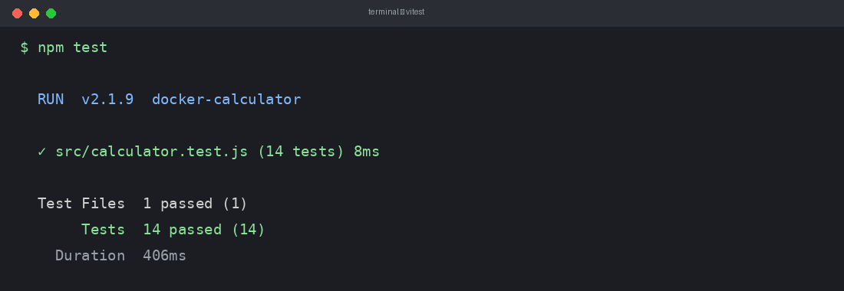
Figure 7.1 — All fourteen unit tests passing under Vitest

8. IMPLEMENTATION

8.1 Implementation of the Project
The application was implemented in stages, each recorded as a Git commit to maintain a clean and meaningful version-control history. The commit log below shows the incremental progression from project scaffolding through the engine, tests, interface, Docker packaging and documentation.
$ git log --oneline
d58551b docs: README with run, test and Docker instructions
faa5183 build: multi-stage Dockerfile (node build -> nginx)
751c434 feat: Braun ET-inspired UI with framer-motion + keyboard
65af3cd test: 14-case Vitest suite for calculator engine
1a2e264 feat: pure calculator reducer (chaining, percent, error)
ac70b3b chore: scaffold Vite + React project
Figure 8.1 — Incremental Git commit history

8.2 Conversion Plan
The application is packaged with a multi-stage Docker build. The first stage uses a Node image to install dependencies, run the test suite and produce an optimized static bundle. The second stage copies only that bundle into a lightweight Nginx image for serving, yielding a small final container of roughly fifty megabytes.
# Stage 1: build
FROM node:22-alpine AS build
WORKDIR /app
COPY package*.json ./
RUN npm ci
COPY . .
RUN npm test # tests gate the image
RUN npm run build

# Stage 2: serve
FROM nginx:1.27-alpine
COPY --from=build /app/dist /usr/share/nginx/html
EXPOSE 80
Figure 8.2 — Multi-stage Dockerfile

8.3 Post-Implementation and Software Maintenance
Because the arithmetic logic is isolated and fully tested, future maintenance such as adding new operations can be carried out with confidence: new behaviour is added to the reducer and covered by additional tests, and the Docker build guarantees that only a passing version can be packaged and deployed.

9. PROJECT LEGACY

9.1 Current Status of the Project
The project is complete and fully functional. The calculator performs all specified operations, the interface is polished and responsive, the fourteen-case test suite passes, and the application builds and runs successfully inside Docker.

9.2 Remaining Areas of Concern
The calculator currently evaluates expressions strictly left-to-right and does not implement operator precedence or parentheses. A scientific mode and a persistent calculation history are natural extensions that remain outside the present scope.

9.3 Technical and Managerial Lessons Learnt
- Separating pure logic from the interface makes automated testing straightforward and greatly improves confidence in changes.
- Running tests inside the Docker build turns the pipeline into a safety gate rather than a mere packaging step.
- Committing work in small, well-described increments produces a history that itself documents the project.

10. SYSTEM SNAPSHOTS
The following screenshots show the finished application. The interface takes visual inspiration from the classic Braun ET-series calculators: a warm charcoal body, round keys, a green LCD-style display, and a single amber equals key as the one accent. Every key press is animated with a Framer Motion spring for tactile feedback.

10.1 Default State
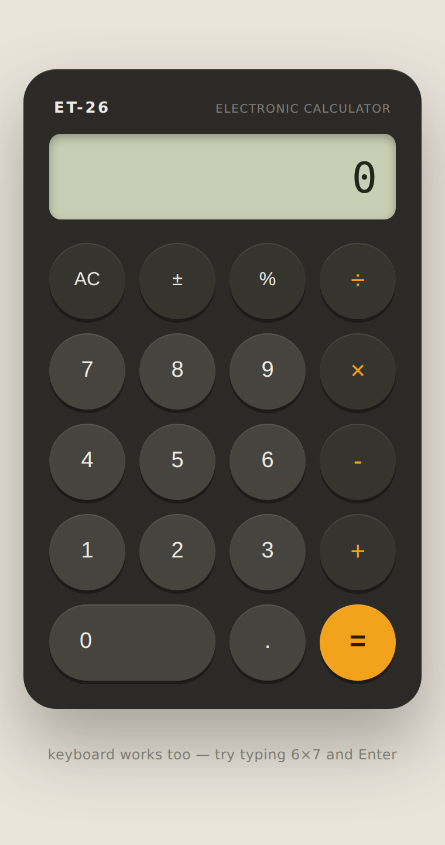
Figure 10.1 — The calculator in its initial state

10.2 Computation Result
Entering 6 × 7 and pressing equals yields 42, with the pending operator shown on the display during entry.
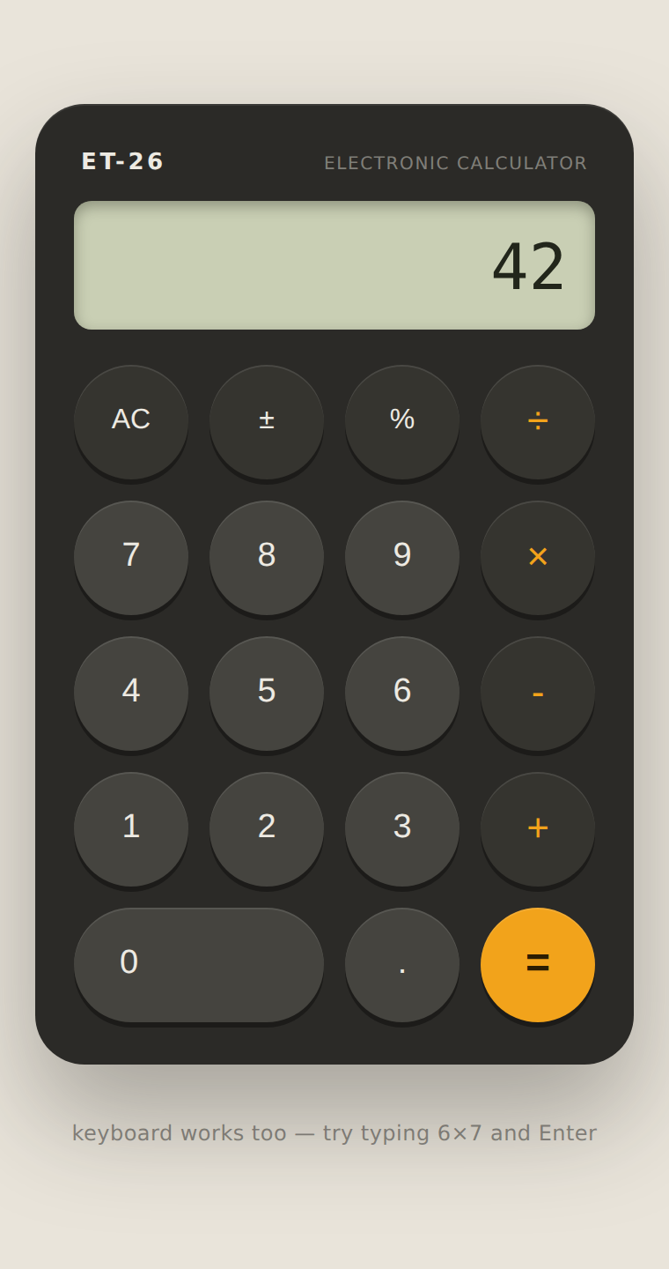
Figure 10.2 — Result of a calculation (6 × 7 = 42)

10.3 Error Handling
Attempting to divide by zero places the calculator in an explicit error state, shown in a distinct colour, which can only be dismissed with the AC (clear) key.
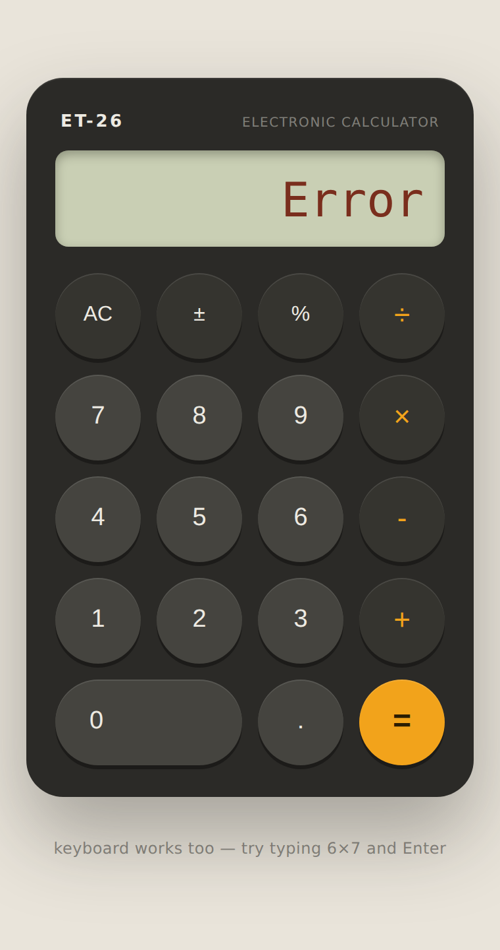
Figure 10.3 — Division-by-zero error state

11. BIBLIOGRAPHY
React Documentation. Meta Open Source. https://react.dev
Framer Motion Documentation. https://www.framer.com/motion/
Vite Documentation. https://vitejs.dev
Vitest Documentation. https://vitest.dev
Docker Documentation. https://docs.docker.com
Pro Git, S. Chacon and B. Straub. https://git-scm.com/book

